Hands on - 6

Azure Kubernetes Service creation

1. Click on “Create a resource” and search for kubernetes services.

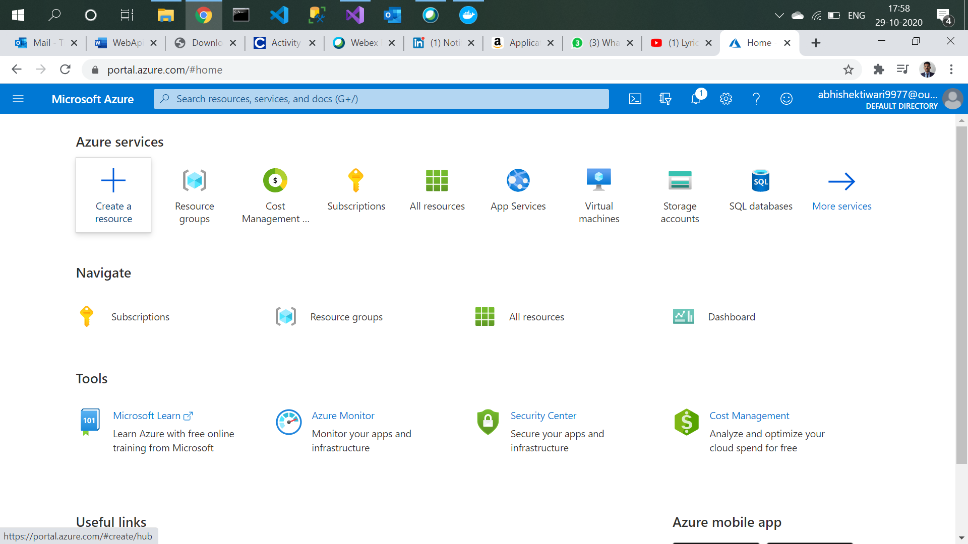

1. Create kubernetes services.

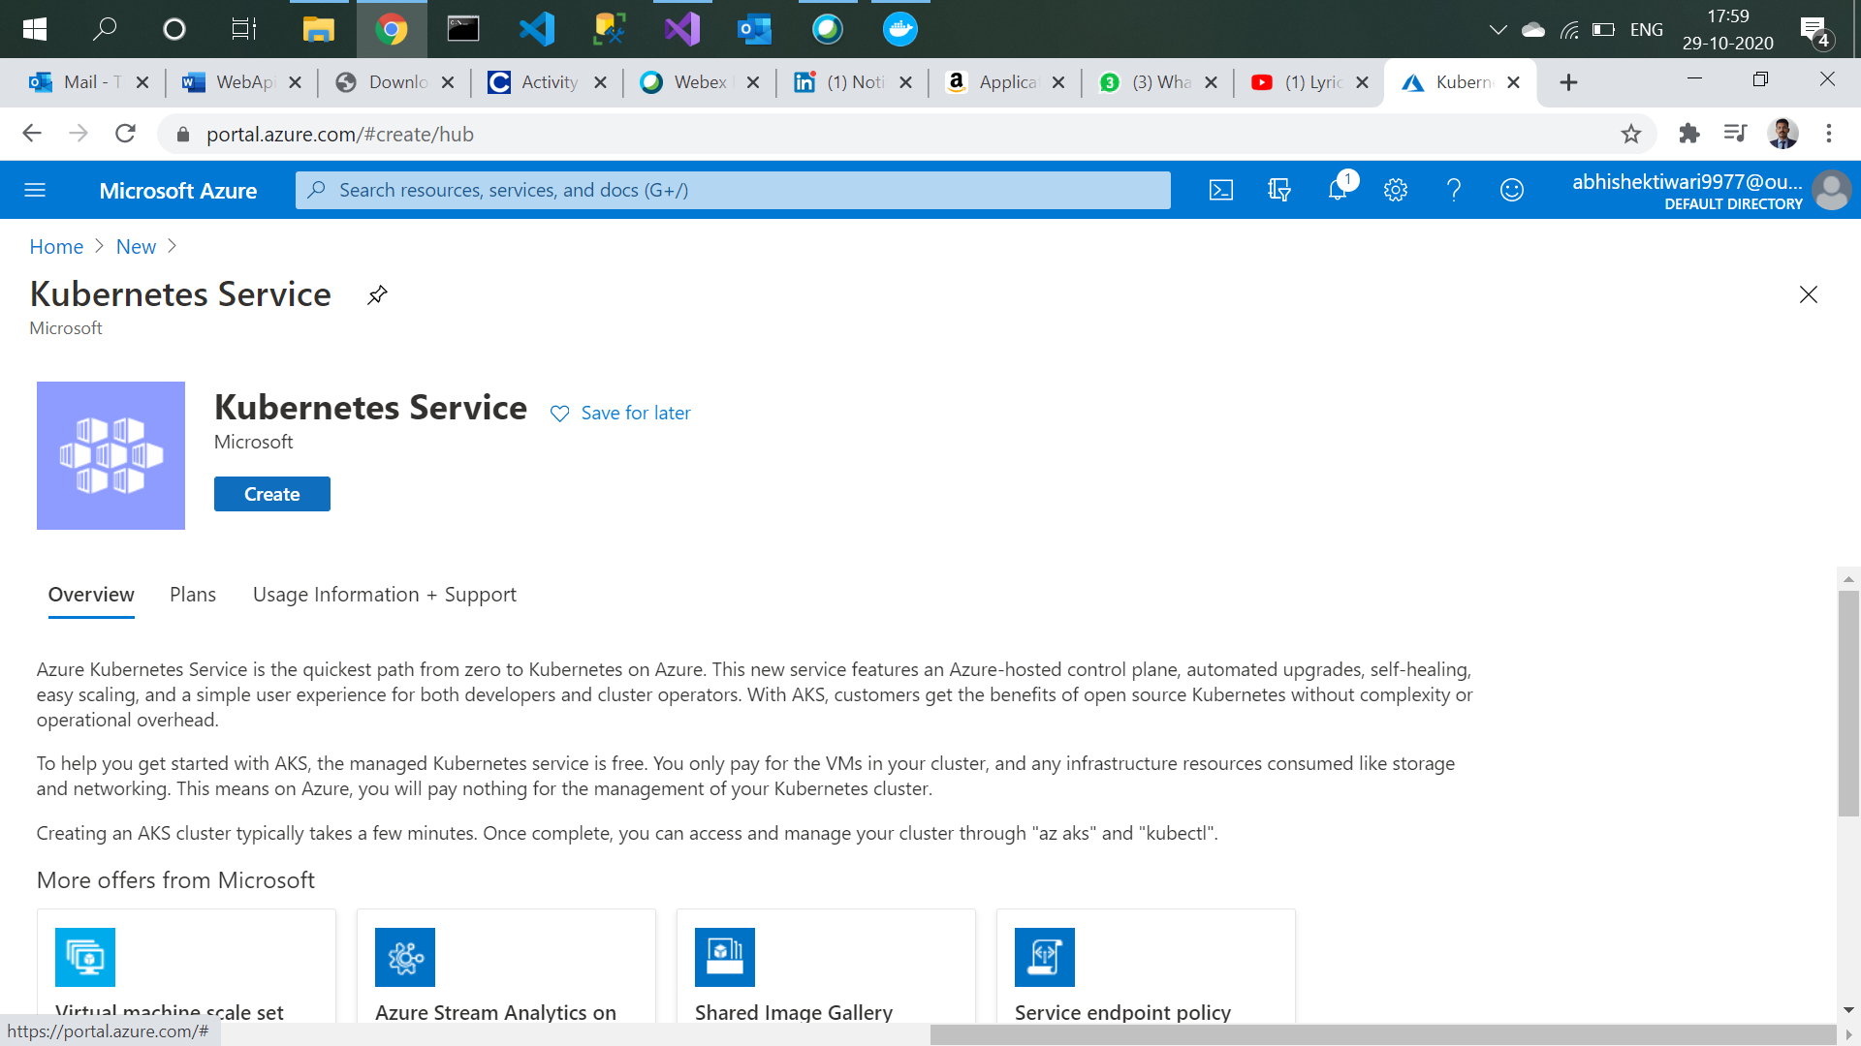

1. Select resource group and enter name of cluster.

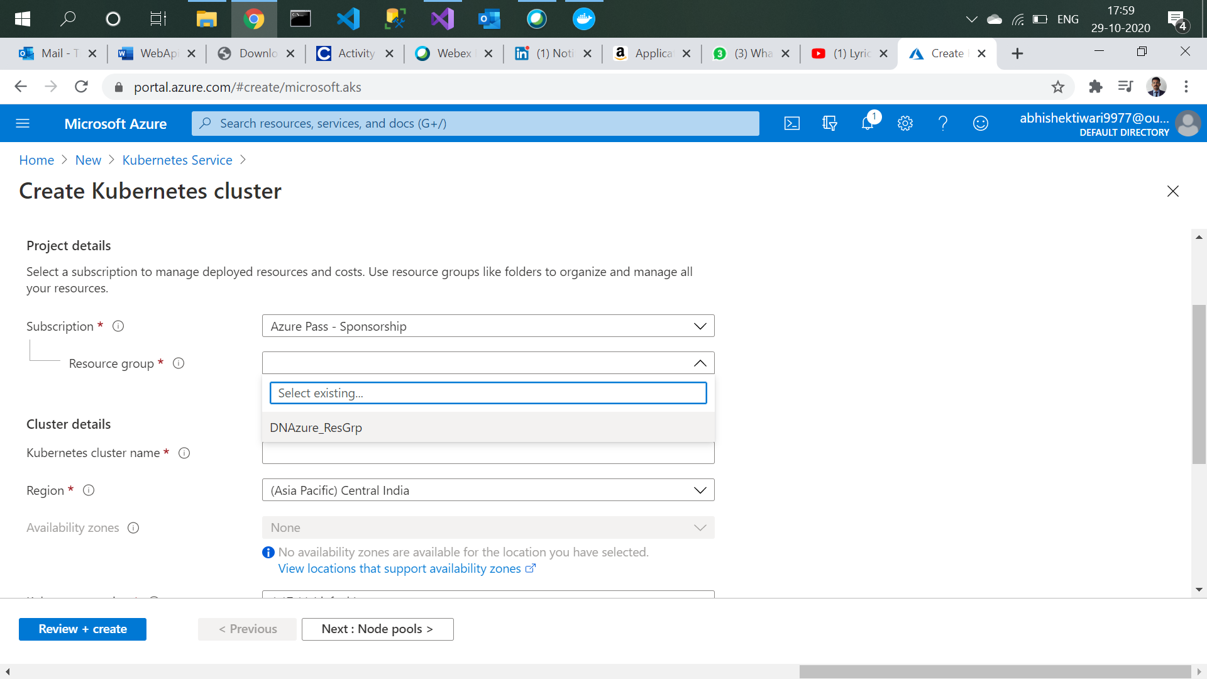

1. Change VM size to BS2.

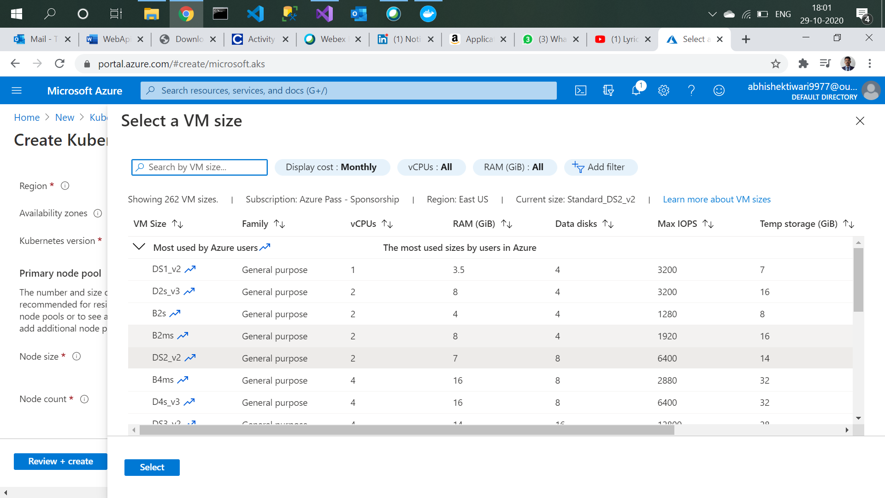

1. Click on create.

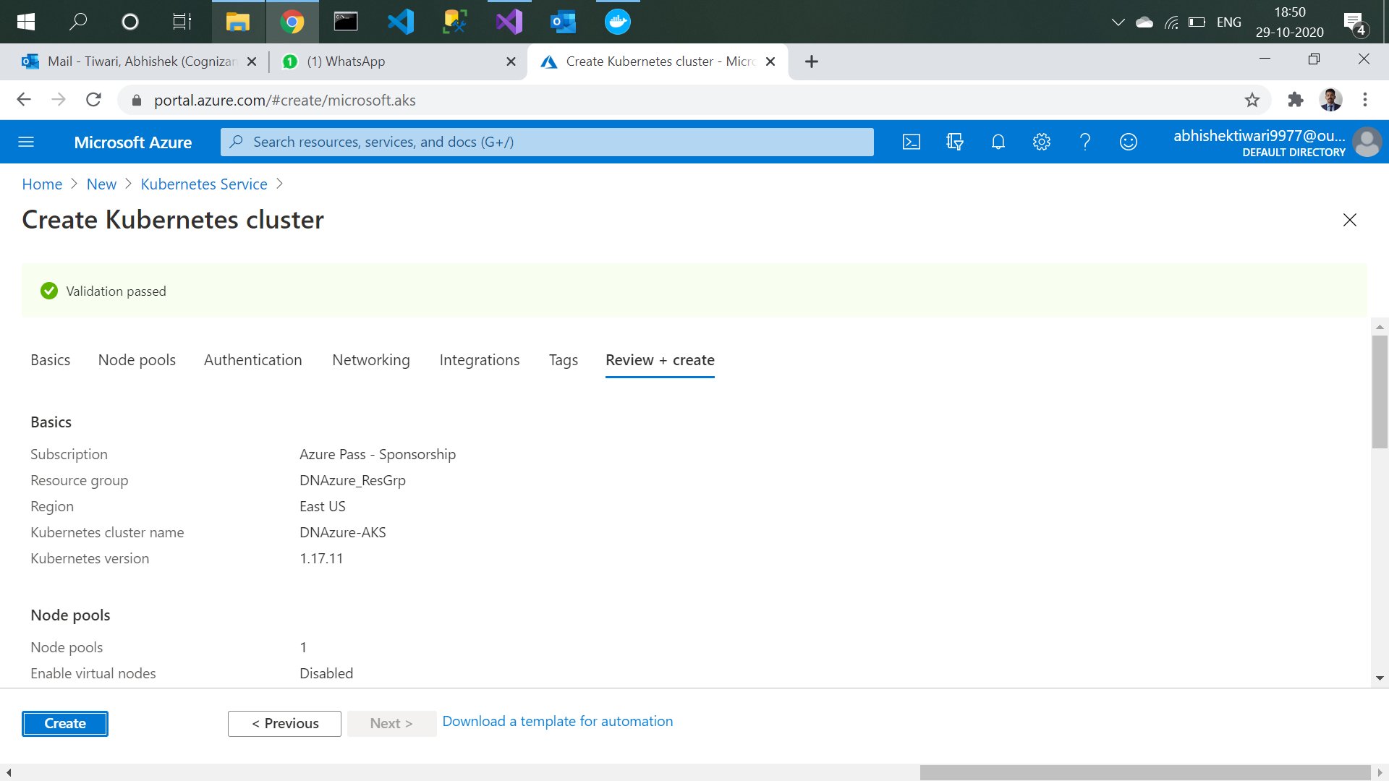

1. Deployment is in progress.

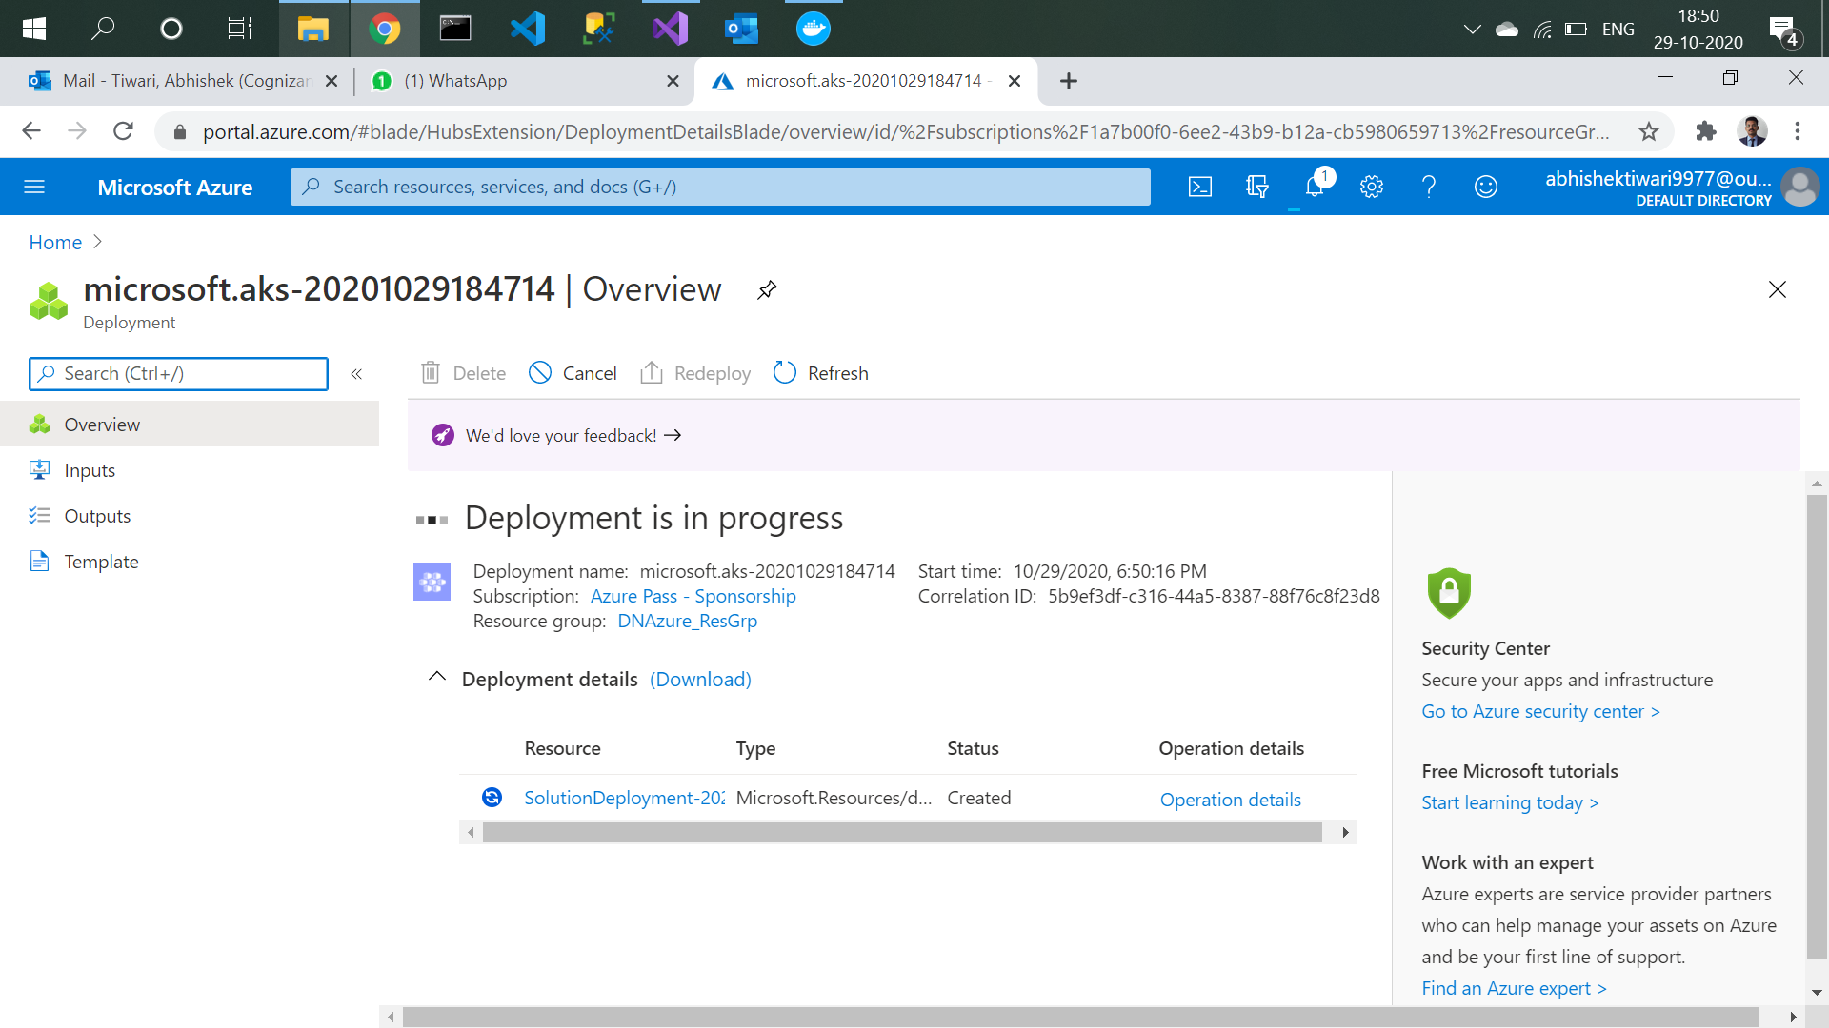

1. Deployment succeeded, click on go to resource.

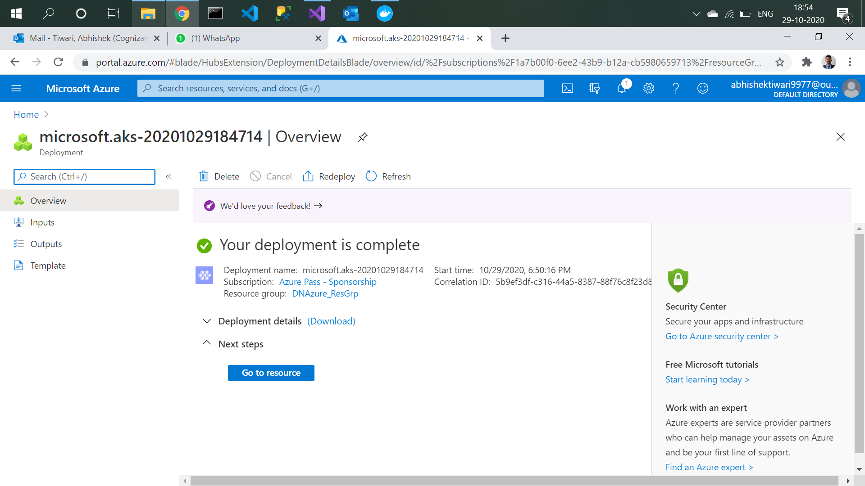

1. Verify name, version, node pools.

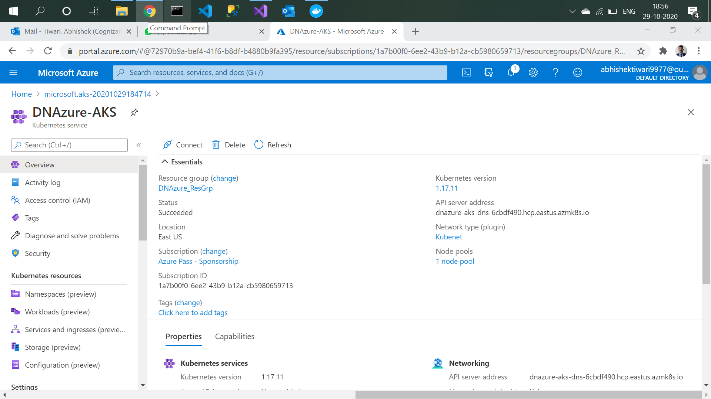

Azure Container Registry creation

1. Go to container and create container registry.

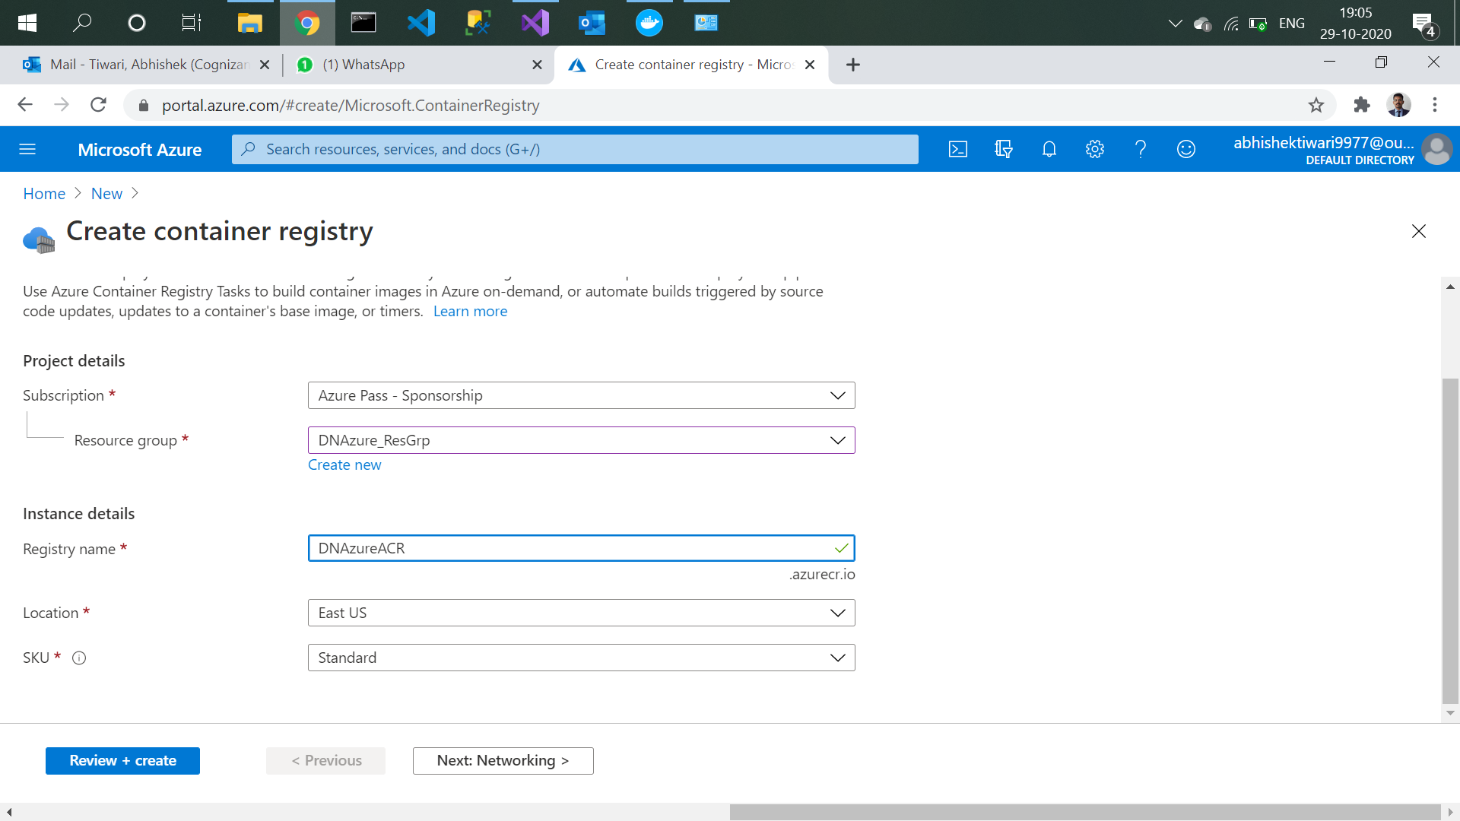

1. Click on create.

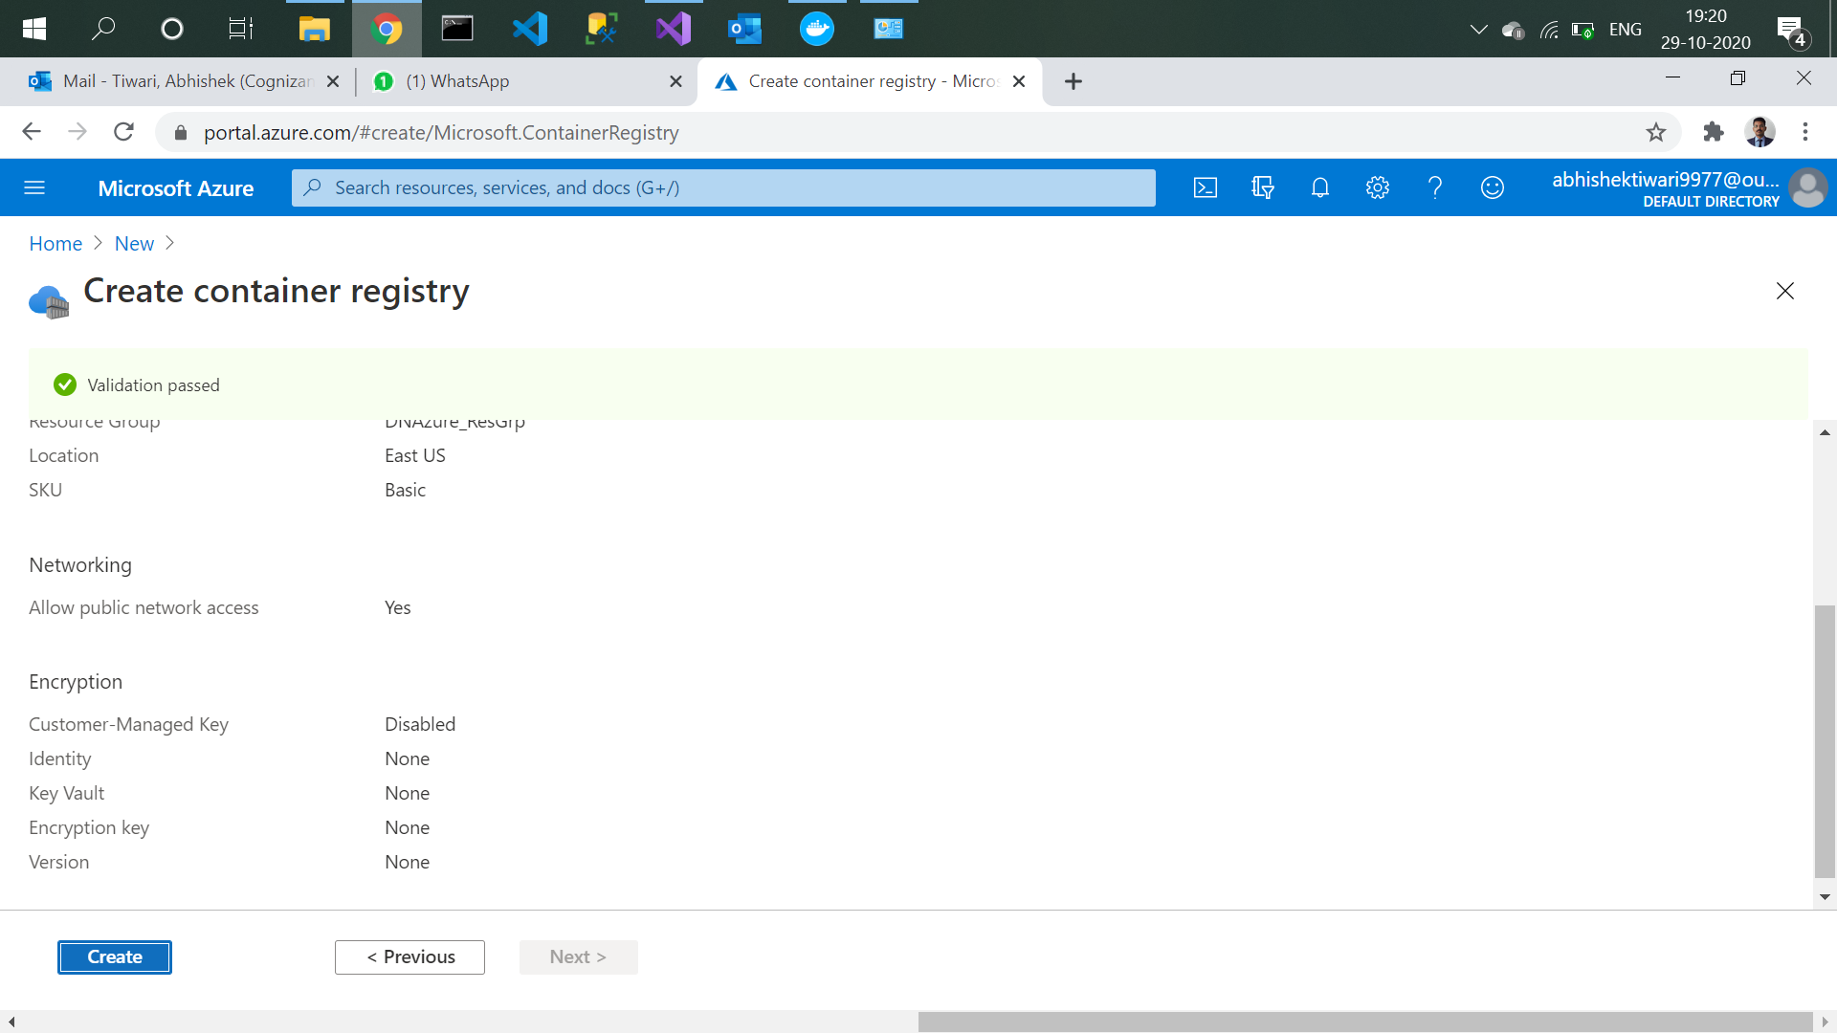

1. Container deployed.

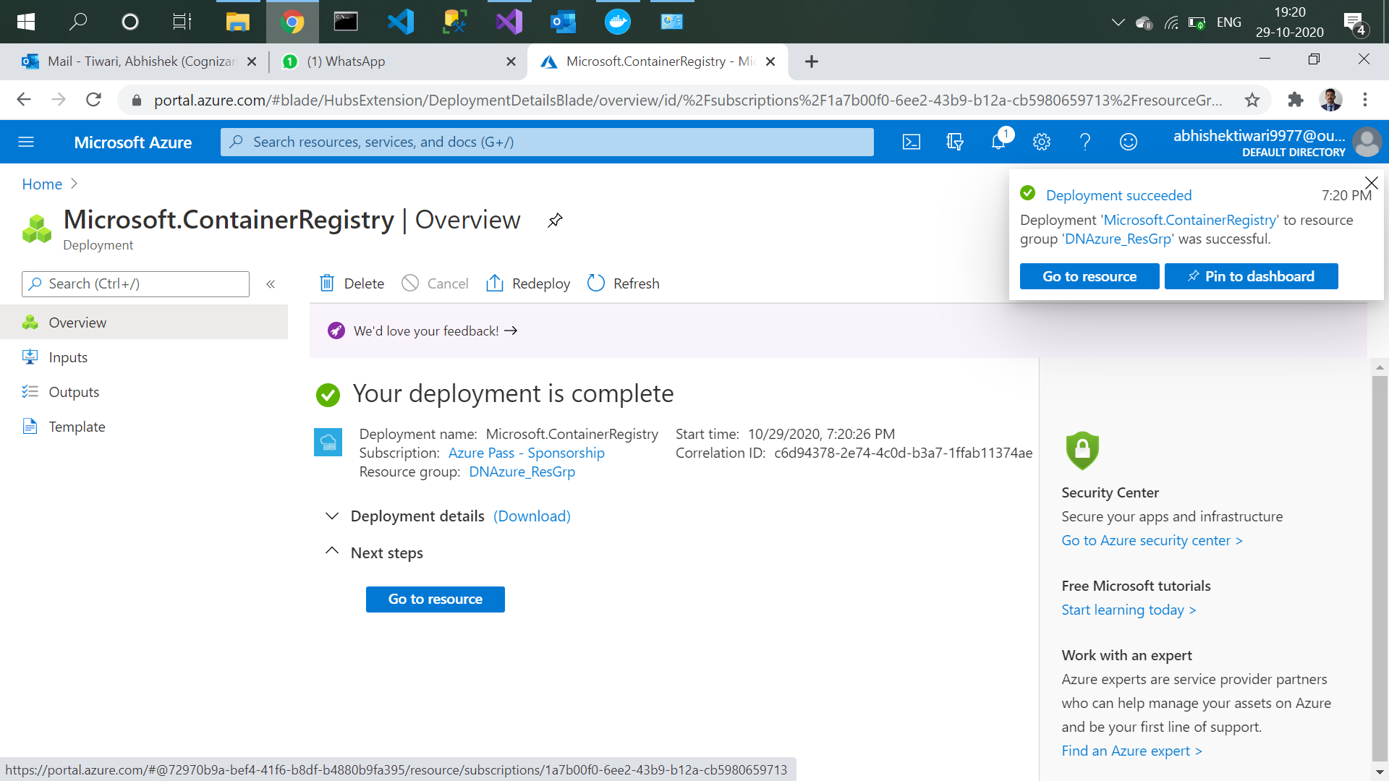

1. Click on Go to resource to verify login server, name etc.

