Hands on 8

CI pipeline modification for Docker integration to ACR

1. After Handson 7, Create container registry.

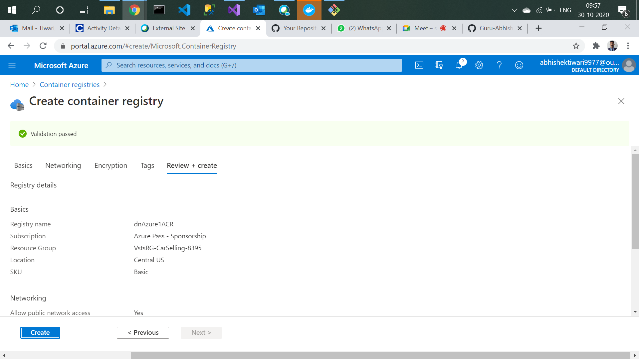

1. Container deployment in progress.

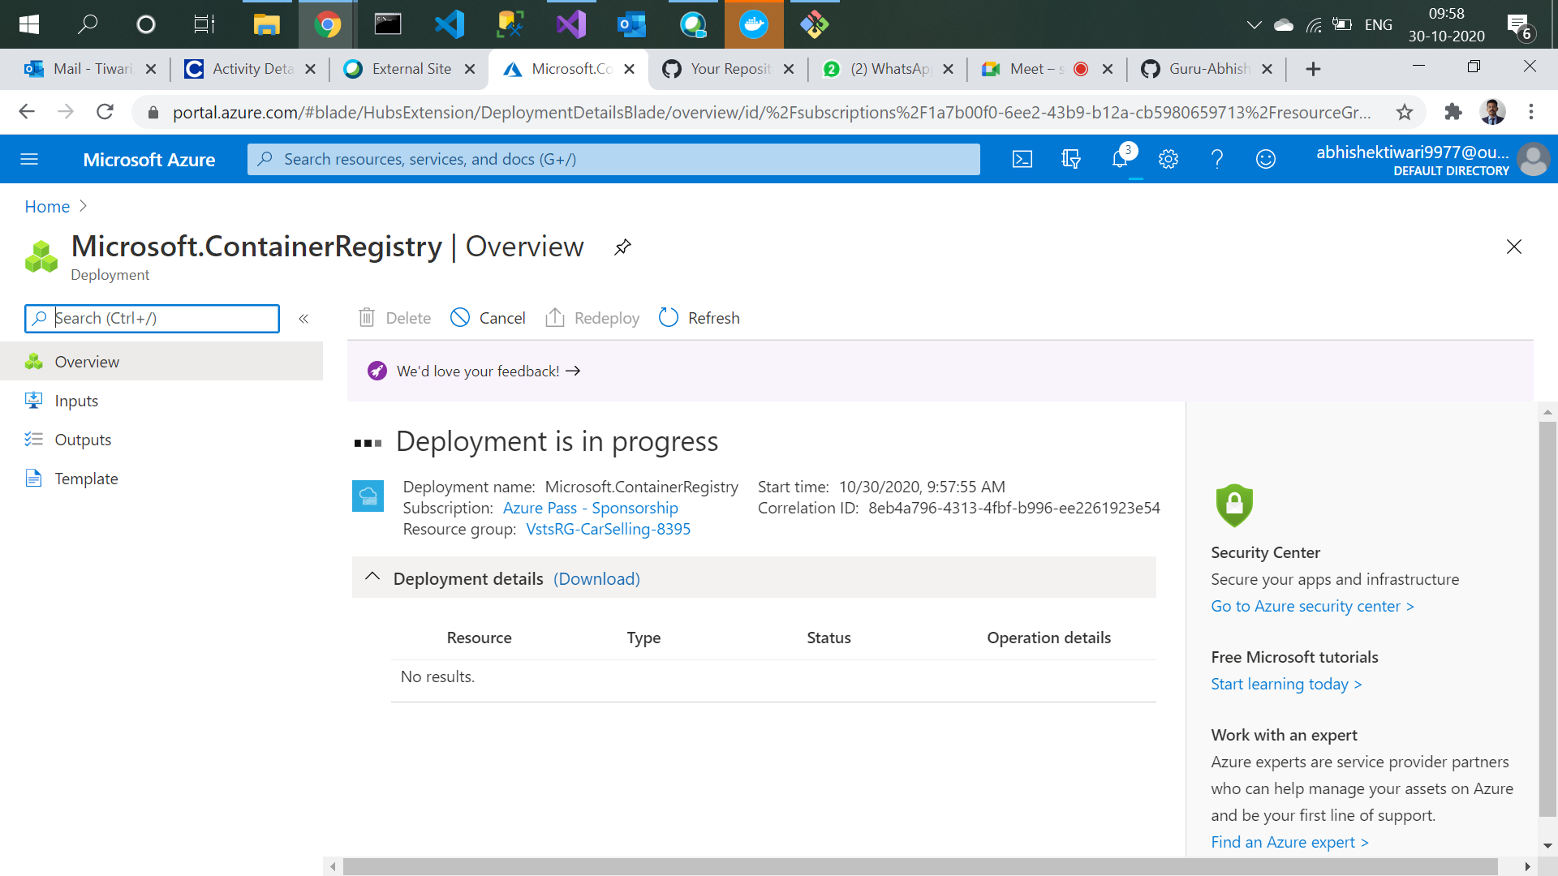

1. Container Deployment succeeded.

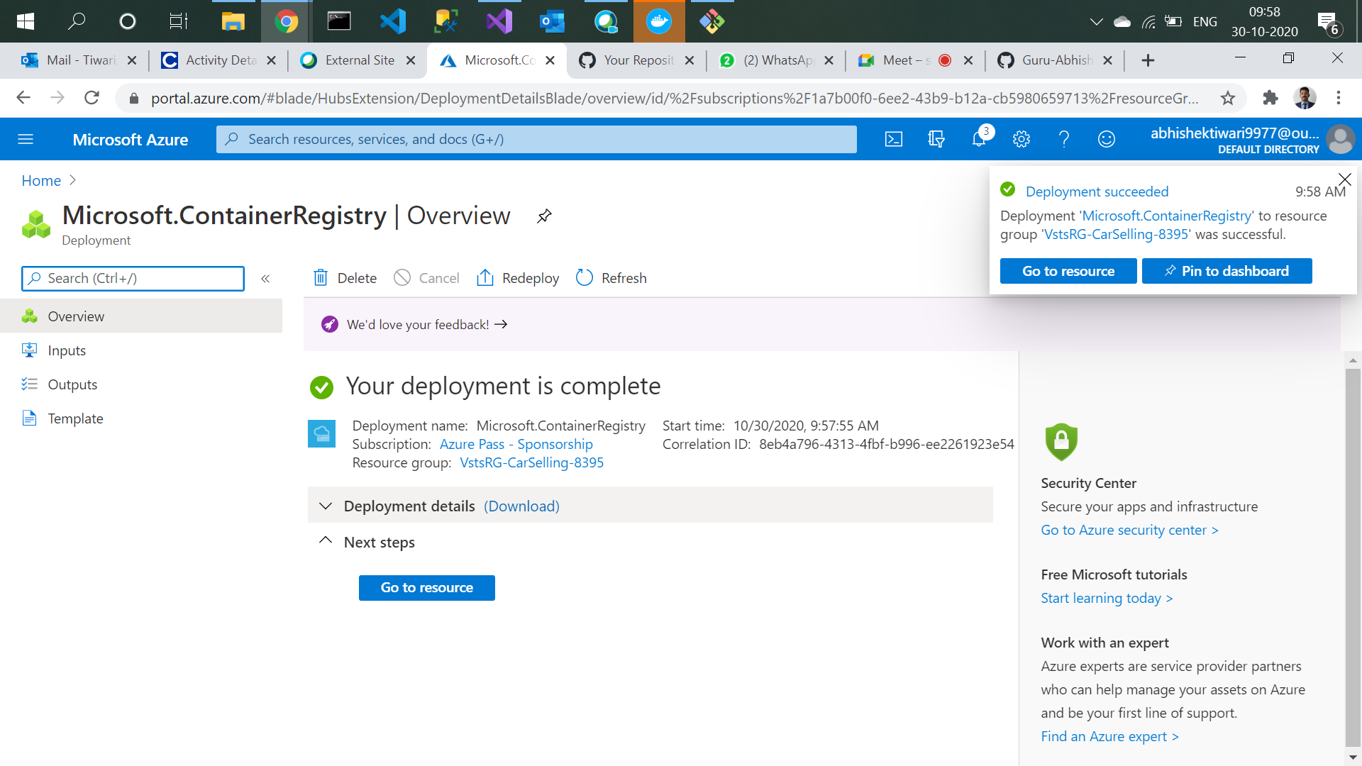

1. Go to your devops starter and delete App service.

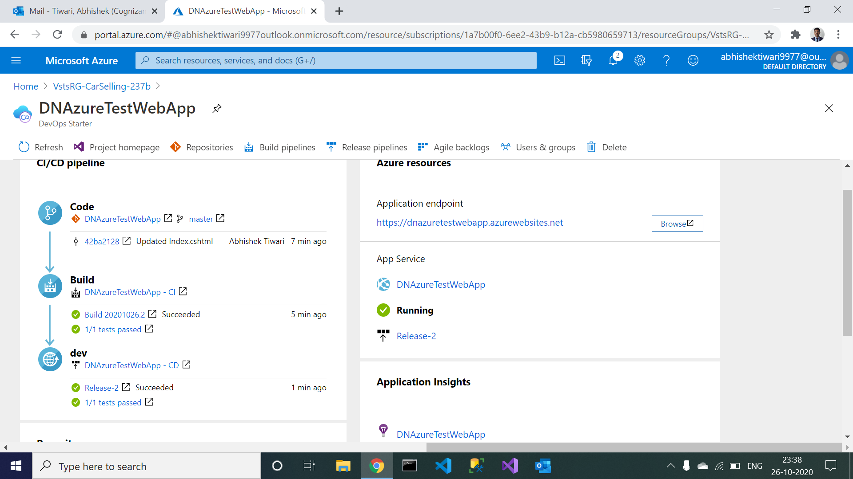

1. Navigate to CD pipeline and disable the Deploy Azure App Service.

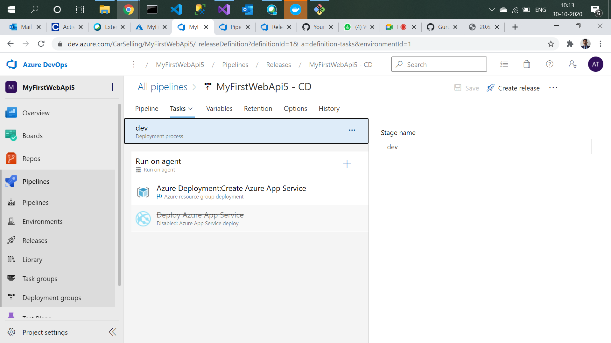

1. Add Docker in agent job 1 as Build and push. Change agent specification to ubuntu-16.04 and import docker file from repository. Click on Save and Queue

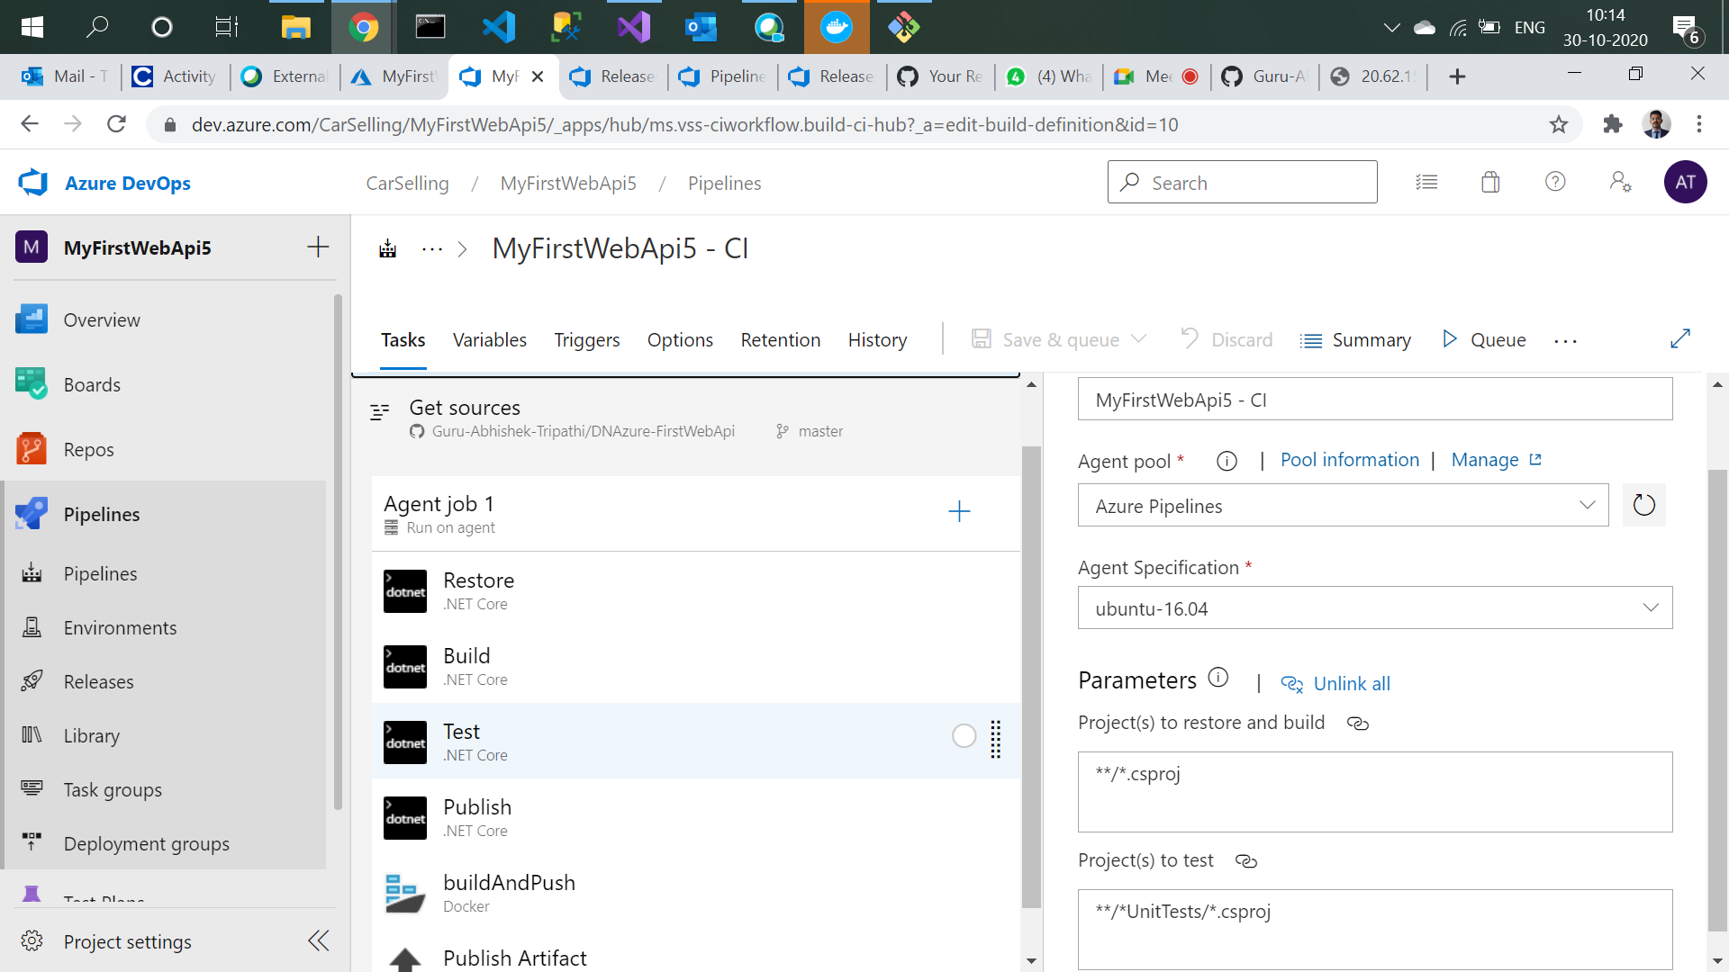

1. Build and release succeeded .

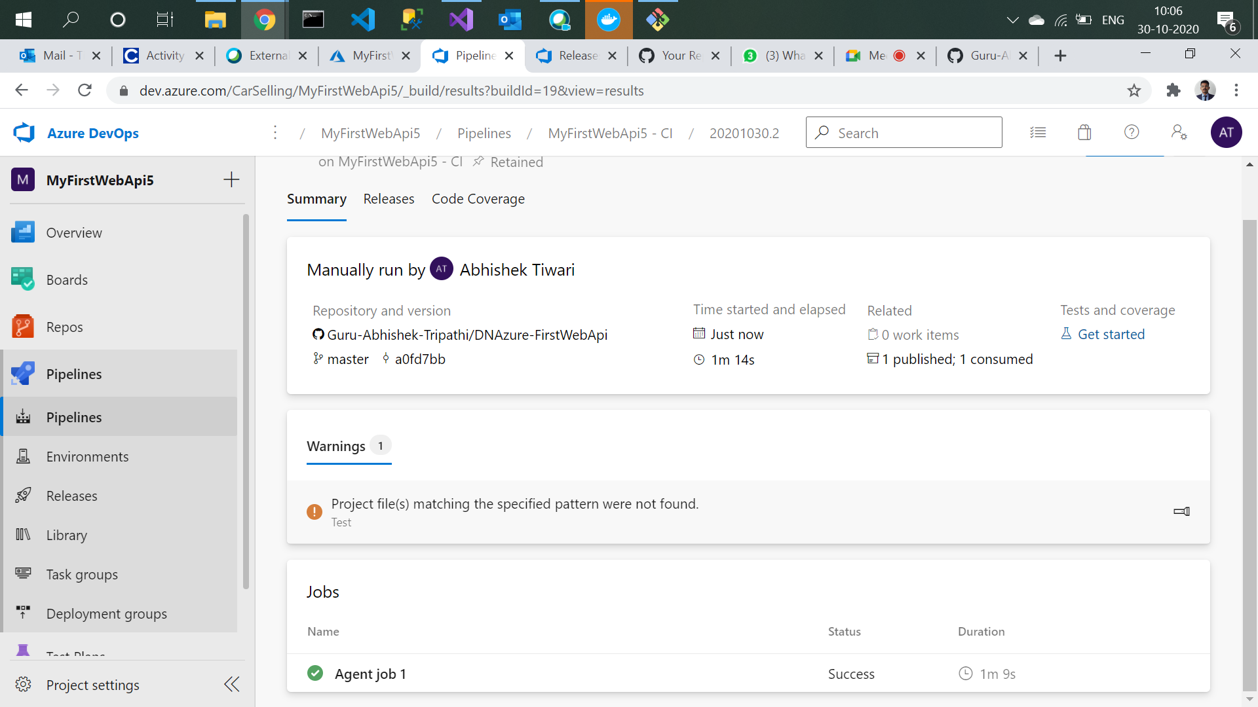

1. Go to container registry and navigate to Access keys. Enable Admin user.

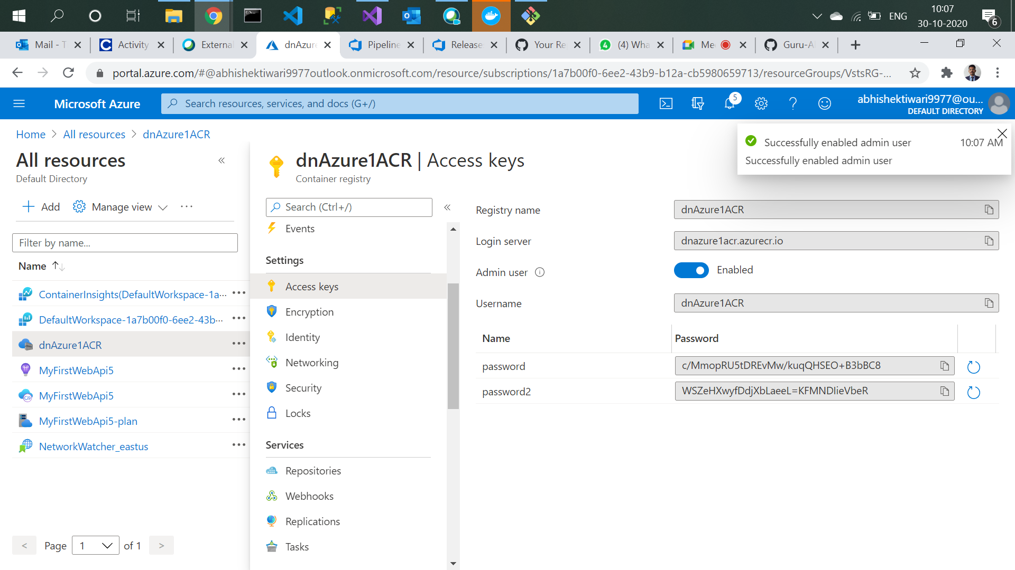

1. Navigate to the repository and click on the repository created.

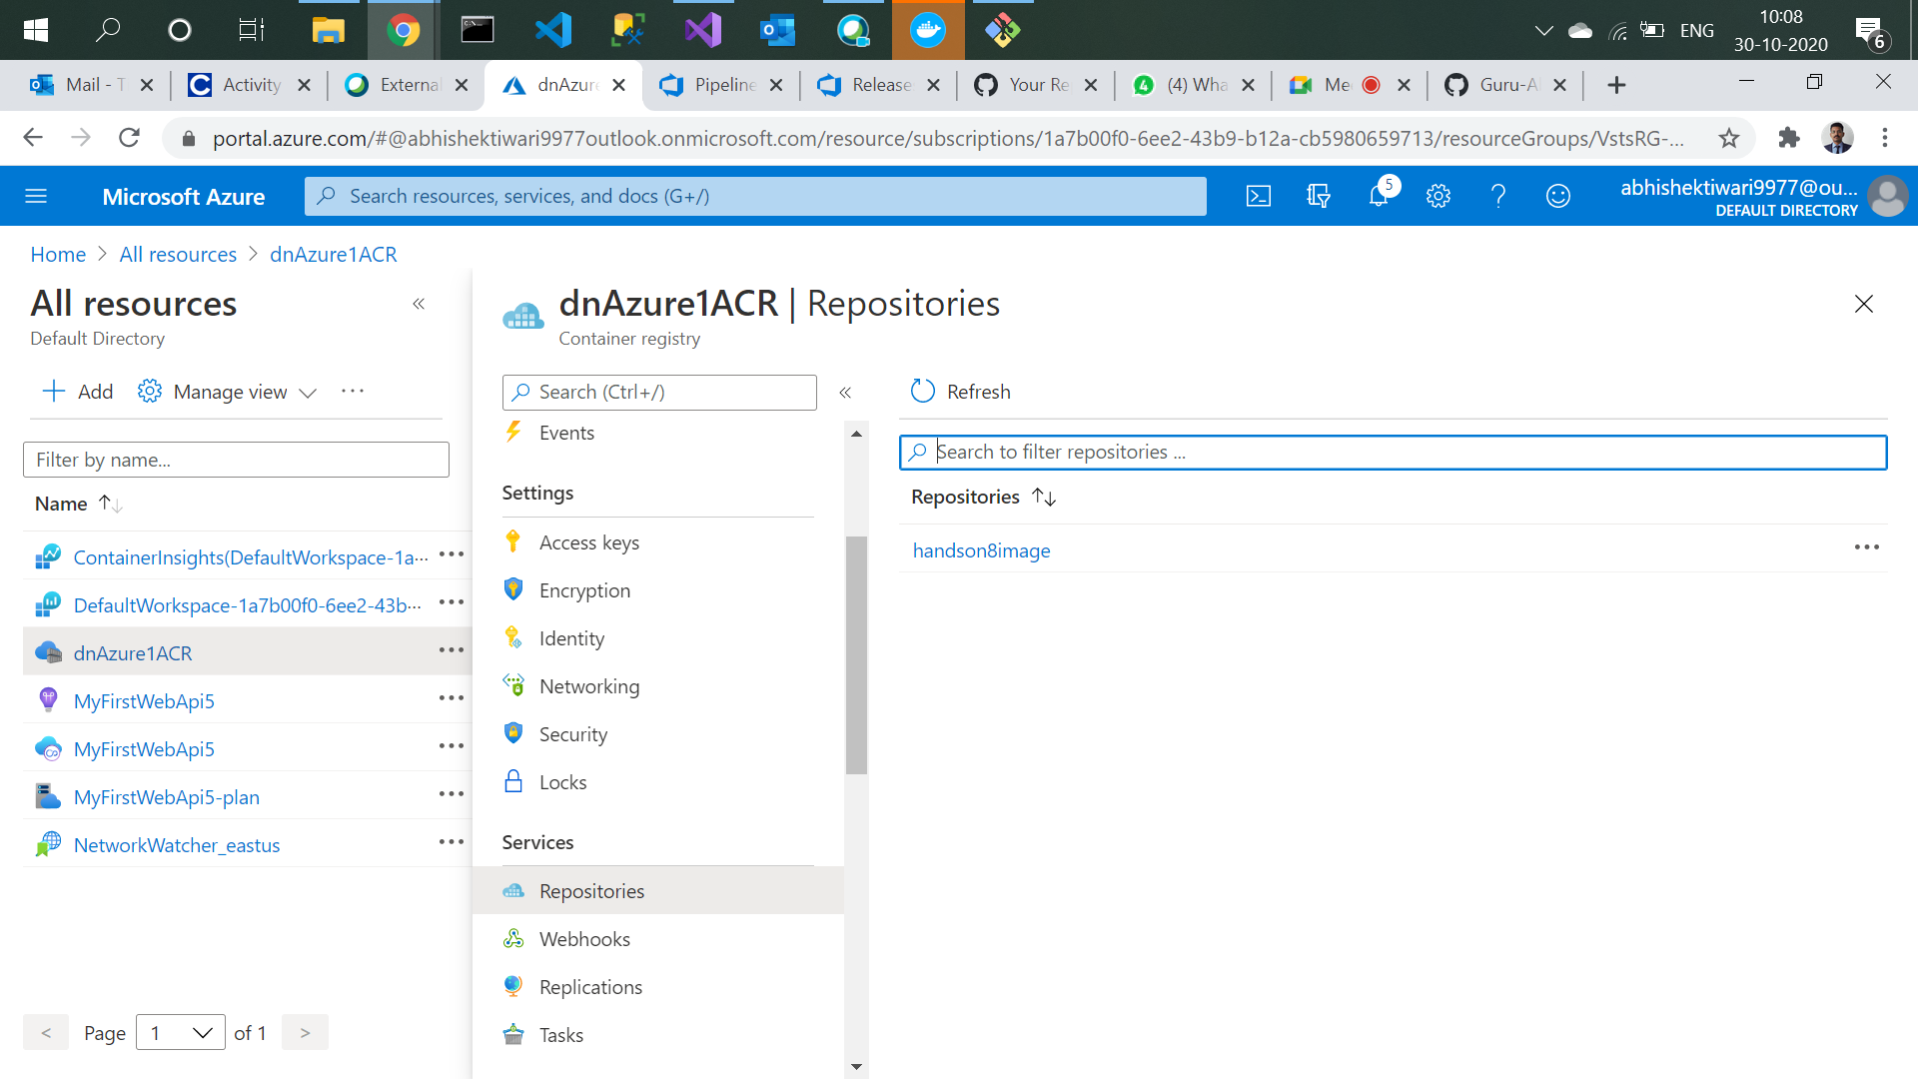

1. Click on three dots in the tags section and the Run instance.

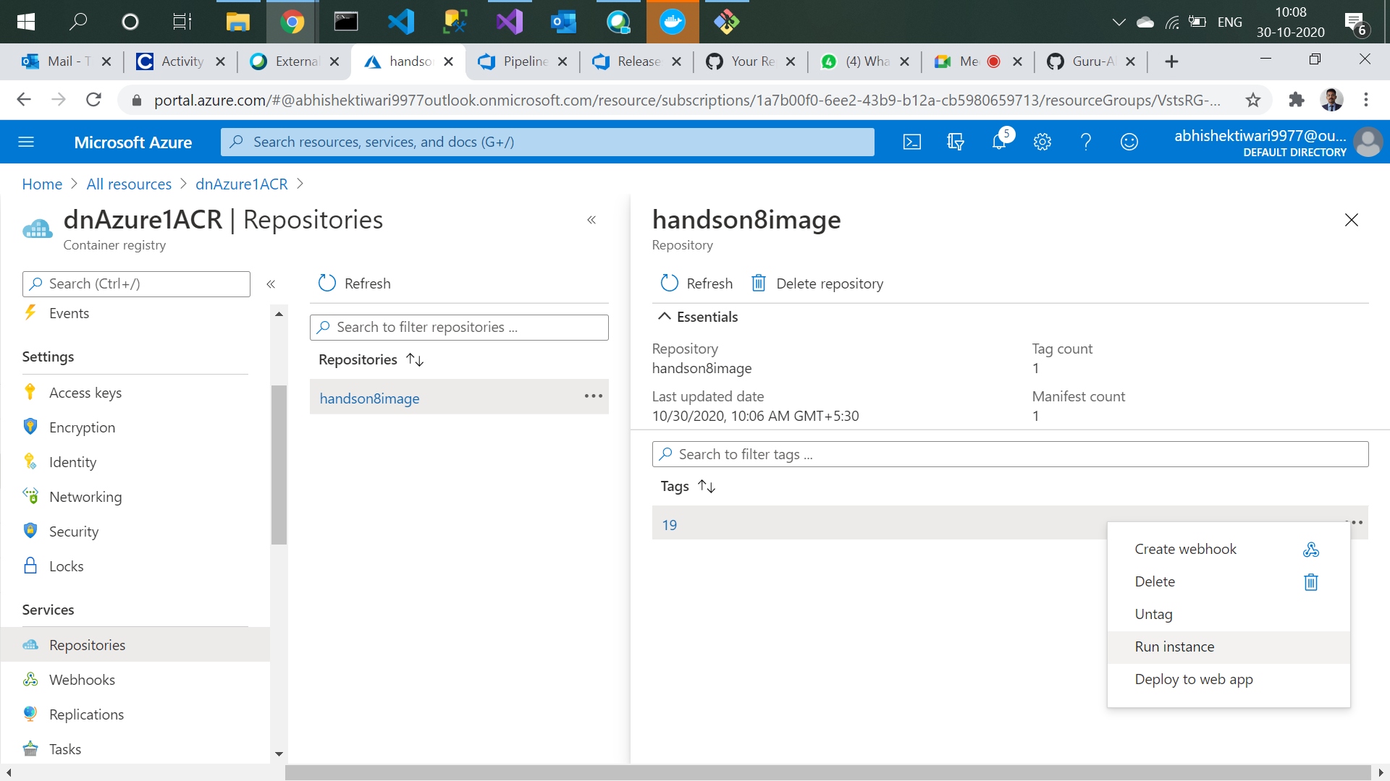

1. Name the container instance.

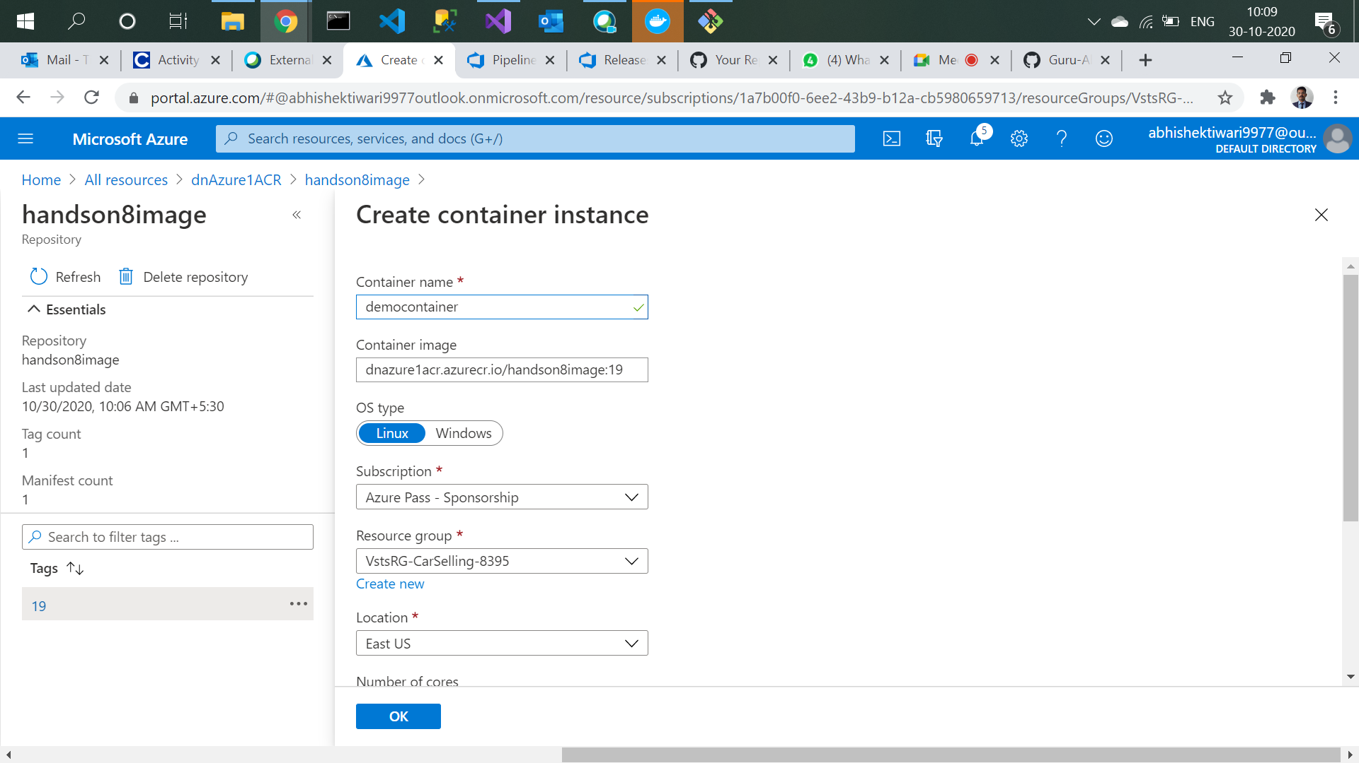

1. Image deployment in progress.

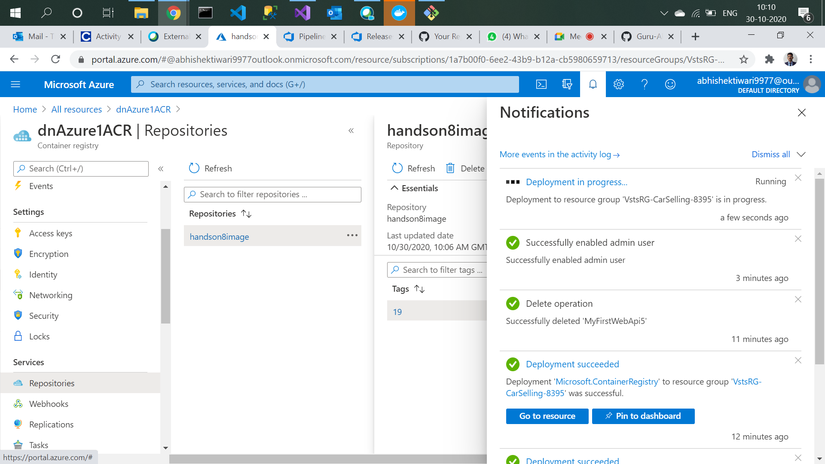

1. Image deployment succeeded.

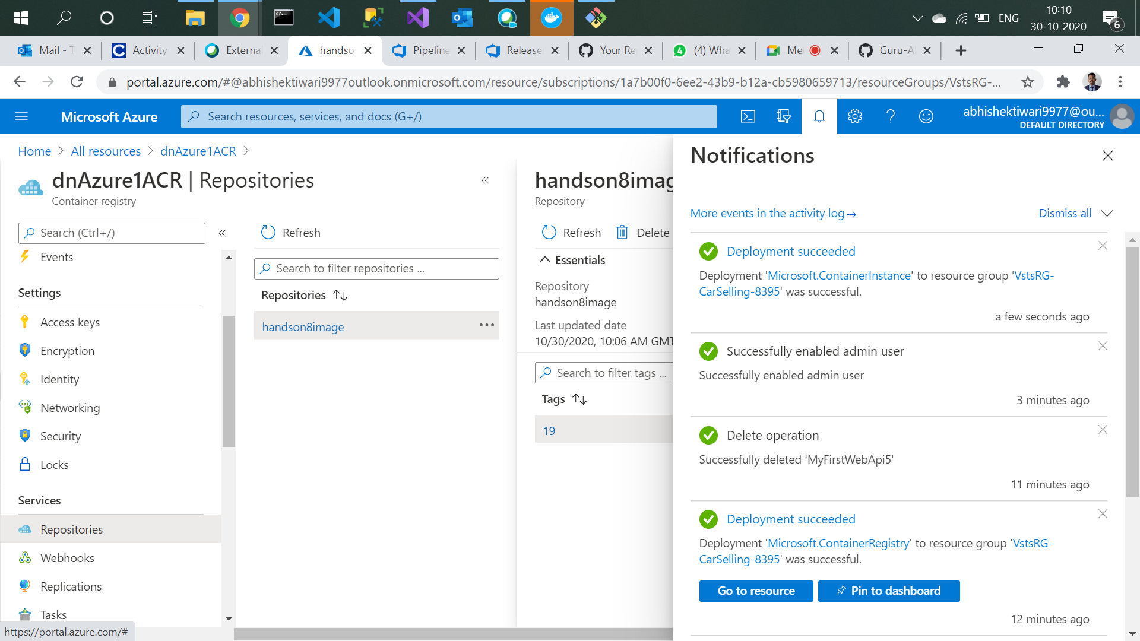

\*\*\* further steps are in hands on 9