Hands on 9

View docker image

1. Open all resources and select the container instance that is created in previous hands on.

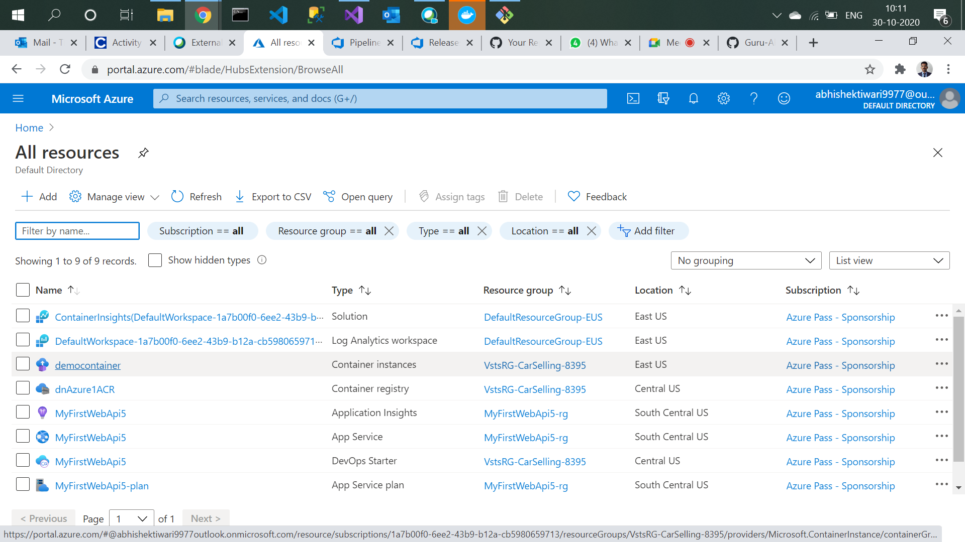

1. Copy the IP address created.

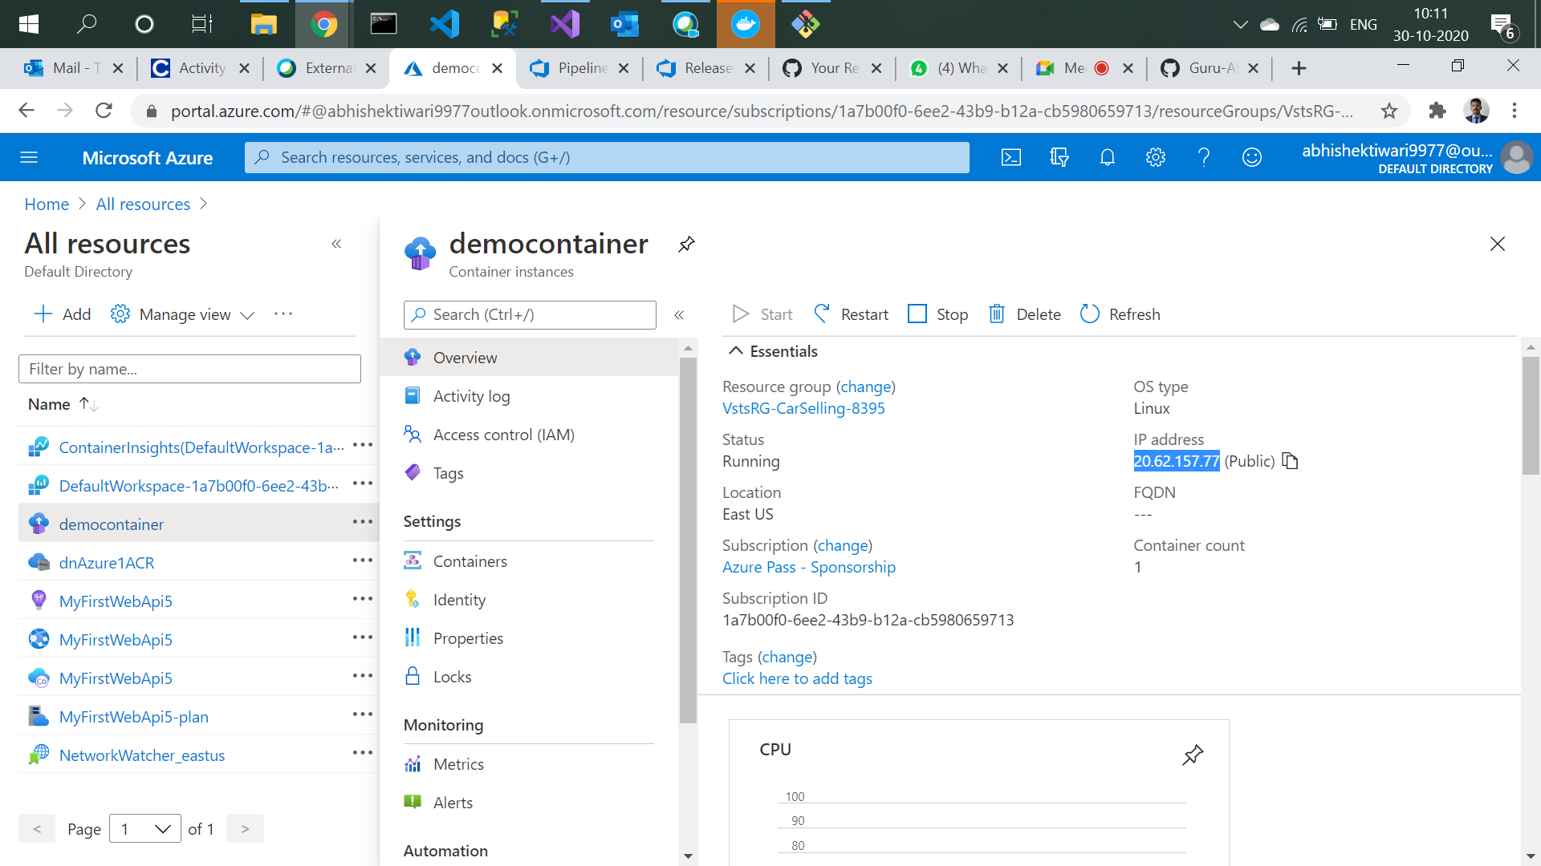

1. Go to URL and run that IP address and append weatherforecast in URL. This is only our Image(Docker).

