Definition of ERP :
An ERP (Enterprise Resource Planning) is a comprehensive software suits that helps organizations
Manage their core business processes, including finance, HR, supply chain, and more. It is powerful
tool that provides real-time visibility and streamlined operations across the enterprise.

SAP BTP: The SAP Business Technology is a versatile platform that enables businesses to innovate ,integrate and transform their business operations in the digital age. With array of tools and services, SAP BTP empowers organizations to surpass competitors, drive business value and provide great experience all through a single platform.

ABAP ON CLOUD(RAP) : ABAP on cloud is an ABAP Environment running on the SAP BTP on top of AWS Infrastructure.

Setting up the ABAP Environment in the SAP-BTP:
Step 1: Go-to SAP BTP trail account. [Get an Account on SAP BTP Trial | SAP Tutorials]
Step 2: Go-to Instances and subscriptions and search ABAP Environment in the service.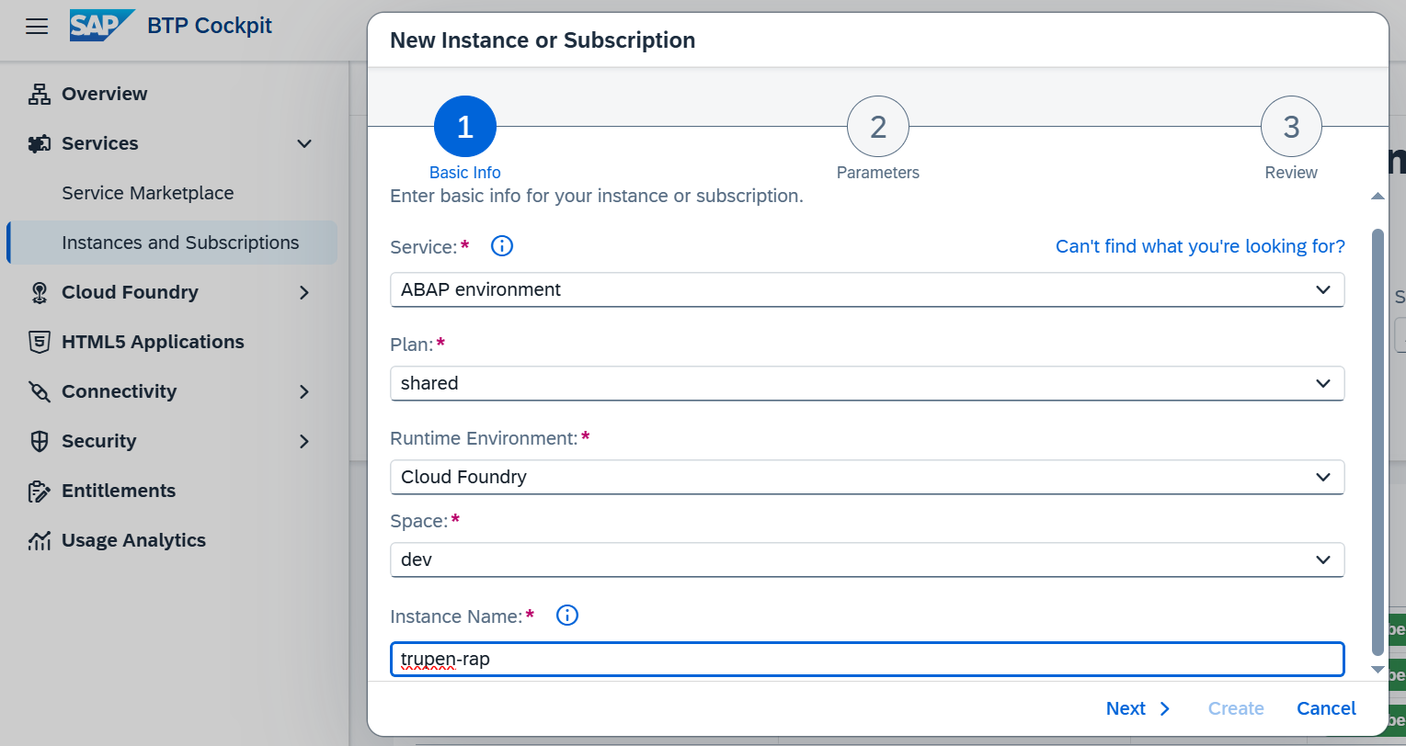
Step 3 : Give the instance Name of your choice. For eg: trupen-rap in my case & click on next.

Step 4 : In the Parameters tab give your email which is mandatory for the logon services in the Eclipse-tool and click on create at the end.
\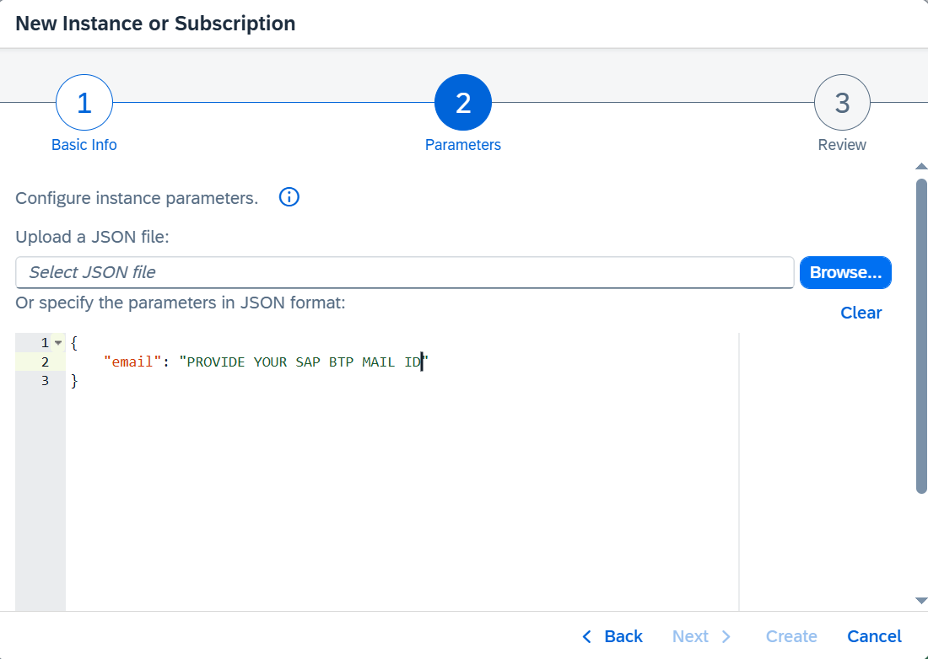
Step 5: Check in the instances area whether the service is created or not, you can see that our service
trupen-rap is successfully created.
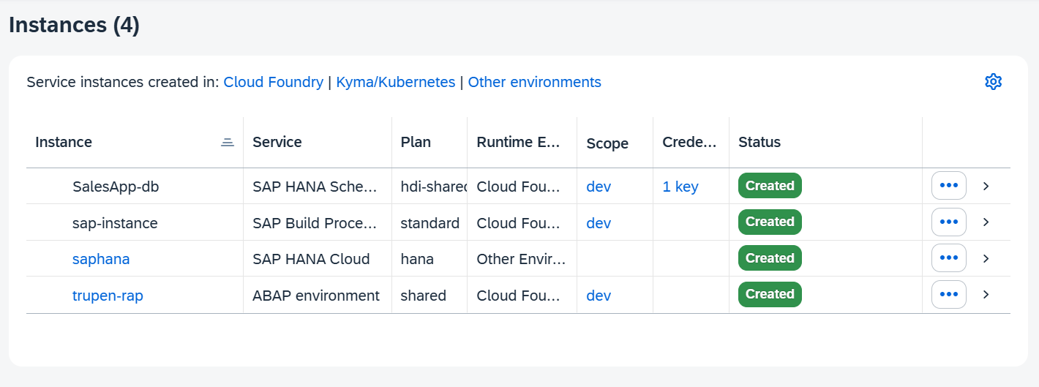

Step 6 : We do require a Service-Key which acts as encrypted code so click click on the create icon to have one service key.
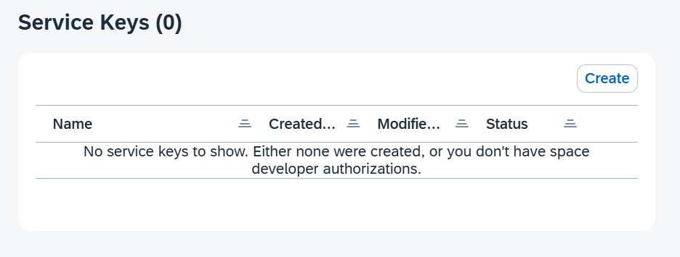
Step 7: Give the name for the service-key,give your email in the JSON Format and click on create.
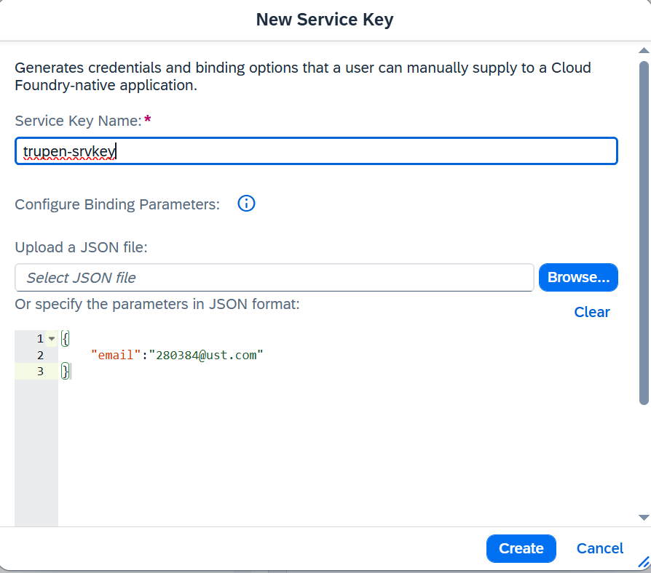

Step : 8 : Verify whether the service-key is created or not.
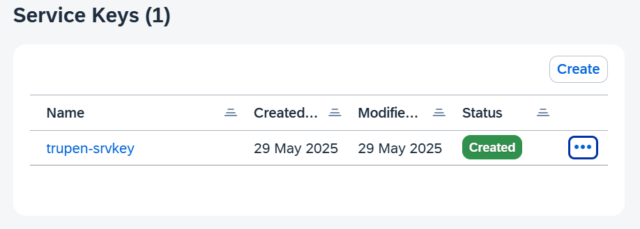
Step:9 : Click on the 3 dots present on the service key and click on download to have it on our system.
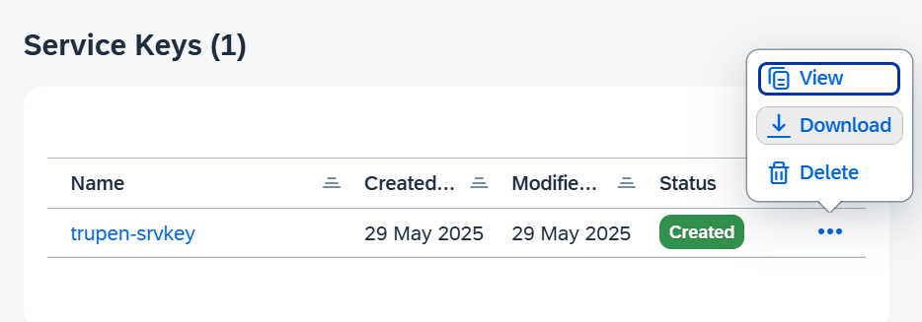
Note : Don’t forget to save the service key in your local system.
Integrating our eclipse with the sap btp account :
1)Open the Eclipse Tool :
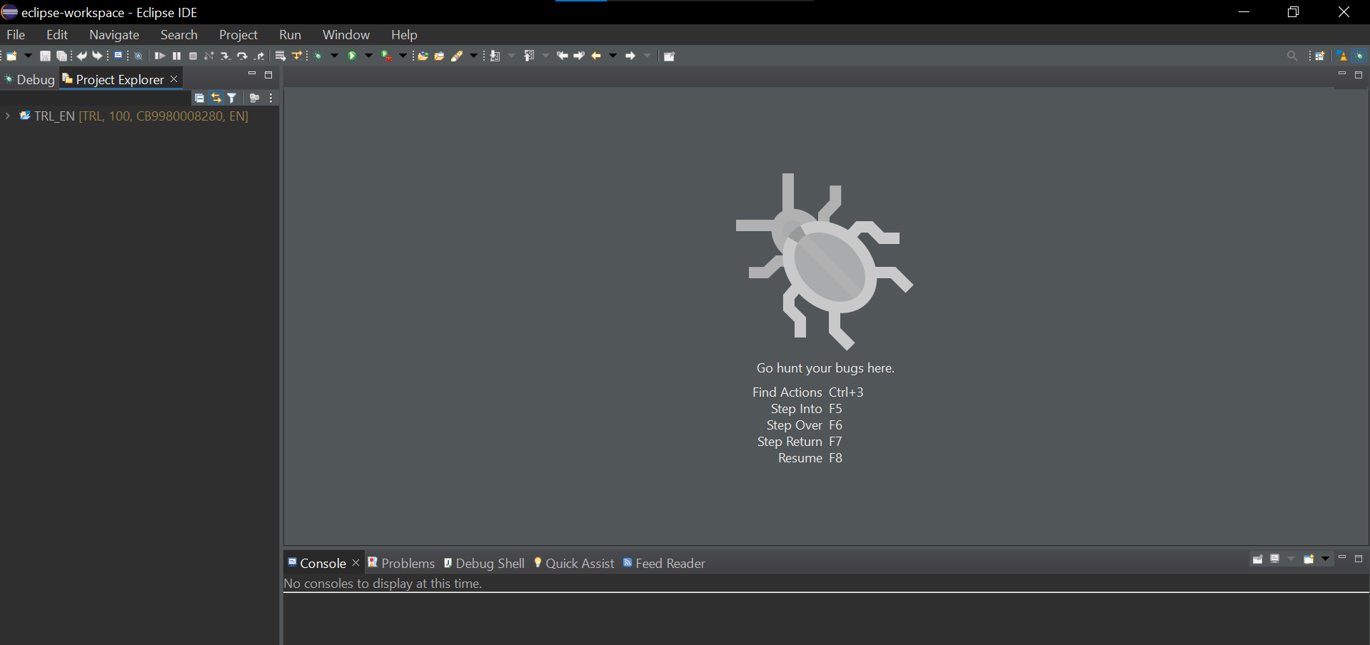
- Navigate to the file icon on the top left corner and select project.

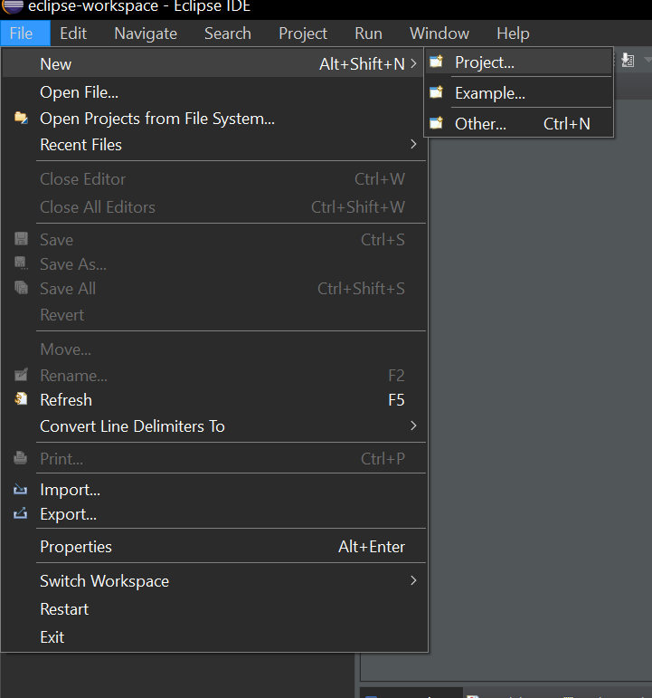

2) Select the ABAP Cloud project from the list of wizards & click on next.

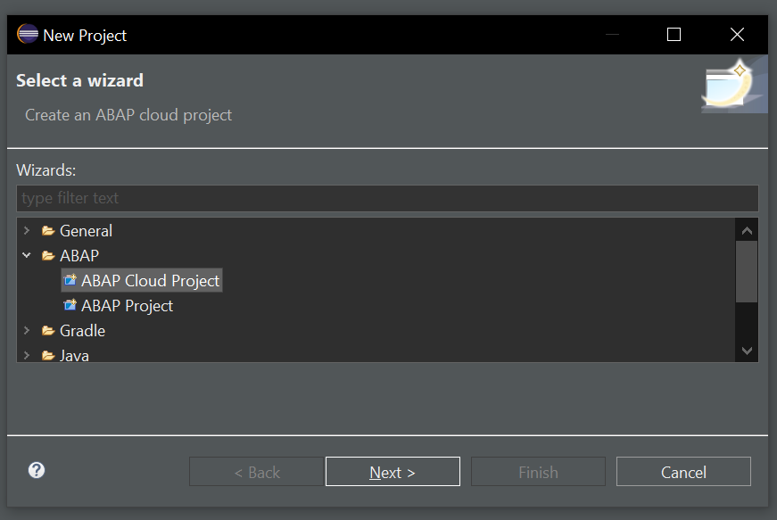

3) Select the SAP BTP ABAP Environment the second options with the option using a service-key,
And click on “Next”.

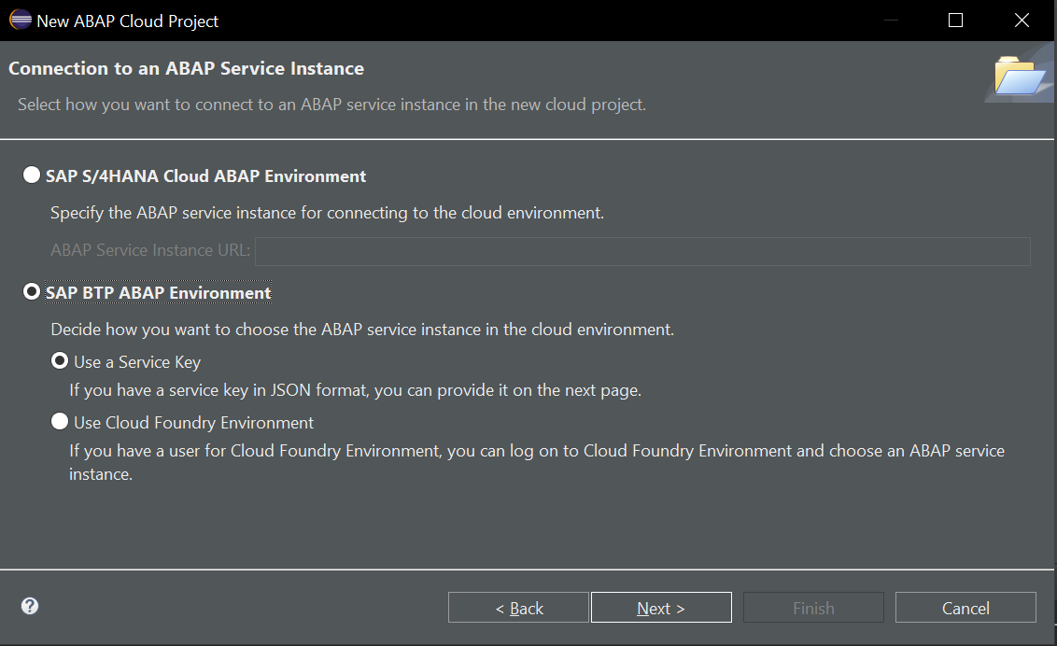
Click on the Import button down under and import the Service-key file from your system which we have downloaded before.
Click on next.
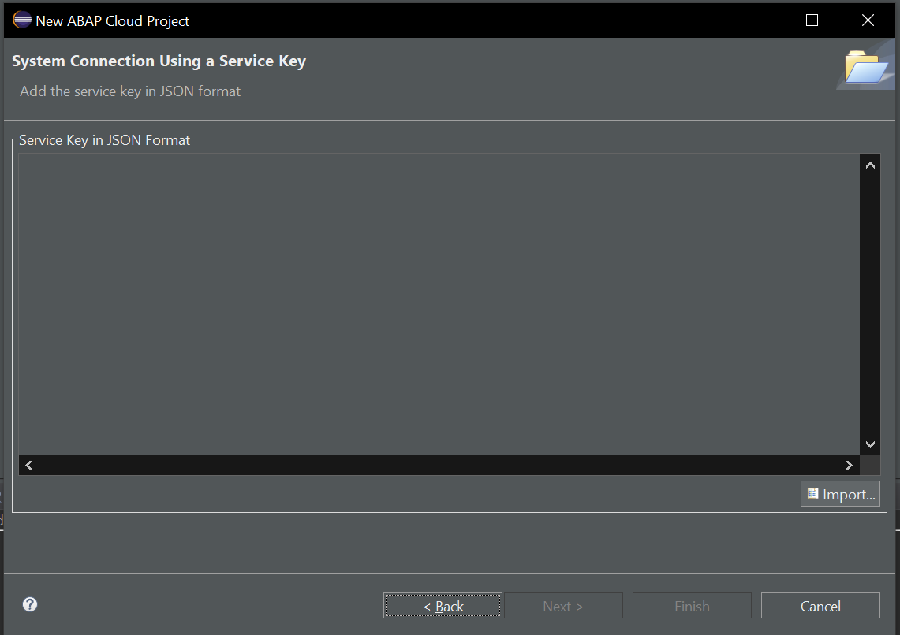

4)Select the Open Logon Page in Browser & the browser asks to sign in into the BTP Cockpit give your email-id and password.
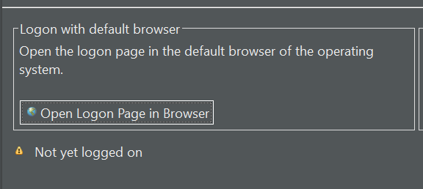

5)The browser gives you the pop like below,if you have given the right credentials.

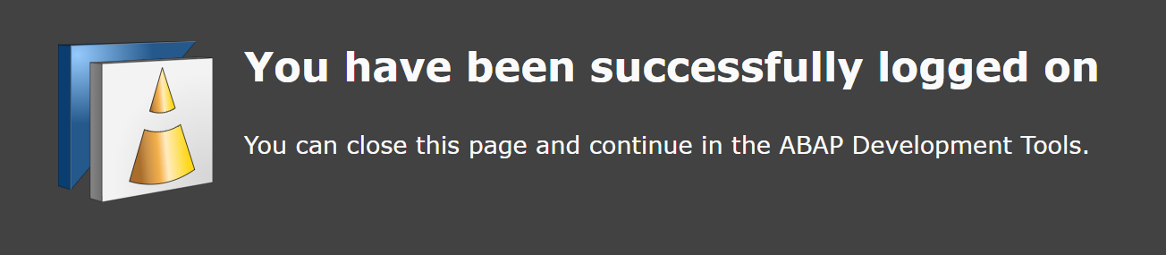

6) Create a package by giving a right click on the ZLOCAL and select the ABAP Package.

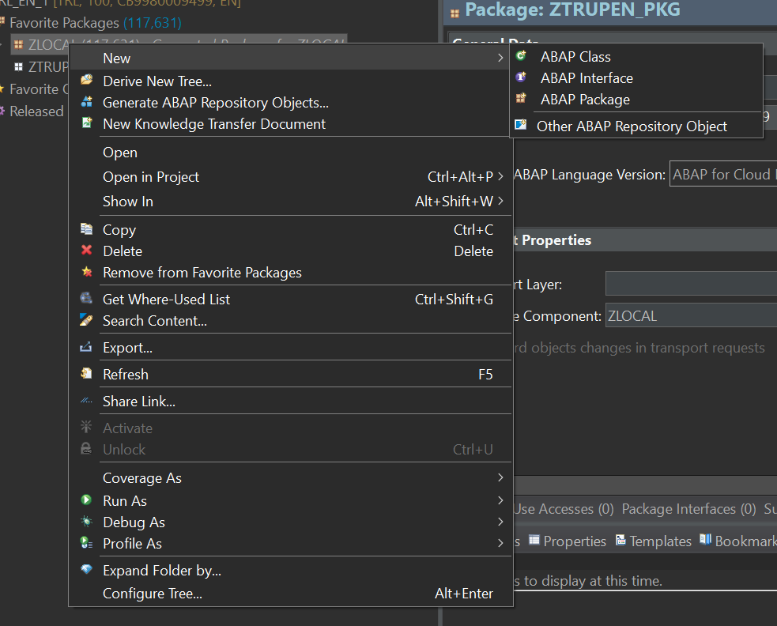

7)Give the name of the Package and don’t forget to add the package to “favorite”.
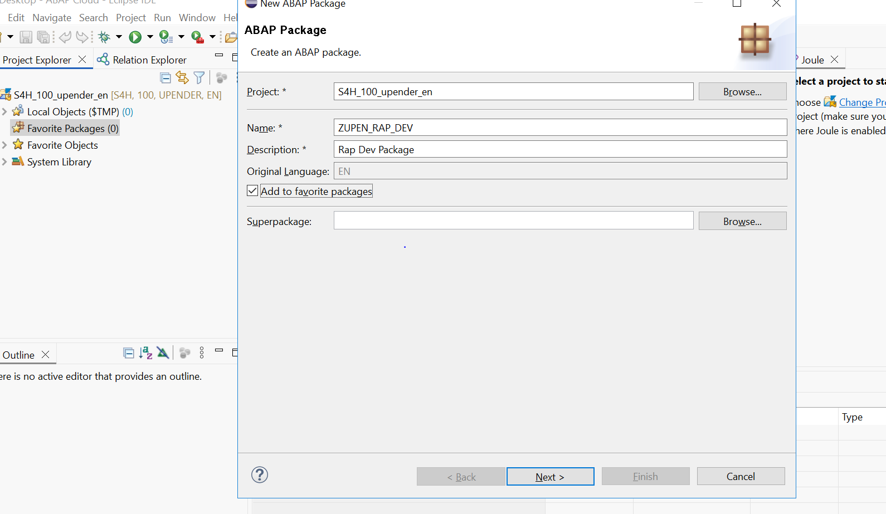
8)Create a new transport Request(TR) and give the Request description
9) Verify whether your package is present or not under the favorite packages.
