Environments, subscriptions & instance based services

Environments
Environments constitute the actual platform-as-a-service offering of SAP BTP that allows for the development and administration of business applications. Environments are anchored in SAP BTP on subaccount level.
SAP BTP offers three environments: ABAP, Cloud Foundry and Kyma. Some existing customers still have Neo, but this is no longer offered.
Subscription based services
You will also see these ones called software as a service (SaaS), or multitenant applications. The experience here is that you subscribe to the service, and in return you receive a URL, from which you can access that service. Opening the URL brings you to a web application from which you can leverage the service. This is how other SaaS like SuccessFactors or S/4HANA Cloud work as well. They are also enabled at a subaccount level, and are independent of the environments. You don’t need to have Cloud Foundry enabled to subscribe to SAP Launchpad Service, for example.
Examples include Launchpad, SAP Business Application Studio, Cloud Integration, Process Automation…
Instance based services
These are the purest services. They provide a specific functionality, like databases, connectivity, authentication…. You connect your application to them to leverage that functionality. These services don’t provide a UI to manage them. Instead, they rely on API to connect to applications and other services and provide their services. They are provisioned inside an environment, so they are environment specific. Each environment has its own organization (for users and applications): In Cloud Foundry, instances are created inside a space. For Kyma, instances are created inside a namespace.

ABAP on Cloud – the environment:
ABAP on cloud is an ABAP environment running on SAP BTP on top of AWS infrastructure. It is a shared ABAP system in trial mode.
- Since it’s a shared system with other abap trial users, we will see all the packages of other users as well.
- With ABAP on Cloud, NO ONE EVER-EVER access SAPGUI, No Tcodes are allowed with GUI. In fact, you cant event use SAPGUI to connect to ABAP on Cloud system
- We don’t have control to install notes, patches, and upgrade
- No access to SPRO (customizing) is allowed in the cloud
- ABAP on Cloud is just abap environment, its not a SAP Solution (like s/4hana or ecc), so you will never find standard sap tables like MARA, VBAK, ACDOCA, MATDOC etc.
- You are only allowed to use DDIC objects which are marked released
- We cannot create everything like what we do in a on-premise system e.g. forms, workflow, scripts, dialog prog.
- We cannot create ABAP programs in the AoC system, all code will be in-form of classes.
- The AoC only allows whitelisted ABAP statements, no other abap statements can be used freely e.g. write.
https://help.sap.com/docs/sap-btp-abap-environment?locale=en-US
- You can create your packages under a standard package ZLOCAL
- The preferred programming model to develop applications is RAP – Restful Application Programming model
- ABAP in Cloud has a code name called “steampunk”
CDS(CORE DATA SERVICES):
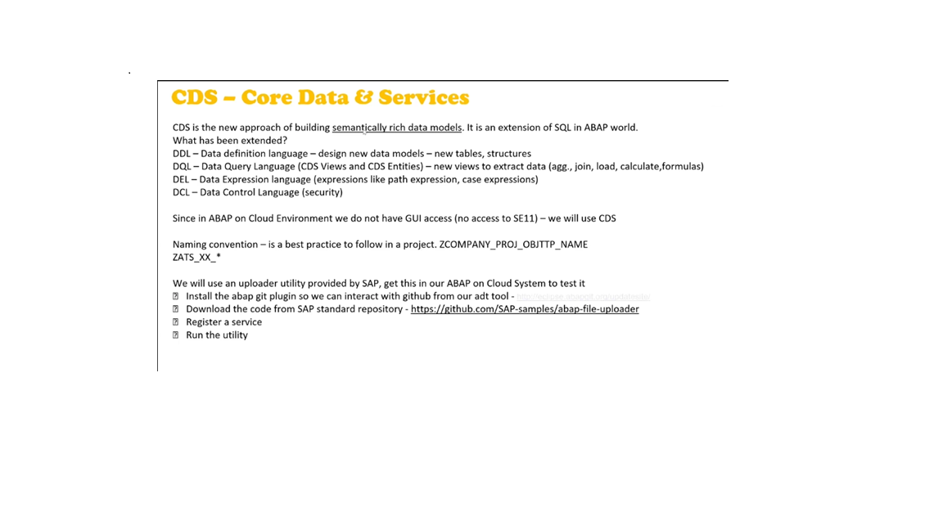
Creating a Data-Element Step 1 : Right click on the package name i.e. ZUPEN_RAP_DEV & select Other ABAP Repository Object

STEP 2 : Search for the Data-Element & give the name for your data-element in my case ZTR_UPEN_DTE_ID
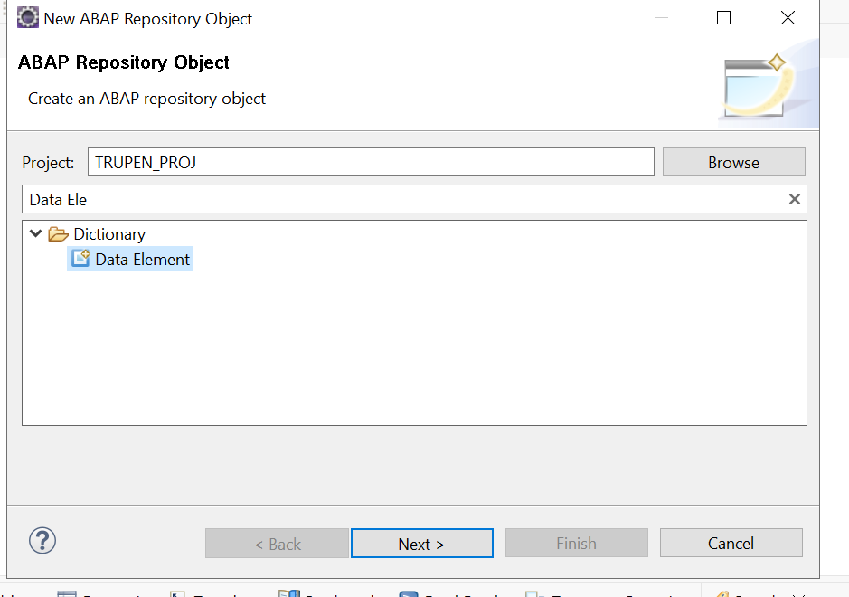
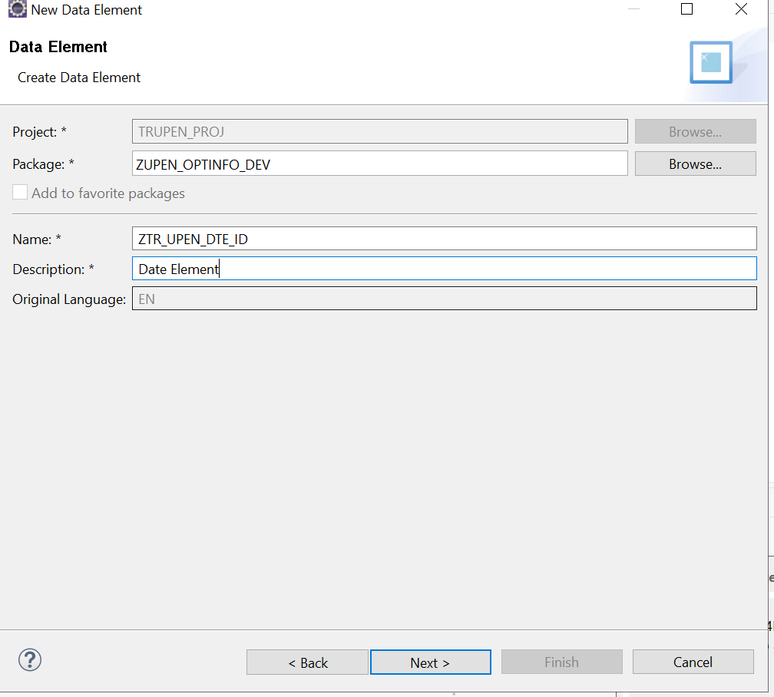

STEP-3 : Click on finish

Give the Category type : Predefined Type
Data Type : Char
Length : 32
Give the field labels : Short : id,
Medium: identifier,
Long : Identifier,
Heading : Identifier.

NOTE : CTRL+F3 To activate the objects
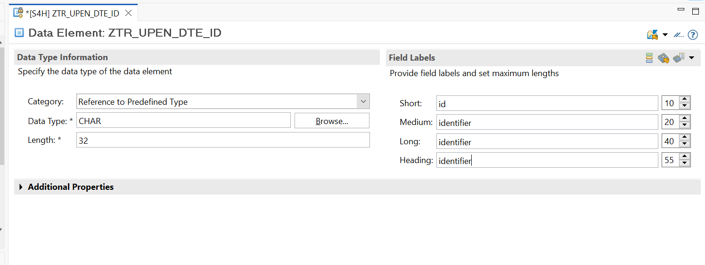
Creating a Domain and resuing it in the dataelements:
Right-click on the Dictionary-Tab and select the new and select the Domain.
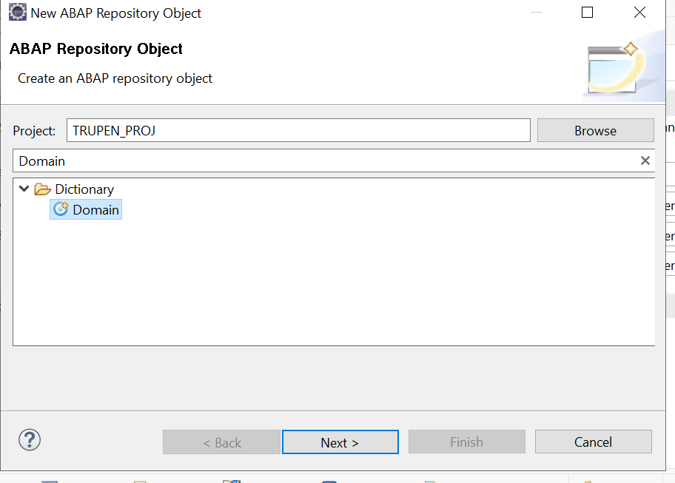
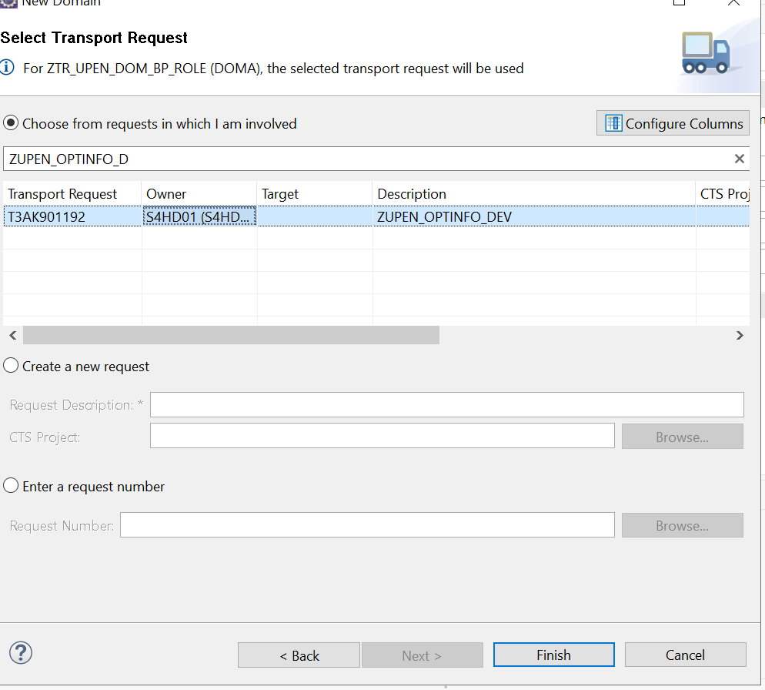

Give the name as ztr_upen_dom_bp_role the domain name .
Give the Data Type as CHAR & length as 2
Give the fixed values as : 01 Customer,02Supplier,03Employee,04Unknown.
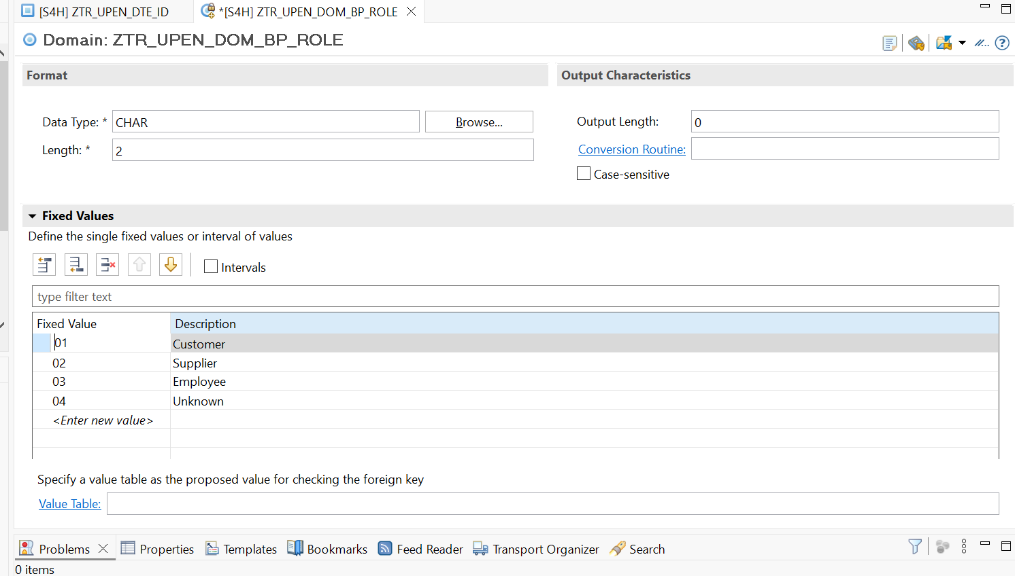
ctrl+f3 to activate the object

Create the New data element and make use of Data-Domain Created :
Name : ZTR_UPEN_DTE_BP_ROLE
Select the Category : Domain
Select the above created for the Type-Name : ZTR_UPEN_DOM_BP_ROLE
CTRL+F3 to activate the object

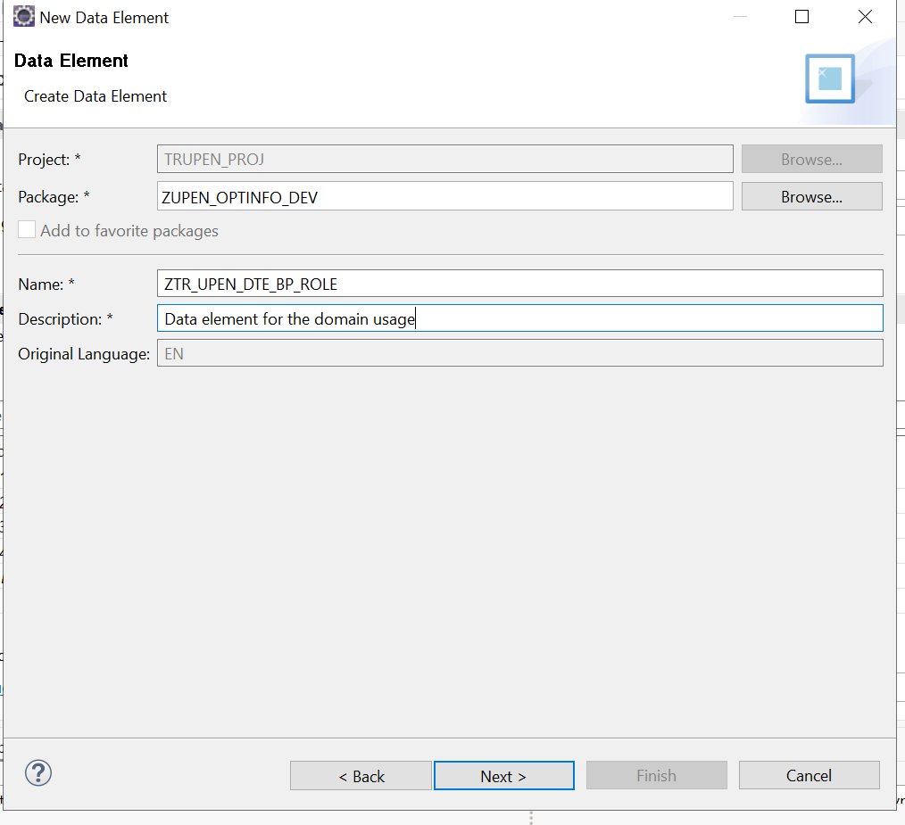
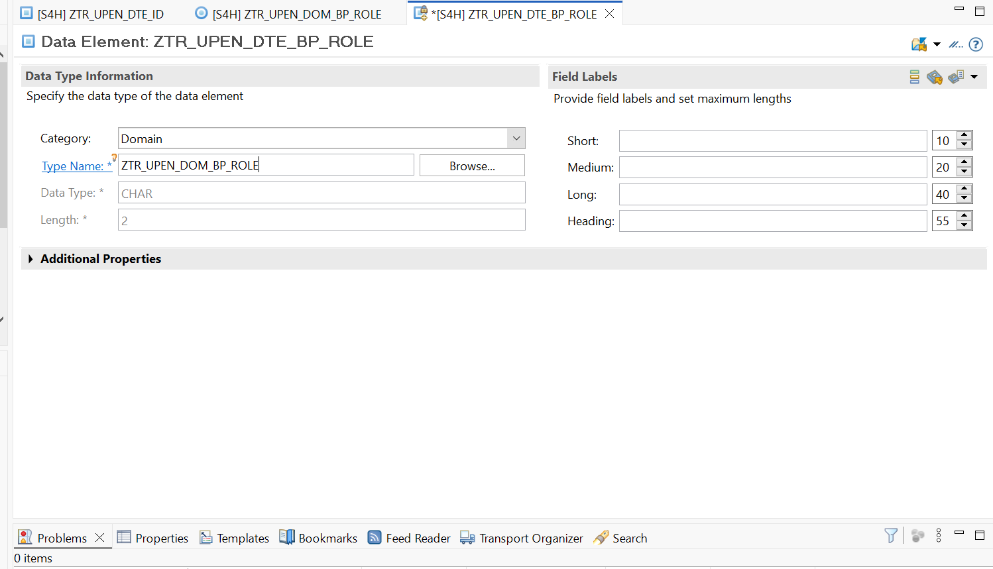

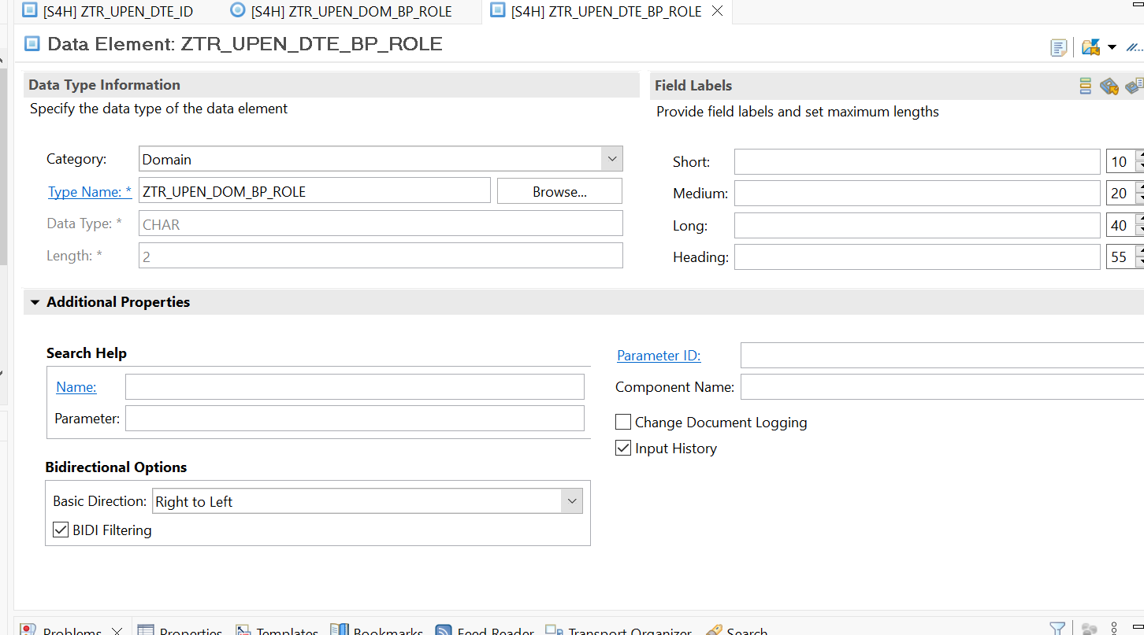
Creating a Database Tables:
Suppose you are working on a company which has recently opt for Rise with SAP and bought a subscription of BTP with ABAP on cloud environment. You do not have an on-premise system, and you have many SAP ABAP consultants in the team. You want to build end to end software in cloud for your customer. We always starts with DB Tables.
Right click on the Data Dictionary New Database Table
Give the name for the table i.e ZUPEN_RAP_TABLE
Click on the next & finish .
ctrl+f3 to activate the table
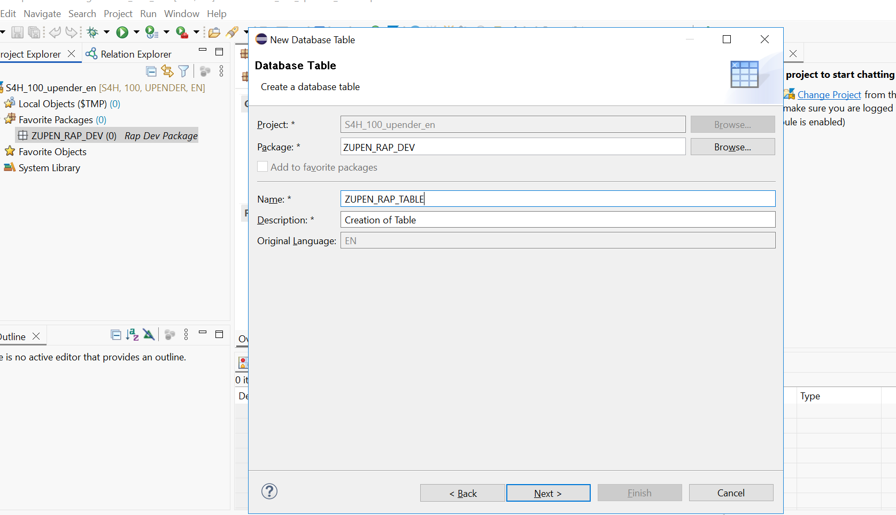
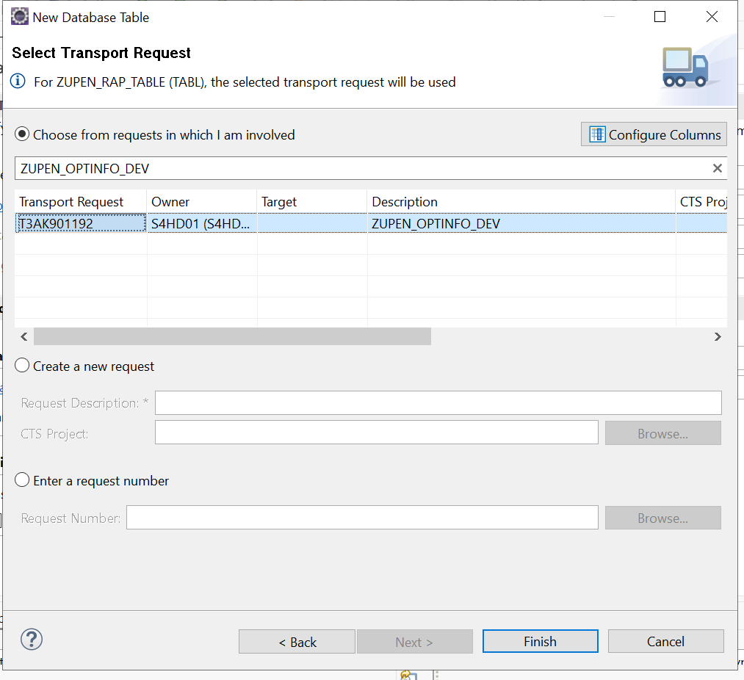

Create a database table named : ZUPEN_RAP_TABLE
@EndUserText.label : 'Creation of Table'
@AbapCatalog.enhancement.category : #NOT_EXTENSIBLE
@AbapCatalog.tableCategory : #TRANSPARENT
@AbapCatalog.deliveryClass : #A
@AbapCatalog.dataMaintenance : #RESTRICTED
define table zupen_rap_table {

key client : abap.clnt not null;
bp_role : ztr_upen_dte_bp_role;
@EndUserText.label : 'Company Name'
company_name : abap.string(256);
@EndUserText.label : 'Street'
street : abap.string(256);
@EndUserText.label : 'Country'
country : abap.char(3);
@EndUserText.label : 'Region'
region : abap.char(5);
@EndUserText.label : 'City'
city : abap.string(256);

}

