SE11 -> Choose Data type->Structure ZTRUPEN_S_ODATA_MAT_BASIC.
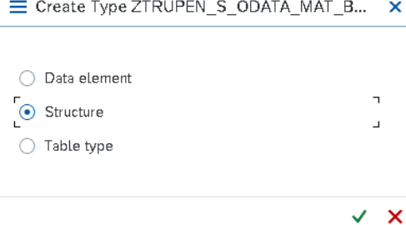\
Create the Structure with following fields.
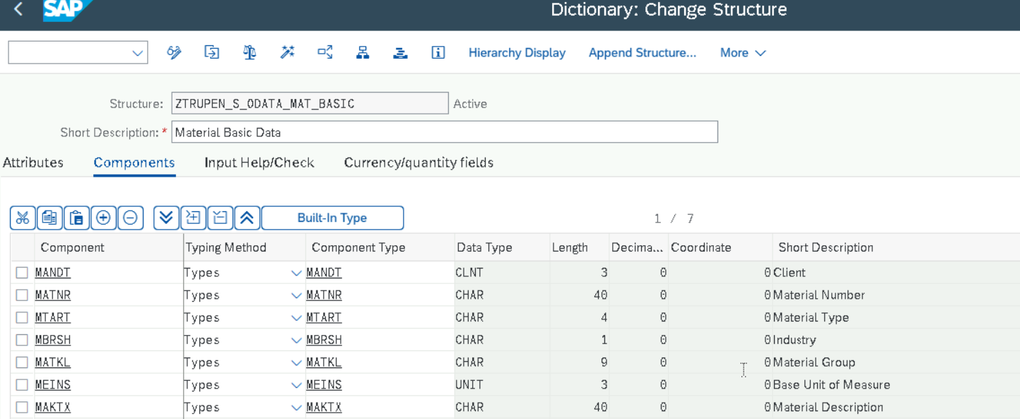
Save and activate the Structure.
SE11->Choose Database table->ZTRUPEN_MATERIAL
Delivery and Maintenance
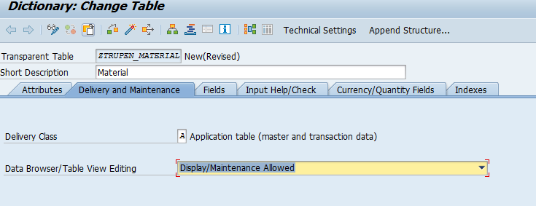
Fields
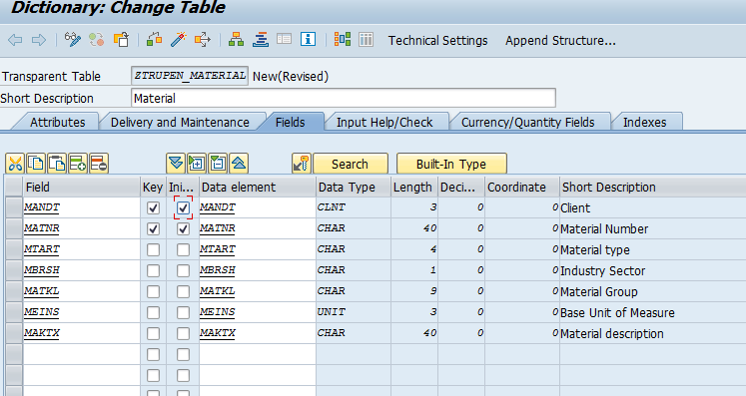
Technical Settings
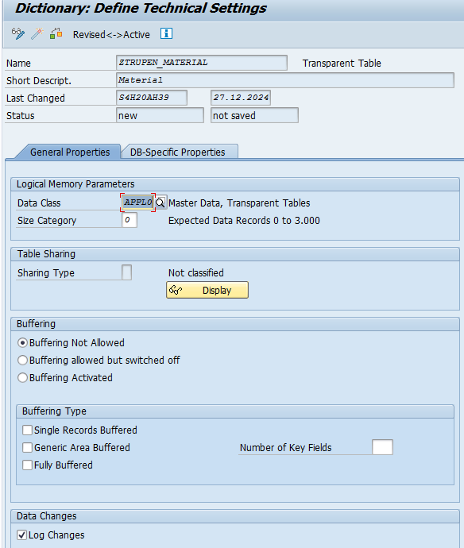
Save and Activate the Table.
GATE WAY SERVICE BUILDER
Open SEGW Transaction and Click on Create Button for the Gateway Service Creation.
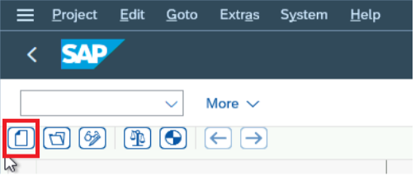
Now Provide the Project name, Description, Project type and Package for Service creation.

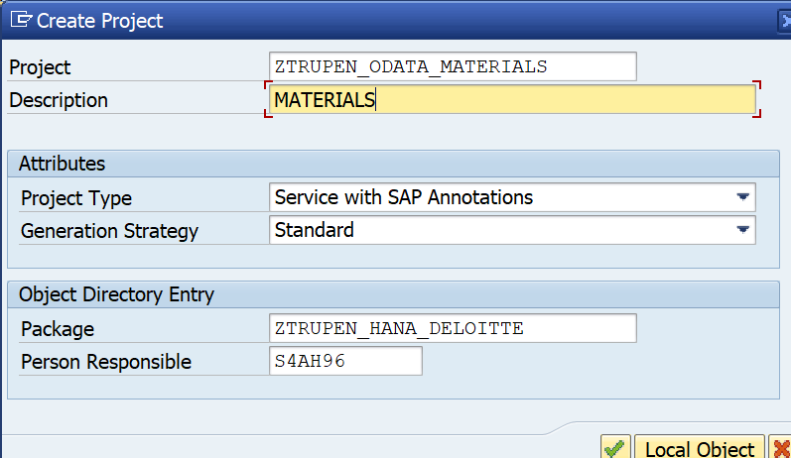
Click on Enter and the below screen will appear.
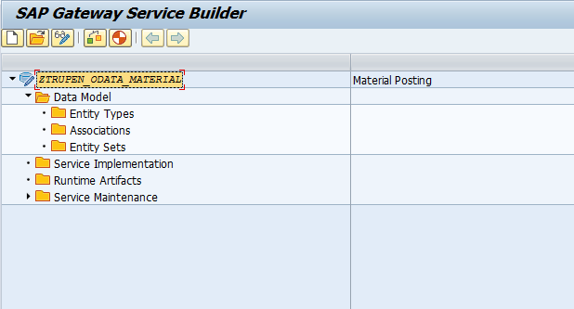
Right Click on the Data Model and Click on import->DDIC Structure
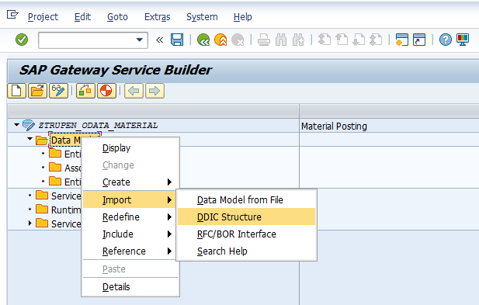
Now Provide the Name and choose type as Entity Type and Pass the Created Structure in the ABAP Structure and Click on Next.
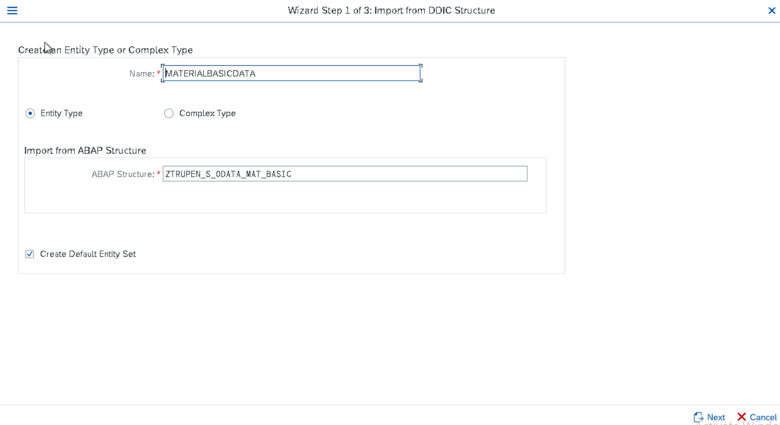
Now select all the Fields and click on next to add the Field list in to the Entity.
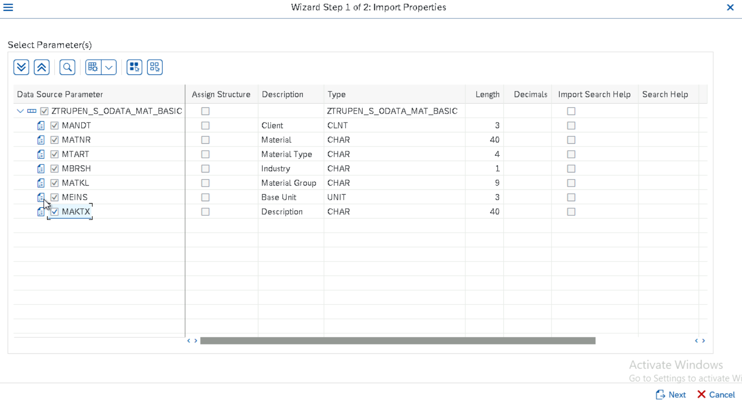
Now Check the Required key fields among the Field selected for the Entity type and Click on Finish.
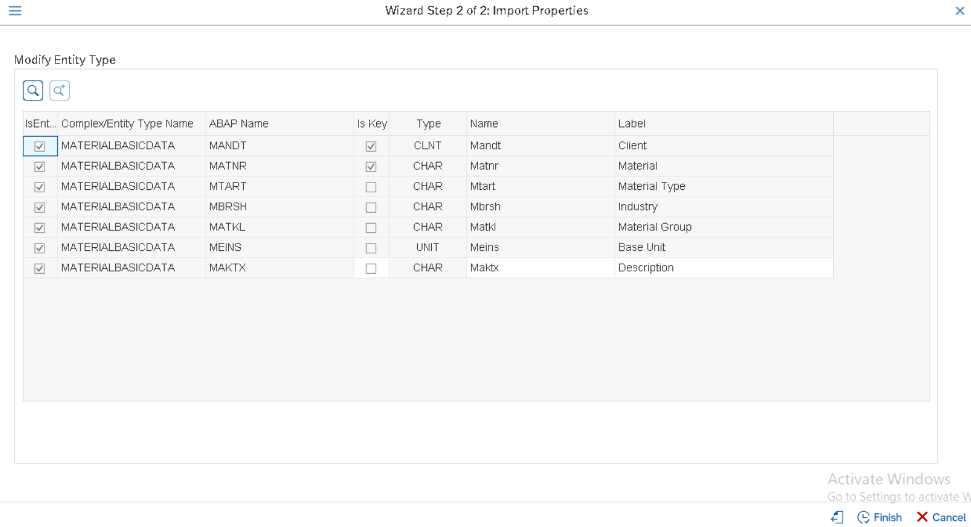
Now the Entity and Entity set is created automatically along with the fields selected in the Entity.
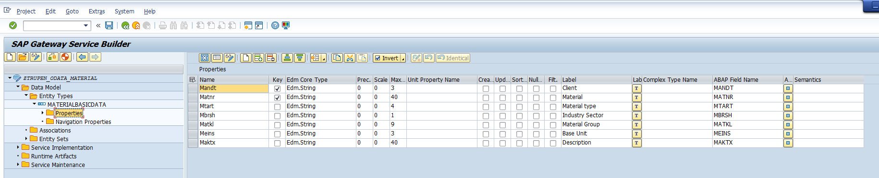
Now Click on generate Runtime Objects to generate the Model Class and Data Provider class and Model provider class.
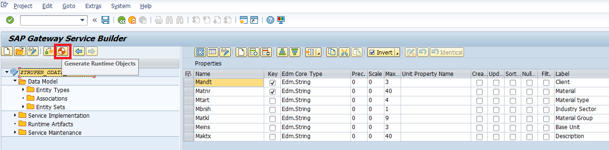
SAVE THE ODATA IN THE LOCAL OBJECT and Click on Enter.
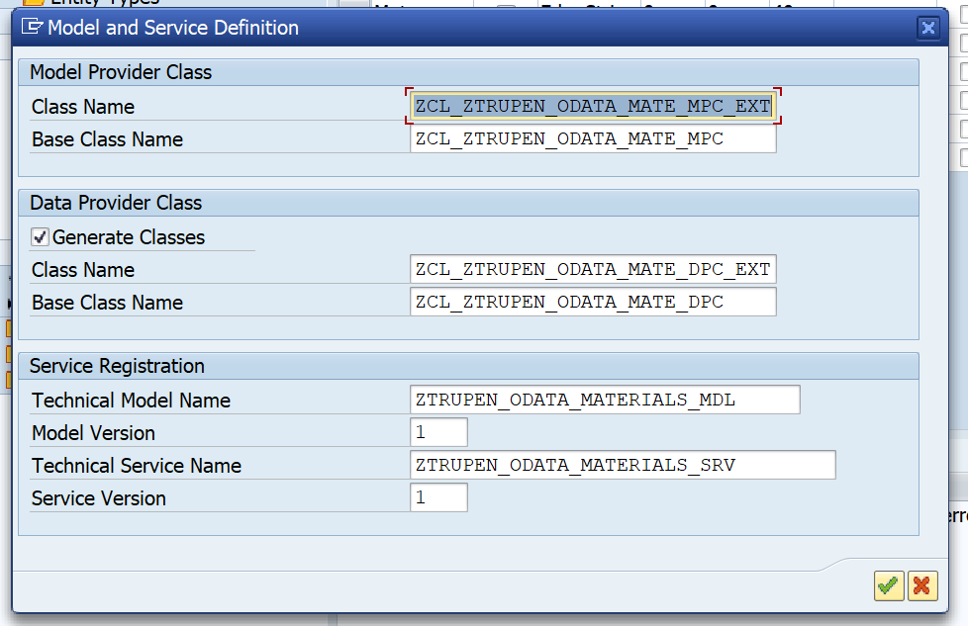
Now Modify the Class name, Model name and service name according to the Naming Conventions and click on Enter.
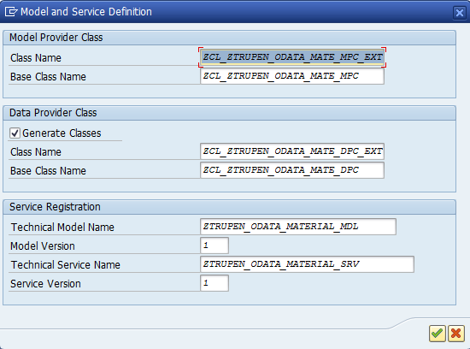
Now Provide the Package Name and click on Save.
SAVE the object in the localobject .
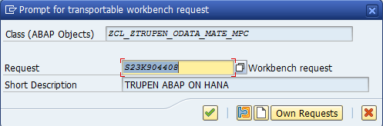
GATEWAY SERVICE Registration
Now we need to register and maintain the service through the Tcode /o/IWFND/MAINT_SERVICE.
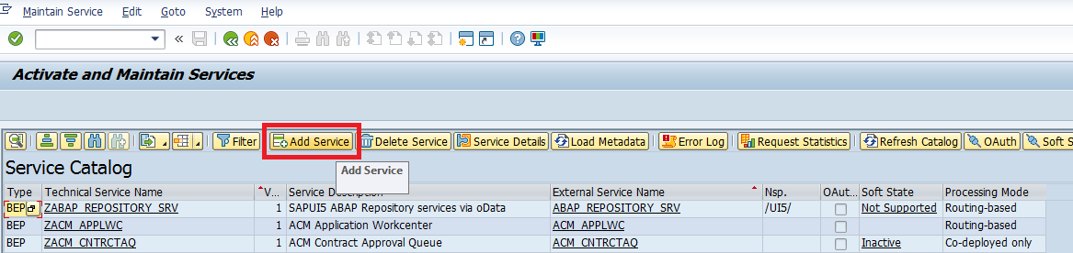
Now Click on Add Service and give the system alias as LOCAL and Service name same as the Service created during Runtime Object generation as ZTRUPEN_ODATA_MATERIAL_SRV and then Click on Add Selected service to activate the ICF Node for the service.
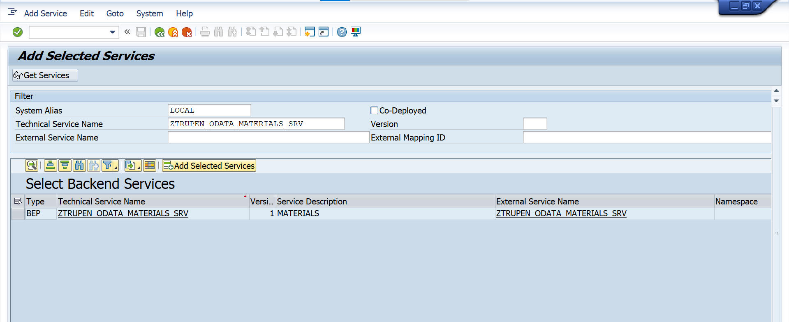
Now we can modify the technical service name and technical model name if required and then click on Enter and provide the TR for the ICF Service.
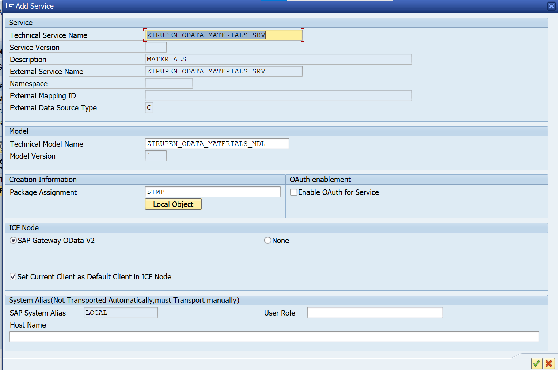
Now the Service is maintained and the ICF node is active for the service.
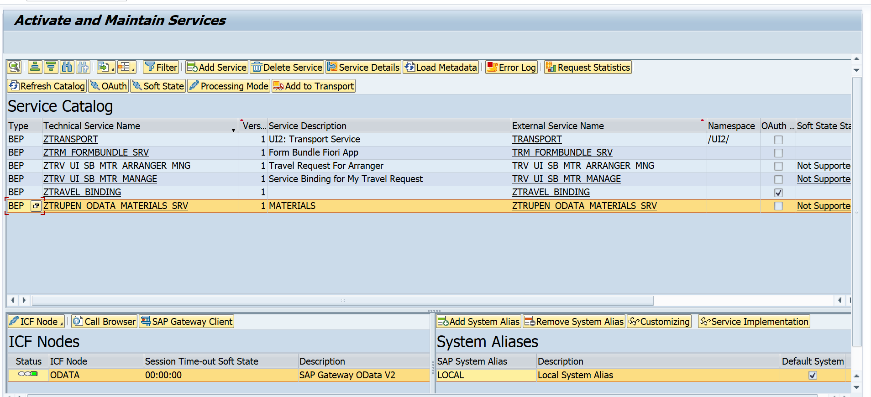
Now Click on SAP Gateway Client Button to check the Service.
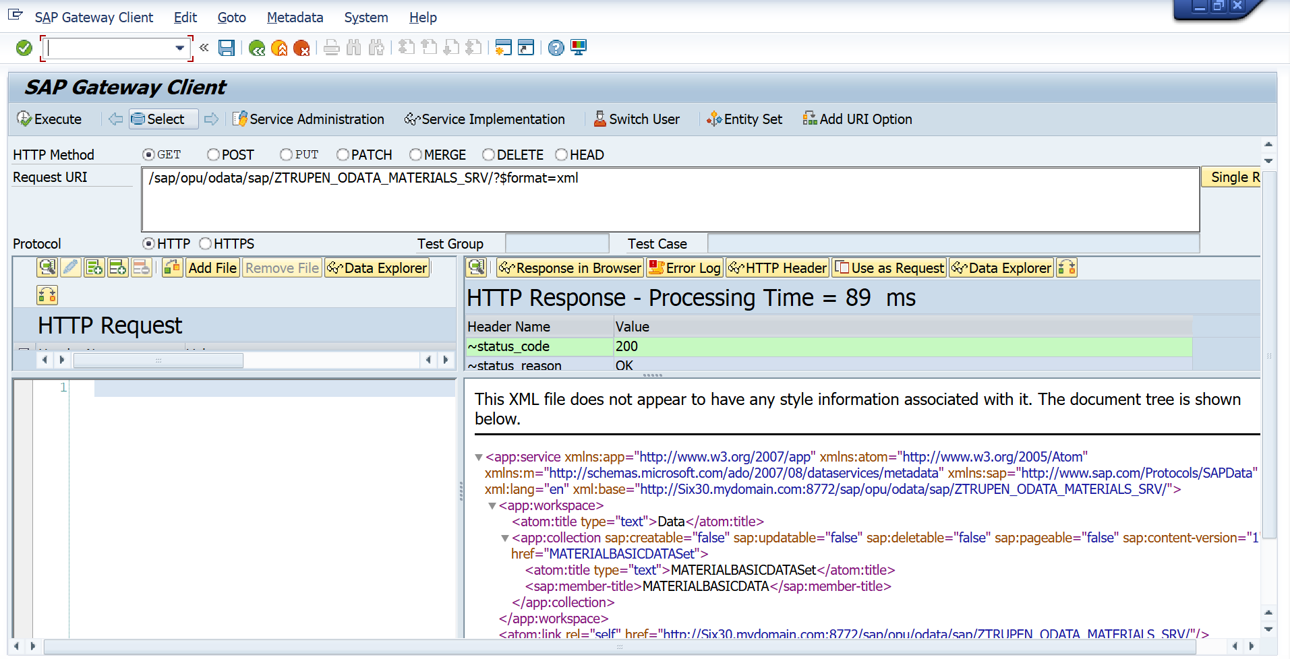
Now the Runtime Object are created and now we need to redefine the methods of data provide class to perform the CRUD Operation.
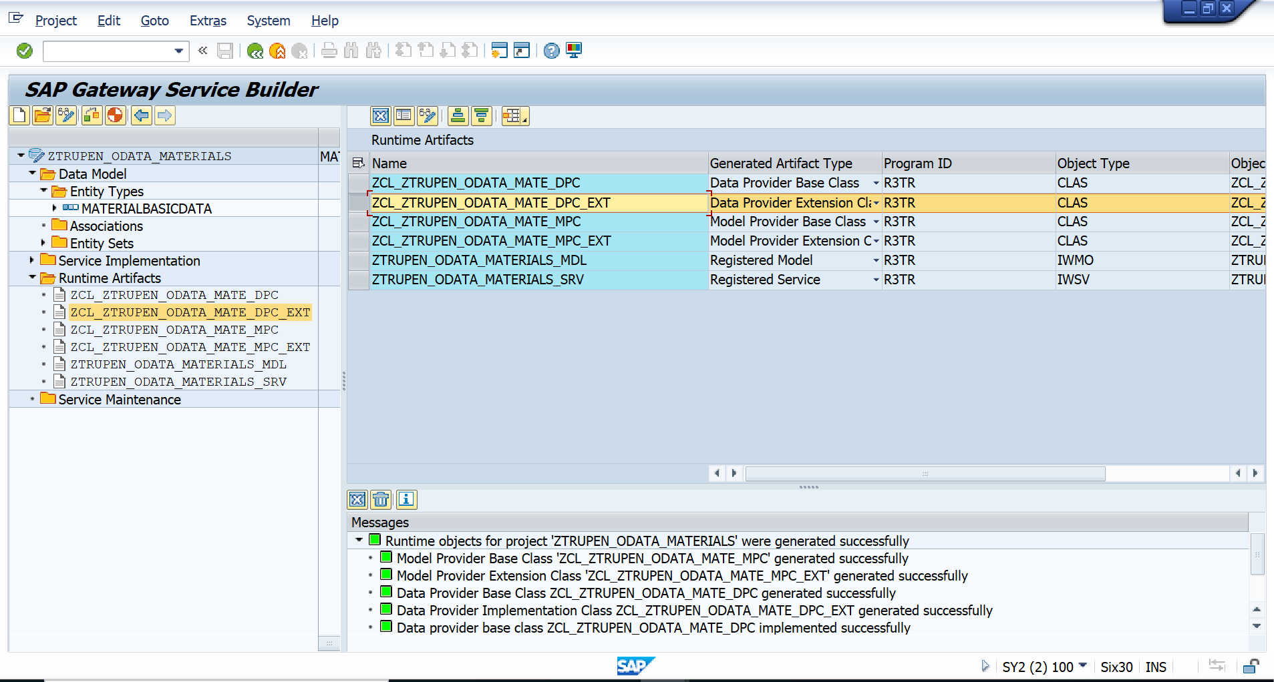
Now Double Click on the ZCL_ZTRUPEN_ODATA_MATE_DPC_EXT Class and Expand the methods->Inherited Methods and then we can redefine the method to write the Logic for Creating material Master in the method MATERIALBASICDAT_CREATE_ENTITY.
Right Click on the Method where we need to redefine the Logic.
We can redefine the other methods MATERIALBASICDAT_DELETE_ENTITY to set the Deletion Indicator and MATERIALBASICDAT_GET_ENTITY to select the data from the Material Master and MATERIALBASICDAT_UPDATE_ENTITY to update the Material Master.
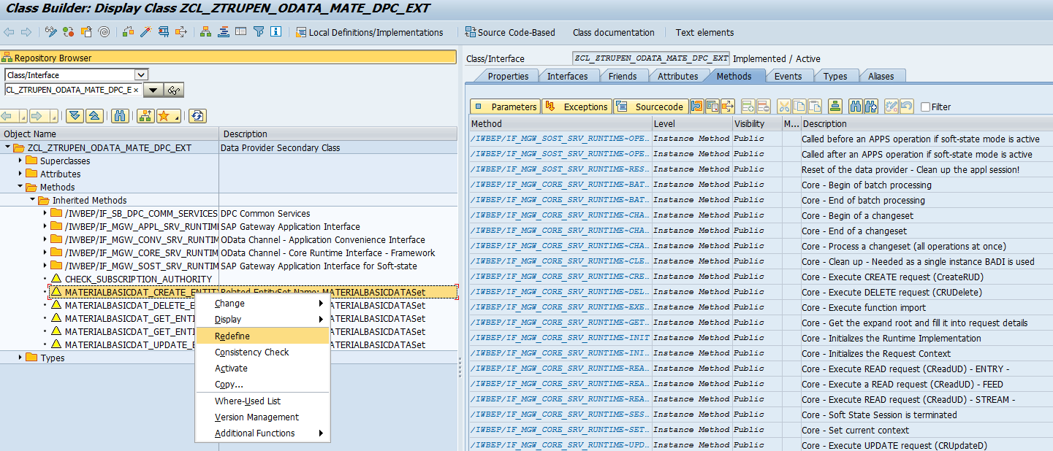
Now the Method can be seen under Redefinitions and we can write our own logic to perform POST or PUT or DELETE or GET Operations by implementing the redefined method.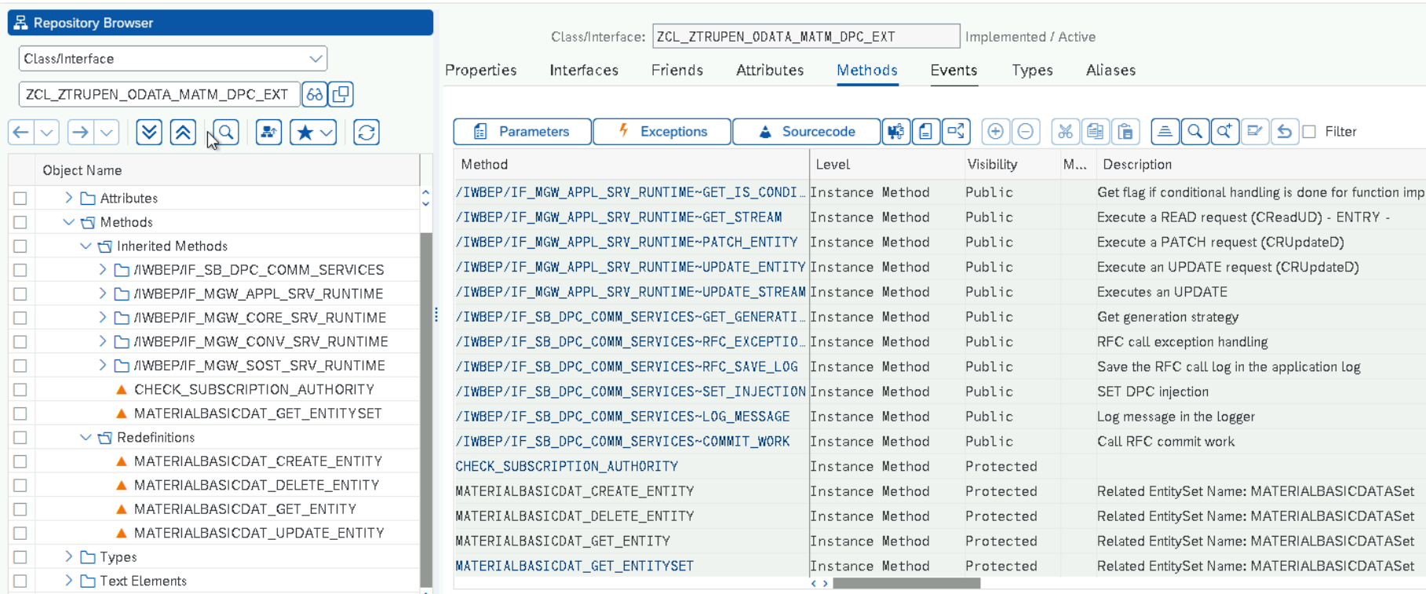
Redefined method Logic
Create – POST Call
METHOD materialbasicdat_create_entity.
DATA : lo_message_container TYPE REF TO /iwbep/if_message_container,
ls_matbasicdata TYPE zcl_ztrupen_odata_mate_mpc=>ts_materialbasicdata.
io_data_provider->read_entry_data( IMPORTING es_data = ls_matbasicdata ).
MODIFY ztrupen_material FROM ls_matbasicdata.
lo_message_container = me->mo_context->get_message_container( ).
"only to display message text.
CALL METHOD lo_message_container->add_message_text_only
EXPORTING
iv_msg_type = 'S'
iv_msg_text = 'Material Created Successfully'
iv_add_to_response_header = abap_true.
er_entity = ls_matbasicdata.
ENDMETHOD.

Read – GET Call
METHOD materialbasicdat_get_entity.
DATA :lo_message_container TYPE REF TO /iwbep/if_message_container,
ls_matbasicdata TYPE zcl_ztrupen_odata_mate_mpc=>ts_materialbasicdata.
READ TABLE it_key_tab INTO DATA(ls_key) WITH KEY name = 'Matnr'.
IF sy-subrc EQ 0.
Ls_matbasicdata-mandt = sy-mandt.
ls_matbasicdata-matnr = |{ ls_key-value }alpha = in |.
SELECT SINGLE * FROM ztrupen_material INTO CORRESPONDING FIELDS OF ls_matbasicdata
WHERE matnr = ls_matbasicdata-matnr.
IF sy-subrc EQ 0.
er_entity = ls_matbasicdata.
ELSE.
lo_message_container = me->mo_context->get_message_container( ).
"only to display message text.
CALL METHOD lo_message_container->add_message_text_only
EXPORTING
iv_msg_type = 'E'
iv_msg_text = 'Material Does Not Exist'
iv_add_to_response_header = abap_true.
ENDIF.
ENDIF.
ENDMETHOD.

DELETE – Delete Call
METHOD materialbasicdat_delete_entity.
DATA : lo_message_container TYPE REF TO /iwbep/if_message_container,
lv_matnr TYPE matnr,
ls_matbasicdata TYPE zcl_ztrupen_odata_mate_mpc=>ts_materialbasicdata.
READ TABLE it_key_tab INTO DATA(ls_key) WITH KEY name = 'Matnr'.
IF sy-subrc EQ 0.
lv_matnr = |{ ls_key-value }alpha = IN|.
SELECT SINGLE * FROM ztrupen_material INTO CORRESPONDING FIELDS OF ls_matbasicdata
where matnr = lv_matnr .
DELETE ztrupen_material FROM ls_matbasicdata.
IF sy-subrc ne 0.
lo_message_container = me->mo_context->get_message_container( ).
"only to display message text.
CALL METHOD lo_message_container->add_message_text_only
EXPORTING
iv_msg_type = 'E'
iv_msg_text = 'Material Deletion failed'
iv_add_to_response_header = abap_true.
ELSE.
lo_message_container = me->mo_context->get_message_container( ).
"only to display message text.
CALL METHOD lo_message_container->add_message_text_only
EXPORTING
iv_msg_type = 'S'
iv_msg_text = 'Material Deleted'
iv_add_to_response_header = abap_true.
ENDIF.
ENDIF.
ENDMETHOD.
Update – PUT Call
method MATERIALBASICDAT_UPDATE_ENTITY.
data : lo_message_container type ref to /iwbep/if_message_container,
ls_matbasicdata type zcl_ztrupen_odata_mate_mpc=>ts_materialbasicdata,
lv_matnr TYPE matnr.
io_data_provider->read_entry_data( importing es_data = ls_matbasicdata ).
select SINGLE matnr FROM ztrupen_material INTO lv_matnr WHERE matnr = ls_matbasicdata-matnr.
IF sy-subrc eq 0.
io_data_provider->read_entry_data( importing es_data = ls_matbasicdata ).
MODIFY ztrupen_material FROM ls_matbasicdata.
IF sy-subrc eq 0.
lo_message_container = me->mo_context->get_message_container( ).
"only to display message text.
call method lo_message_container->add_message_text_only
exporting
iv_msg_type = 'S'
iv_msg_text = 'Material Changed Successfully'
iv_add_to_response_header = abap_true.
ELSE.
lo_message_container = me->mo_context->get_message_container( ).
"only to display message text.
call method lo_message_container->add_message_text_only
exporting
iv_msg_type = 'E'
iv_msg_text = 'Material is not Changed'
iv_add_to_response_header = abap_true.
ENDIF.
ELSE.
lo_message_container = me->mo_context->get_message_container( ).
"only to display message text.
call method lo_message_container->add_message_text_only
exporting
iv_msg_type = 'S'
iv_msg_text = 'Material does not exist'
iv_add_to_response_header = abap_true.
endif.
endmethod.
Testing Inputs
CREATE -Post: http://Six30.mydomain.com:8772/sap/opu/odata/sap/ZTRUPEN_ODATA_MATERIALS_SRV/MATERIALBASICDATASet

{
"Mandt": "100",
"Matnr": "MATERIAL_01",
"Mtart": "FERT",
"Mbrsh": "M",
"Matkl": "001",
"Meins": "PC",
"Maktx": "Test Material Description"
}
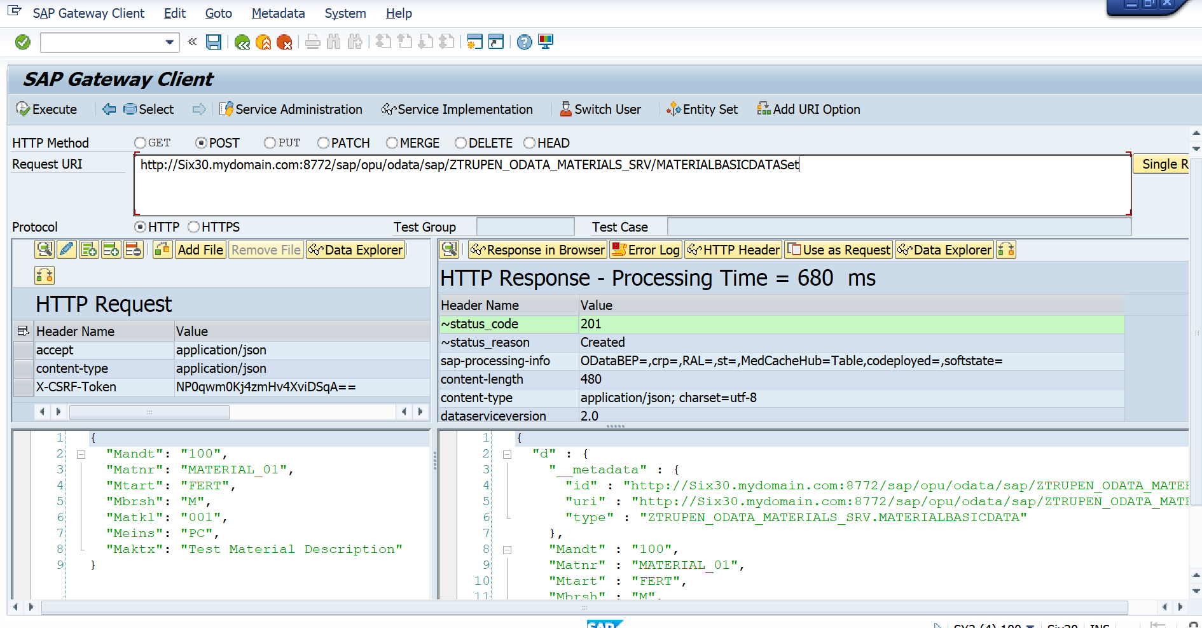
Update -Put: http://Six30.mydomain.com:8772/sap/opu/odata/sap/ZTRUPEN_ODATA_MATERIALS_SRV/MATERIALBASICDATASet(Mandt='100',Matnr='Material1')
{
"Mandt": "100",
"Matnr": "Material1",
"Mtart": "FERT",
"Mbrsh": "M",
"Matkl": "001",
"Meins": "PC",
"Maktx": "Test Material Description"
}
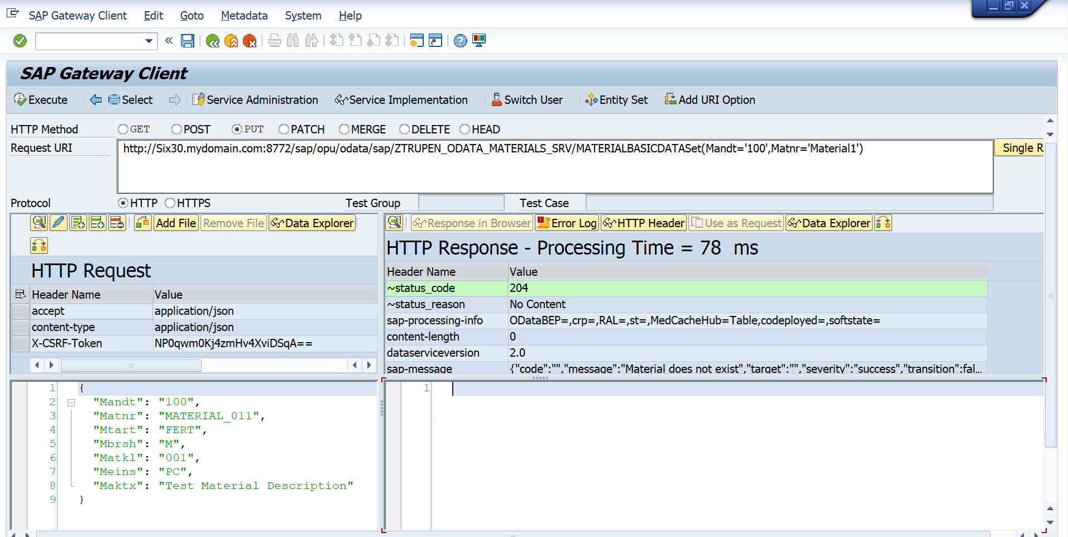
Delete – Delete:
http://atosfaa2.mydomain.com:50000/sap/opu/odata/sap/ZTRUPEN_ODATA_MATEIRAL_SRV/MATERIALBASICDATASet(Mandt='100',Matnr='Material1')

{
"Mandt": "100",
"Matnr": "Material1",
"Mtart": "FERT",
"Mbrsh": "M",
"Matkl": "001",
"Meins": "PC",
"Maktx": "Test Material Description"
}

