CREATING A TABLE FOR PRODUCTS-TABLE:
Right click on the Database Tables and select New Database Table
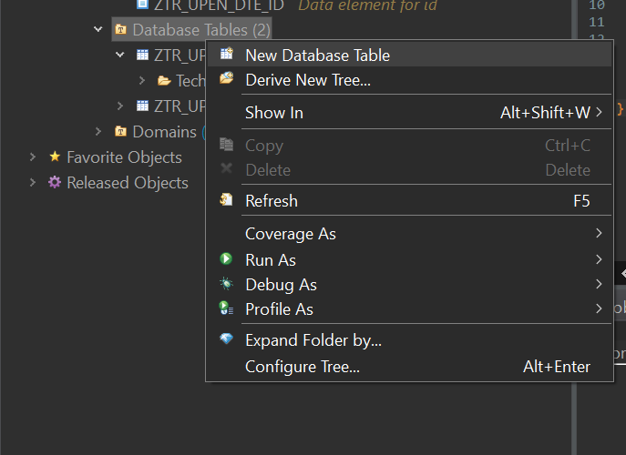
Name of the product Table: ZUPEN_PRODUCT
Click on Next & Finish.
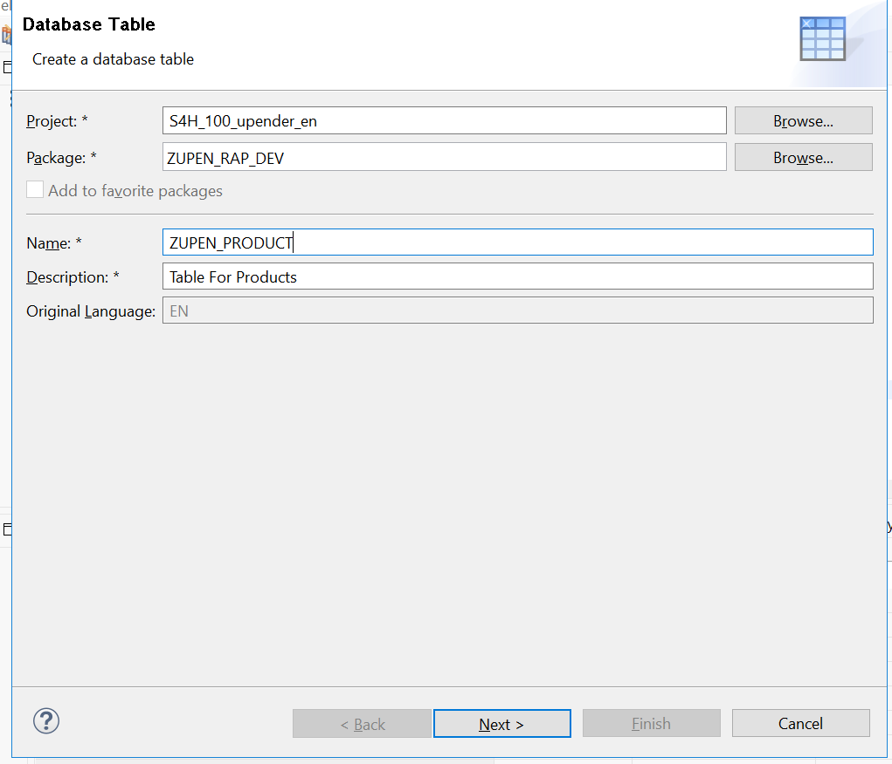
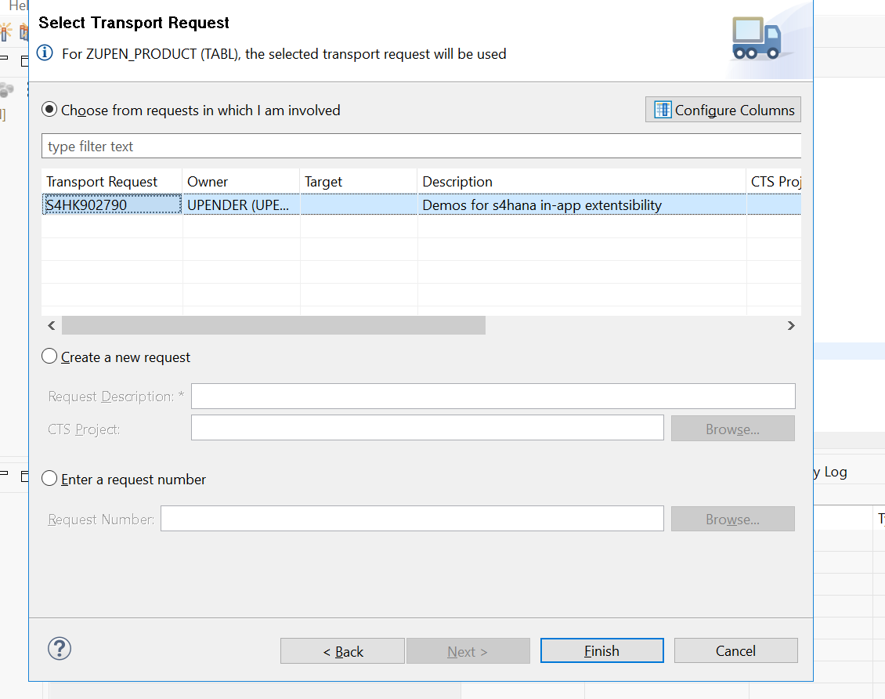

TABLE NAME : zupen_product
@EndUserText.label : 'Table For Products'
@AbapCatalog.enhancement.category : #NOT_EXTENSIBLE
@AbapCatalog.tableCategory : #TRANSPARENT
@AbapCatalog.deliveryClass : #A
@AbapCatalog.dataMaintenance : #RESTRICTED
define table zupen_product {

key client : abap.clnt not null;
key product_id : ztr_upen_dte_id not null;
name : abap.string(256);
category : abap.char(40);
price : int4;
currency : abap.cuky;
discount : abap.int4;

}

CREATING A STRUCTUE FOR ADMINSTRATION-DATA:
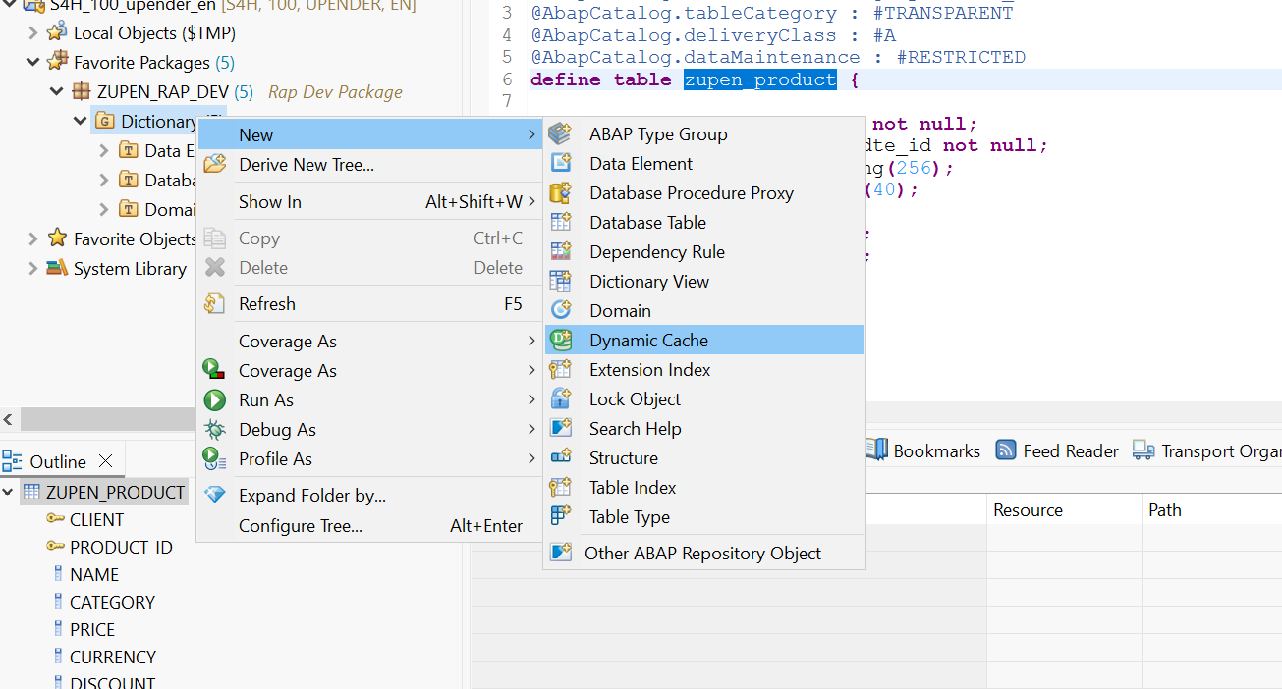

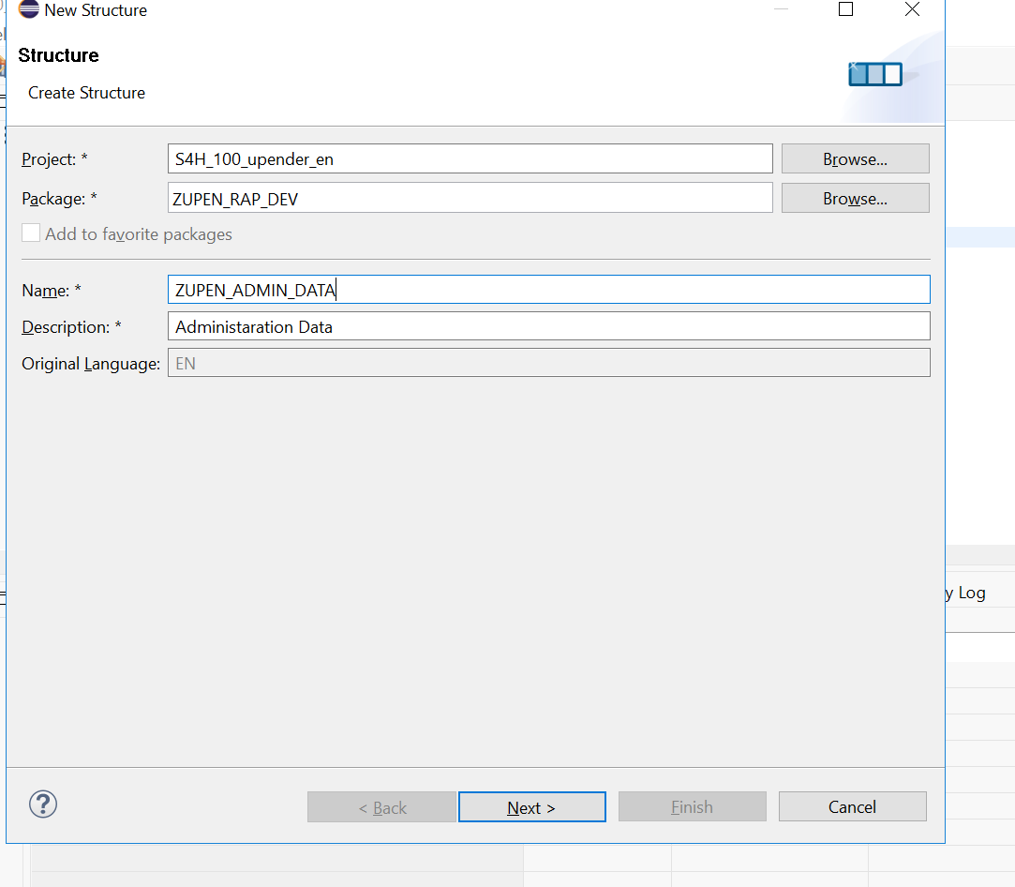
Click on Next & Finish
@EndUserText.label : 'Administaration Data'
@AbapCatalog.enhancement.category : #NOT_EXTENSIBLE
define structure zupen_admin_data {

created_by : abap.char(16);
created_on : timestamp;
changed_by : abap.char(16);
changed_on : timestamp;

}

CREATE A TABLE FOR SALES-HEADER TABLE :
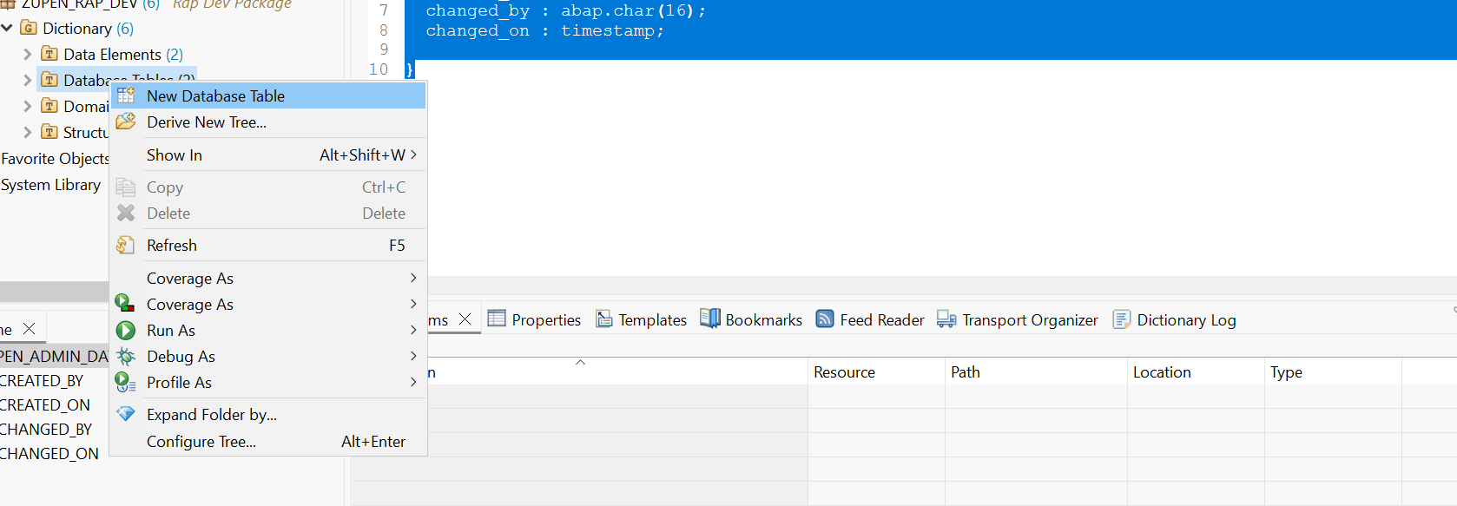

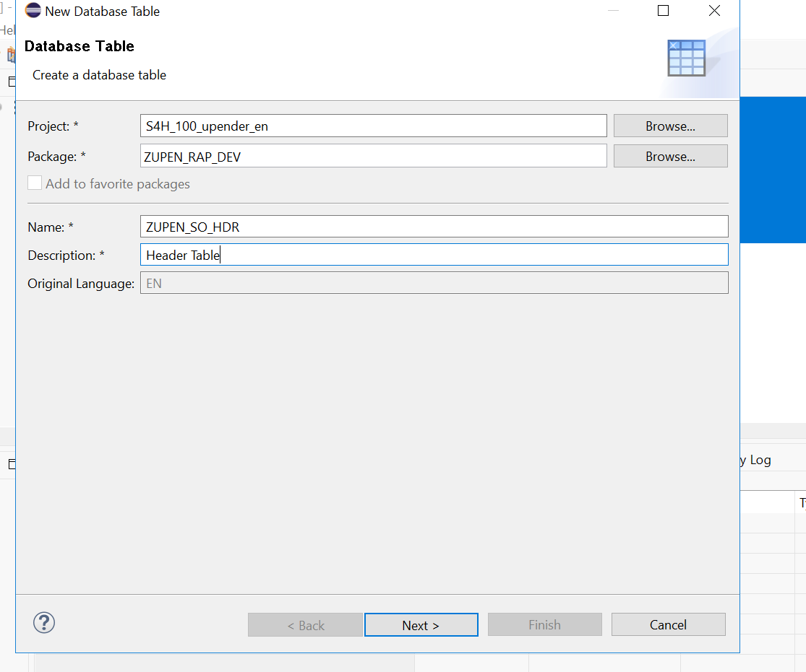

Click on next & finish.
Code:
@EndUserText.label : 'Header Table'
@AbapCatalog.enhancement.category : #NOT_EXTENSIBLE
@AbapCatalog.tableCategory : #TRANSPARENT
@AbapCatalog.deliveryClass : #A
@AbapCatalog.dataMaintenance : #RESTRICTED
define table zupen_so_hdr {

key client : abap.clnt not null;
key order_id : ztr_upen_dte_id not null;
order_no : int4;
@AbapCatalog.foreignKey.screenCheck : true
buyer : ztr_upen_dte_id not null
with foreign key zupen_rap_table
where client = zupen_so_hdr.client
and bp_id = zupen_so_hdr.buyer;
@Semantics.amount.currencyCode : 'zupen_so_hdr.currency_code'
gross_amount : abap.curr(10,2);
currency_code : abap.cuky;
include zupen_admin_data;

}
Activate the code with the ctrl+f3

Create a table sales items table :
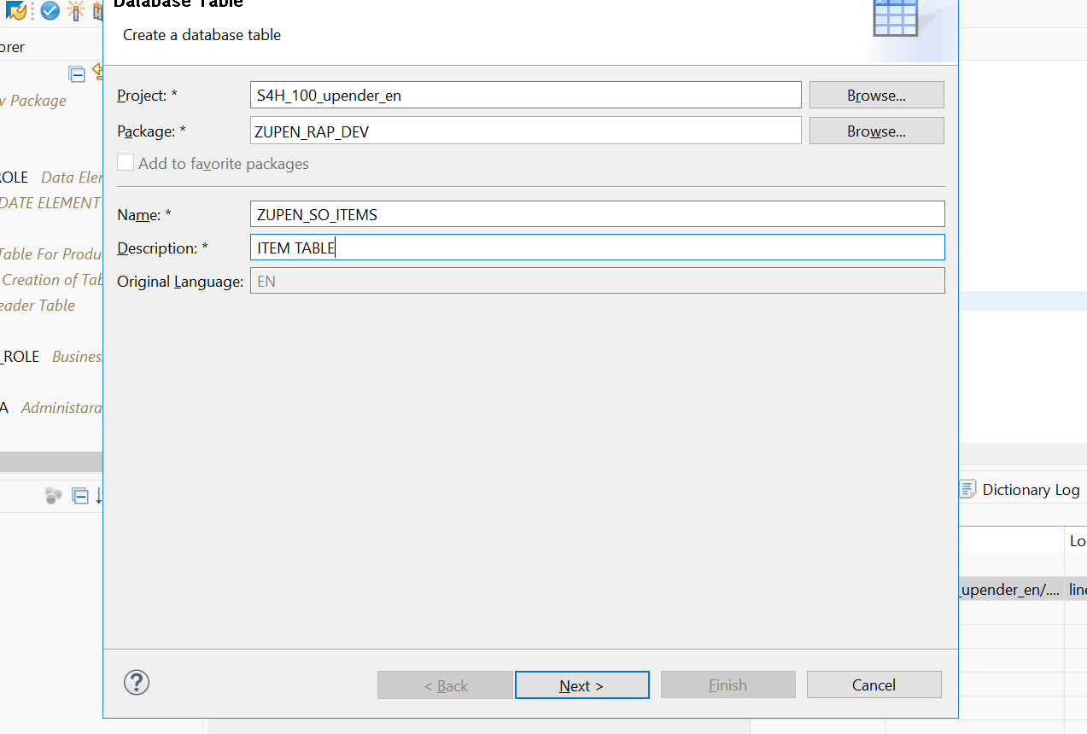
Table Name : ZUPEN_SO_ITEM
Descripiton : Sales Order Items Table
Code :
@EndUserText.label : 'ITEM TABLE'
@AbapCatalog.enhancement.category : #NOT_EXTENSIBLE
@AbapCatalog.tableCategory : #TRANSPARENT
@AbapCatalog.deliveryClass : #A
@AbapCatalog.dataMaintenance : #RESTRICTED
define table zupen_so_item {

key client : abap.clnt not null;
key item_id : ztr_upen_dte_id not null;
@AbapCatalog.foreignKey.screenCheck : false
order_id : ztr_upen_dte_id not null
with foreign key zupen_so_hdr
where client = zupen_so_item.client
and order_id = zupen_so_item.order_id;
@AbapCatalog.foreignKey.screenCheck : true
product : ztr_upen_dte_id not null
with foreign key zupen_product
where client = zupen_so_item.client
and product_id = zupen_so_item.product;
@Semantics.quantity.unitOfMeasure : 'zupen_so_item.uom'
qty : abap.quan(5,0);
uom : abap.unit(3);
@Semantics.amount.currencyCode : 'zupen_so_item.currency'
amount : abap.curr(15,2);
currency : abap.cuky;

}

Pushing Data into our tables :
Create a Class named : ZCL_TR_UPEN_DATA_UPLOADER
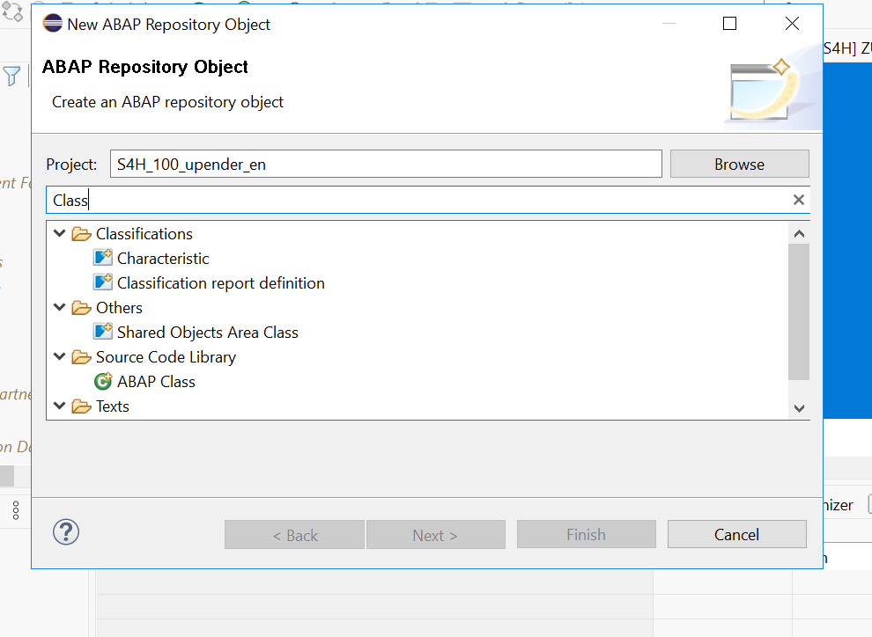

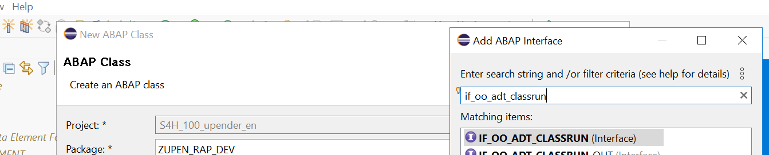 Click on next & Finish.
Code :
CLASS zcl_tr_upen_data_uploader DEFINITION
PUBLIC
FINAL
CREATE PUBLIC.

PUBLIC SECTION.
INTERFACES if_oo_adt_classrun.
PROTECTED SECTION.
PRIVATE SECTION.
METHODS flush.
METHODS fill_master_data.
METHODS fill_transaction_data.
ENDCLASS.

CLASS zcl_tr_upen_data_uploader IMPLEMENTATION.

METHOD if_oo_adt_classrun~main.
flush( ).
fill_master_data( ).
fill_transaction_data( ).
out->write(
EXPORTING
data = 'Processing is completed successfully!'
).
ENDMETHOD.

METHOD flush.
DELETE FROM: zupen_rap_table, zupen_product, zupen_so_hdr, zupen_so_item.
ENDMETHOD.

METHOD fill_master_data.
DATA: lt_bp TYPE TABLE OF zupen_rap_table,
lt_prod TYPE TABLE OF zupen_product.

" Business Partner Entries
APPEND VALUE #( bp_id = cl_uuid_factory=>create_system_uuid( )->create_uuid_c32( )
bp_role = '01'
company_name = 'TACUM'
street = 'Victoria Street'
city = 'Kolkatta'
country = 'IN'
region = 'APJ' ) TO lt_bp.

APPEND VALUE #( bp_id = cl_uuid_factory=>create_system_uuid( )->create_uuid_c32( )
bp_role = '01'
company_name = 'SAP'
street = 'Rosvelt Street Road'
city = 'Walldorf'
country = 'DE'
region = 'EMEA' ) TO lt_bp.

APPEND VALUE #( bp_id = cl_uuid_factory=>create_system_uuid( )->create_uuid_c32( )
bp_role = '01'
company_name = 'Indian IT Trading Company'
street = 'Nariman Point'
city = 'Mumbai'
country = 'IN'
region = 'APJ' ) TO lt_bp.

" Product Entries
APPEND VALUE #( product_id = cl_uuid_factory=>create_system_uuid( )->create_uuid_c32( )
name = 'Blaster Extreme'
category = 'Speakers'
price = 1500
currency = 'INR'
discount = 3 ) TO lt_prod.

APPEND VALUE #( product_id = cl_uuid_factory=>create_system_uuid( )->create_uuid_c32( )
name = 'Smart Office'
category = 'Software'
price = 1540
currency = 'INR'
discount = 32 ) TO lt_prod.

APPEND VALUE #( product_id = cl_uuid_factory=>create_system_uuid( )->create_uuid_c32( )
name = 'Gaming Monster Pro'
category = 'PCs'
price = 15500
currency = 'INR'
discount = 8 ) TO lt_prod.

INSERT zupen_rap_table FROM TABLE @lt_bp.
INSERT zupen_product FROM TABLE @lt_prod.
ENDMETHOD.

METHOD fill_transaction_data.
DATA: o_rand TYPE REF TO cl_abap_random_int,
n TYPE i,
seed TYPE i,
lv_date TYPE timestamp,
lv_ord_id TYPE ztr_upen_dte_id,
lt_bpa TYPE TABLE OF zupen_rap_table,
lt_prod TYPE TABLE OF zupen_product,
lt_so TYPE TABLE OF zupen_so_hdr,
lt_so_i TYPE TABLE OF zupen_so_item.

seed = cl_abap_random=>seed( ).
cl_abap_random_int=>create(
EXPORTING seed = seed min = 1 max = 3
RECEIVING prng = o_rand ).

GET TIME STAMP FIELD lv_date.

SELECT * FROM zupen_rap_table INTO TABLE @lt_bpa.
SELECT * FROM zupen_product INTO TABLE @lt_prod.

DO 10 TIMES.
lv_ord_id = cl_uuid_factory=>create_system_uuid( )->create_uuid_c32( ).
n = o_rand->get_next( ).

READ TABLE lt_bpa INTO DATA(ls_bp) INDEX n.
APPEND VALUE #( order_id = lv_ord_id
order_no = sy-index
buyer = ls_bp-bp_id
gross_amount = 10 * n
currency_code = 'EUR'
created_by = sy-uname
created_on = lv_date
changed_by = sy-uname
changed_on = lv_date ) TO lt_so.

DO 2 TIMES.
READ TABLE lt_prod INTO DATA(ls_prod) INDEX n.
APPEND VALUE #( item_id = cl_uuid_factory=>create_system_uuid( )->create_uuid_c32( )
order_id = lv_ord_id
product = ls_prod-product_id
qty = n
uom = 'EA'
amount = n * ls_prod-price
currency = ls_prod-currency ) TO lt_so_i.
ENDDO.
ENDDO.

INSERT zupen_so_hdr FROM TABLE @lt_so.
INSERT zupen_so_item FROM TABLE @lt_so_i.
ENDMETHOD.

ENDCLASS.

Activate the code with ctrl+f3 and run the code with the ABAP Console.
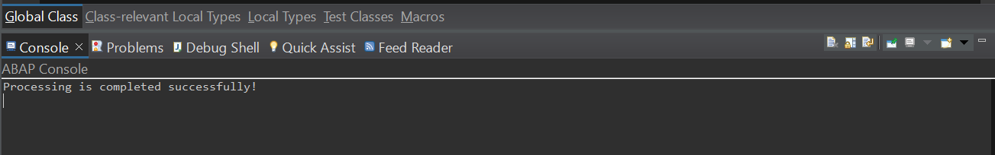
Go-to any of the table and ctrl+f9 to preview the data.
