CORE DATA SERVICES(CDS):
CDS is the new approach of building semantically rich data models. It is an extension of SQL in ABAP world.
What has been extended?
DDL – Data definition language – design new data models – new tables, structures
DQL – Data Query Language (CDS Views and CDS Entities) – new views to extract data (agg., join, load, calculate,formulas)
DEL – Data Expression language (expressions like path expression, case expressions)
DCL – Data Control Language (security)
Since in ABAP on Cloud Environment we do not have GUI access (no access to SE11) – we will use CDS
Naming convention – is a best practice to follow in a project. ZCOMPANY_PROJ_OBJTTP_NAME
ZATS_XX_*
We will use an uploader utility provided by SAP, get this in our ABAP on Cloud System to test it
1)Install the abap git plugin so we can interact with github from our adt tool - http://eclipse.abapgit.org/updatesite/
2)Download the code from SAP standard repository - https://github.com/SAP-samples/abap-file-uploader
3)Register a service
4)Run the utility

CDS Views (DQL) :
Using the views we can build the Data models which can optimum expose the data out of sap system. The execution of CDS view happens inside the database because when we activate a CDS view, system creates a HANA view. All the logic hence gets executed inside the database. This process is known as code-to-data paradigm.
CDS views are obsolete now, a successor concept was introduced in 2019 called CDS entities.
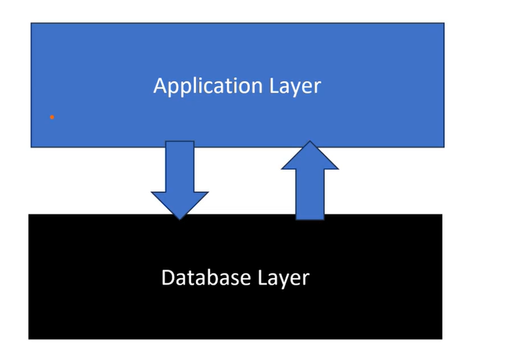

Creating the cds view on top of the products-table:
Right click on the Data Dictionary and search for core-data servicesDataDefinition.
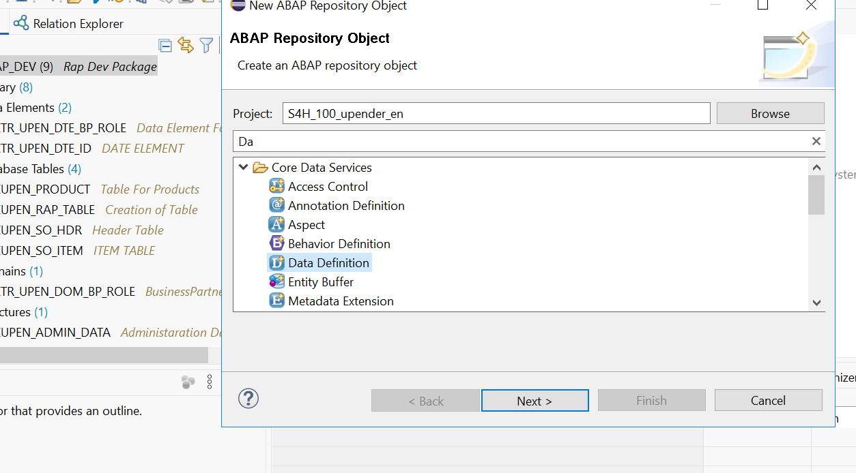

Give the name for your cds view & click on next.
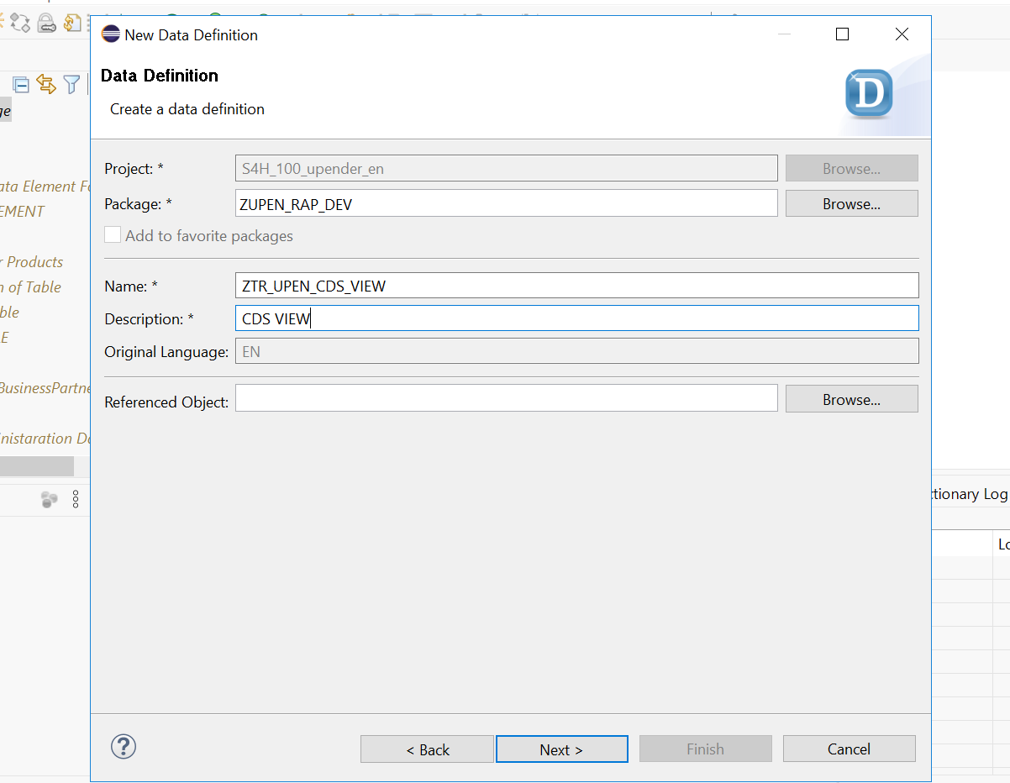

Select the Define View template for your CDS-creation.
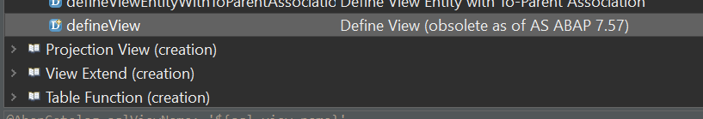

Code :
@AbapCatalog.sqlViewName:'ZBUSINESS'
@AbapCatalog.compiler.compareFilter: true
@AbapCatalog.preserveKey: true
@AccessControl.authorizationCheck: #NOT_REQUIRED
@EndUserText.label: 'CDS VIEW'
@Metadata.ignorePropagatedAnnotations: true
define view ZTR_UPEN_CDS_VIEW as select from zupen_rap_table
{
key bp_id as BpId,
bp_role as BpRole,
company_name as CompanyName,
street as Street,
country as Country,
region as Region,
city as City

}

NOTE:
****The CDS View are becoming obsolete for the ABAP 7.57 version,so we make use of CDS Entities.****
CDS entities
CDS entities are advance version of CDS Views. If you know CDS view, you can implement CDS entities very easily
- When we activate CDS view, 2 objects gets created. One will be HANA view, and another will be the DDIC view. This DDIC view is of no use. When we CDS entity, No DDIC view gets created.
- It save activation time hence the cds entity activation is faster than the cds view activation.
- A view have 3 names – file name, cds name and ddic view name. CDS entity is simplified and just have only one name
- SAP also improved the runtime engine for entities to make it work faster
- CDS entities are strict in nature.

ABAP on Cloud system :
SAP does not allow direct access of some of standard database tables available in AOC environment. These objects are called restricted objects. SAP have built the CDS entities on top of these objects, these entities are marked as Released. Which means we can use them in our code.

Creation of CDS Entities:
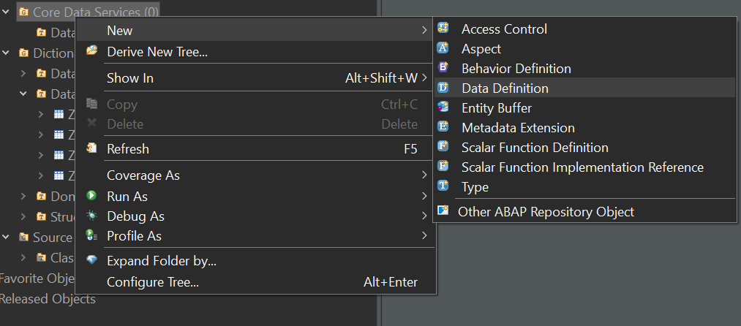
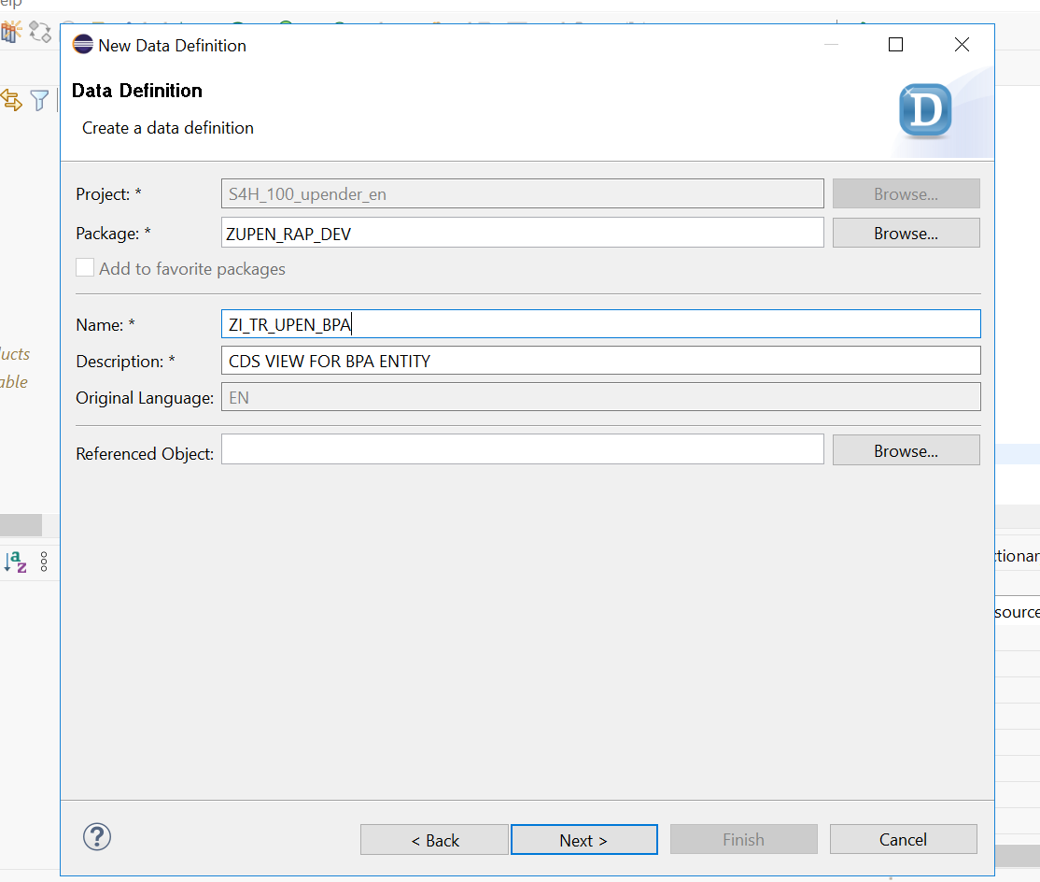

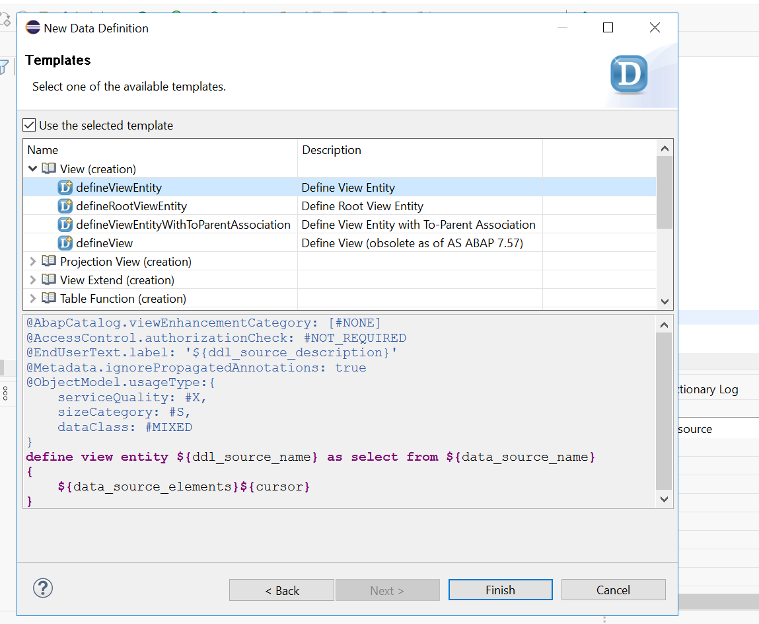
CODE:
@AbapCatalog.viewEnhancementCategory: [#NONE]
@AccessControl.authorizationCheck: #NOT_REQUIRED
@EndUserText.label: 'CDS VIEW FOR BPA ENTITY'
@Metadata.ignorePropagatedAnnotations: true
@ObjectModel.usageType:{
serviceQuality: #X,
sizeCategory: #S,
dataClass: #MIXED
}
define view entity ZI_TR_UPEN_BPA
as select from zupen_rap_table
-- 1. Define the Association to the standard Country view
association [1..1] to I_Country as _Country on $projection.Country = _Country.Country
{
key bp_id as BpId,
bp_role as BpRole,
company_name as CompanyName,
country as Country,
region as Region,
city as City,

-- 2. Now you can expand the path safely
_Country._Text[1:Language = $session.system_language].CountryName as CountryName,

-- 3. It is best practice to expose the association at the end
_Country
}

A primary key is a column OR combination of columns in database tables which gives the uniqueness to every single record of the table.

VDM(Virtual Data Modelling):
It is a best practice/gold standard to build cds entities in SAP system. It is layered approach which provide clear guidance to development teams to create cds views in modular way. It increase the code readability, and reduce the maintenance of the code. All the views are categorised in below categories
- Private views – They starts with P_ / Marked with @VDM.private: true / We should never use them in our code as the contract of these views can change release on release.
- Interface Views – They starts with I_ / Marked with @VDM.viewType: #BASIC , #COMPOSITE / Highly reusable views and can be used as the contract is stable. In AOC system for example we have I_Currency, I_Country
- Consumption Views – They starts with C_ / Marked with @VDM.viewType:#CONSUMPTION / Used for final consumption of data for our use case.
- Help Views – They are marked with I_*VH / Purely used for Value helps in Fiori Applications.

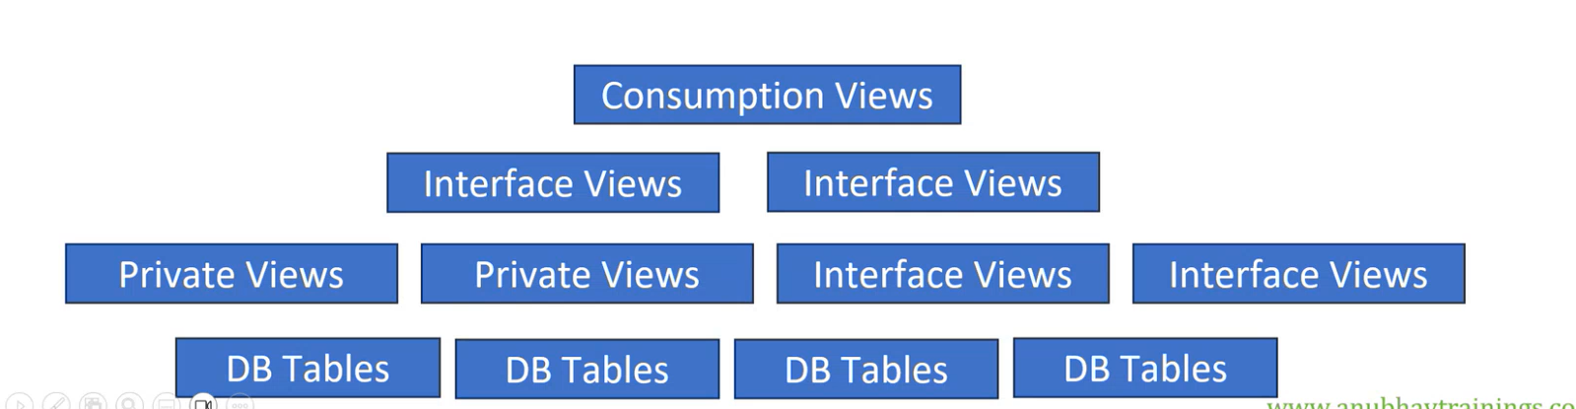

Creating cds entity for product-table :
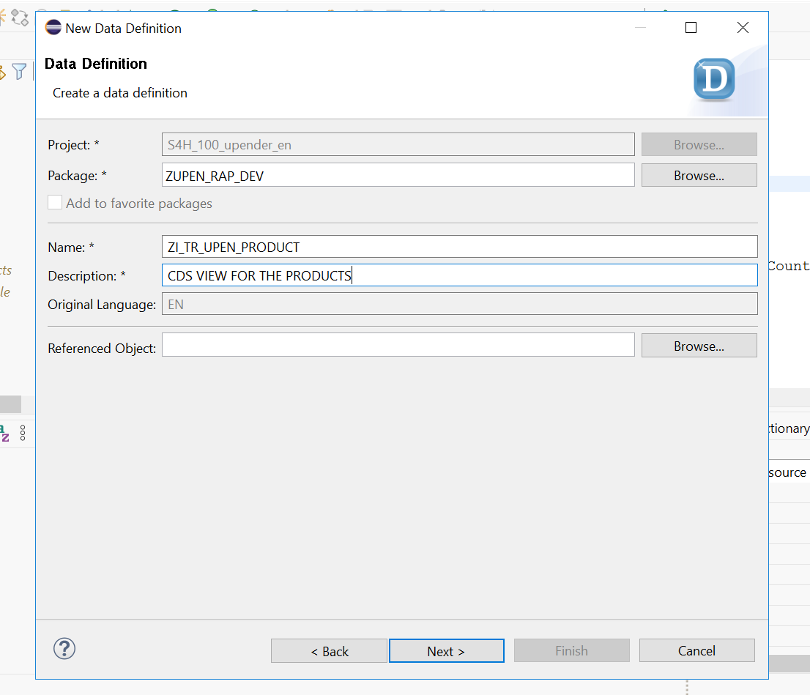

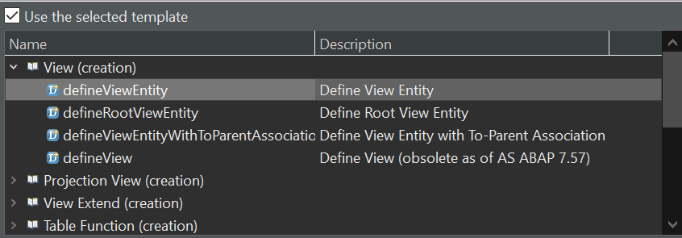

Code :
@AbapCatalog.viewEnhancementCategory: [#NONE]
@AccessControl.authorizationCheck: #NOT_REQUIRED
@EndUserText.label: 'CDS VIEW FOR THE PRODUCTS'
@Metadata.ignorePropagatedAnnotations: true
@ObjectModel.usageType:{
serviceQuality: #X,
sizeCategory: #S,
dataClass: #MIXED
}
define view entity ZI_TR_UPEN_PRODUCT as select from zupen_product
{
key product_id as ProductId,
name as Name,
category as Category,
price as Price,
currency as Currency,
discount as Discount
}

Creating the cds-entity for sales-order table:
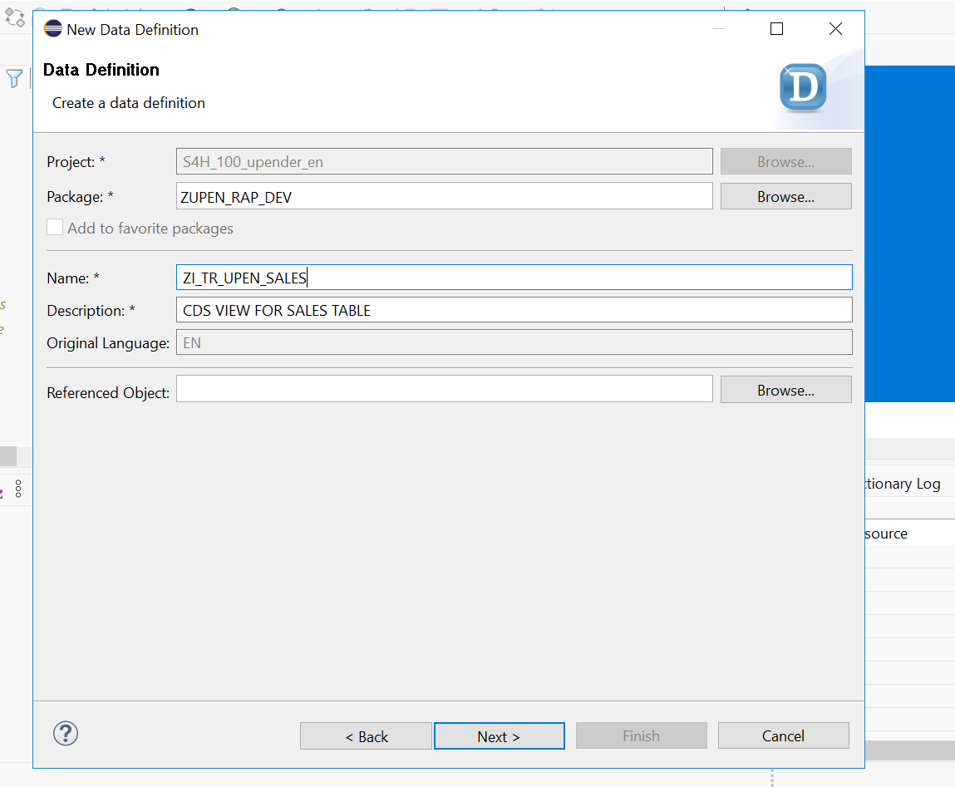
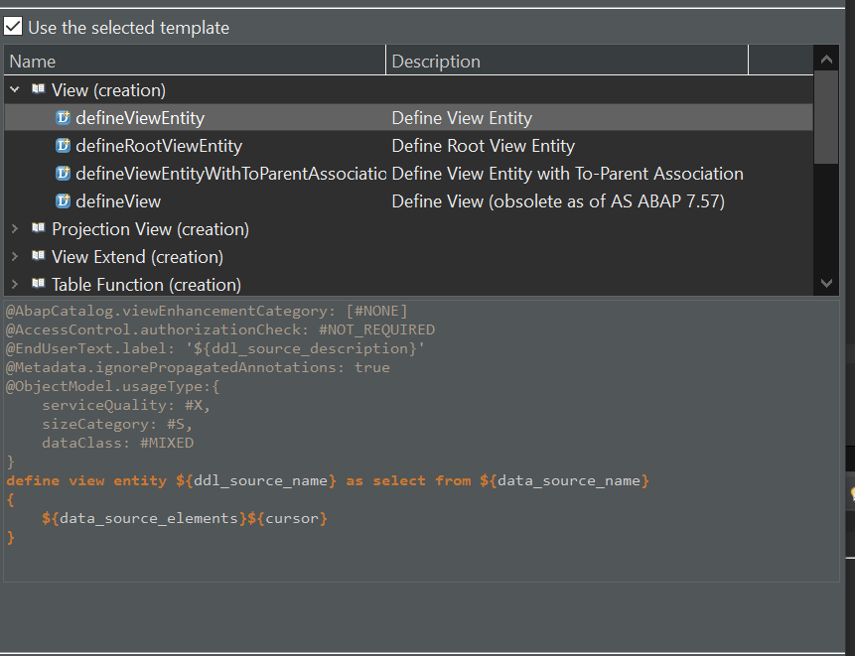

CODE:
@AbapCatalog.viewEnhancementCategory: [#NONE]
@AccessControl.authorizationCheck: #NOT_REQUIRED
@EndUserText.label: 'CDS VIEW FOR SALES TABLE'
@Metadata.ignorePropagatedAnnotations: true
@ObjectModel.usageType:{
serviceQuality: #X,
sizeCategory: #S,
dataClass: #MIXED
}
define view entity ZI_TR_UPEN_SALES as select from zupen_so_hdr as hdr
association[1..*] to zupen_so_item as _Items on
$projection.OrderId = _Items.order_id
{

key hdr.order_id as OrderId,
hdr.order_no as OrderNo,
hdr.buyer as Buyer,
hdr.created_by as CreatedBy,
hdr.created_on as CreatedOn,
_Items

}
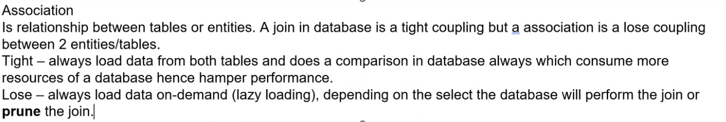

Creating a Composite View:
Create a view such that the relationship can be established between sales,business partner and product tables.
To achieve this we do require a cube annotation i.e
@Analytics.dataCategory: #CUBE
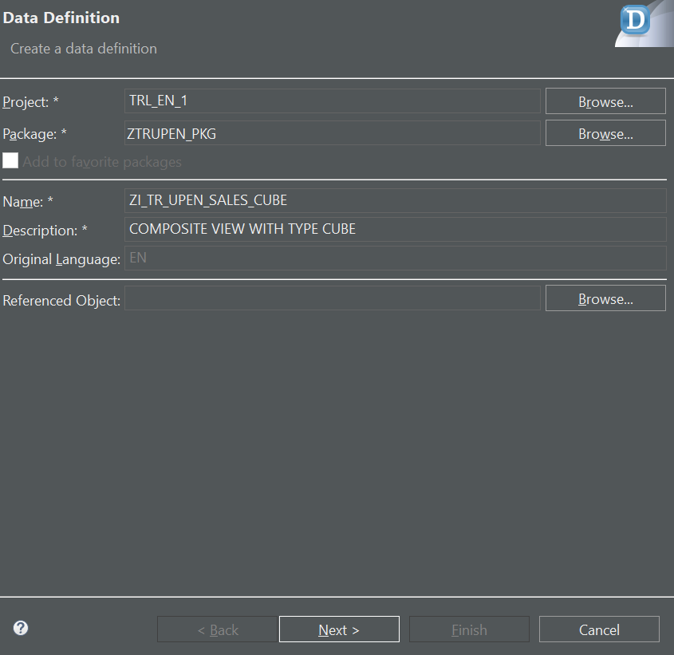

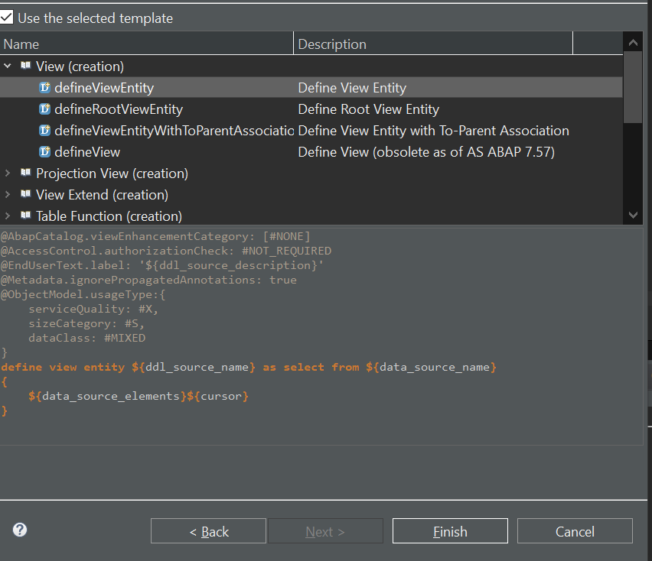
The cube type is used to perform totals on master data against the transactional data.

Code :
@AbapCatalog.viewEnhancementCategory: [#NONE]
@AccessControl.authorizationCheck: #NOT_REQUIRED
@EndUserText.label: 'COMPOSITE VIEW WITH TYPE CUBE'
@Metadata.ignorePropagatedAnnotations: true
@ObjectModel.usageType:{
serviceQuality: #X,
sizeCategory: #S,
dataClass: #MIXED
}
@Analytics.dataCategory: #CUBE
-- REMOVED: @VDM.viewType: #COMPOSITE (Not permitted)
define view entity ZI_TR_UPEN_SALES_CUBE
as select from ZI_TR_UPEN_SALES
association [1..1] to ZI_TR_UPEN_BPA as _BusinessPartner on $projection.Buyer = _BusinessPartner.BpId
association [1..1] to ZI_TR_UPEN_PRODUCT as _Product on $projection.Product = _Product.ProductId
{
key OrderId,
key _Items.item_id as ItemId,

OrderNo,
Buyer,
CreatedBy,
CreatedOn,

_Items.product as Product,

@DefaultAggregation: #SUM
@Semantics.amount.currencyCode: 'CurrencyCode'
_Items.amount as GrossAmount,

_Items.currency as CurrencyCode,

@DefaultAggregation: #SUM
@Semantics.quantity.unitOfMeasure: 'UnitOfMeasure'
_Items.qty as Quantity,

_Items.uom as UnitOfMeasure,

/* Associations */
_Product,
_BusinessPartner
}

Creating a Consumption view :
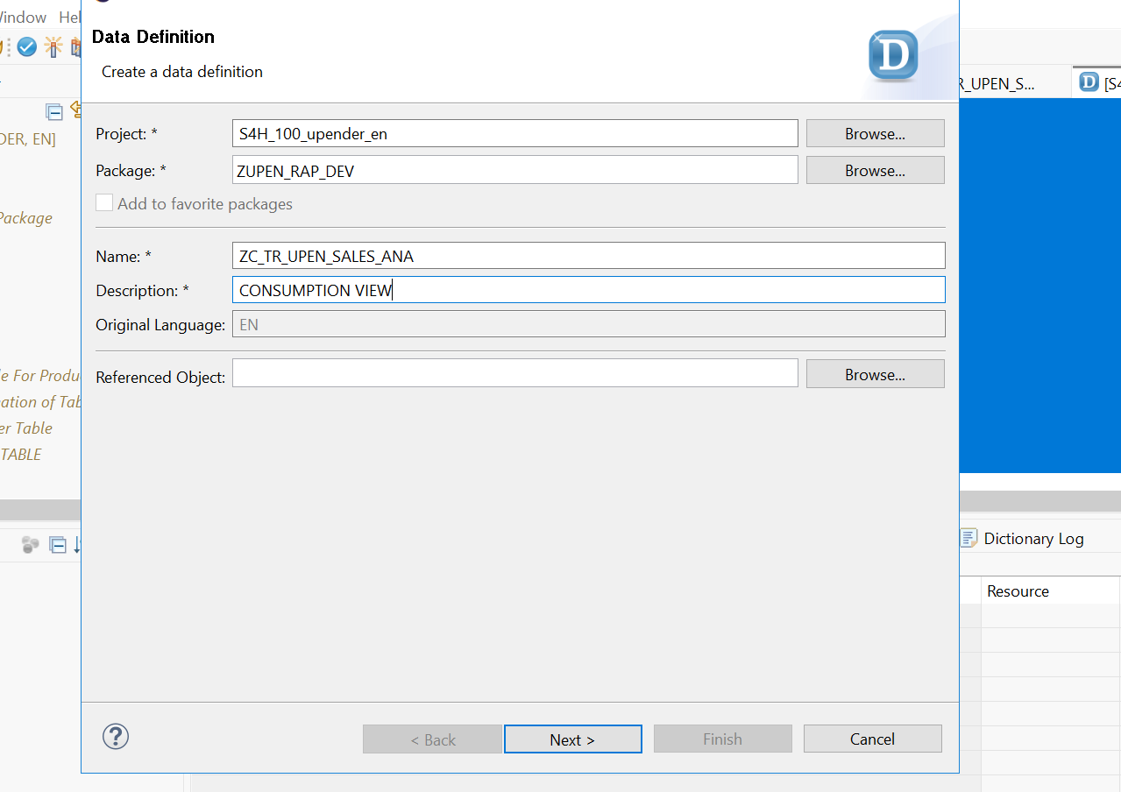
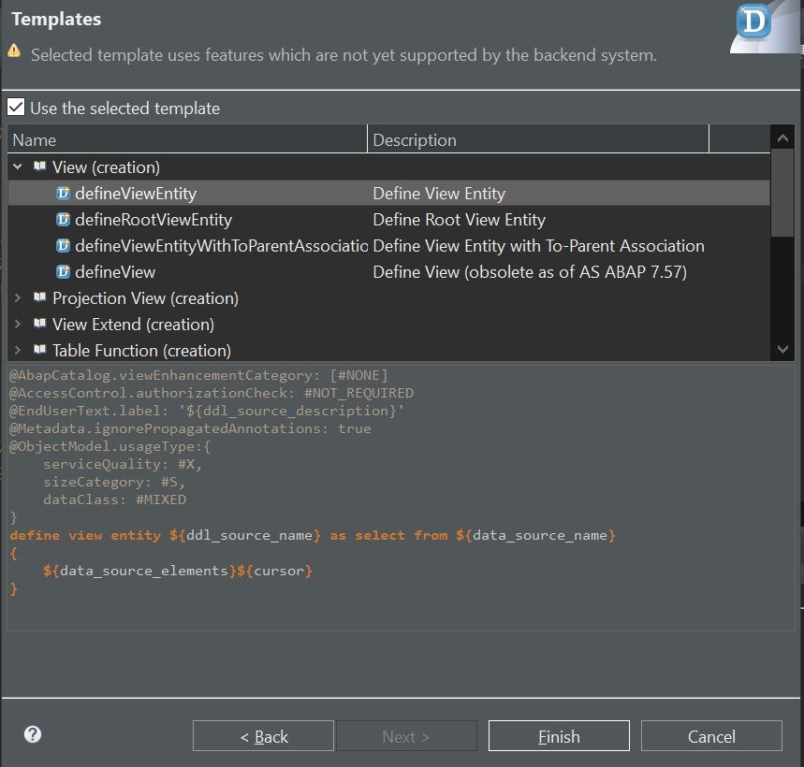

Code :
@AbapCatalog.viewEnhancementCategory: [#NONE]
@AccessControl.authorizationCheck: #NOT_REQUIRED
@EndUserText.label: 'CONSUMPTION VIEW'
@Metadata.ignorePropagatedAnnotations: true
@ObjectModel.usageType:{
serviceQuality: #X,
sizeCategory: #S,
dataClass: #MIXED
}
define view entity ZC_TR_UPEN_SALES_ANA
as select from ZI_TR_UPEN_SALES_CUBE
{
key _BusinessPartner.CompanyName,
key _BusinessPartner.Country,

@Semantics.amount.currencyCode: 'CurrencyCode'
GrossAmount,

CurrencyCode,

@Semantics.quantity.unitOfMeasure: 'UnitOfMeasure'
Quantity,

UnitOfMeasure
}
Service Definition and Service Binding :
Right click on the Consumption View that we have just created.
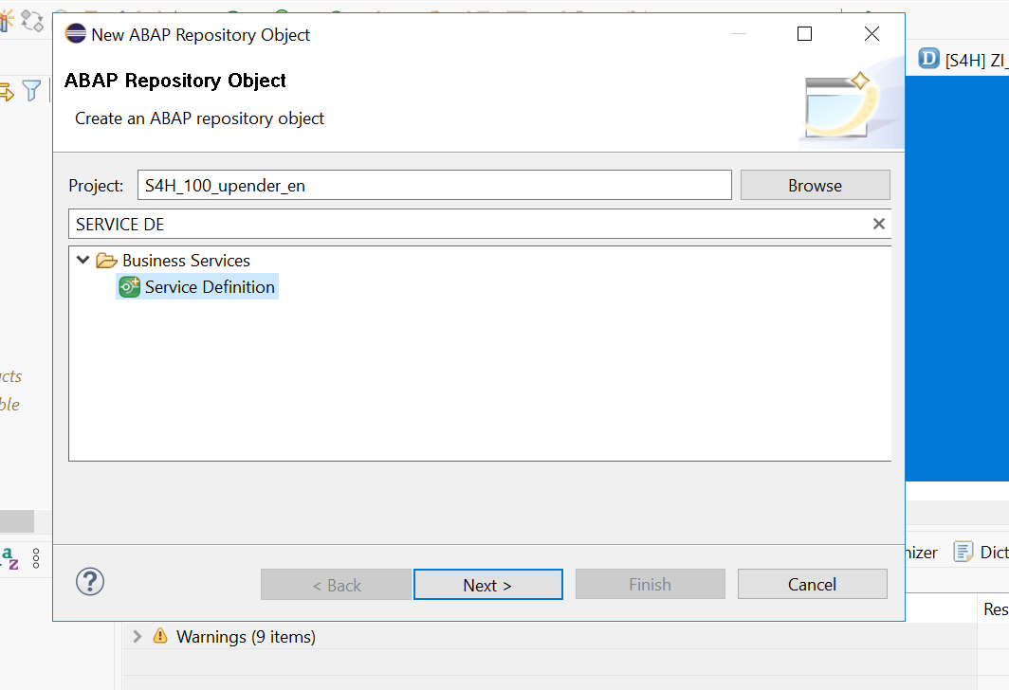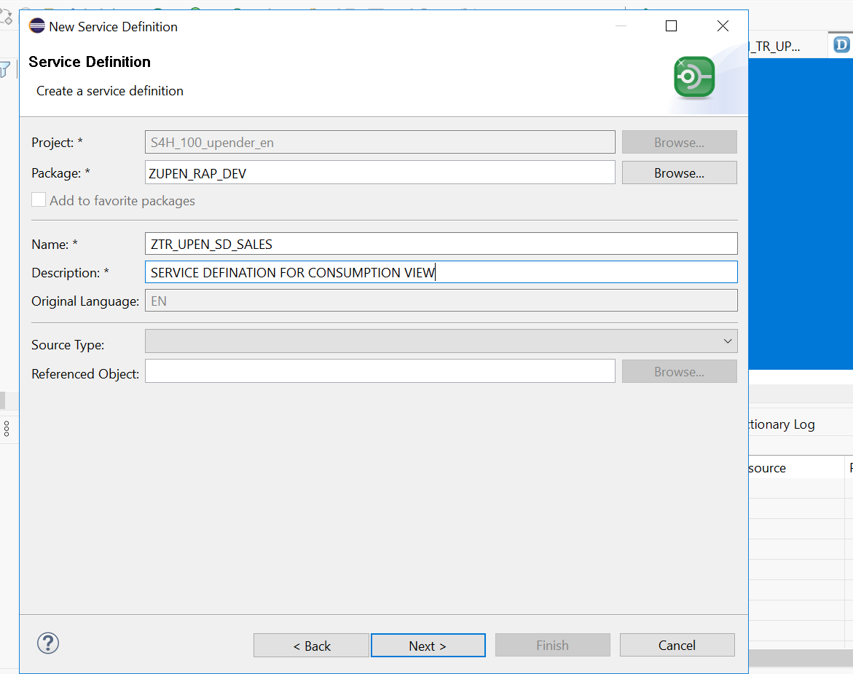
Select the service-defination
Code:
@EndUserText.label: 'SERVICE DEFINATION SALES'
define service ZTR_UPEN_SD_SALES
{
expose ZC_TR_UPEN_SALES_ANA;

}
Create the service binding to expose the our application to the web browser as an API
Right Click on the service definition which we have just created i.e ZTR_UPEN_SD_SALES & select the
Service binding.
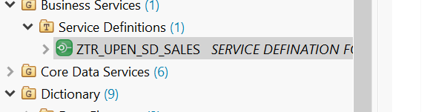

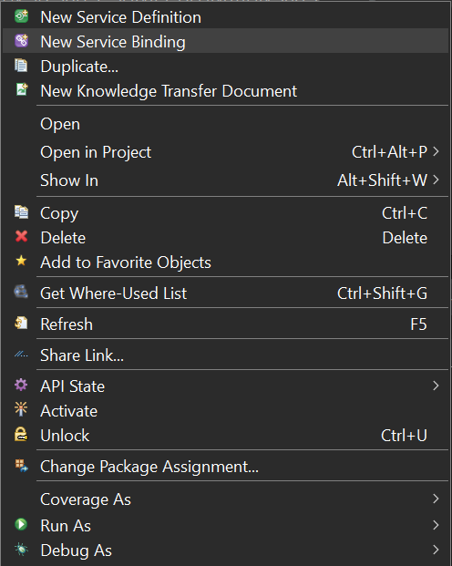

SELECT BINDING TYPE Odata-v2 from the drop down.
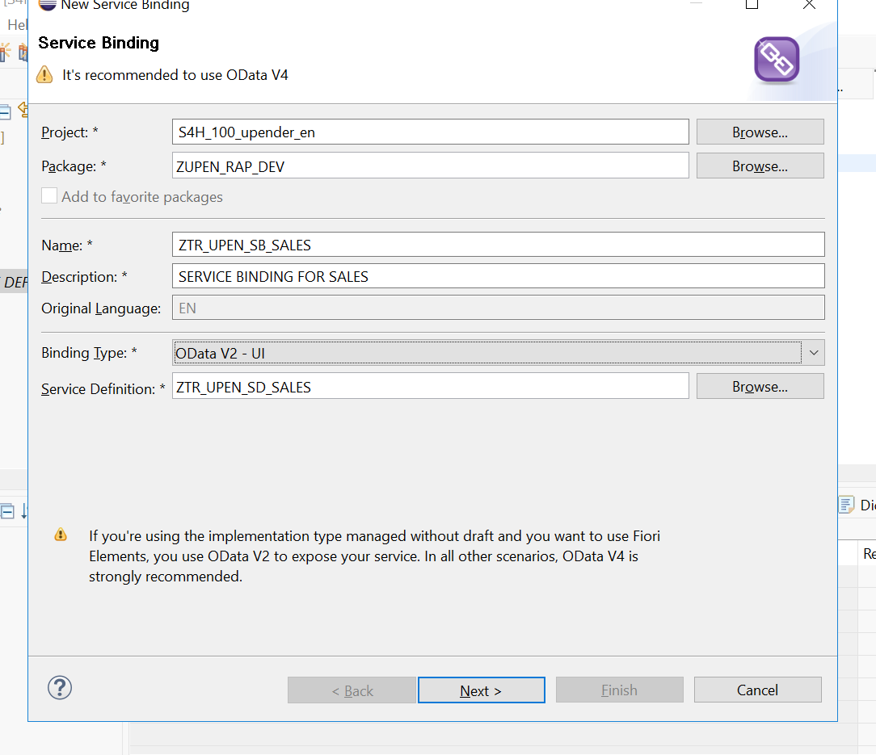
Open the Service binding tab and click on the ‘Publish’ icon
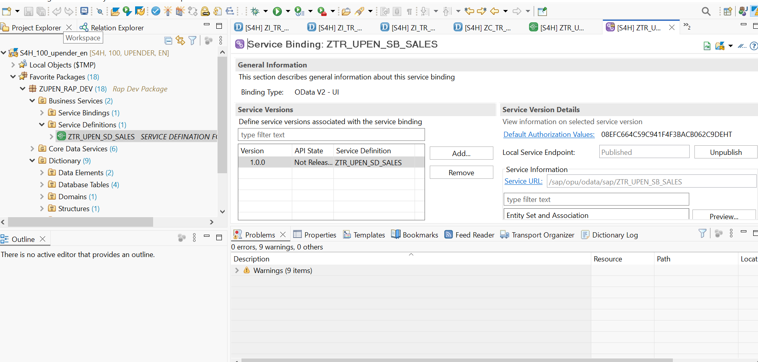
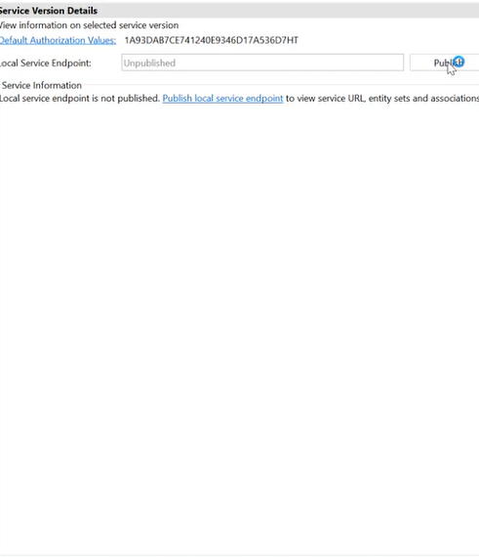
Go to the consumption view and press f8 and the api opens in the web browser.
