AMDP(ABAP Manged Data Procedures):
- Sometimes, the CDS performance is not suitable for our use case and we need more complex technique to process our data deep into database to get best performance using code-to-data paradigm
- We want to use database specific features
- CDS views have limitations
- CDS views cannot be debugged
- Overcome the disadvantages of CDS where we need to branch output of one Queries to another
- We cannot write imperative logic using CDS – IF, ELSE, LOOP, WHITE, EXCEPTION etc.
- CDS also does a strict type check while writing joins and associations
An AMDP is:
- A static function in ABAP class marked with marker interface IF_AMDP_MARKER_HDB
- The function can only have Import and Export parameters and all parameters must be passed by value
- We cannot use complex data types (deep)
- Any DB table which we plan to use with AMDP should be added to using clause
- When we run the AMDP, A procedure gets created inside the DB
- All the code will be written in SQL scripting programming language which will be pushed into the database
- Since we directly execute AMDP in DB, there is no automatic client handling.

SQL-Scripting:
SQL Script is a programming language used inside databases, which is an advance version of plain SQL. It is the last option to improve performance of our applications and achieve code to data paradigm by code-push-down.
Why SQL Script
In the past we used to Fetch the data in ABAP, Loop over the data, Process the data and then write data back to database. We want to fully leverage the computational powers of SAP HANA, hence using SQL script we can achieve it. All our data intensive logic which we write using ABAP can now be pushed down to HANA DB using SQL Script.
https://help.sap.com/docs/SAP_HANA_PLATFORM?locale=en-US&task=use_task
- SQL Script is not case-sensitive and every line ends with semi-colon (;)
- We can use the code constructs like IF, ELSE, LOOP, FOR, WHILE, RAISE
- When we create variables, they are assigned with null value
- The = is comparison operator and := is the assignment operator. We can assign the value to variable using the var = val but when we use the variable in the code, we use value of (:) operator to use a variable.
- When we assign the a query to a variable, the variable will allocate memory automatically

BUILDING THE BASIC AMDP MODEL:
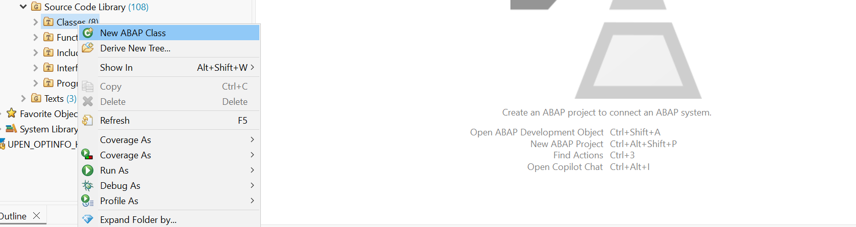
Create a new ABAP Class ‘ZCL_TR_UPEN_AMDP’.
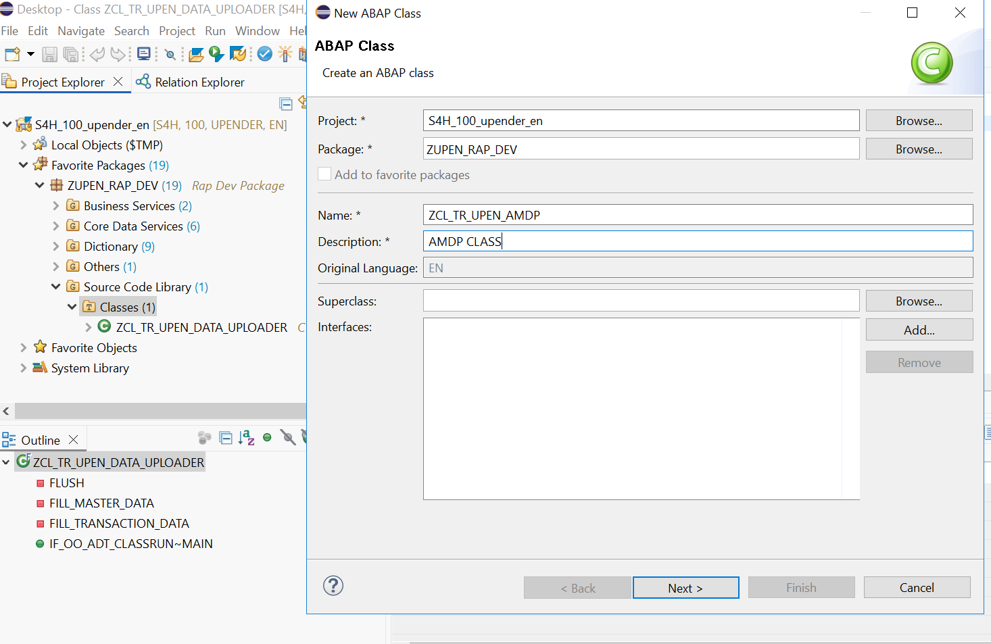
Add the IF_AMDP_MARKER_HDB interface which acts as a runtime method to run all the amdp methods and procedures.
Use the quick feature to add the implementation methods automatically in the code -logic.

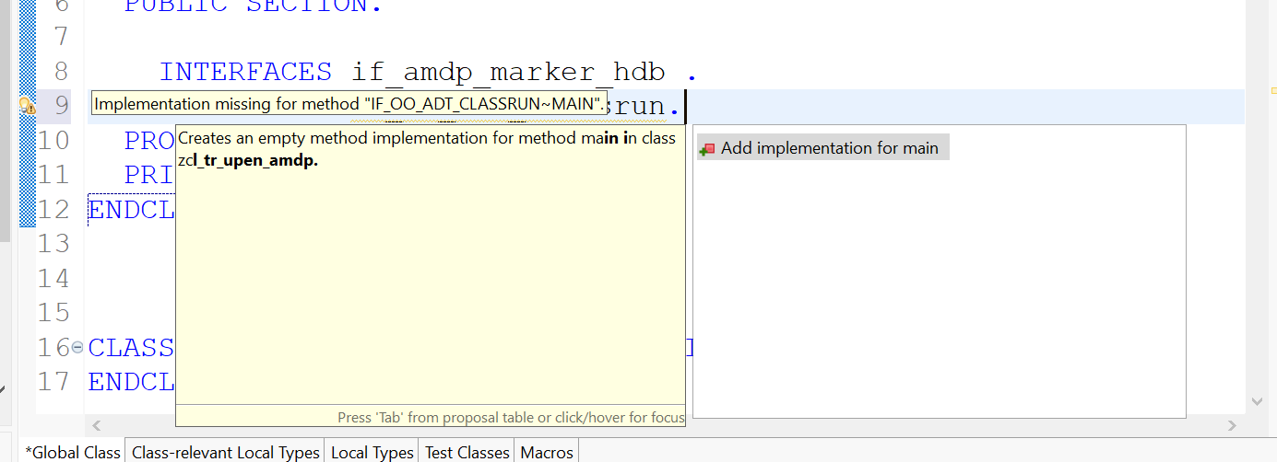

Code :
CLASS zcl_tr_upen_amdp DEFINITION
PUBLIC
FINAL
CREATE PUBLIC.

PUBLIC SECTION.
INTERFACES if_amdp_marker_hdb.
INTERFACES if_oo_adt_classrun.

" Added parameters and changed to CLASS-METHODS for the static call in main
CLASS-METHODS add_numbers
IMPORTING VALUE(x) TYPE i
VALUE(y) TYPE i
EXPORTING VALUE(res) TYPE i.

PROTECTED SECTION.
PRIVATE SECTION.
ENDCLASS.

CLASS zcl_tr_upen_amdp IMPLEMENTATION.

METHOD add_numbers BY DATABASE PROCEDURE
FOR HDB
LANGUAGE SQLSCRIPT
OPTIONS READ-ONLY.
-- SQL Script code
declare a INTEGER;
DECLARE b INTEGER;

--- assign the value to my variable from input params
a := :x;
b := :y;

--- get the total
res := :a + :b;
ENDMETHOD.

METHOD if_oo_adt_classrun~main.
" Variable to hold the result
DATA(lv_res) = 0.

zcl_tr_upen_amdp=>add_numbers(
EXPORTING
x = 30
y = 50
IMPORTING
res = lv_res
).

out->write( |The result of the AMDP addition is: { lv_res }| ).
ENDMETHOD.

ENDCLASS.

Activate the code with ctrl+f3 and to run the main function of the AMDP hit the F9 Which gives the result in the console.
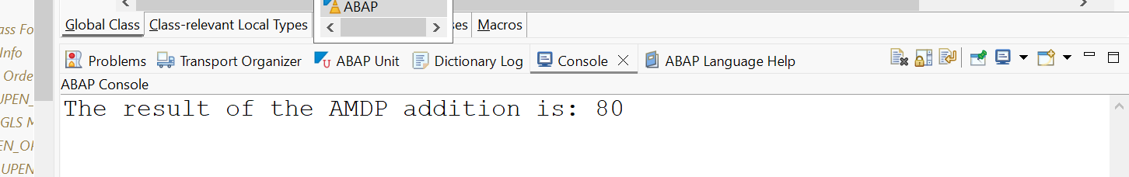

This is an simple AMDP Program for adding of 2 numbers and this calculation occurs in the hana-database itself.

CDS Table Functions:
Bridge the gap between CDS and AMDP, A CDS table function
- Defines the skeleton of the data which we want from DB
- When it executes, it actually calls SQL Script code
- It creates a FUNCTION database unlike AMDP creates a PROCEDURE in database
- The CDS table function, can later be used to build view on view or can be used in OTHER CDS views also as JOIN/Agg
Plain CDS functions:
https://help.sap.com/doc/abapdocu_752_index_htm/7.52/en-US/abencds_f1_builtin_functions.htm

IMPLEMENTING TABLE FUNCTIONS:
Create a Data definition
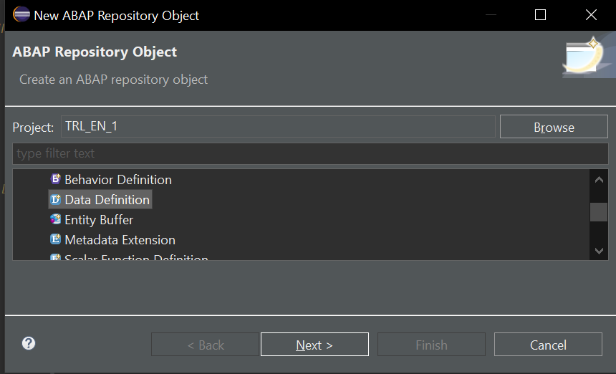
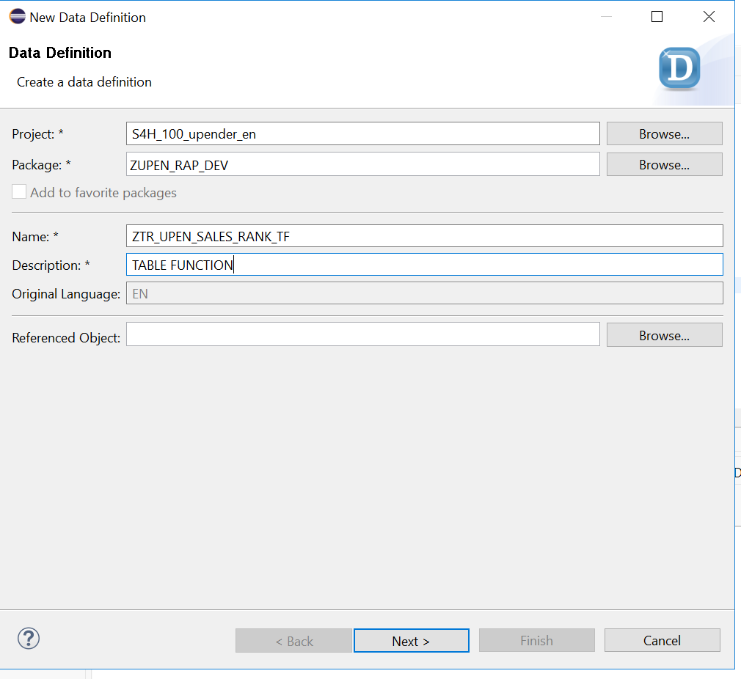
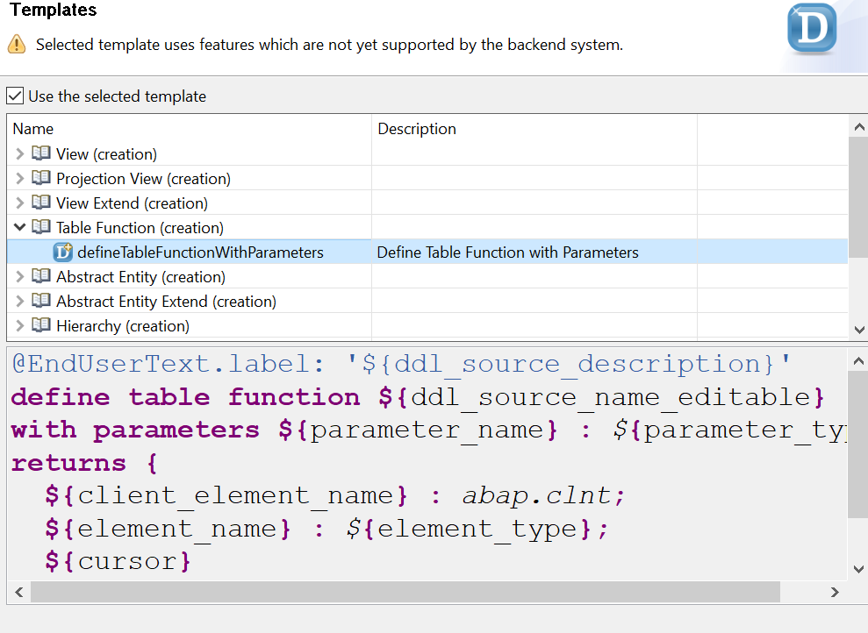
Code :
@EndUserText.label: 'TABLE FUNCTION FOR BANKING SALES'
define table function ZTR_UPEN_SALES_RANK_TF
with parameters
@Environment.systemField: #CLIENT
p_clnt: abap.clnt
returns {
client : abap.clnt;
company_name: abap.char(256);
total_sales: abap.curr(15,2);
currency_code: abap.cuky(5);
customer_rank: abap.int4;

}
implemented by method ZCL_TR_UPEN_AMDP=>get_customer_sales;

Go-to table zupen_rap_table and change the field from string to character.
@EndUserText.label : 'Company Name'
company_name : abap.char(256);
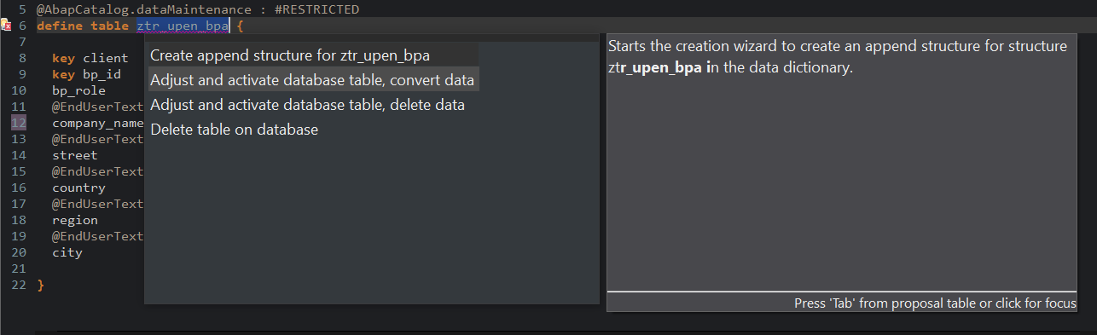
Auto-Correct the code and select Adjust and activate database table, convert data.
Go-to class ZCL_TR_UPEN_AMDP and add the method “get_customer_sales” into this.
Code:
CLASS zcl_tr_upen_amdp DEFINITION
PUBLIC
FINAL
CREATE PUBLIC.

PUBLIC SECTION.
INTERFACES if_amdp_marker_hdb.
INTERFACES if_oo_adt_classrun.

CLASS-METHODS add_numbers
IMPORTING VALUE(x) TYPE i
VALUE(y) TYPE i
EXPORTING VALUE(res) TYPE i.

CLASS-METHODS get_customer_sales
FOR TABLE FUNCTION ZTR_UPEN_SALES_RANK_TF.

PROTECTED SECTION.
PRIVATE SECTION.
ENDCLASS.

CLASS zcl_tr_upen_amdp IMPLEMENTATION.

METHOD add_numbers BY DATABASE PROCEDURE
FOR HDB
LANGUAGE SQLSCRIPT
OPTIONS READ-ONLY.
DECLARE a INTEGER;
DECLARE b INTEGER;
a := :x;
b := :y;
res := :a + :b;
ENDMETHOD.

METHOD get_customer_sales BY DATABASE FUNCTION
FOR HDB
LANGUAGE SQLSCRIPT
OPTIONS READ-ONLY
" UPDATED: Using the actual table name from your definition
USING zupen_rap_table zUPEN_so_hdr zUPEN_so_items.

RETURN SELECT
bpa.client,
CAST( bpa.company_name AS NVARCHAR( 256 ) ) AS company_name,
CAST( SUM( itm.amount ) AS DECIMAL( 15, 2 ) ) AS total_sales,
CAST( itm.currency AS NVARCHAR( 5 ) ) AS currency_code,
RANK() OVER ( ORDER BY SUM( itm.amount ) DESC ) AS customer_rank
FROM zupen_rap_table AS bpa -- UPDATED: Use zupen_rap_table here
INNER JOIN zUPEN_so_hdr AS hdr ON bpa.bp_id = hdr.buyer
INNER JOIN zUPEN_so_items AS itm ON hdr.order_id = itm.order_id
WHERE bpa.client = :p_clnt
GROUP BY bpa.client, bpa.company_name, itm.currency;
ENDMETHOD.

METHOD if_oo_adt_classrun~main.
" 1. Test Addition
zcl_tr_upen_amdp=>add_numbers(
EXPORTING x = 30 y = 50
IMPORTING res = DATA(lv_res)
).
out->write( |Addition Result: { lv_res }| ).

" 2. Test Table Function
" Note: We don't pass p_clnt because the CDS annotation handles it
SELECT * FROM ZTR_UPEN_SALES_RANK_TF INTO TABLE @DATA(lt_sales).

out->write( 'Customer Sales Ranking:' ).
IF lt_sales IS NOT INITIAL.
out->write( lt_sales ).
ELSE.
out->write( 'No data found. Check if zupen_rap_table has entries.' ).
ENDIF.
ENDMETHOD.

ENDCLASS.

Go-to “ZTR_UPEN_SALES_RANK_TF” table function and ctrl+f9 to preview the data as shown below which gives the data group by sales company & sales.
