CORE DATA SERVICES(CDS):
CDS is the new approach of building semantically rich data models. It is an extension of SQL in ABAP world.
What has been extended?
DDL – Data definition language – design new data models – new tables, structures
DQL – Data Query Language (CDS Views and CDS Entities) – new views to extract data (agg., join, load, calculate,formulas)
DEL – Data Expression language (expressions like path expression, case expressions)
DCL – Data Control Language (security)
Since in ABAP on Cloud Environment we do not have GUI access (no access to SE11) – we will use CDS
Naming convention – is a best practice to follow in a project. ZCOMPANY_PROJ_OBJTTP_NAME
ZATS_XX_*
We will use an uploader utility provided by SAP, get this in our ABAP on Cloud System to test it
1)Install the abap git plugin so we can interact with github from our adt tool - http://eclipse.abapgit.org/updatesite/
2)Download the code from SAP standard repository - https://github.com/SAP-samples/abap-file-uploader
3)Register a service
4)Run the utility

CDS Views (DQL) :
Using the views we can build the Data models which can optimum expose the data out of sap system. The execution of CDS view happens inside the database because when we activate a CDS view, system creates a HANA view. All the logic hence gets executed inside the database. This process is known as code-to-data paradigm.
CDS views are obsolete now, a successor concept was introduced in 2019 called CDS entities.
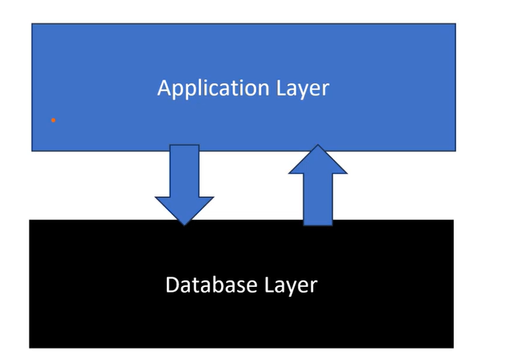

CDS Views: Technical Overview & Core Features
Core Data Services (CDS) provide a next-generation data modeling infrastructure that leverages the "code pushdown" paradigm, executing data-intensive logic directly in the SAP HANA database rather than the application server.
- Key Features: CDS views support semantic richness through annotations, reusable data models, and complex calculations at the database level.
- Define View vs. Define Root View:
  - DEFINE VIEW creates a standard view to project, join, or aggregate data.
  - DEFINE ROOT VIEW designates the top node of a business object hierarchy within the ABAP RESTful Application Programming Model (RAP). This is critical when you intend to expose the data entity for transactional processing or as a primary OData service.
- Projections & Other Types: Projection views allow you to create service-specific subsets of an underlying CDS model without duplicating business logic. Other types include Abstract Entities (used for defining parameter structures without a database table) and Custom Entities (where logic is implemented in ABAP classes).
Enhancing the Model: Associations, Annotations, & Security
To make CDS views powerful and secure, you utilize several advanced components.
- Built-in & Filter Expressions: You can apply string manipulations (like CONCAT), math operations, COALESCE, and CASE statements directly within the view. Filter expressions allow you to constrain data based on specific conditions (e.g., WHERE auart = 'OR').
- Associations: Unlike standard SQL joins, associations define relationships on-demand. The database only performs the join and fetches the associated data if the consumer explicitly requests it.
- Annotations & Extensions: Annotations (starting with @) enrich the view with metadata, instructing the system on how to handle UI rendering, analytics, or OData exposure. Extensions (EXTEND VIEW) allow you to add custom fields to standard SAP views without modifying the core code.
- Authorizations with DCL: Data Control Language (DCL) allows you to define role-based, row-level security. A DCL document ensures that a user querying the view only sees the records they are authorized to access.

CREATION OF THE PKG:
Right click on your project and select new other abap repo. Object and give core data services
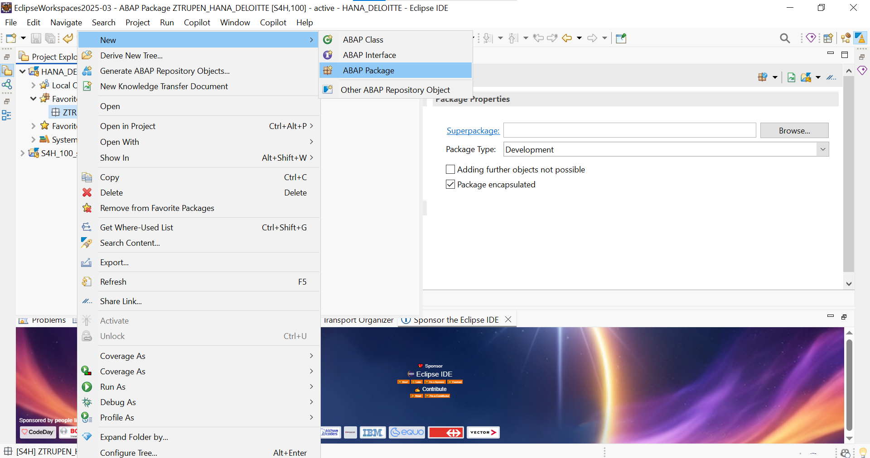
In the CDS(Core data services ) select the Data definition
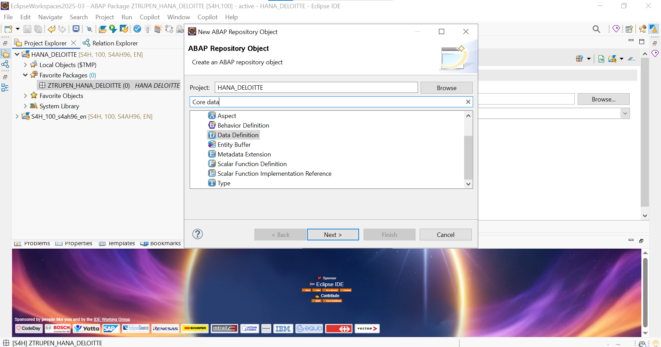

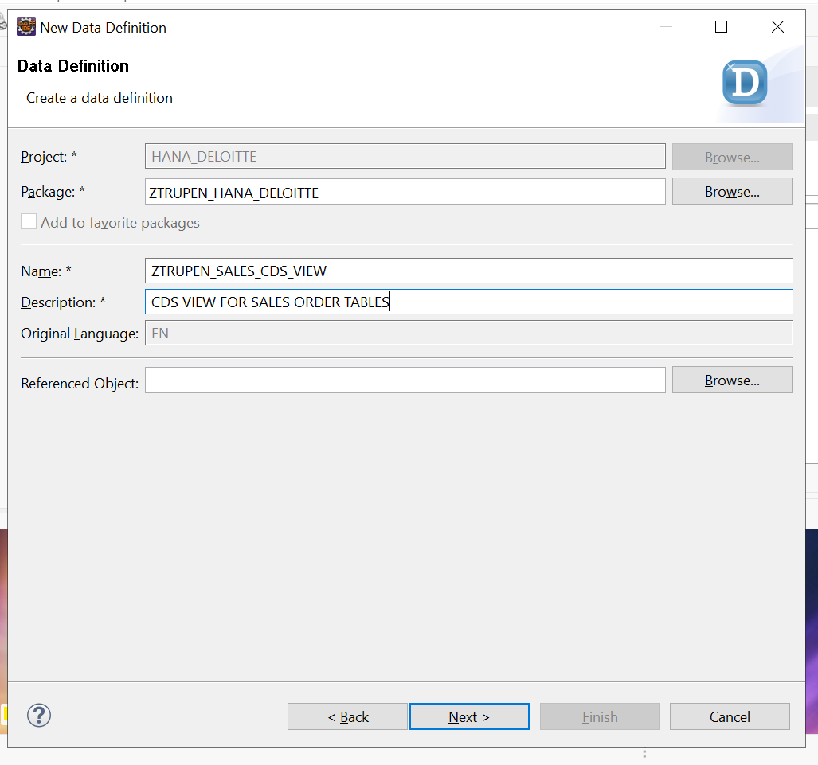

Select the respective TR and click on ‘next’.

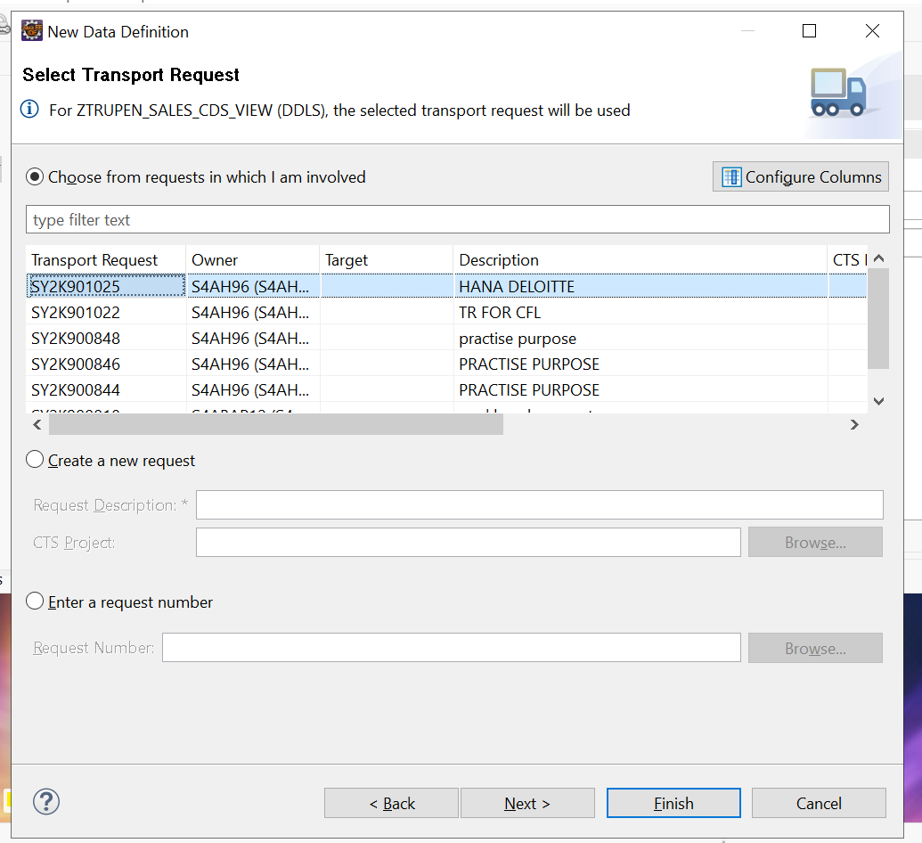

Select the define view entiy template.

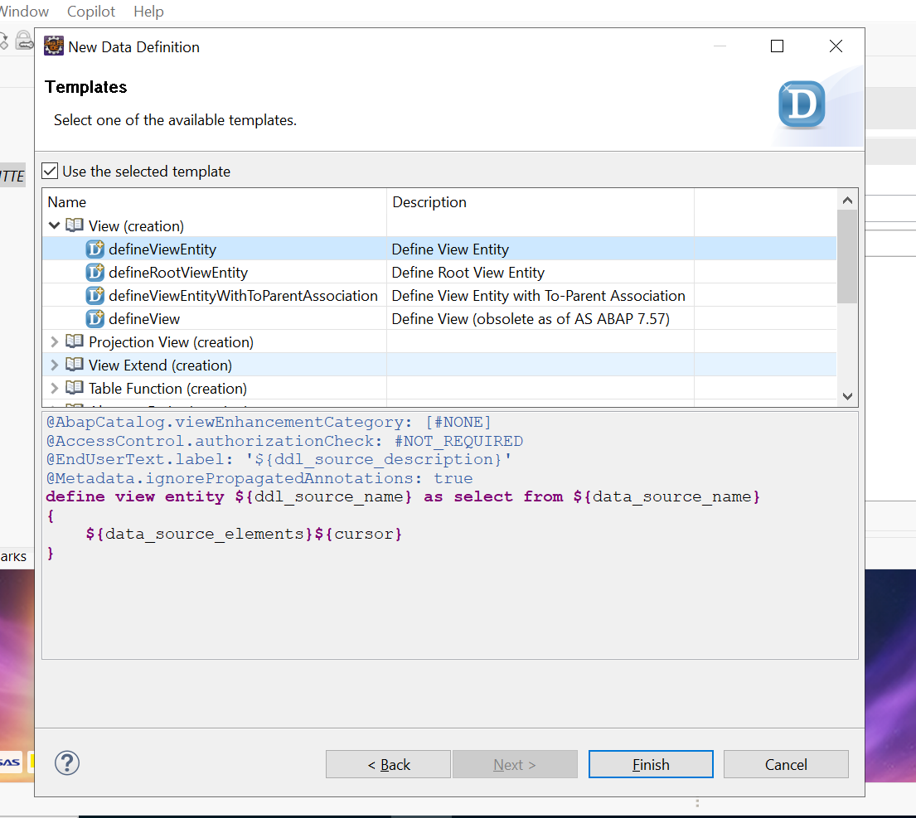

Code :
@AbapCatalog.viewEnhancementCategory: [#NONE]
@AccessControl.authorizationCheck: #NOT_REQUIRED
@EndUserText.label: 'CDS VIEW FOR SALES ORDER TABLES'
@Metadata.ignorePropagatedAnnotations: true
define view entity ZTRUPEN_SALES_CDS_VIEW
as select from I_SalesDocument as Header
association [1..*] to I_SalesDocument as _Items on $projection.SalesOrder = _Items.SalesDocument
{
key Header.SalesDocument as SalesOrder,
Header.CreationDate as CreationDate,

/* 1. String Expression */
concat_with_space('Order No:', Header.SalesDocument, 1) as OrderDescription,

/* 2. Conditional Expression (CASE) */
case
when Header.TotalNetAmount > 100000 then 'High Value'
when Header.TotalNetAmount between 10000 and 100000 then 'Medium Value'
else 'Low Value'
end as ValueCategory,

@Semantics.amount.currencyCode: 'Currency'
Header.TotalNetAmount as NetValue,
Header.TransactionCurrency as Currency,

/* 3. Arithmetic Expression (FIXED): Casting both to decimal to avoid FLTP error */
@Semantics.amount.currencyCode: 'Currency'
cast(Header.TotalNetAmount as abap.dec(15,2)) * cast(0.10 as abap.dec(3,2)) as EstimatedTax,

/* 4. Date Expression */
dats_days_between(Header.CreationDate, $session.system_date) as DaysSinceCreation,

/* 5. Cast Expression */
cast(Header.CreationDate as abap.char(8)) as CreationDateString,

/* Exposing the association for on-demand item data */
_Items
}
Key Expressions Added:
- concat_with_space: Joins strings together with a specified number of spaces (useful for generating descriptive labels).
- case ... end: Allows you to build IF/THEN/ELSE logic directly at the database level to classify data.
- Arithmetic (* 0.10): Performs mathematical calculations directly in the projection list. Ensure you map the currency code to the new calculated field.
- dats_days_between: A built-in date function comparing the order's creation date to the current system date ($session.system_date).
- cast(...): Converts one data type to another on the fly (e.g., date to char).

NOTE: The I_SALESORDER,I_SALESORDERITEM are standard cds view which is build by SAP on top of the vbap,vbrp tables respectively this is the correct approach to follow as SAP suggests to follow clean core starategy.

ASSOCIATION & COMPOSITION:
The difference between association and composition comes down to ownership and lifecycle dependency. While both define a relationship between two entities, they dictate what happens to the child entity when the parent entity is deleted.
Here is the breakdown of how they differ:
1. Association (Independent Lifecycle)
An association is a "knows-a" or "has-a" relationship. The entities are related, but they exist independently of one another.
- Lifecycle: If you delete the parent entity, the child entity remains intact in the database.
- Example: A Customer and an Order. If you delete a specific Order, the Customer still exists.
2. Composition (Dependent Lifecycle)
A composition is a strict "part-of" relationship. The child entity is entirely dependent on the parent entity.
- Lifecycle: If you delete the parent entity, all associated child entities are automatically deleted (cascade delete). The child cannot logically exist without the parent.
- Example: A SalesOrderHeader and SalesOrderItem. If you delete the Sales Order Header, keeping the individual Items makes no sense, so they are deleted together.

DEMO Example:
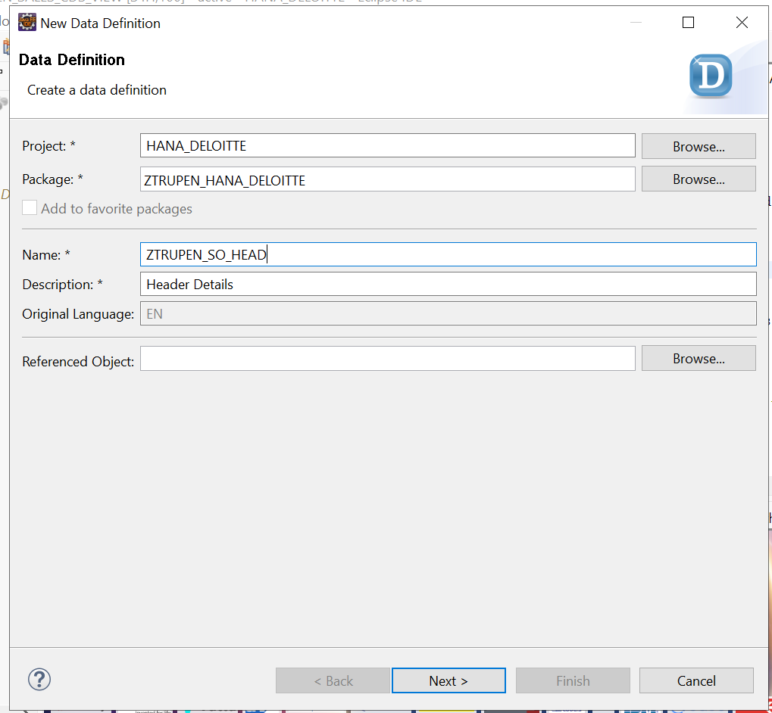
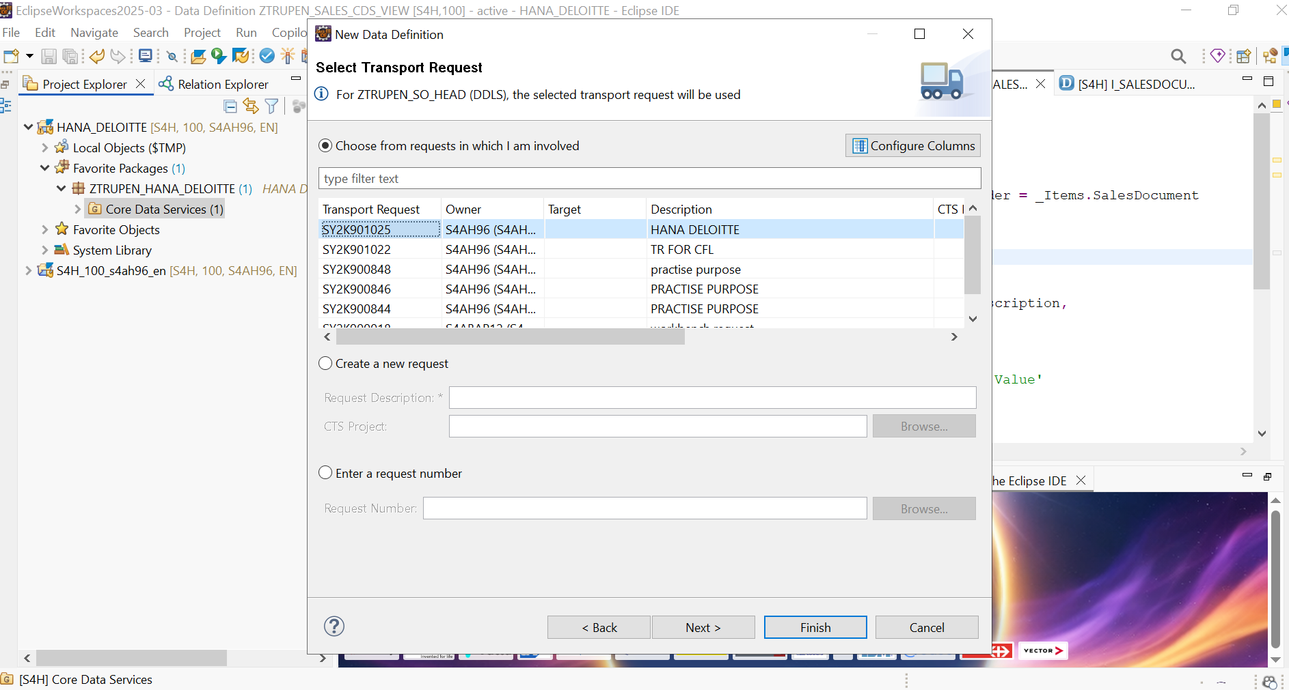

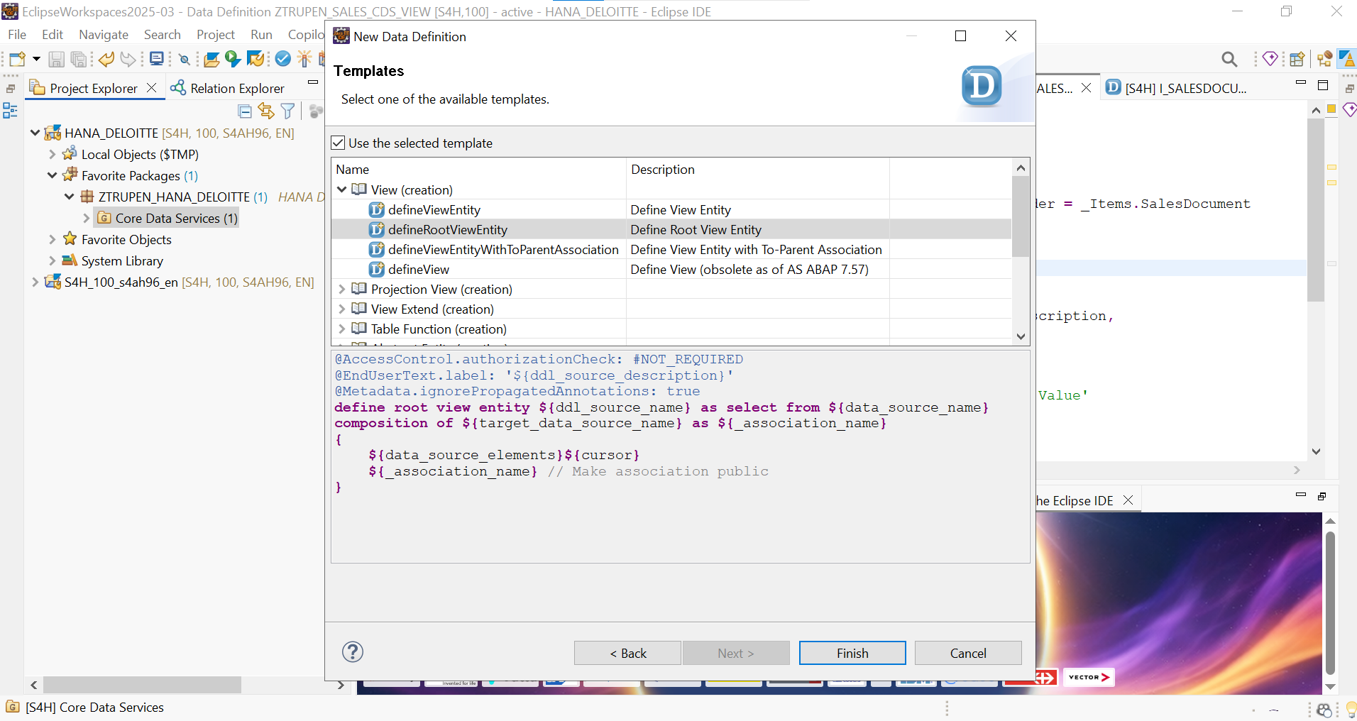

1. The Root View (Parent - Selecting from I_SalesDocument)
Here, we wrap I_SalesDocument. We use Composition to link to our custom item view, and an Association to link to standard SAP master data (I_Customer).
Code :
@AccessControl.authorizationCheck: #NOT_REQUIRED
@EndUserText.label: 'Header Details'
@Metadata.ignorePropagatedAnnotations: true
define root view entity ZTRUPEN_SO_HEAD
as select from I_SalesDocument as Header
/* 2. ASSOCIATION: Loose coupling to a standard SAP Master Data view */
association [0..1] to I_Customer as _Customer
on $projection.SoldToParty = _Customer.Customer
{
key Header.SalesDocument as SalesOrder,
Header.CreationDate as CreationDate,
Header.SoldToParty as SoldToParty,

@Semantics.amount.currencyCode: 'Currency'
Header.TotalNetAmount as NetValue,
Header.TransactionCurrency as Currency,

/* Expose the composition and association */

_Customer
}.

2. The Child View (Item - Selecting from I_SalesDocumentItem)
Here, we wrap I_SalesDocumentItem. This view must define the association to parent back to ZTRUPEN_SO_HEAD to complete the composition tree. We also add an association to I_Product.
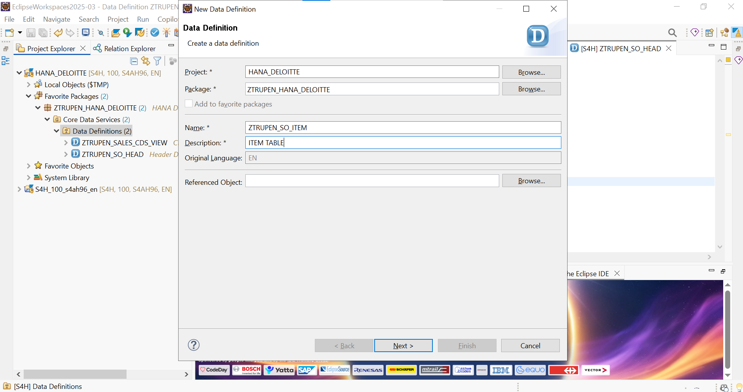

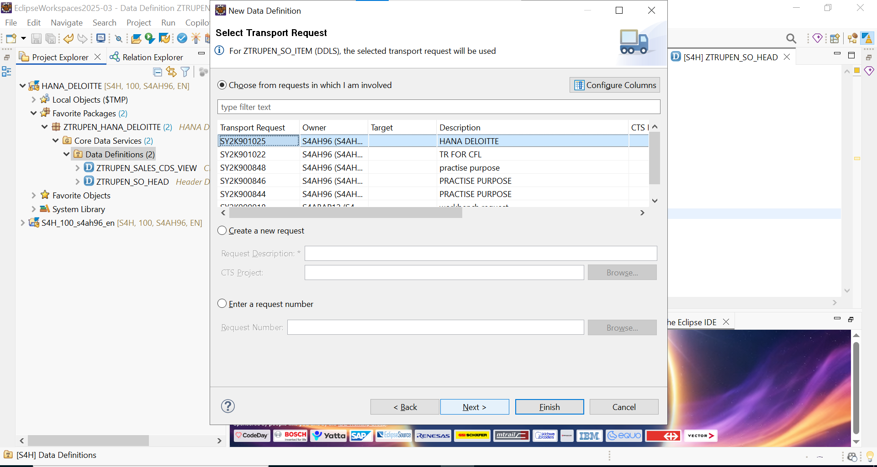

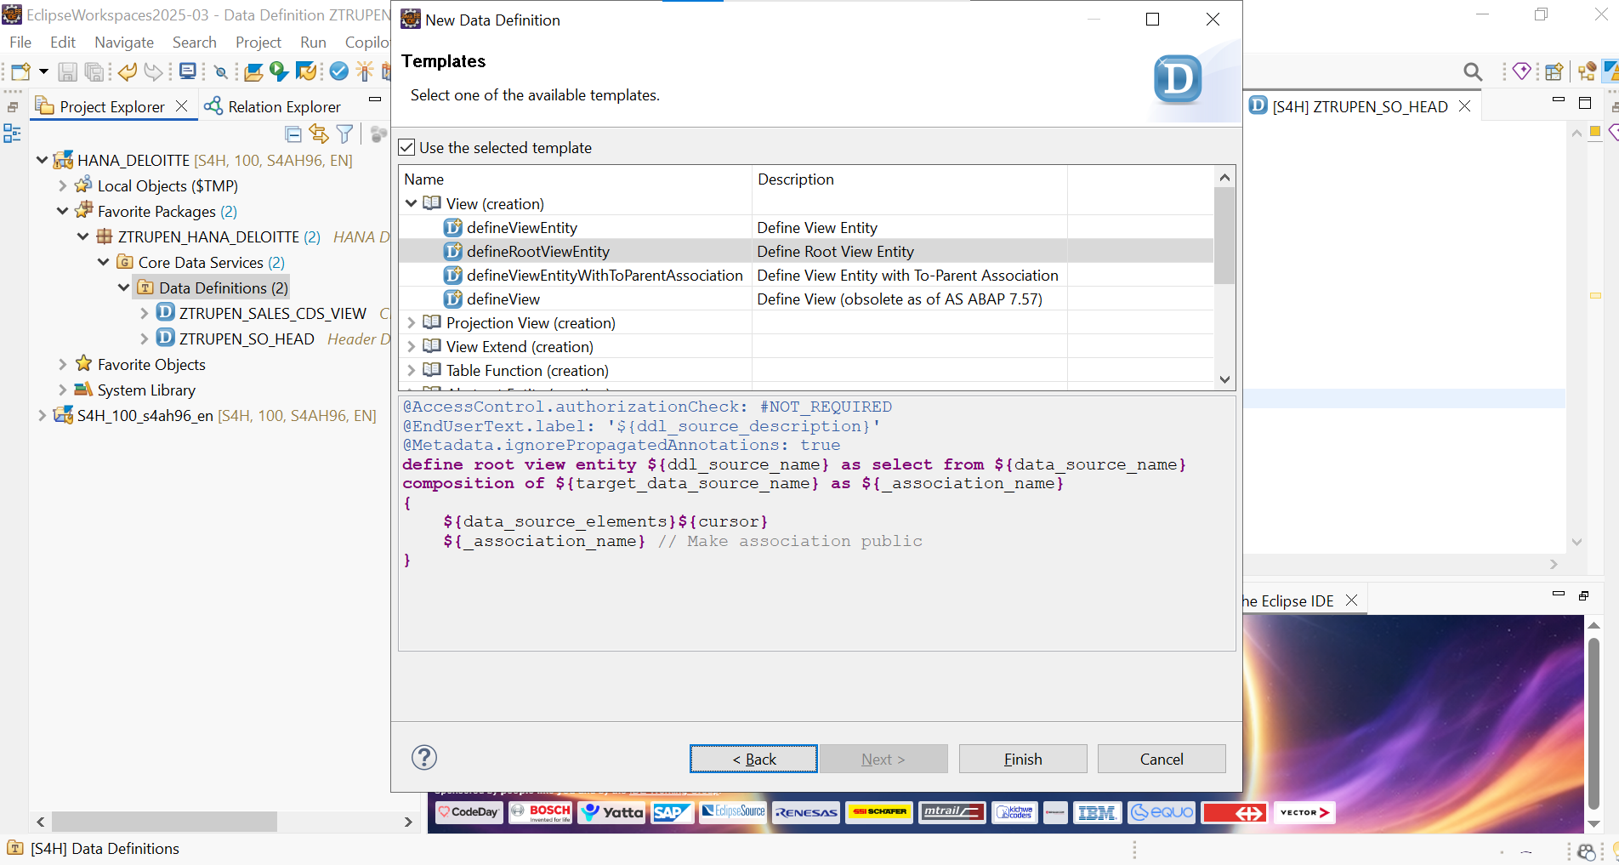

CODE:
@AccessControl.authorizationCheck: #NOT_REQUIRED
@EndUserText.label: 'ITEM TABLE'
@Metadata.ignorePropagatedAnnotations: true
define view entity ZTRUPEN_SO_ITEM as select from I_SalesDocumentItem as Item

/* 1. ASSOCIATION TO PARENT: Completes the Composition tree */
association to parent ZTRUPEN_SO_HEAD as _SalesOrder
on $projection.SalesOrder = _SalesOrder.SalesOrder

/* 2. Standard ASSOCIATION: Loose coupling to standard Material/Product master data */
association [0..1] to I_Product as _Product
on $projection.Material = _Product.Product
{
key Item.SalesDocument as SalesOrder,
key Item.SalesDocumentItem as ItemPosition,

Item.Material as Material,

@Semantics.quantity.unitOfMeasure: 'OrderUnit'
Item.OrderQuantity as OrderQuantity,
Item.OrderQuantityUnit as OrderUnit,

/* Expose the parent association and master data association */
_SalesOrder,
_Product
}

UPDATE THE PARENT CODE AS BELOW WITH PARENT & CHILD RELATIONSHIP:
@AccessControl.authorizationCheck: #NOT_REQUIRED
@EndUserText.label: 'Header Details'
@Metadata.ignorePropagatedAnnotations: true
define root view entity ZTRUPEN_SO_HEAD
as select from I_SalesDocument as Header

/* 1. COMPOSITION: Pointing to our custom wrapper for the Items */
composition [0..*] of ZTRUPEN_SO_ITEM as _Items

/* 2. ASSOCIATION: Loose coupling to a standard SAP Master Data view */
association [0..1] to I_Customer as _Customer
on $projection.SoldToParty = _Customer.Customer
{
key Header.SalesDocument as SalesOrder,
Header.CreationDate as CreationDate,
Header.SoldToParty as SoldToParty,

@Semantics.amount.currencyCode: 'Currency'
Header.TotalNetAmount as NetValue,
Header.TransactionCurrency as Currency,

/* Expose the composition and association */
_Items,
_Customer
}

Projections in CDS Views:
In the modern ABAP RESTful Application Programming Model (RAP), you never expose your base "Root View Entity" directly to a UI or an API. Instead, you create a Projection View (also known as a Consumption View) on top of it.
Think of the base view as your "pure data model" and the projection view as the "service-specific lens." You might create one projection for a Fiori UI (adding UI annotations) and a completely different projection for a system-to-system API (keeping it lightweight).
Key Rules for Projections:
- They use the syntax AS PROJECTION ON.
- You do not use JOIN or ASSOCIATION to bring in new data here; you only expose what already exists in the underlying base view.
- You must "redirect" compositions so the parent-child tree remains intact at the projection layer.
Example: Sales Order Projection View
This projection sits on top of the ZTRUPEN_SO_HEAD view we discussed earlier.
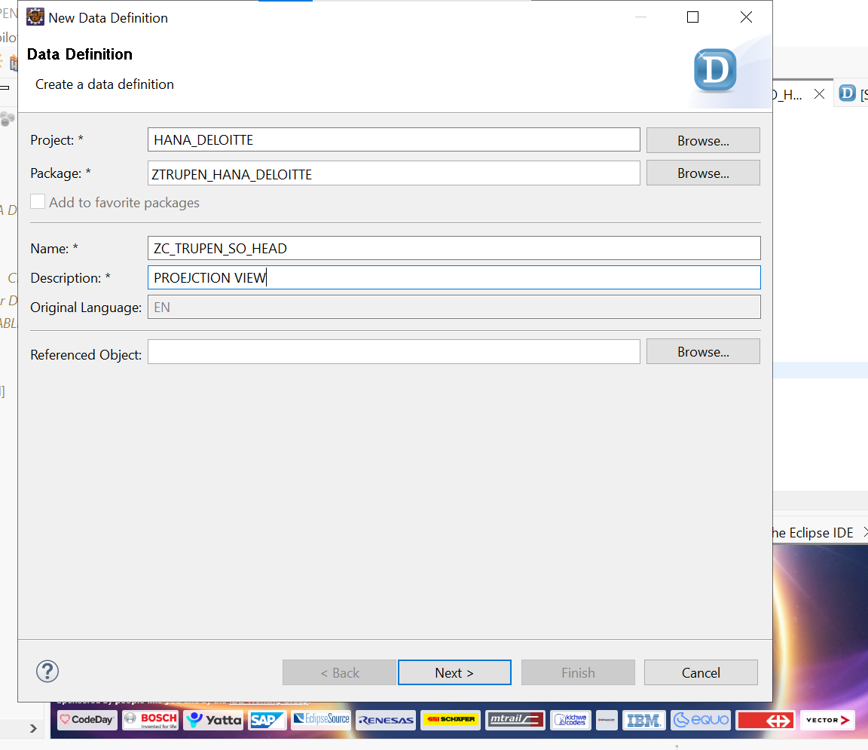

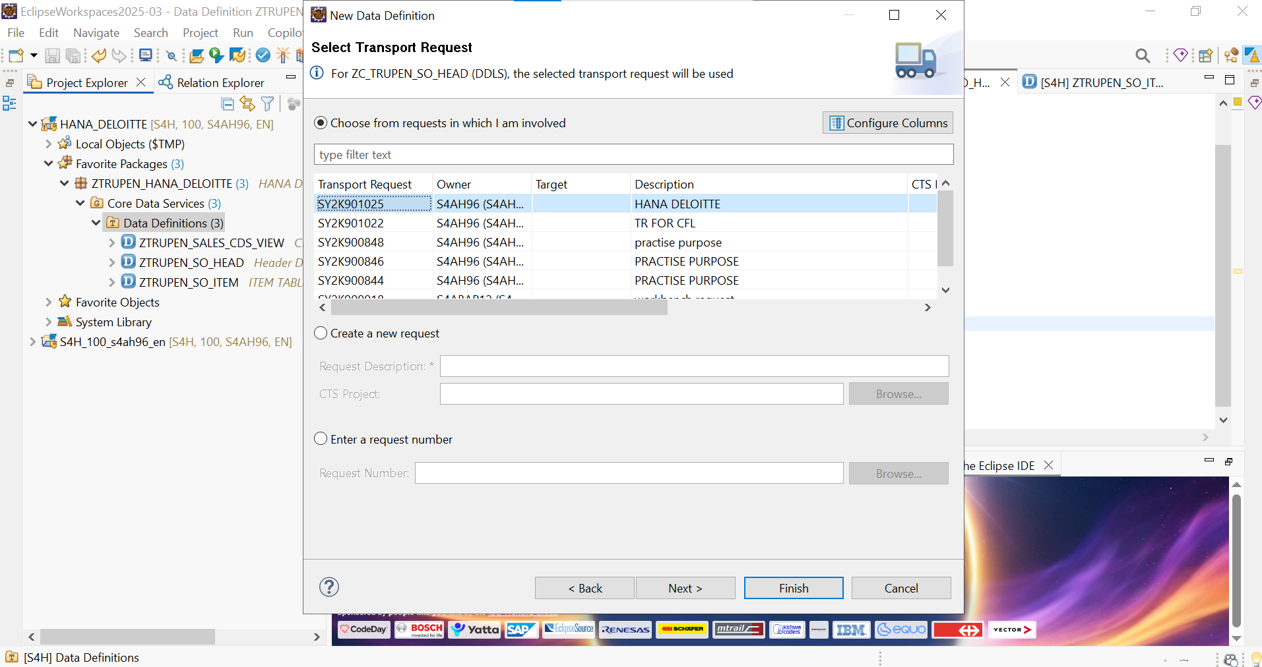

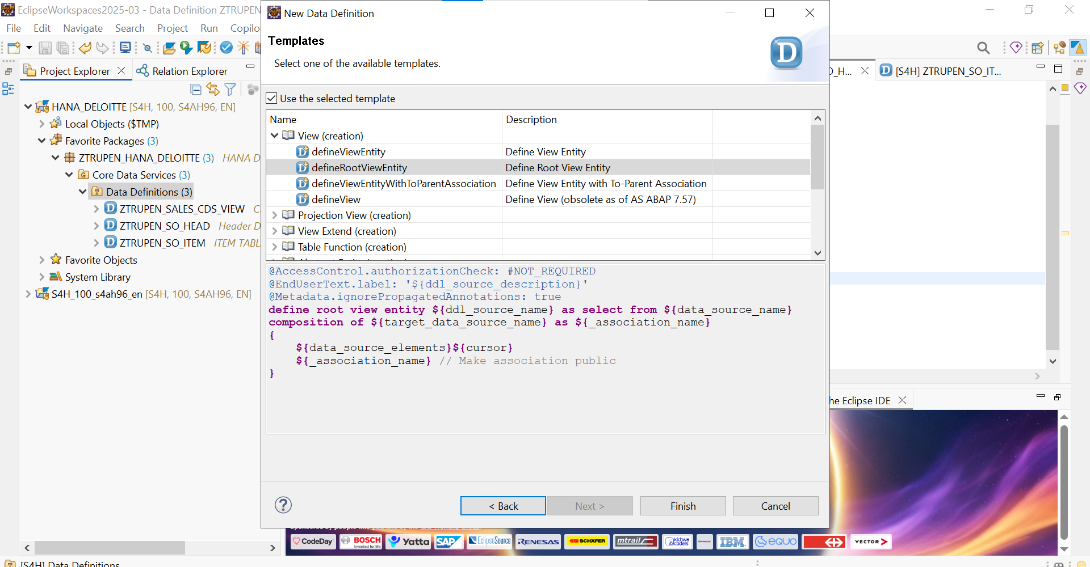

CODE :
@AccessControl.authorizationCheck: #NOT_REQUIRED
@EndUserText.label: 'PROEJCTION VIEW'
@Metadata.allowExtensions: true
@Metadata.ignorePropagatedAnnotations: true
define root view entity ZC_TRUPEN_SO_HEAD
provider contract transactional_query
as projection on ZTRUPEN_SO_HEAD
{
key SalesOrder,
CreationDate,
SoldToParty,

@Semantics.amount.currencyCode: 'Currency'
NetValue,
Currency,

/* Redirects DOWN to the Item view */
_Items : redirected to composition child ZC_TRUPEN_SO_ITEM
}

PROJECTION VIEW FOR ITEM TABLE:
@AccessControl.authorizationCheck: #NOT_REQUIRED
@EndUserText.label: 'PROJECTION VIEW ITEM'
@Metadata.ignorePropagatedAnnotations: true
define view entity ZC_TRUPEN_SO_ITEM
as projection on ZTRUPEN_SO_ITEM
{
key SalesOrder,
key ItemPosition,
Material,

@Semantics.quantity.unitOfMeasure: 'OrderUnit'
OrderQuantity,
OrderUnit,

/* Redirects UP to Projection Header */
_SalesOrder : redirected to parent ZC_TRUPEN_SO_HEAD
}

AUTHORIZATION:
When you move to modern SAP development (like RAP and Clean Core), you stop writing AUTHORITY-CHECK statements inside your ABAP code. Instead, you push that security logic directly down to the SAP HANA database using DCL.
1. How DCL Actually Works
Think of DCL as an invisible WHERE clause.
When a user runs a Fiori app or OData service that queries your CDS view, they don't get all the data and then filter it. Instead, the database looks at the user's SAP login, checks their PFCG roles (transaction SU01), and dynamically rewrites the SQL query before executing it.
- App query: SELECT * FROM ZTRUPEN_SO_HEAD
- What HANA actually runs: SELECT * FROM ZTRUPEN_SO_HEAD WHERE SalesOrganization = '1010' (assuming the user is only allowed to see Sales Org 1010).
If a user has no authorization for any sales organization, the database simply returns zero rows. No ABAP dumps, no unauthorized errors—just an empty list.
2. The Golden Rule: The Annotation
For a DCL file to work, the CDS view it protects must have the correct annotation. In our previous examples, we used #NOT_REQUIRED to bypass errors. To activate security, you must change it in your CDS view to #CHECK or #MANDATORY.
Annotation Value | What it means
#CHECK | If a DCL exists, apply it. If no DCL exists, allow access but throw a syntax warning. (Most common).
#MANDATORY | A DCL must exist. If there is no DCL, the view will not activate. (Maximum security).
#NOT_REQUIRED | No authorization check. Anyone can read everything.
#NOT_ALLOWED | Explicitly bans DCL for this view.
3. The Core Concept: Aspect PFCG_AUTH
To link your CDS view fields to standard SAP security, DCL uses the aspect pfcg_auth function. This tells the database exactly which SAP Authorization Object to check.
You need to know three things to write it:
- The Auth Object: E.g., V_VBAK_VKO (Standard SAP object for Sales Order: Sales Organization).
- The Auth Field: The field inside the object you are checking against (e.g., VKORG).
- The Activity: Usually ACTVT = '03' (Read/Display) for simply viewing data.

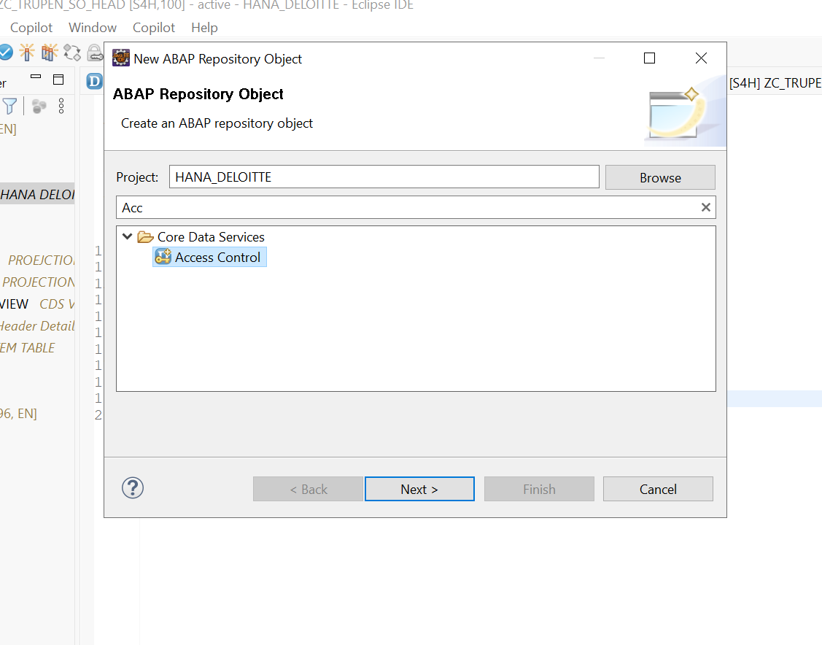

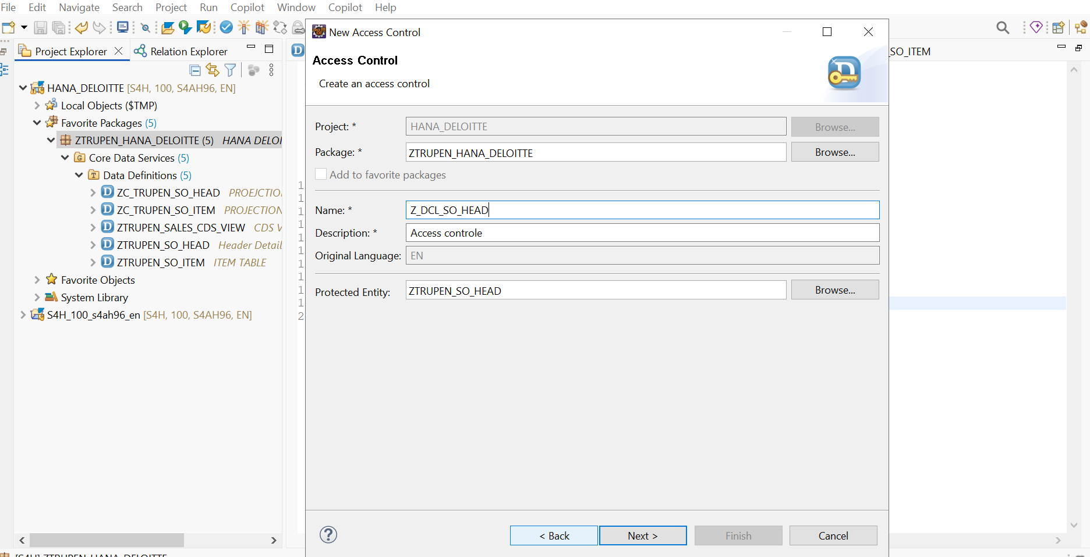

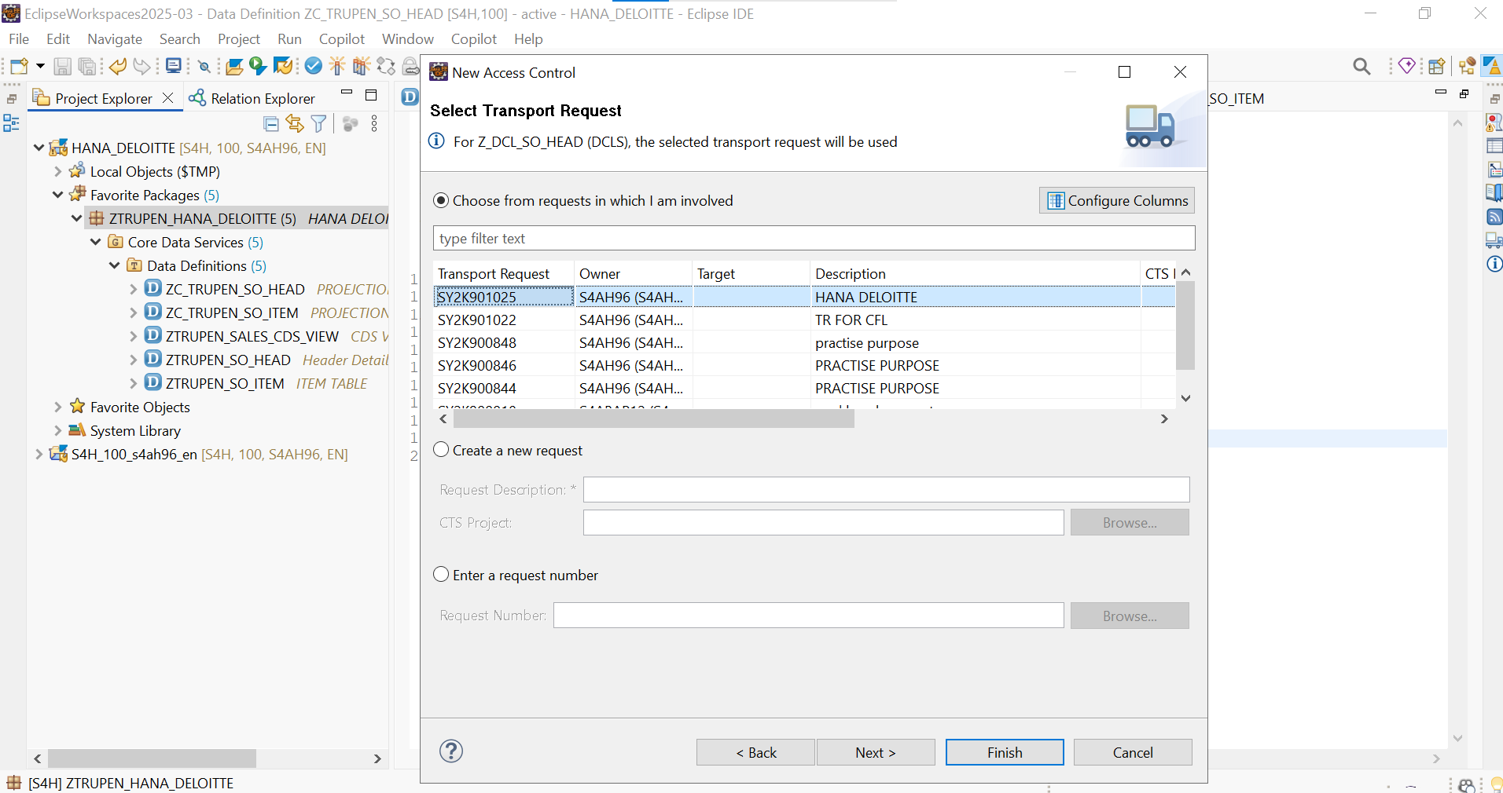

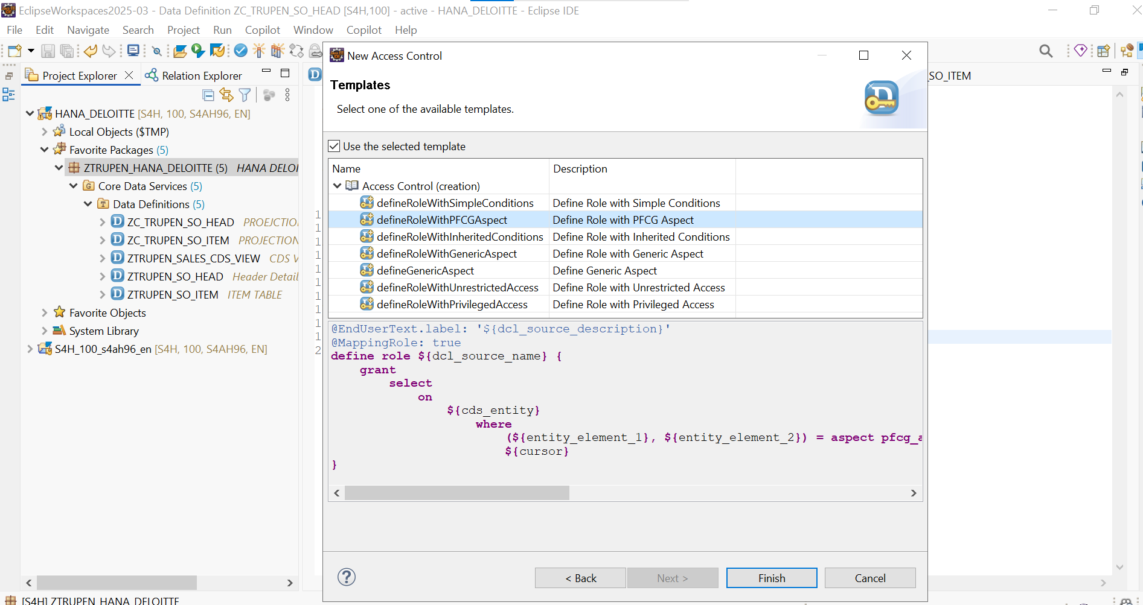

@EndUserText.label: 'Access controle'
@MappingRole: true
define role Z_DCL_SO_HEAD {
/* 1. Tell the system which CDS view we are securing */
grant select on ZTRUPEN_SO_HEAD

/* 2. Define the WHERE clause */
where
/* Map the CDS view field (SalesOrganization) to the Auth Object */
( SoldToParty ) = aspect pfcg_auth(
V_VBAK_VKO, /* Standard Authorization Object */
VKORG, /* Field inside the Auth Object */
ACTVT = '03' /* 03 means Display/Read access */
)
;

}

