**CREATING SERVICES IN SAP CAPM:**

**STEP-1:**  Right click on the srv folder and create a new file named “myservice.cds”

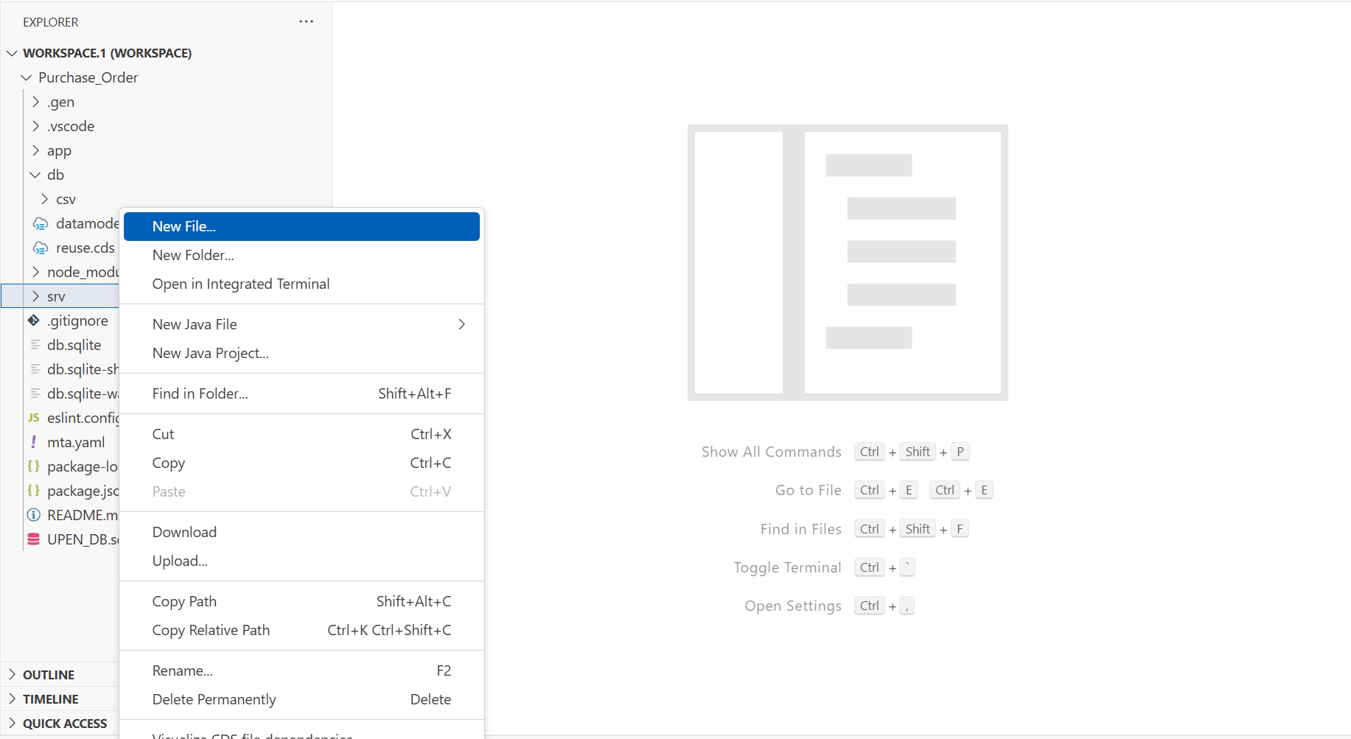

**Script for myservice.cds :   
  
using { upen.demo.master as master } from '../db/datamodel';**

**service MyService {**

**// Expose master context entities**

**entity Students as projection on master.student;**

**entity Semesters as projection on master.semester;**

**entity Books as projection on master.books;**

**}**

**🡺The myserivce.cds created in the srv folder is used for exposing our entities to the web.**

**STEP-2:**  click on the new terminal to run the commands.  
  
**🡺run the command in the terminal : cds run.  
  
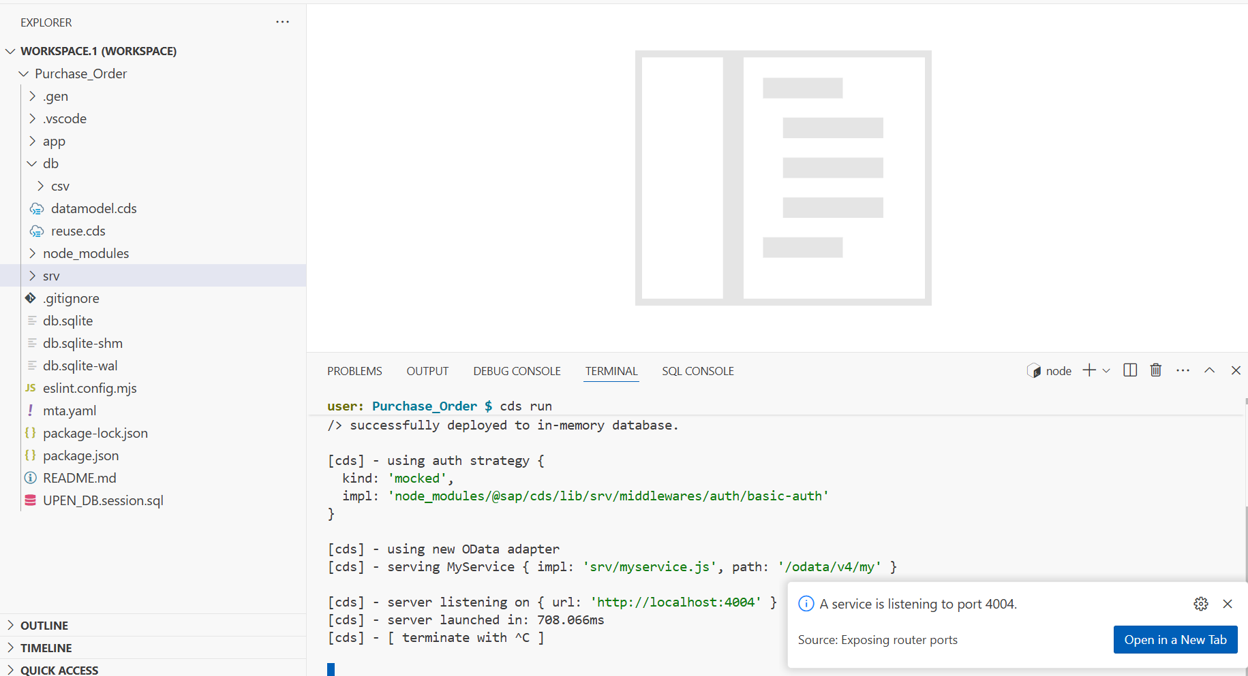**

**🡺Click on the “open In a New Tab”**

**STEP-3: A new pop-up screen is displayed over.**

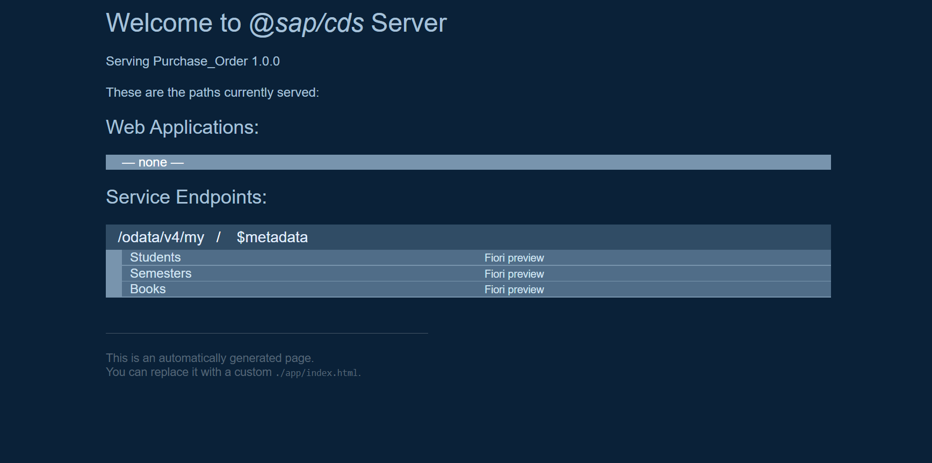

**🡺In the screen you can your entities exposed and automatically the odata-v4 services are created out of the sap cap framework.**

**🡺By default, the odata-v4 gets created.**

**🡺By clicking on the entities names we can see the data coming from the SQLite.**



