Keurig K-Café on BestBuy Canada — Customer Review Intelligence
HanuAi ML Assessment · Task 1: Web Scraping & Sentiment Analysis
Product: Keurig® K-Café™ Single Serve Coffee Maker with Milk Frother – Dark Charcoal (BestBuy.ca SKU 13787125) · 321 public reviews, 2018-10-19 to 2026-10-11

1. Executive summary
We collected all 321 public reviews of the K-Café from BestBuy.ca. Every one was captured under all six sort filters and cross-checked against the site's own review feed. We then scored each review for overall sentiment and for which product aspects it praises or criticises. The product is well liked overall: average 4.29★, 76% of review text is positive, and 83% of reviewers who answered would recommend it. But the complaints cluster tightly, and they cluster on the feature that defines this model.
- The frother is the product, and its biggest risk. The milk frother is the main reason people buy and praise the K-Café (147 positive mentions, the most of any aspect). It is also the most common complaint: it is criticised in 56% of 1–2★ reviews, and a negative frother mention is associated with -1.55★.
- Reliability is the second driver of dissatisfaction. Whole-unit breakdowns (stops brewing, error lights, dead after weeks or months) appear in 49% of 1–2★ reviews (-0.85★). Together, 69% of all detractor reviews report a hardware failure.
- Warranty replacements that fail again make it worse. 9% of reviews describe a replacement unit. Those reviews average 3.48★, because customers judge the brand on the second failure, not the first.
- The strengths are table stakes. Coffee taste, ease of use and design are praised often but move the rating little (+0.23★, +0.36★, +0.03★). Customers expect them. Fixing failures is worth far more stars than adding features.
Top recommendations: (1) run a root-cause and design review of the frother; (2) make frother care part of the unboxing; (3) give first-time warranty replacements a QA check; (4) use this review stream as an always-on quality early-warning signal. Section 4 has the details.

2. Data and method

2.1 What was collected
Field | Definition | Profile
Primary Key | Official BestBuy review ID (BBY-…); SHA-1 fallback if missing | unique
Title / Review Text | As displayed; promotion disclosure tag removed (kept as a flag) | 3 reviews have no body text
Date | Submission timestamp → YYYY-MM-DD | 2018-10-19 → 2026-10-11
Rating | Stars out of 5 | avg 4.29★
Source | Where the review was written (BestBuy reviews are syndicated) | keurig.ca 96%, bestbuy.ca 4%
Reviewer Name | Public display name only | 309 distinct
Extras | Would recommend, verified purchaser, location, helpful votes, language, BestBuy sub-ratings, filters found in

2.2 How it was collected
- Selenium path (what a customer sees). Headless Chrome opens the public review page and selects each sort filter: Most Relevant, Most Helpful, Newest, Oldest, Highest Rating and Lowest Rating. It clicks "Show More" until the button disappears, about 32 clicks per filter, and BeautifulSoup parses every card.
- JSON path (enrichment and fallback). The page's own review feed (the request "Show More" makes) is paginated for the same six sort orders. It adds the official review ID, the verified-purchaser flag and votes, and serves as a fallback if the browser is blocked.
- Coverage. Each filter returned 321 reviews through both paths, with an identical set of IDs. The union across filters is 321 unique reviews, which matches BestBuy's reported total, so nothing was missed. Using several filters is mainly a completeness check here, and a safeguard on products where one sort order truncates.
- Compliance (robots.txt). Checked programmatically before scraping (product pages are explicitly allowed). Only public data is collected, with no login, randomised 2–4 s delays and cool-downs between filters.

2.3 Sentiment: model choice and validation
Overall sentiment comes from nlptown/bert-base-multilingual-uncased-sentiment, a BERT model fine-tuned on product reviews in six languages. It matters here because about 9% of reviews are French or Spanish. The model predicts 1–5 stars; we use the expected star value, where 3.5 or above is Positive and 2.5 or below is Negative. Star ratings serve as weak ground truth for choosing between models:
Model | Accuracy | Macro F1 | Negative F1 | Spearman ρ
VADER (baseline) | 0.79 | 0.51 | 0.57 | 0.49
BERT multilingual reviews (chosen) | 0.87 | 0.67 | 0.77 | 0.71

BERT beats the VADER lexicon baseline on every metric. The gain is largest on the negative class (0.77 vs 0.57), which is the class that matters for finding problems. 3★ reviews are the hardest for both models, because customers often write 3★ text that reads as positive or negative.
Aspect categorisation, in the same style as the brief's example labels ['Good Design & Quality (Pos)']: each review is split into sentences. Each sentence is matched to one of 12 product aspects by a transparent keyword lexicon, built after reading the reviews, and by semantic similarity using MiniLM sentence embeddings. The sentence is then scored with the same BERT model. A review can therefore carry both 'Great Coffee Taste (Pos)' and 'Frother Failure / Weak Froth (Neg)'. Reviews with no specific aspect get an overall tag such as 'Satisfactory & Recommended (Pos)'.

3. Insights
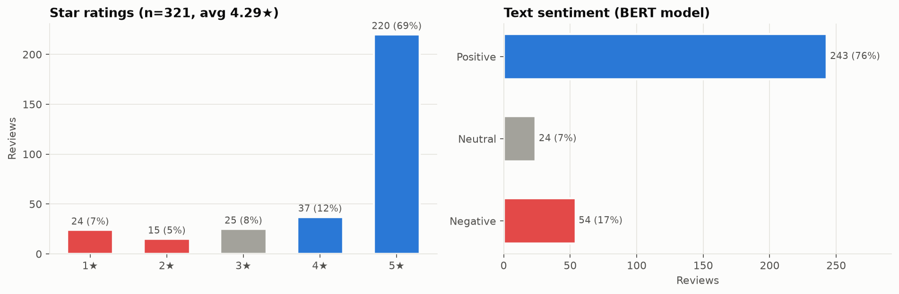
Figure 1 – Ratings are heavily 5★, but 20% of reviews are 3★ or lower.

3.1 Drivers of satisfaction and dissatisfaction
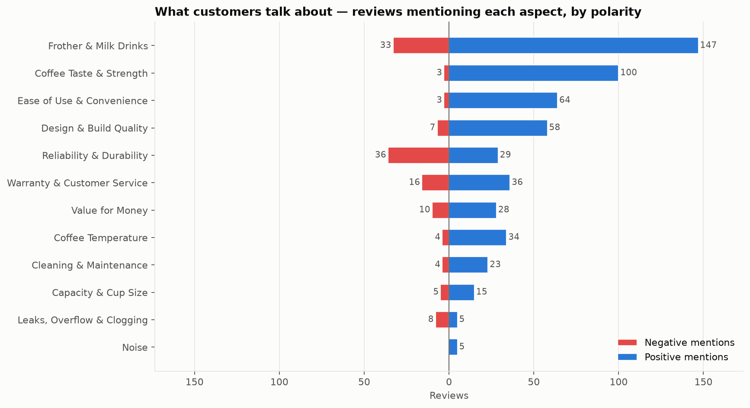
Figure 2 – Reviews mentioning each aspect, split into positive and negative.
Aspect | Reviews | % of all | Pos | Neg | Net | % of 1–2★ citing (Neg)
Frother & Milk Drinks | 190 | 59% | 147 | 33 | +0.60 | 56%
Coffee Taste & Strength | 108 | 34% | 100 | 3 | +0.90 | 3%
Ease of Use & Convenience | 69 | 21% | 64 | 3 | +0.88 | 0%
Design & Build Quality | 68 | 21% | 58 | 7 | +0.75 | 13%
Reliability & Durability | 67 | 21% | 29 | 36 | -0.10 | 49%
Warranty & Customer Service | 53 | 17% | 36 | 16 | +0.38 | 13%
Value for Money | 41 | 13% | 28 | 10 | +0.44 | 18%
Coffee Temperature | 39 | 12% | 34 | 4 | +0.77 | 8%
Cleaning & Maintenance | 29 | 9% | 23 | 4 | +0.66 | 5%
Capacity & Cup Size | 22 | 7% | 15 | 5 | +0.45 | 3%
Leaks, Overflow & Clogging | 13 | 4% | 5 | 8 | -0.23 | 13%
Noise | 5 | 2% | 5 | 0 | +1.00 | 0%

Satisfaction drivers:
- The frother, when it works. 147 reviews praise lattes, cappuccinos and froth quality. This is why people choose the K-Café over a basic Keurig.
- Coffee taste. Praised in 100 reviews, with a net sentiment of +0.90.
- Ease of use and design. Consistently positive. Customers mention set-up, one-touch brewing and the look on the counter.
Dissatisfaction drivers:
- Frother failure / weak froth. Typical reports: the frother stops spinning, only heats the milk, or stops working after a few weeks or months. It is criticised in 33 reviews (56% of detractors). The most common phrases in negative frother sentences are 'frother stopped', 'stopped frothing' and 'sent replacement'.
- Breakdowns. Reliability is the only large aspect with negative net sentiment (-0.10). Reports describe units dead on arrival, stuck with all lights on, or failing just inside or outside warranty.
- Leaks and overflow. 8 negative reviews describe leaks, overflow or clogging. The volume is low but the net sentiment is clearly negative (-0.23), and these complaints are vivid: 'coffee grounds all over the counter'.
- Value for money. When value is criticised the rating drops sharply (-0.93★). That complaint almost always follows a failure: 'expensive for something that broke'.

3.2 What moves the star rating
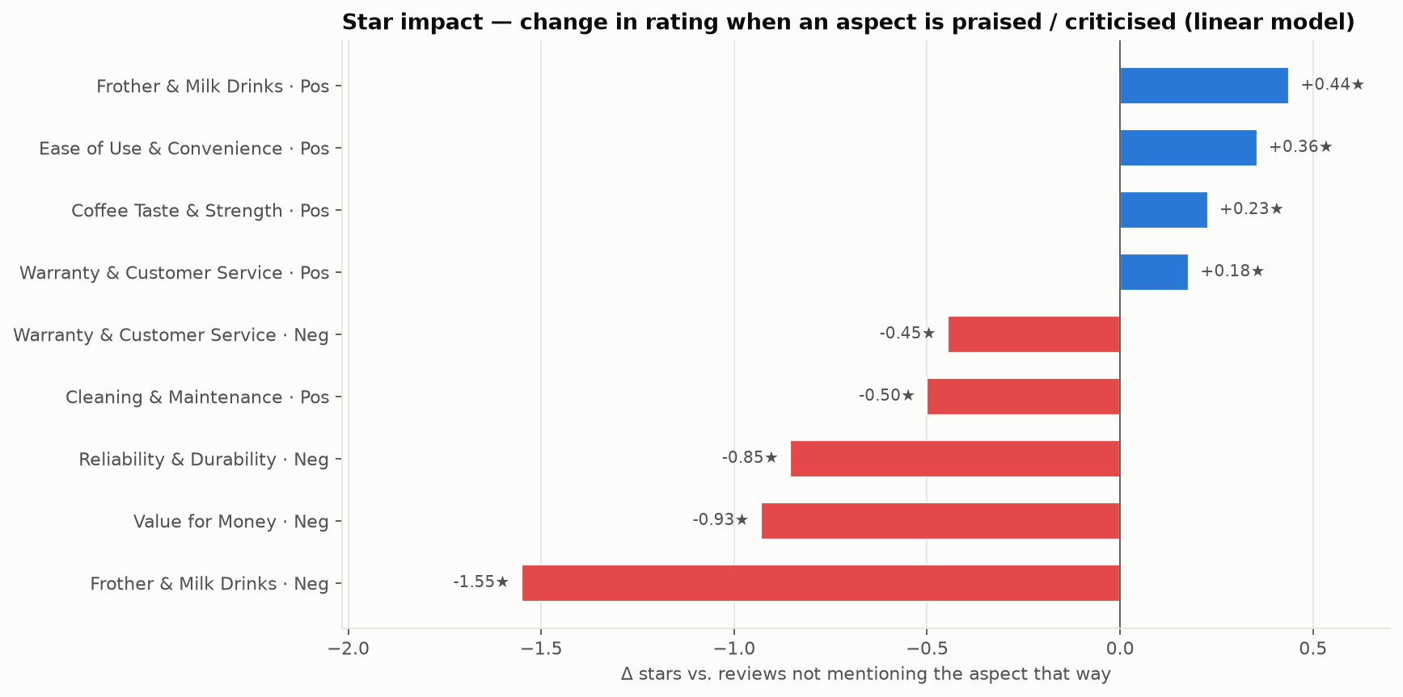
Figure 3 – Linear model of rating on aspect flags. Bars show the change in stars versus reviews that don't mention the aspect that way.
Failures cost far more stars than strengths add. The three costliest complaints are frother & milk drinks (-1.55★), value for money (-0.93★) and reliability & durability (-0.85★). The most valuable praise, frother & milk drinks, adds only +0.44★. This asymmetry is the main business message: protecting the 4.3★ average depends on fixing failures, not on promoting features. Only flags present in at least 10 reviews are modelled; the model explains about half the variance in ratings, and a small negative coefficient on a positive aspect means that aspect tends to appear in long, mixed reviews.

3.3 Trends over time
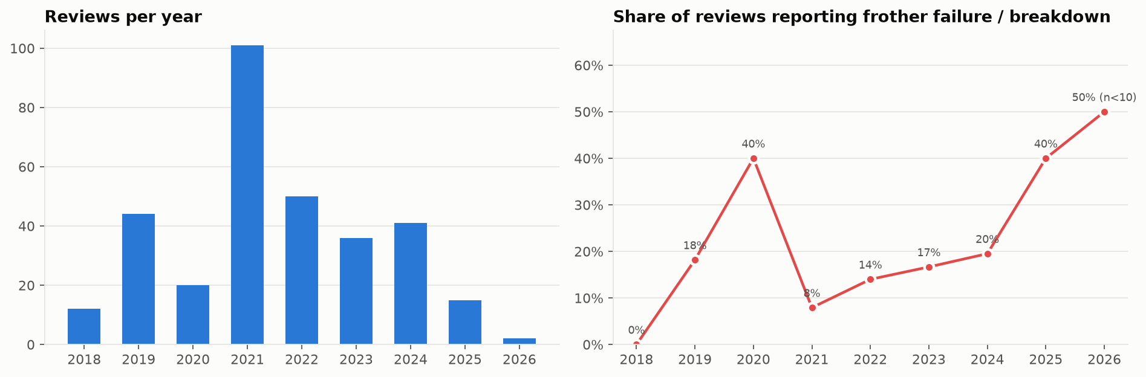
Figure 4 – Review volume per year and share of reviews reporting a frother failure or breakdown.
Review volume peaked in 2021 (101 reviews). The failure share was highest in 2020 (40%, average 3.60★, recommend rate 45%). Since 2024, 26% of reviews report a failure, versus 16% over the product's lifetime. Note that 2025–26 is based on few reviews. Whether the rise is real and points to a supplier or design change should be confirmed against Keurig's warranty claims.

3.4 Other signals stakeholders should know
- Verified vs non-verified. Verified purchasers average 4.54★; non-verified reviewers average 3.68★. Many non-verified reviewers received the unit as a gift or a warranty replacement, and they are the unhappiest group.
- Promotion bias. Checked for incentivised reviews (BestBuy's 'collected as part of a promotion' disclosure): 0 found. No disclosed sampling campaign explains the 2021 volume peak, which is more likely the pandemic-era home-coffee boom.
- Syndication. 96% of the reviews shown on BestBuy.ca were written on keurig.ca and syndicated. Only 12 are native BestBuy reviews, and no review has a single helpful vote. BestBuy's own customers are barely represented, which is an opportunity for post-purchase review requests.
- Hidden detractors. 20 reviews (6%) give 4–5★ but still criticise something, most often reliability or the frother. Star averages hide these early warnings; text analytics catches them.

4. Recommendations
# | Action | What to do | Owner | Why / expected impact
1 | Frother root-cause and design review | Tear down returned units. Test the magnetic whisk coupling, motor and base-to-frother electrical contact, and milk-residue build-up. Run accelerated life tests at 2× daily use. | Keurig product engineering / QA | Largest single lever: frother complaints appear in 56% of 1–2★ reviews (-1.55★ per affected review)
2 | Make frother care part of the product | Quick-start card plus a QR video on cleaning the whisk and which milks froth (skim and almond froth poorly). Consider an in-app or LED 'clean frother' reminder. | Keurig product marketing / CX | Cuts usage-related 'weak froth' complaints and support calls
3 | Fix the replacement loop | QA-check warranty replacement units. After a second failure, offer an upgrade or refund instead of a third identical unit. Extend frother-only warranty coverage. | Keurig customer care | Replacement stories average 3.48★; one more failure turns a recoverable customer into a public detractor
4 | Brew temperature and leak checks | Review temperature tolerance (lukewarm complaints) and the needle and reservoir seal design (overflow and clog reports). Add a descaling prompt. | Keurig engineering | Addresses the remaining hardware complaints (lukewarm coffee, leaks, clogging)
5 | Improve the listing and the review base | On BestBuy.ca: set expectations on milk types and frothing on the product page, and ask buyers for native reviews 30 and 90 days after purchase. | BestBuy merchandising | More representative ratings; fewer expectation-gap returns
6 | Always-on review monitoring | Schedule this pipeline weekly. Alert when the share of 'Frother Failure' or 'Breakdown' reviews in a rolling 90-day window exceeds the lifetime baseline. | Data / quality analytics | Early warning of a bad production batch weeks before warranty data shows it

5. Scraping challenges and solutions

5.1 What we actually ran into
Challenge | What happened | How it was solved
Silent hang on robots.txt | BestBuy's edge holds open, and never answers, requests that carry Python's default urllib user agent. The standard-library robots parser hung indefinitely. | Fetch robots.txt with a browser user agent and a timeout, then parse it locally.
Rate limiting after about 1,000 card loads | After three full filters, 'Show More' stopped returning reviews (Oldest stalled at 30, Highest/Lowest at 10) and API calls timed out. | Throttle detection (list stops growing, or fewer than 95% of the expected total), then close the browser, cool down 90 s / 180 s / 270 s and retry. 45 s cool-down between filters, 2–4 s jitter between clicks.
Lost progress on failure | One failed filter used to discard all earlier work. | Per-filter checkpoint files; a re-run only scrapes what is missing. Raw HTML is saved so the parser can be re-run offline.
Two card templates | Syndicated (keurig.ca) cards use schema.org itemprop markup; native BestBuy cards don't. The first parser lost 12 reviewer names and texts. | Selector fallbacks (itemprop, then structural) plus a reconciliation step that matches against the JSON feed and reports unmatched rows.
Hashed CSS class names | Classes look like reviewItem_kwbTe and change with each front-end build. | Match on stable prefixes ([class*=reviewItem_]), data-* attributes and element IDs (#Sort).
Duplicate posts | One reviewer posted identical text twice in the same second, which broke the natural key. | Key = reviewer + timestamp + title + an occurrence counter; duplicates are flagged rather than silently dropped.
Network loss mid-run | The machine lost connectivity overnight (ERR_INTERNET_DISCONNECTED). | The retries plus checkpoints meant the next run resumed with no data loss.

5.2 Toolkit for scaling up (more products, retailers, daily runs)
- Rotating proxies and IP blocking. A pool of residential or datacentre proxies with health checks. Rotate per session, not per request, to keep cookies consistent. Evict IPs that return 403/429 or a challenge page, and cap requests per IP per minute.
- Retry mechanisms. Exponential back-off with jitter that honours Retry-After (implemented here). Add a per-domain token-bucket limiter and a circuit breaker that pauses a domain after repeated failures.
- Bot detection and fingerprinting. Use real browser engines (Playwright or Selenium) with consistent user agent, viewport, locale and timezone. Disable automation flags (done here), or use undetected-chromedriver / playwright-stealth. Use human-like scroll and click timing.
- CAPTCHA. First, avoid triggering one: low rates, warm sessions, good IP reputation. If a CAPTCHA appears, detect it, back off, and retry later from a clean IP. Solving services (2Captcha, CapSolver) exist, but using them can breach a site's terms of service. For a commercial pipeline the right fix is a data partnership or an official API.
- Load reduction. Incremental runs: scrape 'Newest' only until a known review ID appears, which cuts load by about 95%. Schedule off-peak and distribute products across workers.
- Monitoring. Daily smoke test asserting that the parsed count equals the site-reported count. Schema and null-rate checks. Alert when a selector returns zero cards.

6. Limitations and next steps
- Labels. Star ratings are only weak labels for sentiment, and 3★ reviews are ambiguous. A small hand-labelled set of about 200 sentences would allow proper precision and recall for each aspect.
- Generalisation. The aspect lexicon was built from this product's reviews. For other products, combine it with zero-shot or LLM-based aspect extraction, such as an open-source instruction model with a fixed label set.
- Scope. A single product and retailer with 321 reviews. Yearly trends for 2025–26 rest on fewer than 20 reviews each. Extending to keurig.ca, Amazon.ca and sibling models (K-Café Essentials, K-Latte) would separate product-specific problems from brand-wide ones.

Appendix – deliverables
File | Contents
Task1_BestBuy_Scraping_Sentiment.ipynb | Scraper (Selenium + JSON), cleaning, sentiment, insights; commented throughout
outputs/bestbuy_keurig_reviews_sentiment.xlsx | Sheets: Reviews_Sentiment (all fields and labels), Brief_Format_Example, Aspect_Drivers, Star_Impact, Yearly_Trend, Filter_Coverage, Model_Validation
outputs/bestbuy_keurig_reviews_sentiment.csv | Same review-level table as CSV (UTF-8)
outputs/raw_selenium, outputs/raw_api | Per-filter raw checkpoints (and HTML snapshots) for reproducibility
figures/*.png | Charts used in this report

