Vehicle Safety Complaints — EDA, Text Mining & Failure Insights
HanuAi ML Assessment · Task 2: Advanced EDA & Text Mining
Data: NHTSA vehicle owner complaints received 2020–2024 (418,884 records, 291,999 complaints, all makes). Text-mining deep dive: Tesla, Inc. (9,544 complaints).

1. Executive summary
The assignment's dataset was not attached, so we used the closest public equivalent: the US Department of Transportation's (NHTSA) vehicle owner complaint database. Like the brief's example, it pairs structured fields with a free-text failure narrative that must be turned into component tags, failure-mode tags and issue types. We profiled and cleaned all 2020–2024 complaints, then mined Tesla's complaints to show what a manufacturer's quality team gets from this approach.
- Text mining turns free text into decision-ready structure. 96% of complaints receive an issue type, and 74% of those NHTSA filed as 'UNKNOWN OR OTHER' are recovered. The narrative is the only place the symptom, trigger and outcome are recorded.
- The most frequent failures. Electrical / electronics & software leads (2,766 complaints, 29%). It is followed by ADAS false activation (phantom braking) (21%) and Suspension / steering component failure (11%).
- Clear root-cause signals. Phantom-braking complaints are strongly tied to specific scenes (Overpass / bridge / shadow ×42.0; Oncoming / passing vehicle ×21.1; Highway / freeway ×2.9, where ×N is how many times more often the condition appears than in other complaints). They happen at highway speed (median 70 mph) on almost new cars (median 6,900 miles). That points to the perception software, not wear.
- Severity ranks differently from volume. Driver-assistance failures to act carry a 27% crash rate, against 9% across all Tesla complaints. Unintended-acceleration reports carry 69%, mostly at parking speeds. Volume alone would hide both.
- Complaint spikes follow publicity. The largest monthly spikes coincide with the opening of public NHTSA investigations, so complaint counts measure awareness as well as defects. Spikes need to be read alongside the news timeline.

2. Understanding the data

2.1 Source and structure
File: COMPLAINTS_RECEIVED_2020-2024 (tab-separated, no header, 51 fields defined in NHTSA's CMPL.txt). Grain: one row per complaint × component. 88,185 complaints are listed under more than one component, so counting rows overstates volume. All complaint counts in this report are unique complaints (ODINO).
Group | Columns | Use
Identifiers | CMPLID, ODINO, VIN | Row ID, complaint ID; VIN dropped (identifying)
Vehicle | MFR_NAME, MAKETXT, MODELTXT, YEARTXT, fuel/drive/transmission | Who is accountable; model-year cohorts
Failure | COMPDESC (NHTSA component code), CDESCR (narrative, ≤2,048 characters) | What failed, and the only free-text field
Severity | CRASH, FIRE, INJURED, DEATHS, MEDICAL_ATTN, VEHICLES_TOWED_YN, POLICE_RPT_YN | Risk, recall and liability exposure
Context | MILES, VEH_SPEED, FAILDATE, LDATE, STATE | Early-life vs wear-out failures; highway vs parking; trends
Product-specific | Tire DOT/size/failure type, child-seat type | Only filled for tire or child-seat complaints (structurally empty otherwise)
Personal data | Operator name, dealer name/phone/zip, city | Dropped from all analysis tables

2.2 Data quality issues and fixes
Issue | Rows | Fix
Exact duplicate rows | 0 | dropped
Complaints listing more than one component (row = complaint x component) | 88,185 | kept for component analysis; collapsed to one row per complaint for text mining
MILES = 0 (NHTSA code for 'not provided') | 4,552 | set to NaN
VEH_SPEED = 0 (NHTSA code for 'not provided') | 51,936 | set to NaN
OCCURENCES = 0 (NHTSA code for 'not provided') | 1 | set to NaN
NUM_CYLS = 0 (NHTSA code for 'not provided') | 3 | set to NaN
Model year 9999 (unknown) | 5,924 | set to NaN
Component 'UNKNOWN OR OTHER' | 41,033 | kept as its own class; text mining recovers the real component
Mileage > 500,000 | 337 | set to NaN (typos)
Speed > 150 mph | 288 | set to NaN
Failure date after complaint-received date | 6 | failure date set to NaN
Failure date before the vehicle's model year - 1 | 343 | failure date set to NaN
Empty complaint narrative | 0 | kept for structured EDA, excluded from text mining
Personal / identifying fields (names, phone, VIN, city) | 418,884 | dropped from the analysis tables

Two more text issues: 18% of narratives are all upper case (older submission channels), so text is lower-cased before matching. Narratives also carry boilerplate that describes how the complaint was filed (FOIA redaction notices, links, and the NHTSA hotline template 'The contact owns a… The contact stated…'). Left in, it made clusters group by writing style rather than by failure, so it is stripped before modelling. Files are read as UTF-8 to avoid garbled characters.

2.3 Critical columns: key statistics (all makes)
Across 291,999 complaints, 4% involved a crash. The median vehicle was 5 years past its model year, and 25% of dated failures happened within the first three model years, which is when a design or manufacturing defect is most likely.
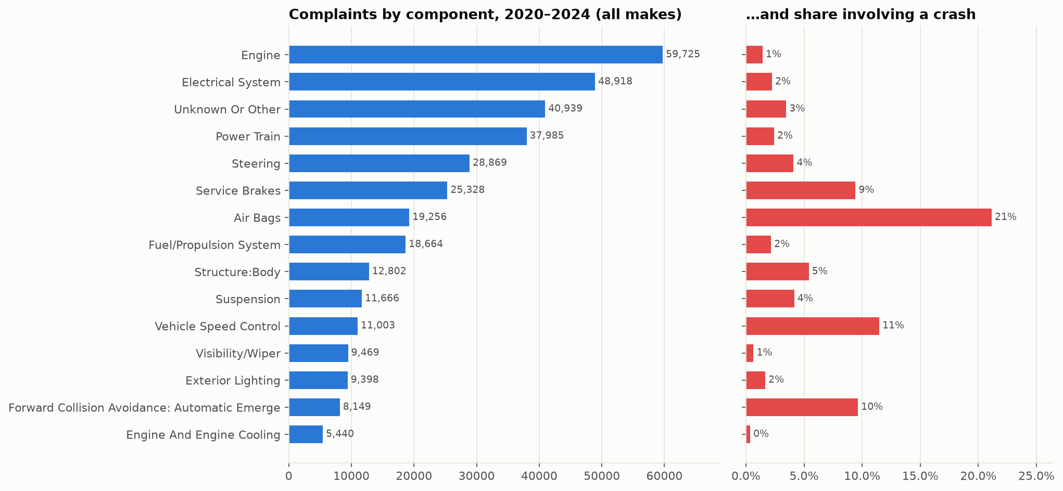
Figure 1 – Complaints by NHTSA component (all makes), with the share involving a crash.
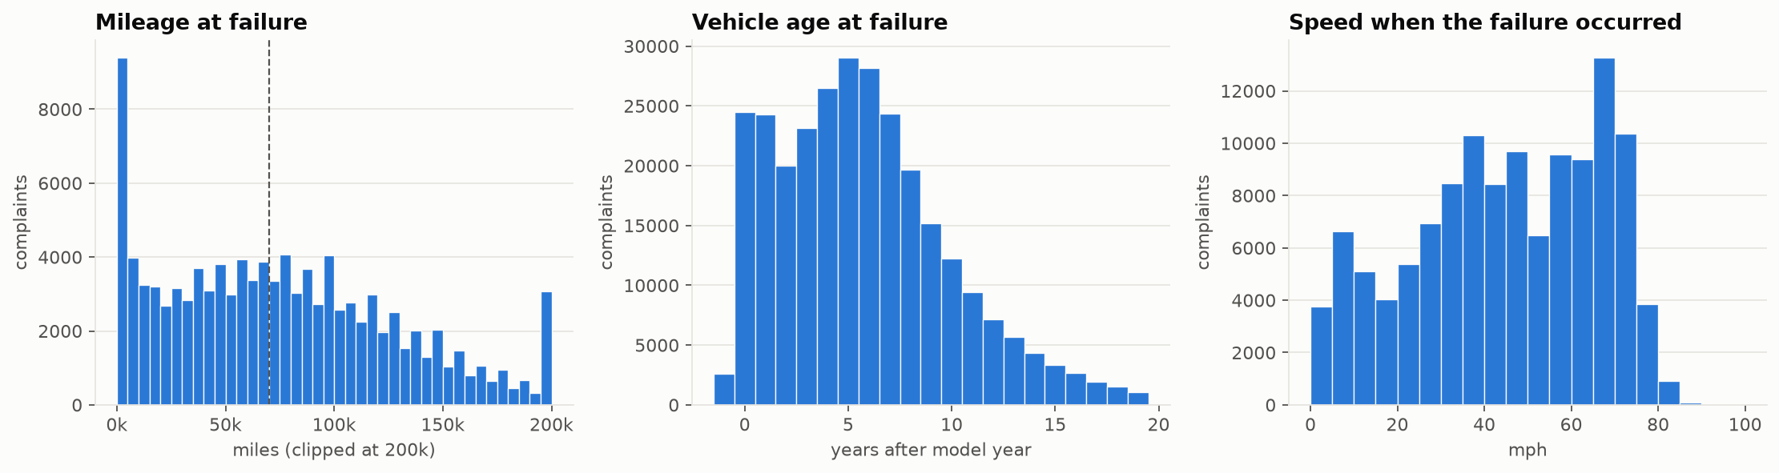
Figure 2 – Mileage, vehicle age and speed at failure (all makes).
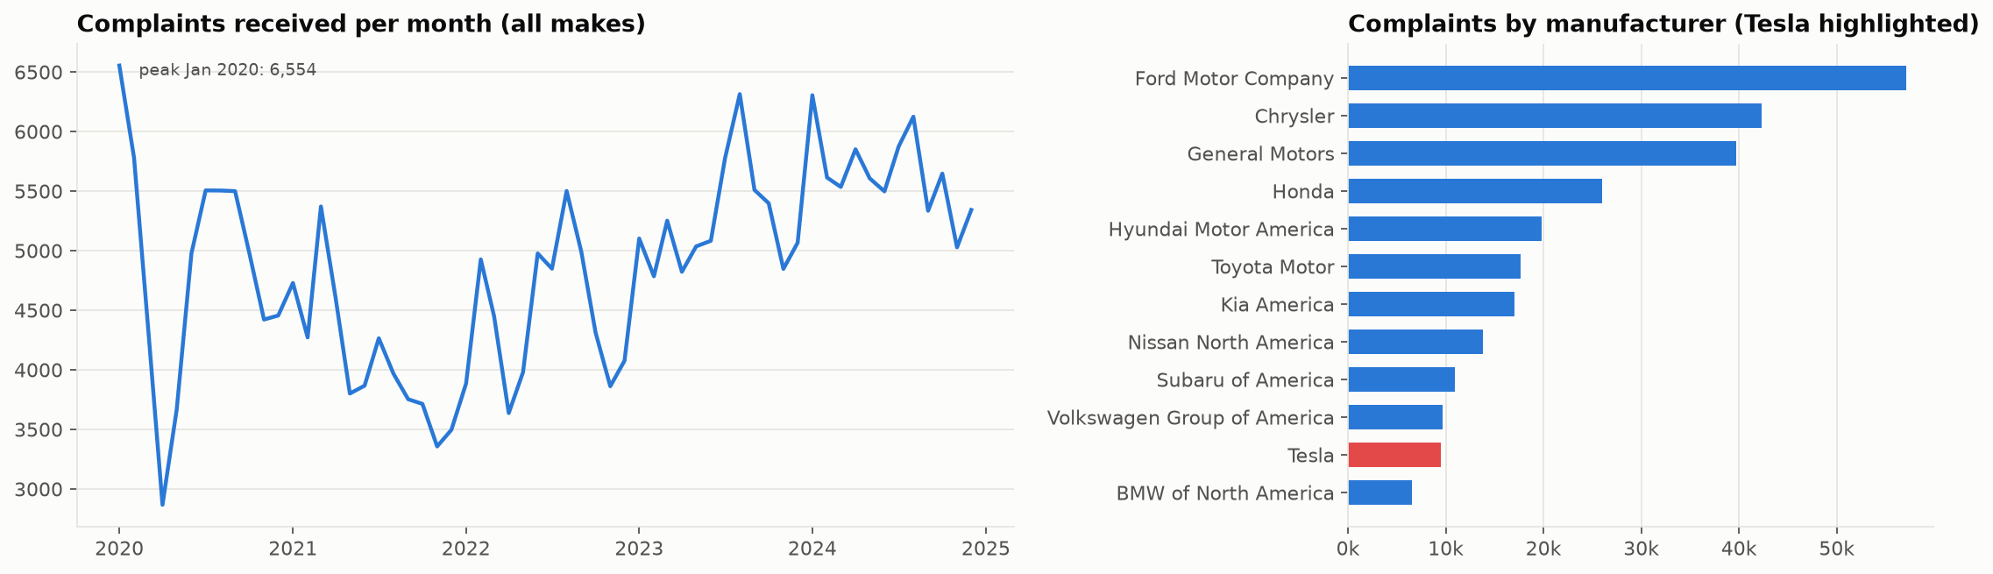
Figure 3 – Monthly volume and complaints by manufacturer. Raw counts are not normalised by fleet size.

3. Text mining: from narrative to structured tags
The only true free-text column is CDESCR, at about 100 words on average and more than 99% unique values. MODELTXT and COMPDESC are controlled vocabularies. COMPDESC is coarse: 'ELECTRICAL SYSTEM' says nothing about the symptom, and one in ten Tesla complaints is filed as 'UNKNOWN OR OTHER'.
Entity schema. The brief's own example entities were in the missing Excel file, so we defined seven entity classes for failure analysis. They are extracted with a curated, auditable pattern dictionary (exported to the Excel deliverable), plus regular expressions for numbers and TF-IDF key phrases as data-driven tags:
Entity class | Most frequent tags (% of Tesla complaints)
COMPONENT | Touchscreen / MCU (20%), Tires / wheels (17%), Lights (14%)
FAILURE_MODE | Phantom / false braking (18%), Warning message / alert (12%), Failure to brake / detect (10%)
ADAS_FEATURE | Traffic-aware / adaptive cruise (20%), Autopilot (17%), Full Self-Driving (FSD) (7%)
TRIGGER_CONDITION | Highway / freeway (25%), Low speed / parking (14%), After software update (5%)
CONSEQUENCE | Crash / collision (31%), Towed / stranded (7%), Injury (6%)
SERVICE_ACTION | Part replaced / repaired (23%), Service centre visit (17%), Recall referenced (11%)
NUMERIC | speed (mph), mileage, repair cost ($), from structured fields or the text
KEY_PHRASES | Top 3 distinctive 2–3-word phrases per complaint (TF-IDF)

Issue types. The tags plus the NHTSA component code map to 15 issue types under 8 groups (software / ADAS behaviour, electrical / electronic, mechanical component failure, powertrain and HV battery, body and structural, occupant protection, fire / thermal, comfort). A complaint can have several issue types; the first match is its primary issue.
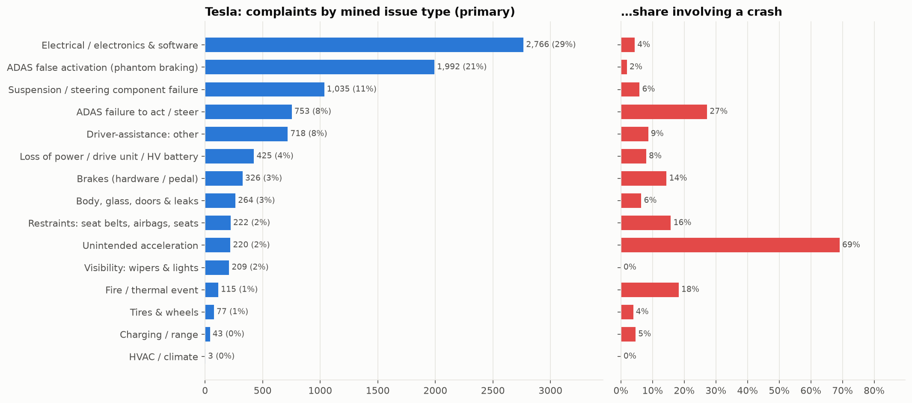
Figure 4 – Tesla complaints by mined primary issue type, with the share involving a crash.

4. Insights for stakeholders

4.1 Most frequent and most severe failures
Primary issue | Group | Complaints | Share | Crash | Injury | Median mph | Median miles
Electrical / electronics & software | Electrical / electronic issue | 2,766 | 29% | 4% | 2% | 45 | 50,000
ADAS false activation (phantom braking) | Software / ADAS behaviour | 1,992 | 21% | 2% | 1% | 70 | 6,900
Suspension / steering component failure | Mechanical component failure | 1,035 | 11% | 6% | 1% | 25 | 34,000
ADAS failure to act / steer | Software / ADAS behaviour | 753 | 8% | 27% | 8% | 65 | 18,000
Driver-assistance: other | Software / ADAS behaviour | 718 | 8% | 9% | 4% | 65 | 5,000
Loss of power / drive unit / HV battery | Powertrain & HV battery | 425 | 4% | 8% | 2% | 45 | 35,117
Brakes (hardware / pedal) | Mechanical component failure | 326 | 3% | 14% | 4% | 65 | 10,222
Body, glass, doors & leaks | Body & structural | 264 | 3% | 6% | 5% | 45 | 30,000
Restraints: seat belts, airbags, seats | Occupant protection | 222 | 2% | 16% | 13% | 35 | 22,000
Unintended acceleration | Software / ADAS behaviour | 220 | 2% | 69% | 17% | 5 | 8,000
Visibility: wipers & lights | Electrical / electronic issue | 209 | 2% | 0% | 0% | 50 | 13,715
Fire / thermal event | Fire / thermal | 115 | 1% | 18% | 10% | 40 | 37,500

4.2 Trends and significant changes
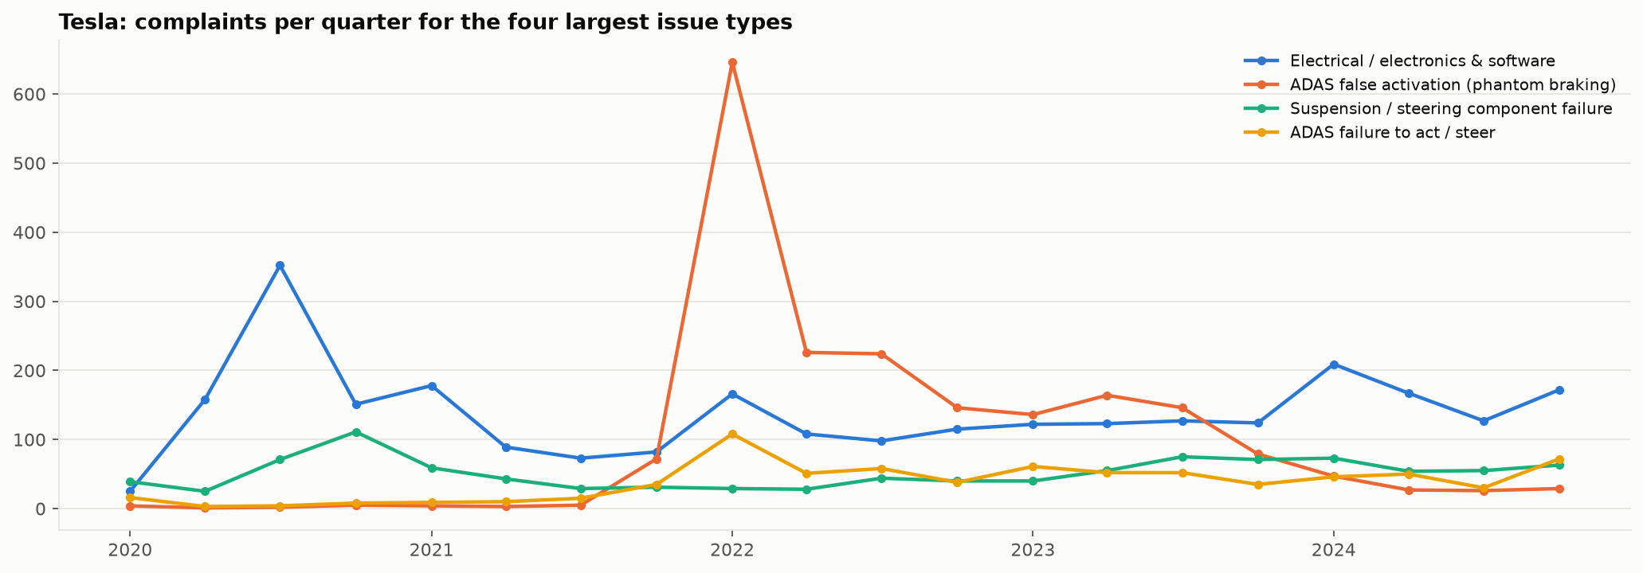
Figure 5 – Quarterly complaints for the four largest issue types.
Month-level spikes (more than 3 standard deviations above that issue's monthly mean):
Issue | Month | Complaints | Monthly mean | z
Electrical / electronics & software | 2020-06 | 155 | 46 | 3.2
Electrical / electronics & software | 2020-07 | 208 | 46 | 4.8
ADAS false activation (phantom braking) | 2022-02 | 500 | 33 | 6.8
Suspension / steering component failure | 2020-11 | 52 | 17 | 3.8
Suspension / steering component failure | 2023-08 | 46 | 17 | 3.2
ADAS failure to act / steer | 2022-02 | 84 | 13 | 5.7

Interpretation: the June–July 2020 electrical spike matches the period when NHTSA opened its investigation into Model S/X touchscreen (MCU) failures, which later led to a recall. The February 2022 phantom-braking spike matches the opening of NHTSA's phantom-braking investigation into Model 3/Y. Public attention drives filing, so a spike means 'many people are now reporting', not necessarily 'the defect rate jumped'. An early-warning system should flag the slow rise that comes before the news, not the spike after it.
Issue | Year | Prev. year | This year | Change
ADAS false activation (phantom braking) | 2022 | 84 | 1242 | +1379%
Brakes (hardware / pedal) | 2022 | 12 | 152 | +1167%
ADAS false activation (phantom braking) | 2021 | 12 | 84 | +600%
Driver-assistance: other | 2022 | 48 | 302 | +529%
ADAS failure to act / steer | 2022 | 69 | 255 | +270%
ADAS failure to act / steer | 2021 | 31 | 69 | +123%
Unclassified | 2023 | 62 | 130 | +110%
Restraints: seat belts, airbags, seats | 2023 | 34 | 69 | +103%

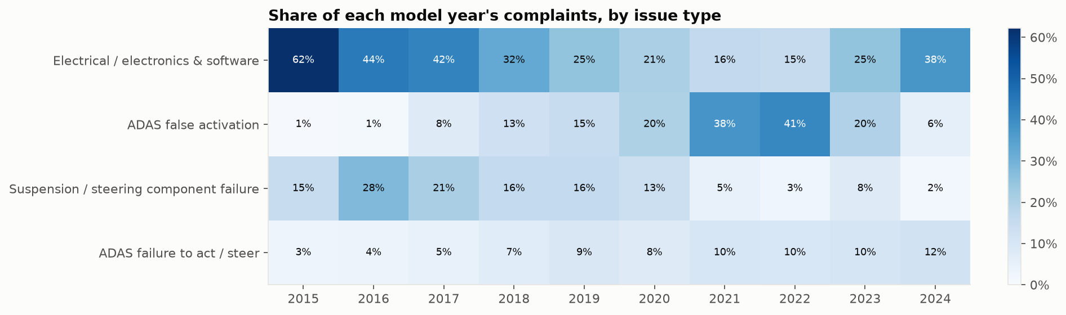
Figure 6 – Share of each model year's complaints by issue type (cohort view).
Each failure family belongs to a different generation of vehicle. Phantom braking peaks in model years 2022 and 2021 (41% and 38% of those years' complaints), which matches the period when Model 3/Y moved from radar to camera-only perception. That is a hypothesis to confirm with the sensor configuration per VIN. Suspension and steering failures peak in model years 2016–2017 (up to 28%), and electrical/MCU complaints dominate the oldest cohorts (62% of model year 2015). Each points to a specific design generation or supplier window rather than a general quality level.

4.3 Clustering, topic modelling and root causes
Sentence-embedding clustering (MiniLM + K-Means, k = 16 by silhouette) and an independent NMF topic model recover the same main failure families (agreement AMI = 0.44). Silhouette scores are low, as is usual for free text, because complaints mix several problems. Clusters are therefore read through their dominant tags, not taken as hard partitions.
# | Size | Distinctive terms | Dominant issue | Purity | Top conditions
9 | 1010 | cruise, cruise control, control, brakes, lane, braking, highway, speed | ADAS false activation (phantom braking) | 38% | Highway / freeway (57%); Oncoming / passing vehicle (11%)
4 | 889 | lane, speed, stop, right, incident, warning, brake, road | ADAS failure to act / steer | 21% | Highway / freeway (34%); Low speed / parking (31%)
11 | 857 | braking, cruise, control, cruise control, phantom, phantom braking, br | ADAS false activation (phantom braking) | 76% | Highway / freeway (57%); Oncoming / passing vehicle (12%)
3 | 804 | parking, warning, mph, stop, left, wheel, right, brake | ADAS failure to act / steer | 14% | Low speed / parking (33%); Highway / freeway (17%)
2 | 785 | suspension, wheel, tire, service, noise, control, arm, tires | Suspension / steering component failure | 82% | Low speed / parking (24%); Highway / freeway (13%)
6 | 717 | phantom, braking, phantom braking, cruise, cruise control, control, hi | ADAS false activation (phantom braking) | 98% | Highway / freeway (47%); Overpass / bridge / shadow (11%)
7 | 713 | service, recall, battery, safety, warranty, charge, center, repair | Electrical / electronics & software | 36% | Low speed / parking (13%); After software update (12%)
12 | 698 | screen, mcu, failure, turn, control, camera, display, working | Electrical / electronics & software | 75% | Low speed / parking (9%); Weather (rain/snow/fog) (6%)
0 | 672 | turn, lane, safety, driver, wipers, update, autopilot, software | Electrical / electronics & software | 35% | Highway / freeway (20%); After software update (18%)
10 | 591 | screen, mcu, service, center, control, camera, unit, safety | Electrical / electronics & software | 88% | Low speed / parking (18%); Highway / freeway (9%)

Root-cause hypotheses. 'Lift' is how much more often a condition appears in this issue than in other complaints:
Issue | n | Characteristic conditions (lift) | Components (lift) | Root-cause hypothesis and how to test it
ADAS false activation (phantom braking) | 1,992 | Overpass / bridge / shadow ×42.0; Oncoming / passing vehicle ×21.1; Highway / freeway ×2.9 | Accelerator / pedal ×1.7 | Vision-based perception misreads high-contrast static scenes (overpass shadows, bridges) and oncoming large vehicles as obstacles. It occurs on new vehicles at highway speed, so the cause is software or calibration, not wear. Test: replay drives through flagged scene types against each software version.
Suspension / steering component failure | 1,035 | Low speed / parking ×2.3 | Suspension / control arm ×70.5; Tires / wheels ×4.6; Steering ×2.9 | Front suspension links (control arm or ball joint) fracture or separate, usually at low speed while turning or parking, at moderate mileage, and concentrated in specific Model S model years. This suggests a component fatigue or supplier batch issue. Test: tear-down of returned parts by production lot.
Electrical / electronics & software | 2,766 | Cold temperature ×2.5; After software update ×1.6; Weather (rain/snow/fog) ×1.6 | Horn / yoke controls ×11.8; Touchscreen / MCU ×9.5; HVAC / heat pump ×7.7 | Touchscreen/MCU blackouts and reboots (memory wear on older Model S/X), camera and sensor faults, and HVAC/heat-pump faults that rise in cold weather. Test: field logs by firmware version and ambient temperature.
ADAS failure to act / steer | 753 | Weather (rain/snow/fog) ×1.6; Highway / freeway ×1.6; Low light / glare ×1.6 | Lights ×1.9; Accelerator / pedal ×1.9; Brakes (hardware) ×1.9 | The system fails to brake, warn or steer at highway speed, more often in low light, glare or bad weather. This is the highest-severity group. Test: link crash complaints to sensor-degradation conditions.
Unintended acceleration | 220 | median speed 5 mph; crash rate 69% | Accelerator / pedal | Acceleration claims at parking speeds with a very high crash rate. This is consistent with pedal misapplication or mode confusion when parking. Test: pedal and brake telemetry for the complaint VINs.

5. Actionable recommendations and business impact
# | Action | What to do | Owner | Business impact
1 | Scenario-based ADAS regression testing | Build a test suite from the 1,992 phantom-braking narratives (overpass, shadow, oncoming truck). Gate each software release on it. | Software / ADAS validation | Targets the top software complaint. Fewer rear-end risks, less regulatory exposure, fewer goodwill costs.
2 | Severity-weighted triage | Rank issues by complaints × crash/injury rate, not volume. ADAS failure-to-act and unintended acceleration move ahead of screen faults. | Product safety office | Engineering effort goes where injury and liability risk is.
3 | Suspension lot investigation | Correlate control-arm and ball-joint failures with production date and supplier lot. Consider a targeted inspection campaign for the affected model years. | Quality / supplier QA | Avoids an uncontained field failure and a broader recall later.
4 | Cold-weather and firmware telemetry for electronics | Add ambient temperature and firmware version to field-failure dashboards for MCU, camera and HVAC. | Electrical engineering | Faster root-cause confirmation; fewer repeat service visits.
5 | Pedal-misapplication safeguards | Low-speed obstacle-aware acceleration limiting and clearer drive-mode feedback when parking. | Vehicle dynamics / HMI | Removes a high-crash-rate complaint type.
6 | Always-on complaint monitoring | Run this pipeline monthly on NHTSA data. Alert on a rising slope (not just spikes) for any issue × model year, and benchmark against peers. | Quality analytics | Weeks of early warning before warranty data or regulators raise it.

6. Value for HanuAi's customers
- Transferable to roads and infrastructure. The same pipeline (narrative, then entity tags, then issue type, then root-cause lift) applies directly to road and infrastructure maintenance: citizen pothole and defect reports, inspection notes, maintenance logs and incident reports.
- From text to decisions. Free-text logs that nobody reads become a structured, queryable asset. Severity-weighted prioritisation decides which defects to fix first, and condition lift (weather, location, asset age) gives engineers testable root-cause hypotheses.
- Early warning. Trend and spike detection on incoming reports catches emerging failure clusters before they turn into incidents.

7. Key learnings and further improvements
- Grain before statistics. Counting raw rows overstated complaint volume by about 40%, because one complaint is repeated per component. Understanding the grain comes first.
- Sentinel values. Zeros, '9999' and 'UNKNOWN OR OTHER' mean 'missing' in this dataset. Treating them as values would distort mileage, speed and component statistics.
- Boilerplate shapes clusters. The first clustering run grouped complaints by template wording (hotline scripts, FOIA notices) instead of by failure. Removing boilerplate before modelling is essential.
- Volume reflects awareness. Complaint spikes follow investigations and media coverage. Interpreting spikes needs an external event timeline.
Further improvements:
- Measured accuracy. Hand-label about 500 complaints to measure tag precision and recall per class, then fine-tune a small transformer (e.g. DeBERTa) for multi-label issue classification that generalises beyond the pattern dictionary.
- LLM-based extraction. Use an open-source instruction LLM (e.g. Llama 3 or Mistral, run locally) to extract component, symptom, trigger and outcome as JSON, and compare it with the dictionary on the labelled set.
- Normalise and close the loop. Join with NHTSA recall and investigation files and with registration counts. That allows complaints per 10,000 vehicles and measures whether recalls actually reduce complaints.
- Topic modelling over time. BERTopic with UMAP and HDBSCAN for variable-size topics and better outlier handling. Track topics over time to detect new failure modes automatically.

Appendix – deliverables
File | Contents
Task2_EDA_TextMining.ipynb | EDA, cleaning, entity extraction, issue typing, clustering/NMF, root-cause lift, trends; commented throughout
outputs/tesla_complaints_text_mining.xlsx | Complaints_Tagged (all tags, issue types, clusters), Tag_Frequency, Entity_Dictionary, Issue_Summary, Root_Cause_Profiles, Clusters, NMF_Topics, Significant_Changes, Monthly_Spikes, EDA sheets
outputs/tesla_complaints_tagged.csv | Tagged complaint table (UTF-8)
figures/*.png | Charts used in this report
data/raw/ | NHTSA source file and data dictionary (CMPL.txt)

