**1.Write a program to print "Hello World" using JavaScript with html page.**

<!DOCTYPE html>

<html lang="en">

<head>

<meta charset="UTF-8">

<meta name="viewport" content="width=device-width, initial-scale=1.0">

<title>Hello world page</title>

</head>

<body>

<script>

document.write("Hello, World")

</script>

</body>

</html>



**2. Write a program to add two numbers and print the result. Use let and var keywords.**

<!DOCTYPE html>

<html lang="en">

<head>

<meta charset="UTF-8">

<meta name="viewport" content="width=device-width, initial-scale=1.0">

<title>Document</title>

<script>

function add(){

var n1,n2,sum;

n1=parseInt(document.getElementById("first").value);

n2=parseInt(document.getElementById("second").value);

sum=n1+n2

document.getElementById("answer").value=sum;

}

</script>

</head>

<body>

<p>Enter the first number :<input id="first"></p>

<p>Enter the second number :<input id="second"></p>

<button onclick="add()">Add</button>

<p>Sum = <input id="answer"></p>

</body>

</html>

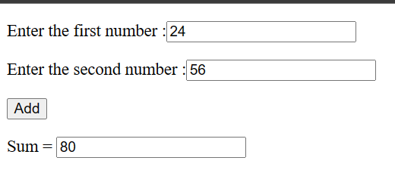

**3. Write a program to add, subtract, multiply and divide two numbers and print the result using JavaScript.**

<!DOCTYPE html>

<html lang="en">

<head>

<meta charset="UTF-8">

<meta name="viewport" content="width=device-width, initial-scale=1.0">

<!-- <link href="index.js"> -->

<title>Calculator</title>

</head>

<body>

<div>

<label>Enter the first no. </label>

<input type="text" id="n1" name="firstno." placeholder="Enter 1st no.">

</div>

<div>

<label>Enter the second no. </label>

<input type="text" id="n2" name="secondno." placeholder="Enter 2nd no.">

</div>

<p1>Answer=<input id="answer"></p1><br>

<button style="background-color: lightcoral;border-radius: 50%;" onclick="add()">+</button>

<button style="background-color:lightblue;border-radius: 50%;"onclick="sub()">-</button>

<button style="background-color:lightgreen;border-radius: 50%;"onclick="mul()">*</button>

<button style="background-color:lightseagreen;border-radius: 50%;"onclick="div()">/</button><br>

<script src="index.js"></script>

</body>

</html>

function add(){

let n1=parseInt(document.getElementById("n1").value)

let n2=parseInt(document.getElementById("n2").value)

let sum=n1+n2;

document.getElementById("answer").value=sum

}

function sub(){

let n1=parseInt(document.getElementById("n1").value)

let n2=parseInt(document.getElementById("n2").value)

let sub=n1-n2;

document.getElementById("answer").value=sub

}

function mul(){

let n1=parseInt(document.getElementById("n1").value)

let n2=parseInt(document.getElementById("n2").value)

let mul=n1*n2;

document.getElementById("answer").value=mul

}

function div(){

let n1=parseInt(document.getElementById("n1").value)

let n2=parseInt(document.getElementById("n2").value)

let div=n1/n2;

document.getElementById("answer").value=div

}

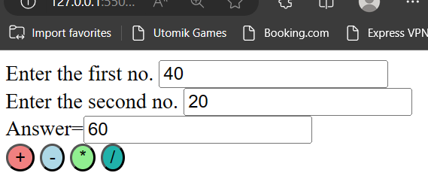

**4. Find maximum number from 3 given numbers.**

**HTML:**

<!DOCTYPE html>

<html lang="en">

<head>

<meta charset="UTF-8">

<meta name="viewport" content="width=device-width, initial-scale=1.0">

<title>Maximun Number</title>

</head>

<body>

<div>

<p style="color: rgb(89, 89, 197);">Check maximun number form given no. :</p>

<label>Enter 3 no. </label>

<input type="text" id="no1." name="num1">

<input type="text" id="no2." name="num2">

<input type="text" id="no3." name="num3">

</div>

<button type="button" onclick="greater_no()" name="button" style="background-color: aquamarine;">Maximun</button>

<p >Ans :<input id="result"></p><br>

<script src="index.js"></script>

</body>

</html>

**Js:**

greater_no=()=>{

let num1=document.getElementById("no1.").value;

let num2=document.getElementById("no2.").value;

let num3=document.getElementById("no3.").value;

//let split_ele=arr_ele.split(',');

// let max=arr_ele[0]

// for(let i=1;i<length.split_ele;i++){

// if(max<arr_ele[i]){

// max=arr_ele[i];

// }

// }

if(num1>num2 && num1>num3){

max=num1

}

else if(num2>num3 && num2>num1)

max=num2

else if(num3>num1 && num3>num2){

max=num3

}

else{

max='All are equal values .'

}

document.getElementById("result").value=max;

}

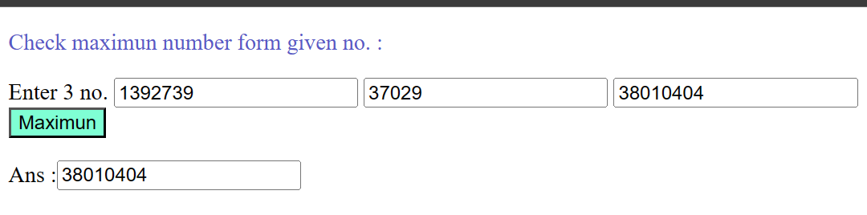

**5. Calculate area of circle, use Pi as a constant variable.**

**HTML:-**

<!DOCTYPE html>

<html lang="en">

<head>

<meta charset="UTF-8">

<meta name="viewport" content="width=device-width, initial-scale=1.0">

<title>Area:</title>

</head>

<body>

<p >Enter the radious of circle: <input type="text" id="radious" name="radiour"></p>

<button type="button" onclick="area()" style="border-radius: 30%;background-color: blueviolet;">Area</button>

<p >Area of the circle :<input id="result" ></p>

<script src="index.js"></script>

</body>

</html>

**JS:-**

area=()=>{

var rad=document.getElementById("radious").value

const pi=3.1415

area_of_circle=pi*rad*rad

document.getElementById("result").value=area_of_circle

}

