## **What is cloud analytics? :-**

## Cloud analytics is a service model in which elements of the data analytics process are provided through a public or private cloud. Cloud analytics applications and services are typically offered under a subscription-based or utility (pay-per-use) pricing model

## Gartner defines the six key elements of analytics as data sources, data models, processing applications, computing power, analytic models and sharing or storage of results. In its view, any analytics initiative “in which one or more of these elements is implemented in the cloud” qualifies as cloud analytics. Gartner analyst Bill Gassman noted that vendors offering cloud-based technologies designed to support a single element refer to themselves as cloud analytics companies, which can cause confusion for potential users.

**Why we need cloud analytics**

**Scalability: Cloud analytics allows organizations to easily scale up or down their computing resources based on their changing needs. This means that they can quickly and easily process and analyze large amounts of data without having to invest in expensive on-premises infrastructure.**

**Cost-effectiveness: Cloud analytics can be more cost-effective than traditional on-premises solutions because it eliminates the need for organizations to purchase and maintain their own hardware and software.**

**Flexibility: Cloud analytics provides organizations with the flexibility to choose the tools and services that best meet their specific needs. They can choose from a wide range of cloud analytics solutions that offer different features and capabilities.**

**Accessibility: Cloud analytics allows organizations to access their data from anywhere, at any time, using any device with an internet connection. This makes it easier for remote workers and teams to collaborate and share data.**

**Faster time-to-insight: Cloud analytics solutions can process and analyze data more quickly than traditional on-premises solutions, which means that organizations can get insights from their data faster and make more informed decisions.**

**Examples :**

**Business intelligence dashboards:** business intelligence tools such as Tableau, Power BI, and QlikView allow organizations to create interactive dashboards use for visualize data and gain insights into their operations.

**Predictive analytics:** predictive analytics tools such as IBM Watson Studio, Google Cloud Machine Learning, and AWS SageMaker enable organizations to build machine learning models that can help them make more accurate predictions about future outcomes.

**Real-time analytics**: Cloud-based real-time analytics solutions such as Google Cloud Dataflow, Apache Kafka, and AWS Kinesis enable organizations to process and analyze data in real-time as it is generated, allowing them to quickly detect and respond to events and trends.

**Customer analytics:** customer data and gain insights into customer behavior, preferences, and needs.

**Financial analytics:** Oracle Financial Analytics, SAP Financial Analytics, and IBM Cognos Analytics enable organizations to analyze financial data and gain insights into their financial performance, profitability, and cash flow**.**

## **NetApp’s cloud analytics solutions**

NetApp offers solutions designed to help improve the performance, management and protection of data. Data is at the core of any analytics project and NetApp offers the IT solutions across the hybrid cloud to help accelerate data analysis and improve data availability.

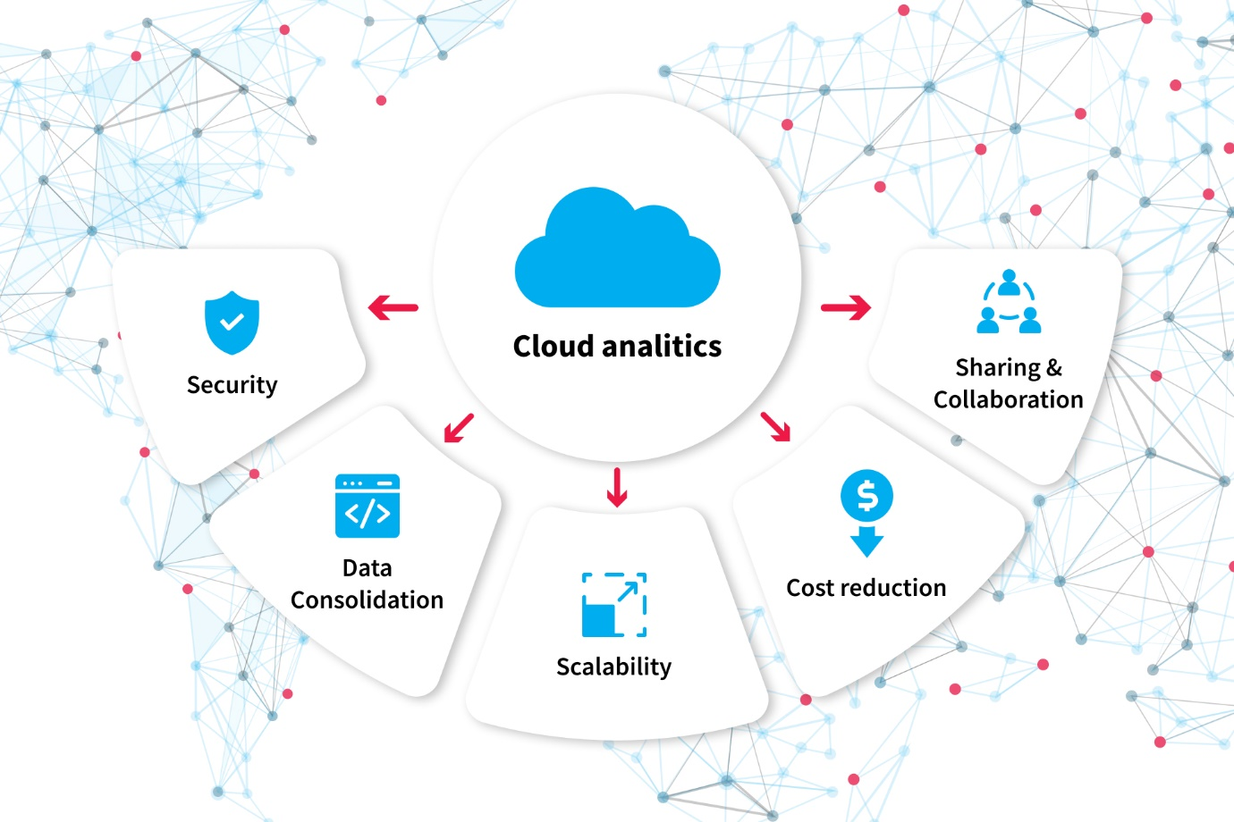

**Example :**

hosted data warehouses, software-as-a-service business intelligence (SaaS BI) and cloud-based social media analytics.

### How does cloud analytics work?

cloud analytics systems must be hosted on an internet platform

they are run on state-of-the-art data centers that can provide the processing power and storage space needed for analyzing massive amounts of data.

In cloud analytics systems, all generated data is collected and securely stored in the cloud, where it can be accessed from any internet-connected device. The cloud analytics system can then clean, organize, process, and analyze the data using proprietary algorithms. These insights are presented to the user through different data visualizations and other intuitive formats.

**Data sources**

**Data models:**

**Processing applications**

**Computing power:**

**Analytic models:**

**Data sharing and storage**

**cloud analytics salary**

The salary for cloud analytics professionals can vary widely depending on factors such as location, experience, skills, and industry. According to Payscale, the average salary for a cloud data analyst is around $80,000 per year, while a cloud solutions architect can earn an average salary of around $125,000 per year.

**here are many companies that provide cloud computing services, here are some of the most prominent ones:**

Amazon Web Services (AWS)

Microsoft Azure

Google Cloud Platform (GCP)

IBM Cloud

Oracle Cloud

Salesforce

Dropbox