**ELECTROHUB**

**A PROJECT REPORT**

***Submitted by***

**Bikash Bishnucharan Pradhan - 05**

**Himsnsu Kumar Jena - 33**

**Irfan Kureshi - 52**

**Najmuddin Rashid – 110**

**Under the Guidance Of**

Prof. Jayshri Patil

***In fulfillment for the award of the degree***

***Of***

# Master of Computer Application

At

Sarvajanik College of Engineering & Technology, Surat

# Sarvajnik University, Surat

January, 2023



Sarvajanik Education Society

Sarvajanik College of Engineering & Technology, Surat.

Master of Computer Application Departments

Academic Year 2022-23

**Date: 09-01-2023**

**CERTIFICATE**

This is to certify that the project entitled “ELECTROHUB” has been Submitted by BIKASH BISHNUCHARAN PRADHAN(46), HIMANSU KUMAR JENA(52), IRFAN KURESHI(60),NAJMUDDIN RASHID(92) towards the fulfillment of the degree of Master of Computer Applications (M.C.A.) in (1st Semester) of Sarvajanik University, Surat during the academic year 2022-23.

**Guide Name: Prof.** Jayshree Patil

**(Prof. Prashant Keswani**

**(Guide’s Signature) Head - M.C.A. Department)**

**Examiners’ Signature:**

**1.__________________________**

**2.__________________________**

**3.**__________________________

**ACKNOWLEDGEMENT**

We would like to express our deep and sincere gratitude to our Project Mentor Prof. Jayshree patil and Our HOD Prof. Prashant Keswani, for giving us the opportunity to do this project and provide valuable guidance throughout this project. Your vision, sincerity and motivation have deeply inspired us. She has taught us the methodology to carry out the project and to present the project work as clearly as possible. It was a great privilege and honour to work and study under her guidance. We are extremely grateful for what she has offered us. We would also like to thank her for her friendship, empathy, and great sense of humor.

We would like to take opportunity to thank my college, Sarvajanik College of Engineering and Technology, Surat for giving me this tremendous opportunity to work in the real-time project.

We are very thankful and fortunate enough to get support and guidance from all Teaching staffs of Masters of Computer Application Department which helped us in successfully completing our project work. Also, we would like to extend our sincere regards to all the non-teaching staff of Masters of Computer Application Department for their timely support.

**Thanking You**

YOUR FAITHFULLY

Bikash Bishnucharan Pradhan

Himansu Kumar Jena

Irfan Kureshi

Najmuddin Rashid

**INDEX**

• **Abstract**

**1. Introduction**

1.1 Proposed System and its Objective

1.2 Core Components

1.3 Minimum and Maximum Software/Hardware Requirement

1.4 Advantage and Limitations of the Proposed System

**2. Requirement Determination & Analysis**

2.1 Requirement Determination

2.2 Targeted Users

**3. System Design**

3.1 Use Case Diagram

3.2 Activity Diagram

3.3 Data Dictionary

**4. Screenshots**

**5. Proposed Enhancements**

**6. Conclusion**

**7. Bibliography**

**INTRODUCTION**

* 1. **PROPOSED SYSTEM AND ITS OBJECTIVE**

The purpose of Electrohub is to set selling electronic items on web app.

This website allows people to buy and sell physical services , and digital products over the internet.

Through our website, a business can process orders , accepts payments , manage shipping and logistics , and provide customer service.

In e-commerce website, we easily find best products and purchase electronics items like(Desktop , Laptop , Smart Phones , etc..)

Our website provides the quality service to the end user. This project aims is used for all people who like to saving their time.

**Objective:-**

The objective of this application is to develop a system that effectively manages all the data related to the products sell and purchage mange of customer and admin.

The purpose is to maintain a centralized database of all shoping related information.

**1.2 CORE COMPONENT**

* Admin :- Admin is authorized for a specific task like to add , update , delete ,search categories, subcategories, brands, various products, maintain location like (state ,city)
* After login with valid emailid and password the admin can perform all the tasks within the website
* Admin can also block or Un-block the user in website.
* User :

User are 2 types registered user & guest user.

Registerd user:

* Login
* Give Feedback
* View Product
* Manage cart(Add, Update and Delete into cart)
* Manage Wishlist (Add, Delete and Move into cart)
* Make Order
* Manage Their Account.
* Change Password
* Forgot Password
* Guest User
* Registration
* View Product
* Manage cart(Add, Update and Delete into cart)
* Make Order
* Give FeedBack

**1.3 Minimum and Maximum Software/Hardware Requirement**

* Hardware Requirements

|  |  |
| --- | --- |
| Minimum RAM | 1GB |
| Hard Disk | 128 GB |
| Processer | Intel Pentium 4( 1.50 GHZ) or above |
| Ethernet connection | LAN OR a wireless adapter (Wi-Fi) |

* Software Requirements

|  |  |
| --- | --- |
| Operating System | Windows 7 & above |
| Front Design | HTML, CSS, Jquery, Bootstrap |
| Front-End Language | Laravel Framework |
| Back-End Language | phpMyadmin,MySQL |
| Browser | Chrome, Firefox, Microsoft Edge |
| Server | Apache, XamppServer |
| Tool Used | VS Code |

**1.4 Advantage and Limitations of the Proposed System**

Advantages of Proposed System -

* It is trouble-free to use so all user can understand the all functionality.
* This System is provide best user Interface so user can easily access this system.
* This system is provide all functionality automatically so it is very useful for time saving.

Limitation -

* Without internet, you cannot access this system.
* Event management pros and cons involve working with people.
* Clients' temperaments run the gamut from thankful and appreciative to critical and demanding.

1. **REQUIREMENT DETERMINATION & ANALYSIS**

**2.1 Requirement Determination**

**Admin Modual**

1. Dashboard: In this section, admin can see all detail in brief like listed categories, Sponsors, Total Events, Total Registered Users, Total Booking, Total New Booking, Total Confirmed Booking and Total Cancelled Booking.
2. Category: In this section, admin manage event category (add and update).
3. Manage Sponsors: In this section, admin can add sponsors and manage sponsors details (Add/Update/Delete).
4. Events: In this section, admin manage events (add and update).
5. Manage Users: In this section, admin can update details of registered users and also block them.
6. Manage Booking: In this section, admin can manage booking by cancel and confirm it.
7. News: In this section admin manage news (add and delete).
8. Website Setting: In this section, admin can update about us and another general website setting.

**User Modual**

In this module there is two types of user guest user and registered user.

Guest User: In this guest user can see only general information like about us, event details, contact details and new about events.

Registered users can do following activity

1.Books the events.

2.Update his/her own profile.

3.Change Password.

4.Users can also cancel booking which is not confirmed.

5.Registered user can also recover his/her own password.

**2.2 Targeted Users**

* Admin
* Customer

**SYSTEM DESIGN**

3.1 Use Case Diagram

3.2 Activity Diagram

3.3 Data Dictionary

Event Management System (EMS) contains 10 MySQL tables:

**tbladmin :** This table store the admin login details

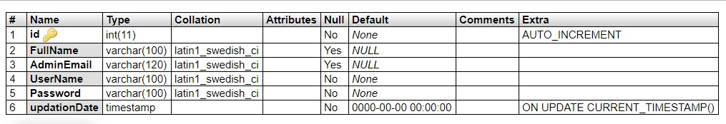

**tblusers:** This table store the user personal and login details.

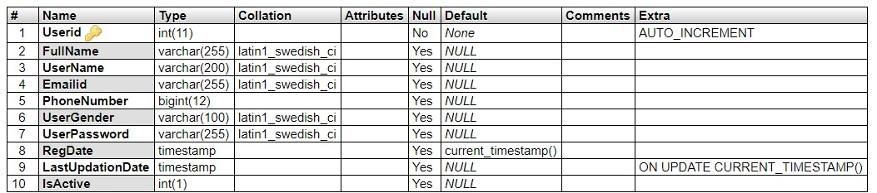

**tblcategory:** This table store the event category details.

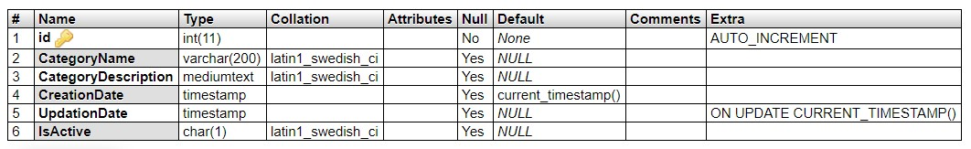

**tblsponsers:** This table store the event sponsor details.

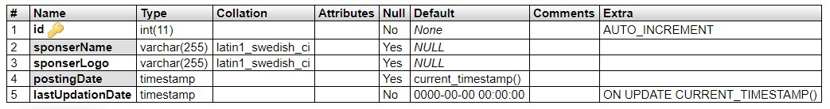

**tblevents:** This table store the event full details.

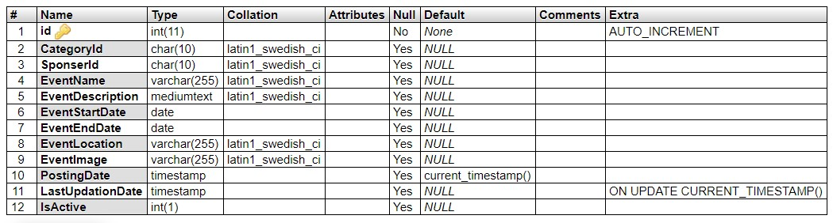

**tblbookings:** This table store the event booking details.

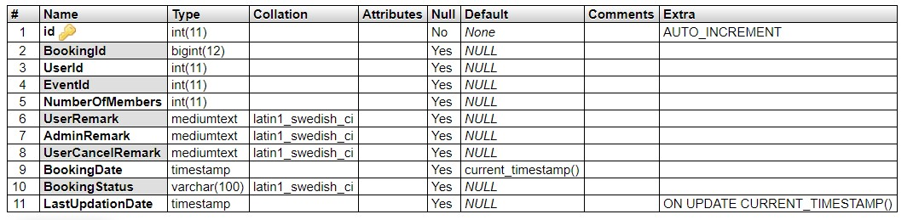

**tblnews:** This table store the news details.

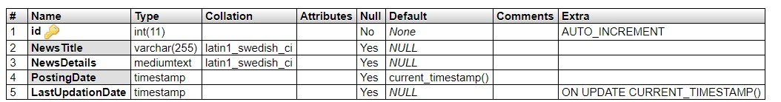

**tblnews:** This table store the pages info details.

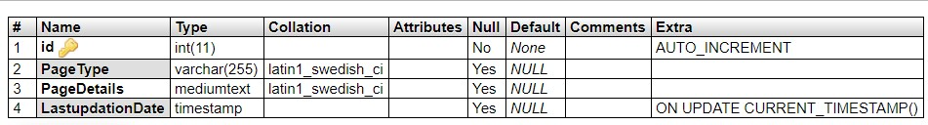

**tblgenralsettings :** This table store the website general settings.

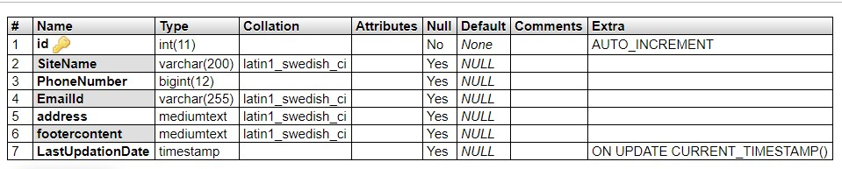

**tblsubscriber:** This table store the subscribers info.

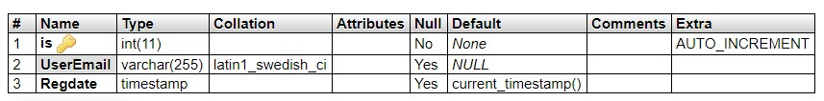

**4. PROJEC SCREENSHOT**

-----------------------------