**RECOMMENDING BEST RESTAURANTS FOR TOURISTS VISITING BANGALORE FROM VARIOUS COUNTRIES**

1. **BUSINESS PROBLEM**

People usually love travelling and exploring places. Many people travel across the world and explore many things during their vacation. Some do this as this primary work as well. When you travel to a new country, the main thing that changes and may affect people is the **FOOD.** Few many adapt with the new food style, but few may not. But in all big cities, food style of many countries is served in many restaurants. This project focuses for tourists/travelers who are coming from various countries to a particular city in India, Bangalore. These tourists may or may not love the Bangalore food style. So, in order to feel them comfortable with the food style, this project helps them with the variety of food restaurants surrounding them. It could be Indian, Chinese, American etc. Based on the familiarity and the type of the restaurant, people could choose the restaurant they want to go. For this I have primarily made use of Foursquare neighborhood data technique which would help me to find the restaurants nearby a particular neighborhood.

1. **DATA ACQUISTION AND CLEANING**

As I have chosen to work with Bangalore City, I need many location data related to Bangalore. I have collected as many neighborhood areas as possible in Bangalore City, their geographical locations like the latitude and longitude values etc. These neighborhood names, their latitude and longitude values could help me to proceed with my project. I have collected this information from various sites, cleaned and brought into a format which is easy to work with. A sample data set is shown below

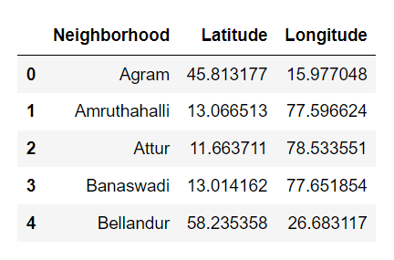

1. **METHODOLOGY**

**3.1 Geo-coordinates of Bangalore**

Initially I have collected the co-ordinates of Bangalore city and mapped the neighborhoods with some Circle Marker. These Circle Marker displays the each and every neighborhood with respect to its corresponding latitude and longitude values.

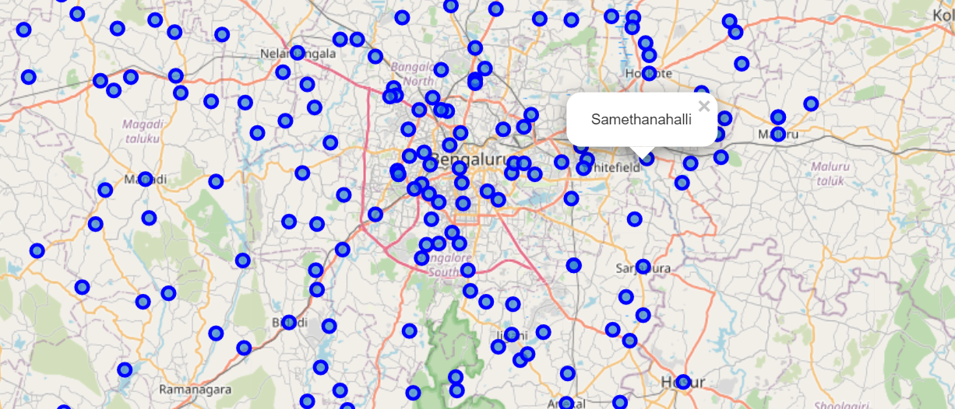

**3.2 Explore one neighborhood from the dataset**

From the dataset I have taken the first neighborhood and I wanted to know the restaurants surrounding the neighborhood. For this I have used the Foursquare Location data. This technique resulted me giving all the specific, loved, famous restaurants surrounding that particular neighborhood with a certain radius specified by me. But still I haven’t listed the restaurants orderly in terms of familiarity and most used.

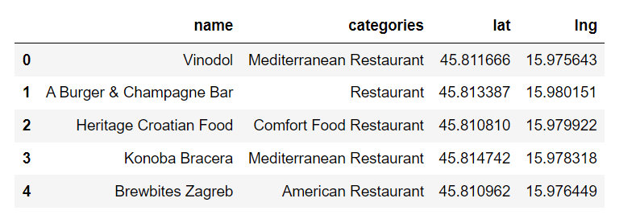

The above data is for only one neighborhood in a big city, Bangalore. The categories field will really help me to guide tourists to choose the best restaurants around them.

**3.3 Exploring all the neighborhoods from the dataset**

Now that I have listed the venues for only one neighborhood. There are many areas in Bangalore where people stay and will be searching for restaurants. Having the insights for all the neighborhoods would be a wise thing, so that any tourist person who wish to go for particular type of restaurant in a particular area of Bangalore, these venue details could help them greatly. So, for each neighborhood, based on the familiarity of the neighborhood, corresponding venues and its categories are listed along with their latitude and longitude values.

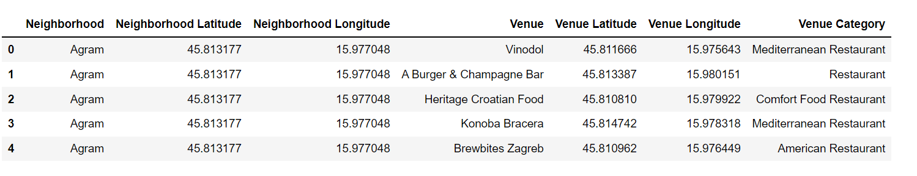

**3.4 Performing One Hot Encoding over Venue Category**

Now, I have performed One Hot Encoding over the venue category so the categorical names are transferred to 0’s and 1’s. It is then normalized by taking the mean of each neighborhood value. This is helpful for determining the frequency of category that is mostly in use in the particular area. With this frequency you can also find the top-most categories in a particular venue.

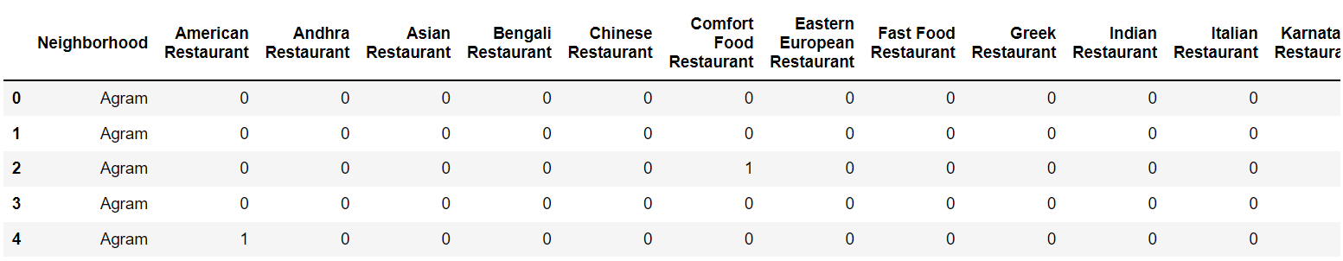

1. **RESULTS**

After performing the One Hot Encoding Analysis, I have listed the top 10 restaurant categories in each neighborhood. So, if someone would like to have a particular food style in a particular area in Bangalore and he has no idea about which restaurant in that area is most famous, this Result could help them to choose the restaurant wisely. Having known the area, I have the results for top most restaurant categories in that area. So, based on the wish and mood of a person he could choose any kind of available restaurants. Since Bangalore is in India, non-Indian style of restaurants may be in least common venue category as those are not mostly loved by Bangalore people. But the tourist person coming from other country can make use of that restaurant.

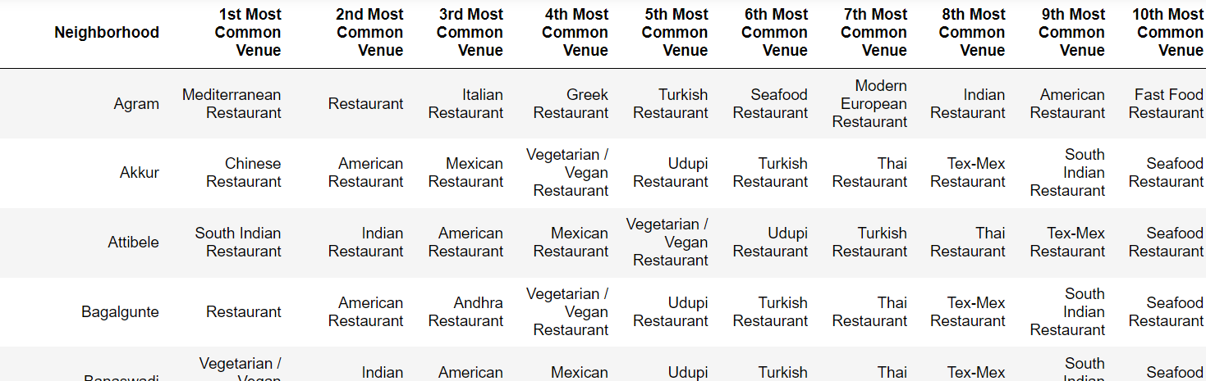

So, if the person is staying in “Agram” locality, I would suggest him to have a try in Mediterranean Restaurant. If he is not satisfied with that, he could go for other cuisines available in his locality.

1. **DISCUSSION**

Going one step ahead, I have used clustering algorithm to find out similar neighborhoods across Bangalore. This data could help tourists to know that similar kind of restaurants are familiar in similar cluster places. So, when the traveler moves from one place to other place in Bangalore this clustering could help him to find similar and familiar kind of restaurants/cuisines available in the new locality he stays.

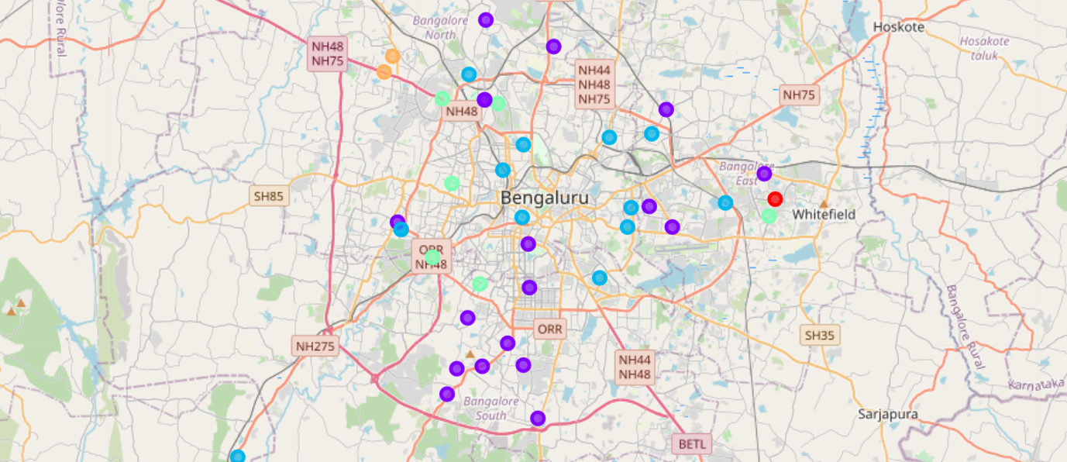

The similar neighborhoods are grouped into clusters. From this visualization, one can easily identify similar neighborhoods and restaurants across Bangalore which could help him to know that similar kind of restaurants/cuisines will be available when they move to another neighborhood.

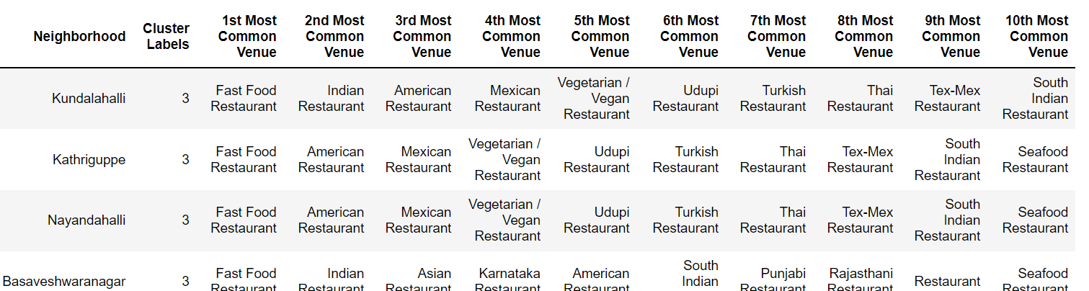

From the above result, we could infer that if a person moves from Kundalahalli to Nayandahalli, he could have an idea that there also he should have Fast food as it is in topmost priority. If he wishes to try different kind of cuisine based on the cluster dataset, he could even move to that venue so that he can have different cuisine which is familiar in that locality.

1. **CONCLUSION**

This project gives a great solution for tourists/travelers who are coming from various countries to a particular city in India, Bangalore. They could feel comfortable with the food style, showing variety of restaurants/cuisines surrounding them. Based on the familiarity and the type of the restaurant, people could choose the restaurant they want to go. The clustering algorithm used would really be helpful when they travel to other areas of Bangalore.