1. Create an HTML form that contain the Student Registration details and write a JavaScript to validate Student first and last name as it should not contain other than alphabets and age should be between 18 to 50.

<html>
<head>
<script type="text/javascript">
function validateStudent(){
var regName = /^[a-zA-z]+[a-zA-Z]+$/;
var fname = document.getElementById('fsname').value;
var lname = document.getElementById('lsname').value;
var age = document.getElementById('age').value;
var phone = document.getElementById('phone').value;

if(age<18 || age>50)
alert("student age must be 18 to 50");
if(!regName.test(fname))
alert("invalid name");
if(!regName.test(lname))
alert("invalid name");
}
</script>
</head>
<body>
<form>
<h1>Student Form :</h1>
student first name :
<input type="text" name="fsname" id="fsname"><br>
student last name :
<input type="text" name="lname" id="lsname"><br>
student age :
<input type="text" name="age" id="age"><br>
student mobile :
<input type="text" name="phone" id="phone"><br>
<input type="button" value="validate" onclick="validateStudent()">
</form>
</body>
</html>

//Output:
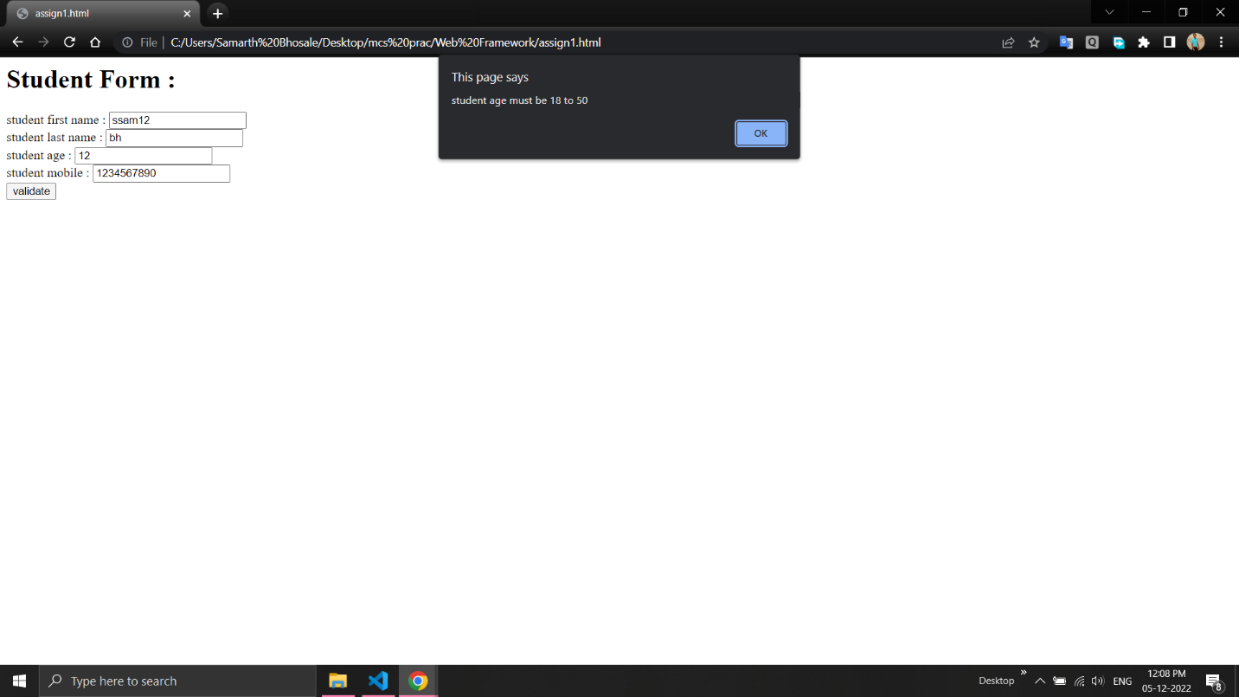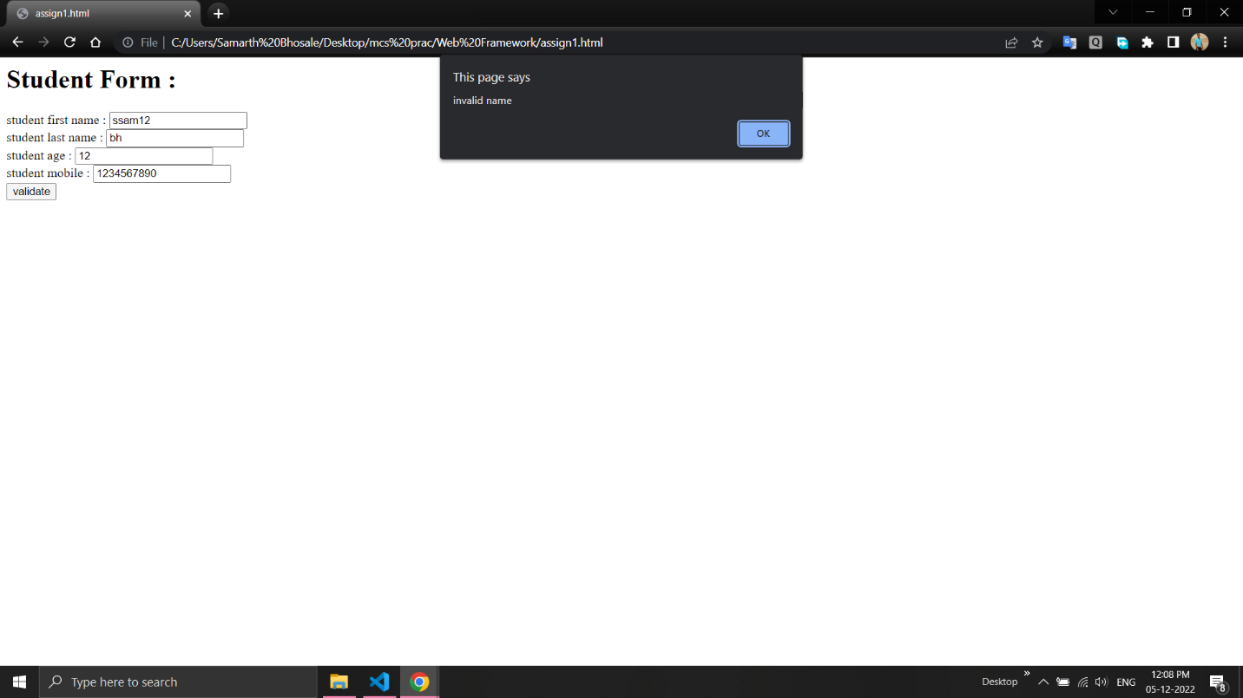

2. Create an HTML form that contain the Employee Registration details and write a JavaScript to validate DOB, Joining Date, and Salary.

<html>
<head>
<script type="text/javascript">
function validate(){
var regName=/^[a-zA-z]+[a-zA-Z]+$/;
var dateformatdob = /^(0?[1-9]|[12][0-9]|3[01])[\/\-](0?[1-9]|1[012])[\/\-]\d{4}$/;
var dateformatjdate = /^(0?[1-9]|[12][0-9]|3[01])[\/\-](0?[1-9]|1[012])[\/\-]\d{4}$/;
var salaryformat=/^\d{1,6}(?:\.\d{0,2})?$/
var name=document.getElementById("name").value;
var dob=document.getElementById("dob").value;
var jdate=document.getElementById("jdate").value;
var salary=document.getElementById("salary").value;

if(!regName.test(name))
alert("invalid name is given");
if(!dateformatjdate.test(jdate))
alert("invalid joining date is given");
if(!dateformatdob.test(dob))
alert("invalid date of birth is given");
if(!salaryformat.test(salary))
alert("invalid salary");
}
</script>
</head>
<body>
<form>
<h1>Employee Rsgistration Details</h1>
employee name :
<input type="text" name="fname" id="name"><br>
date of birth :
<input type="text" name="dob" id="dob"><br>
joining date :
<input type="text" name="jdate" id="jdate"><br>
salary :
<input type="text" name="salary" id="salary"><br>
<input type="button" value="validate" onclick="validate()">
</form>
</body>
</html>

//Output: 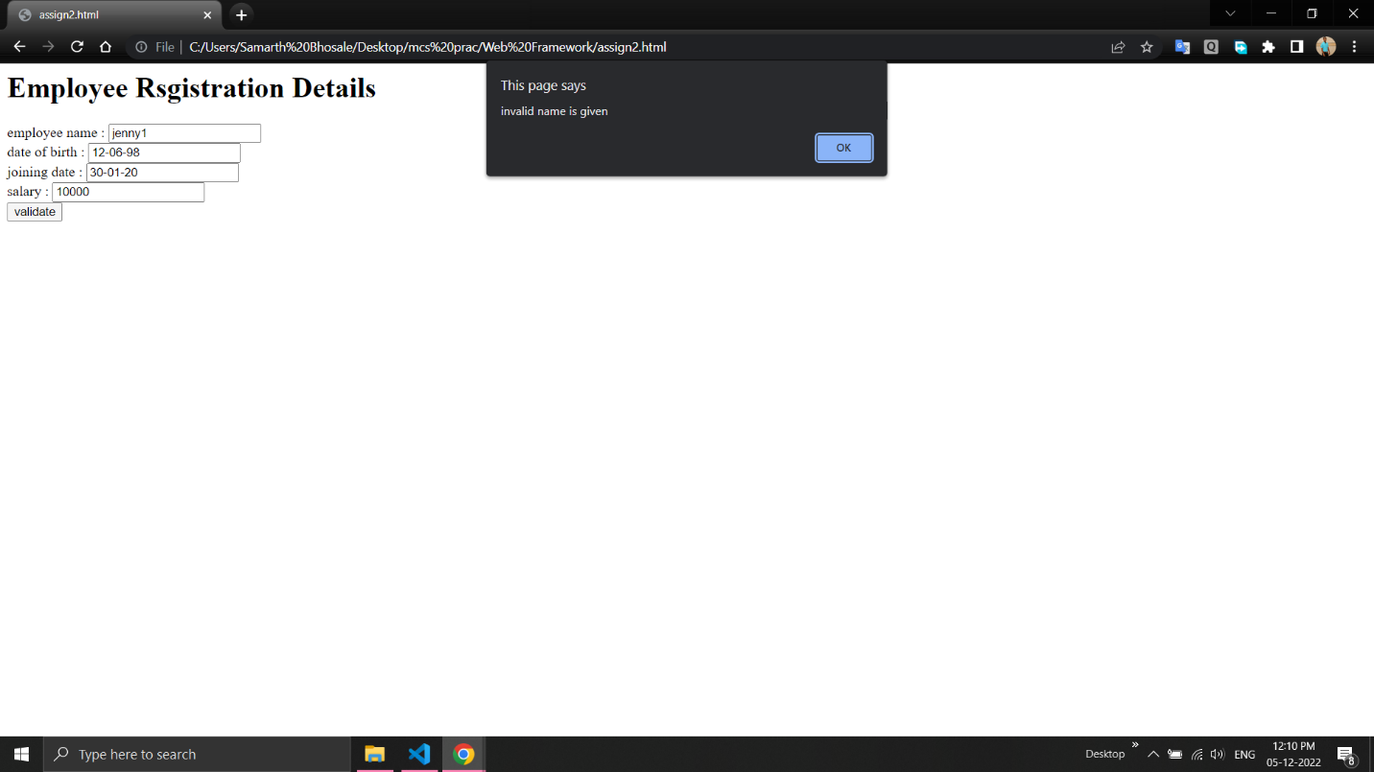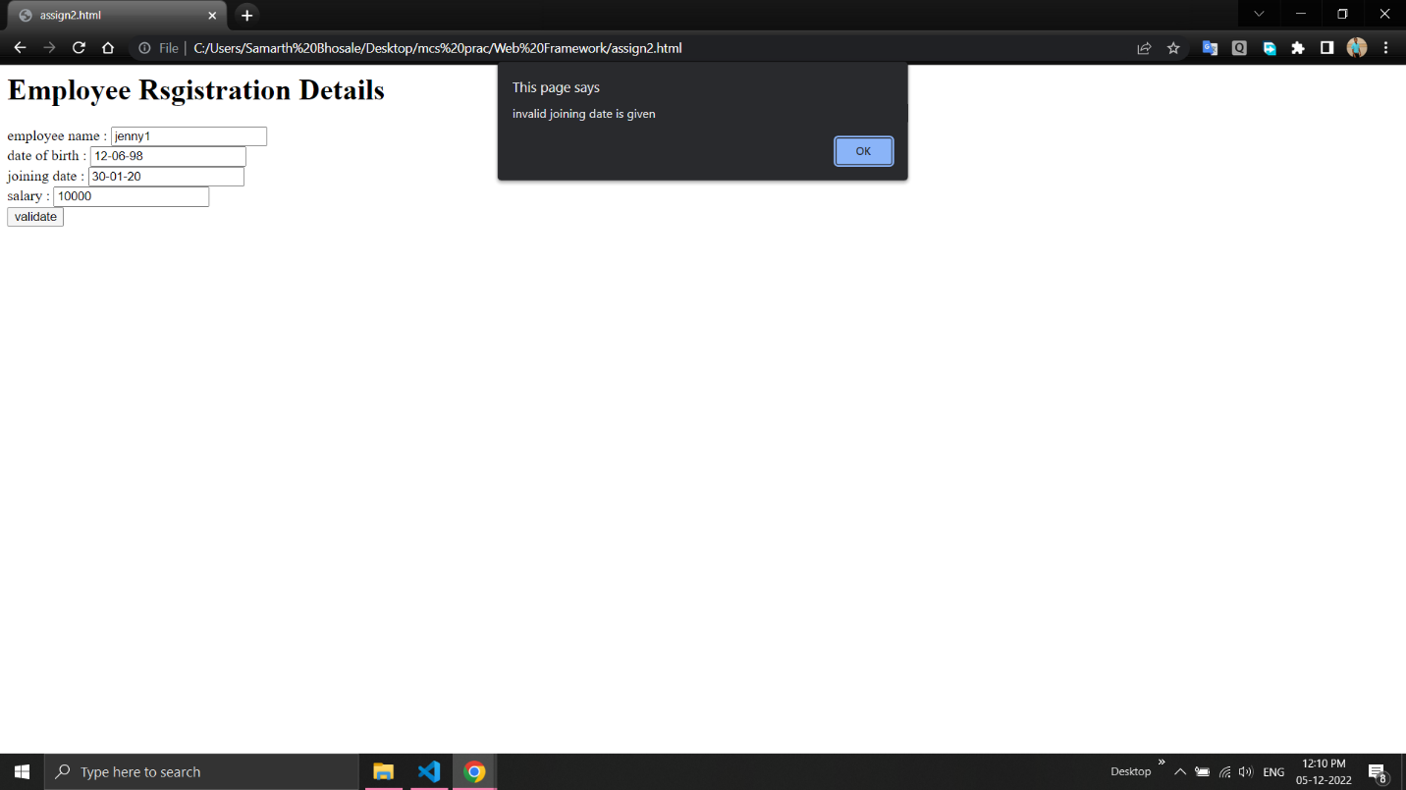
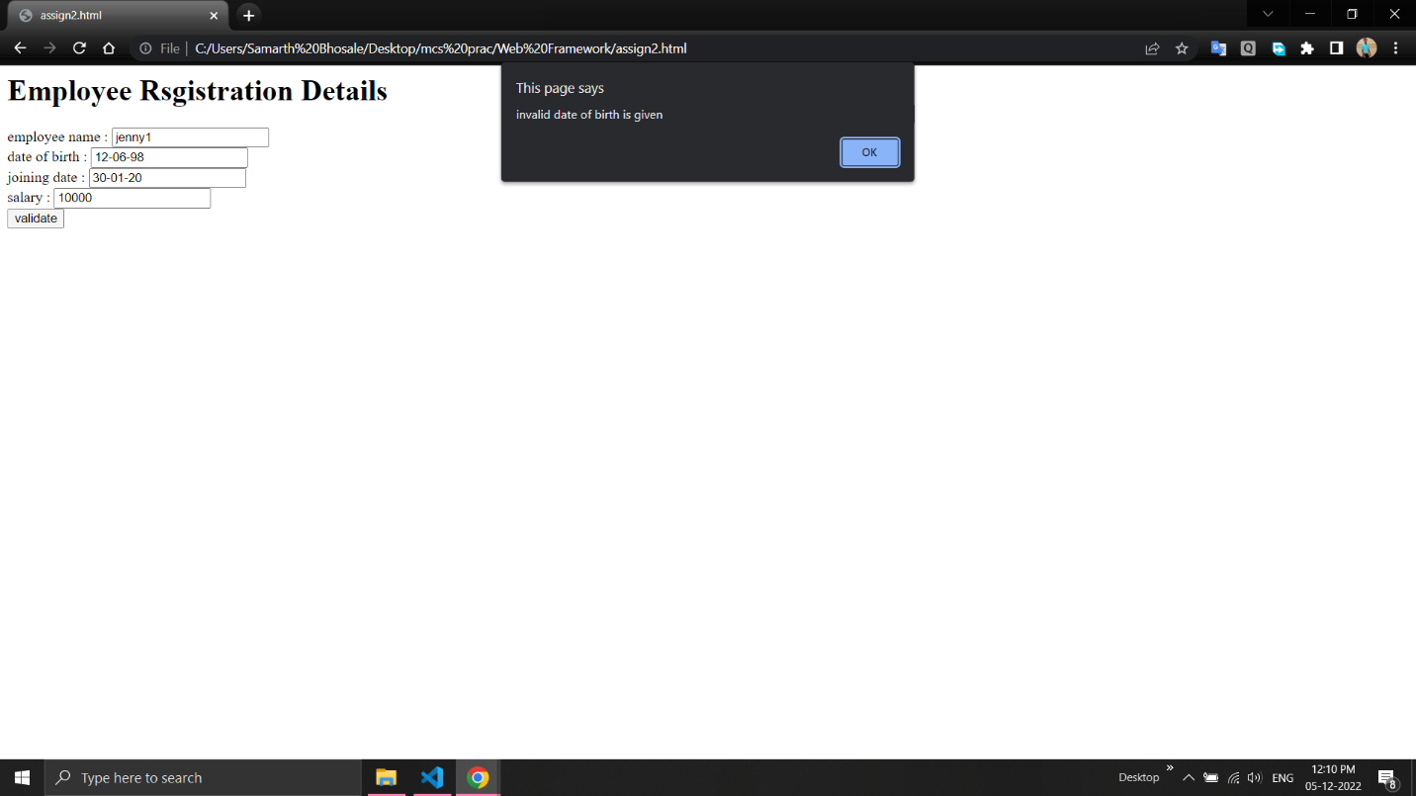

3. Create an HTML form for Login and write a JavaScript to validate email ID using Regular Expression.

<html>
<head>
<script>
function validateform(){
var email = document.getElementById("email").value;
var password = document.getElementById("psw").value;
if (!(/^\w+([\.-]?\w+)*@\w+([\.-]?\w+)*(\.\w{2,3})+$/.test(email)))
alert("You have entered an invalid email address!");
}
</script>
</head>
<body>
<form name="myform" onsubmit="return validateform()">
<h1>Please fill in this form to Login.</h1>

Email :
<input type="text" autocomplete="off" placeholder="Enter Email" name="email" id="email" required><br>
Password :
<input type="password" autocomplete="off" placeholder="Enter Password" name="psw" id="psw" required><br>
<button type="submit" class="registerbtn">Register</button>
</form>
</body>
</html>

//Output:
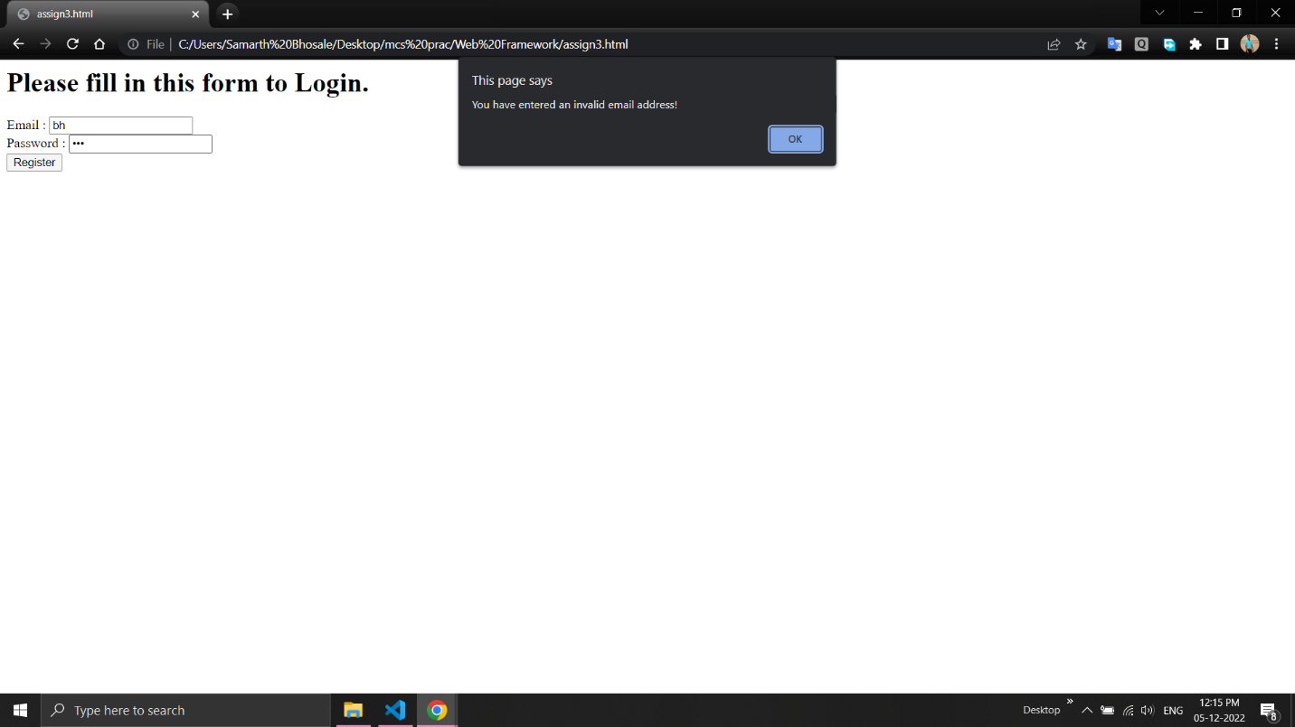

4. Create a Node.js file that will convert the output "Hello World!" Into upper-case letters.

var http = require('http');
var uc = require('upper-case');
http.createServer(function (req, res){
res.writeHead(200, {'Content-Type': 'text/html'});
res.write(uc.upperCase("hello world..!!!"));
res.end();
}).listen(8080);

//Output:
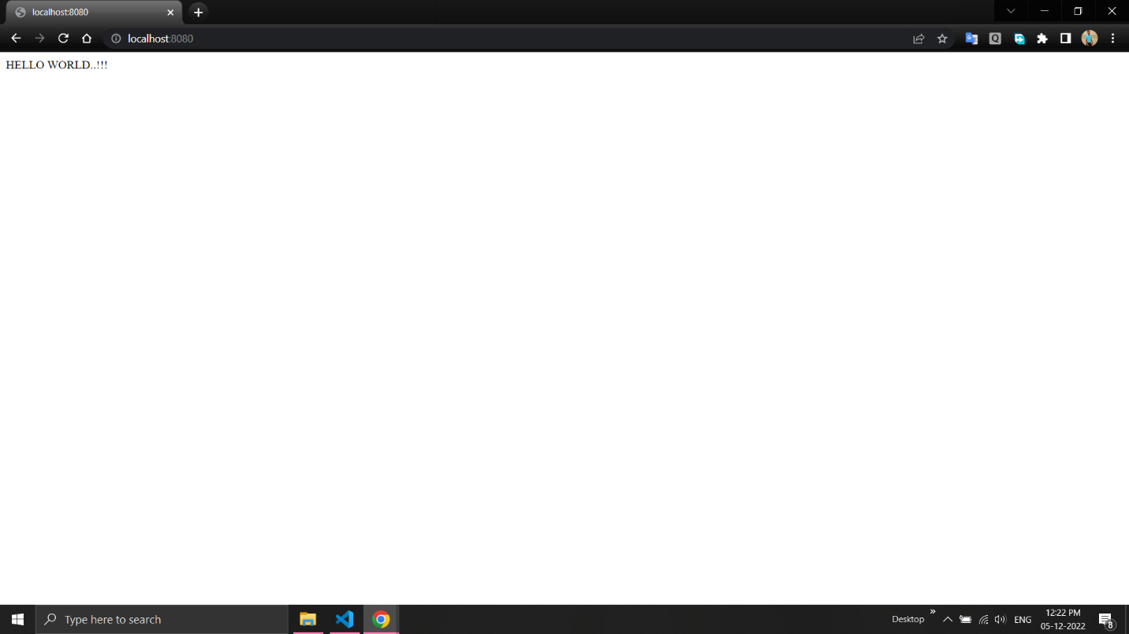

5. Using Node.js create a web page to read two file names from user and append contents of first file into second file.

var fs = require('fs');
console.log("\nFile Contents of file before append:");
var a = fs.readFileSync("file1.txt", "utf8");
fs.appendFile("file2.txt", a, function(err){
if (err)
console.log(err);
else {
console.log("\nFile Contents of file after append:",
fs.readFileSync("file2.txt", "utf8"));
}
});

//Output:
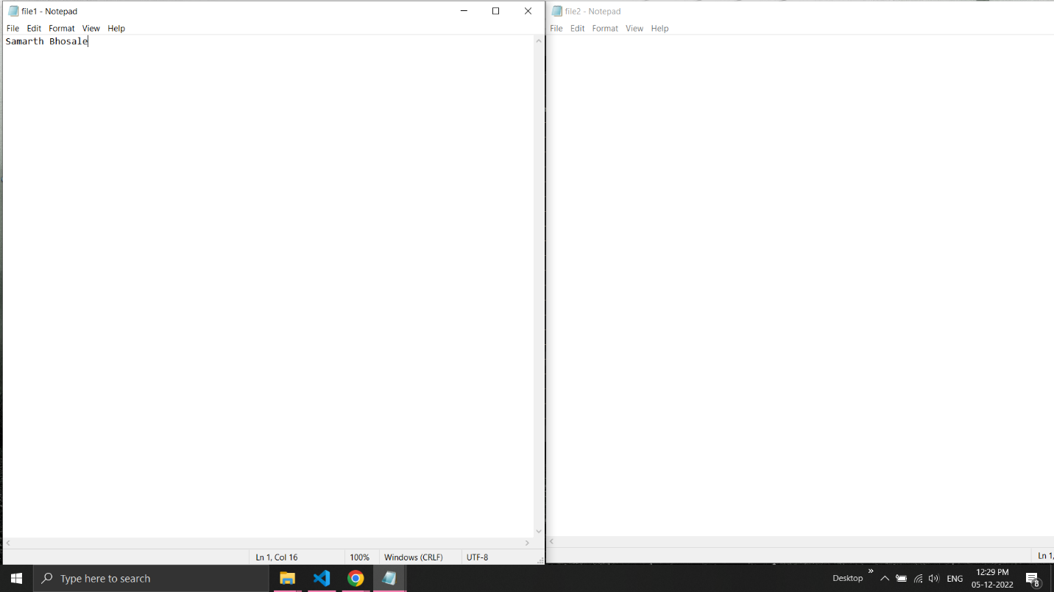

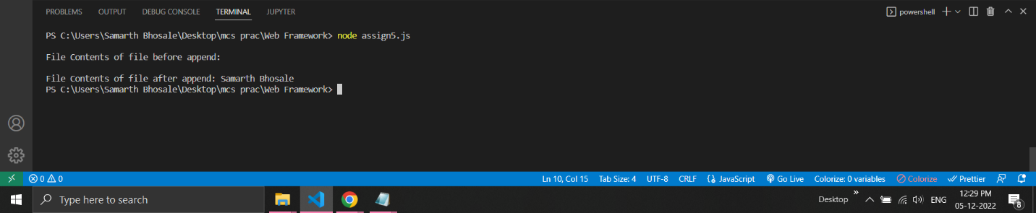
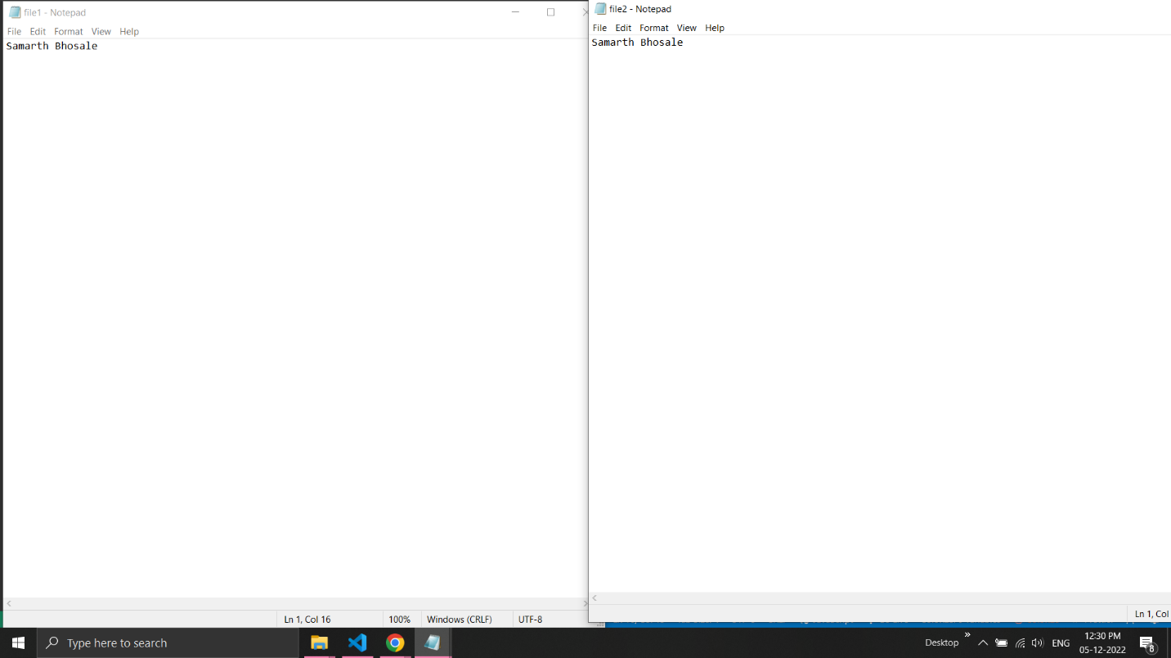

6. Create a Node.js file that opens the requested file and returns the content to the client. If anything goes wrong, throw a 404 error.

var http = require('http');
var url = require('url');
var fs = require('fs');

http.createServer(function (req, res) {
var q = url.parse(req.url, true);
var filename = "." + q.pathname;

fs.readFile(filename, function(err, data) {
if (err) {
res.writeHead(404, {'Content-Type': 'text/html'});
return res.end("404 Not Found");
}
res.writeHead(200, {'Content-Type': 'text/html'});
res.write(data);
return res.end();
});
}).listen(8080);

//Output:
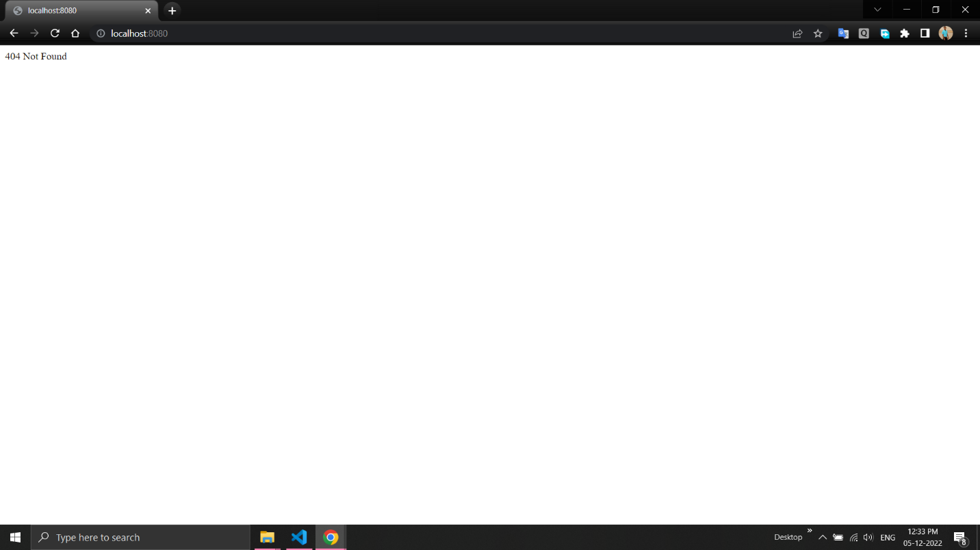

7. Create a Node.js file that writes an HTML form, with an upload field.

var http = require('http');
http.createServer(function (req, res) {
res.writeHead(200, {'Content-Type': 'text/html'});
res.write('<form action="fileupload" method="post" enctype="multipart/form-data">');
res.write('<input type="file" name="filetoupload"><br>');
res.write('<input type="submit">');
res.write('</form>');
return res.end();
}).listen(8080);

//Output:
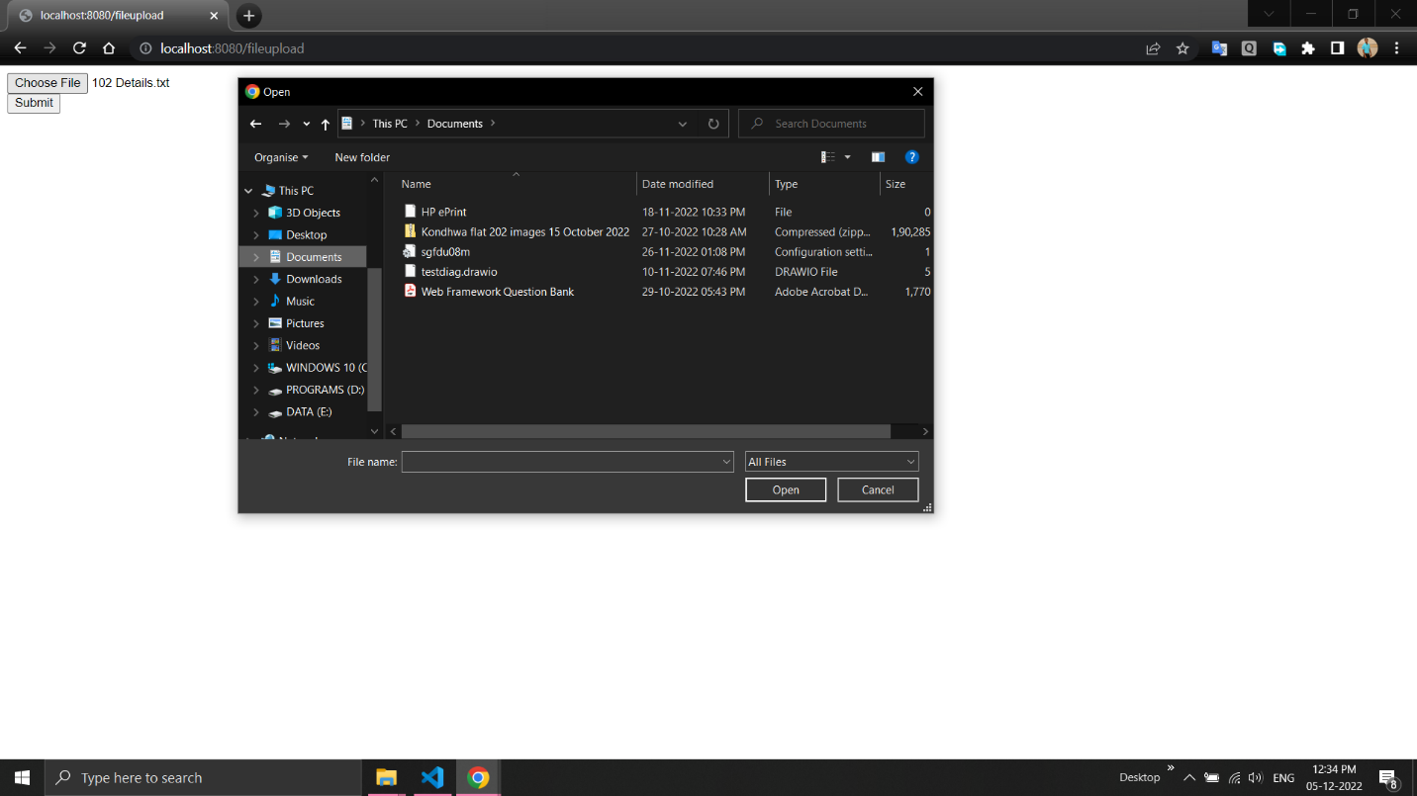

8. Create a Node.js file that demonstrate create database and table in MySQL.

var mysql = require('mysql');
var con = mysql.createConnection({
host: "localhost",
user: "root",
password: "",
database: "sam"
});

con.connect(function(err) {
if (err) throw err;
else
console.log("Connected!");
con.query("create database sam13", function (err, result) {
if (err)
console.log(err);
console.log("Database Created");
});
});

con.query("use sam13",function(err){
if(err)
console.log(err);
else
console.log("Database { "+"sam13 } selected!");
});

var sql = "create table customer1(name varchar(10), address varchar(10))";
con.query(sql, function (err, result) {
if (err)
console.log(err);
else
console.log("Table Created");
});

//Output:
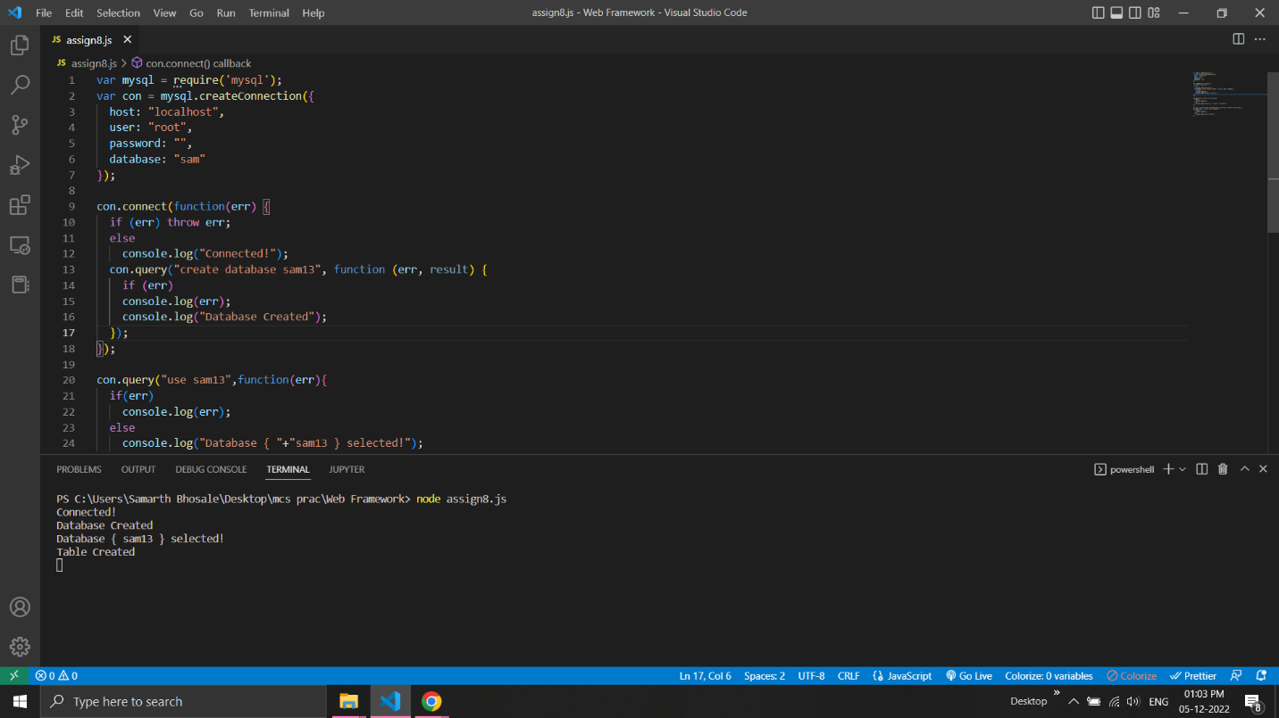

9. Create a node.js file that Select all records from the "customers" table, and display the result object on console.

var mysql = require('mysql');
var con = mysql.createConnection({
host: 'localhost',
user: "root",
password: "",
database:'sam'
});

con.connect(function(err) {
if (err) throw err;
else
console.log("Connected!");
});

con.query('select * from customer1', function(err,rows){
if(err) throw err;
else
console.log(rows);
});

//Output:
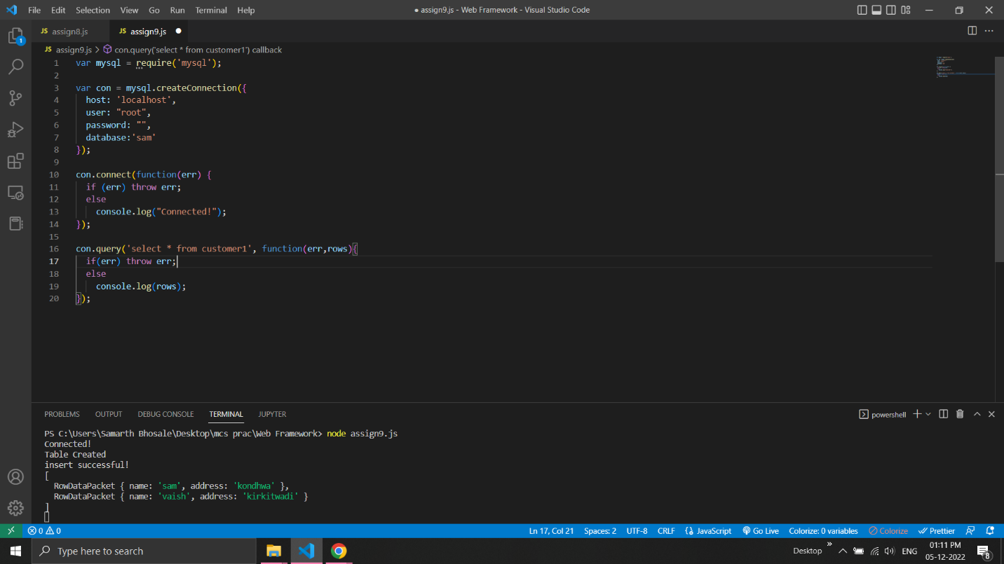

10. Create a node.js file that Insert Multiple Records in "student" table and display the result object on console.

var mysql = require('mysql');
var con = mysql.createConnection({
host: "localhost",
user: "root",
password: "",
database: "sam"
});
con.connect(function(err) {
if (err) throw err;
else{
console.log("Connected!");

con.query("create table students1(roll int primary key, name text, address text)",function(err){
if(err) throw err;
else{
con.query("insert into students1 values(111,'sam','kondhwa'),(222,'vaish','kirkitwadi'),(333,'saarth','wanawadi')",function(err){
if(err) throw err;
else{
console.log("data inserted!");
con.query("select * from students", function (err, result) {
if (err) throw err;
else
console.log(result);
});
}
});
}
});
}
});

//Output:
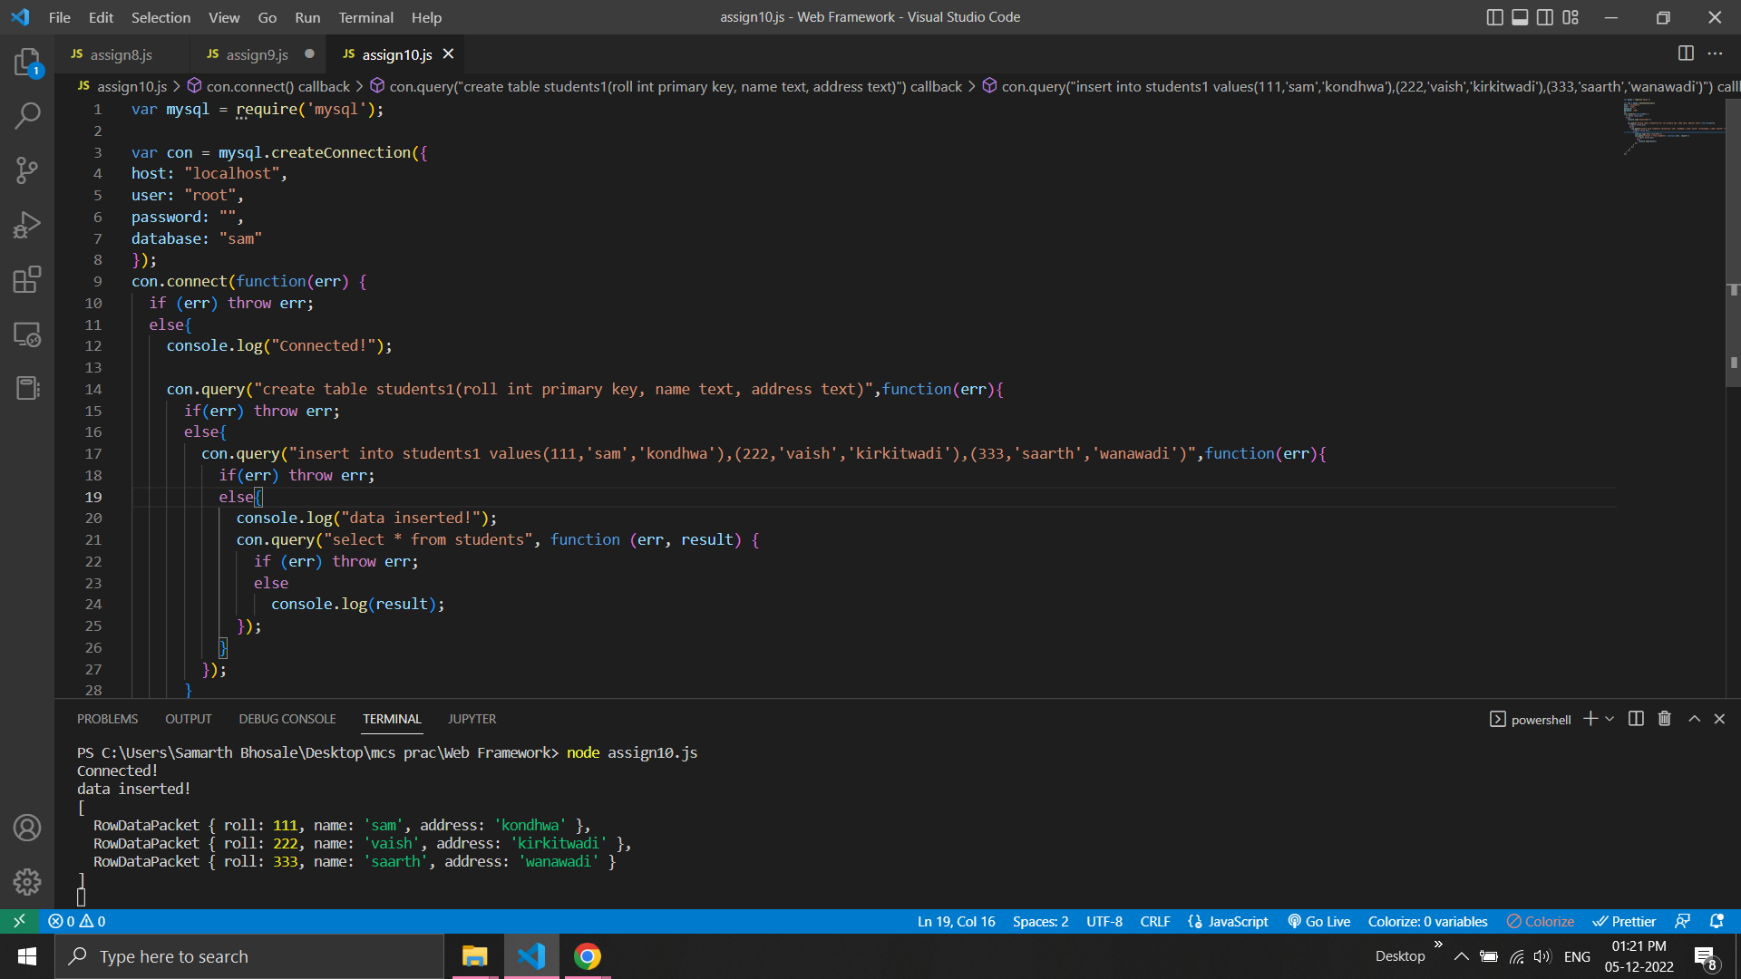

11. Create a node.js file that Select all records from the "customers" table, and delete the specified record.

var mysql = require('mysql');
var con = mysql.createConnection({
host: "localhost",
user: "root",
password: "",
database: "sam"
});

con.connect(function(err) {
if (err) throw err;
else{
console.log("Connected!");
con.query("select * from customer1", function (err, result) {
if (err) throw err;
else{
console.log(result);
con.query("delete from customer1 where name = 'riya'", function (err, result){
if (err) throw err;
else{
console.log("Deleted Record : " + result.affectedRows);
con.query("select * from students1", function (err, result) {
if (err) throw err;
else
console.log(result);
});
}
});
}
});
}
});

//Output:
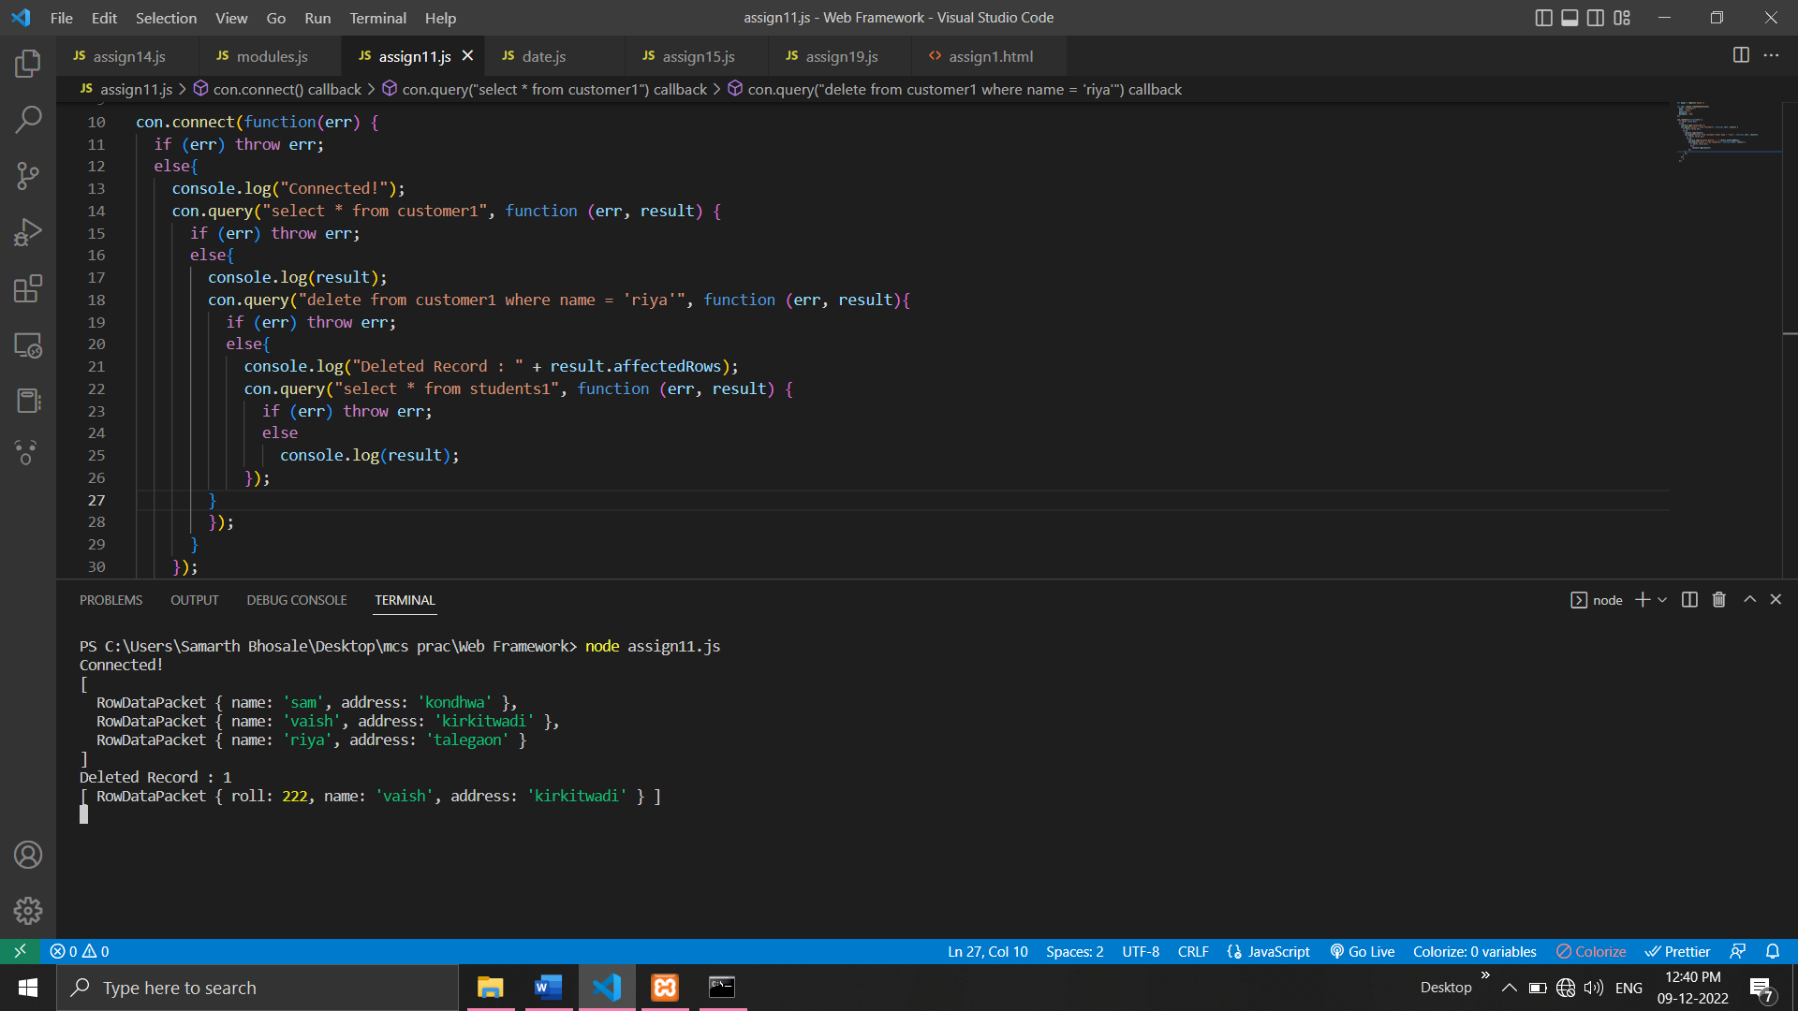

12. Create a Simple Web Server using node js.

var http = require('http');
var server = http.createServer(function (req, res) {
res.write("<h1>Server Created!</h1>");
});
server.listen(8080);

//Output:
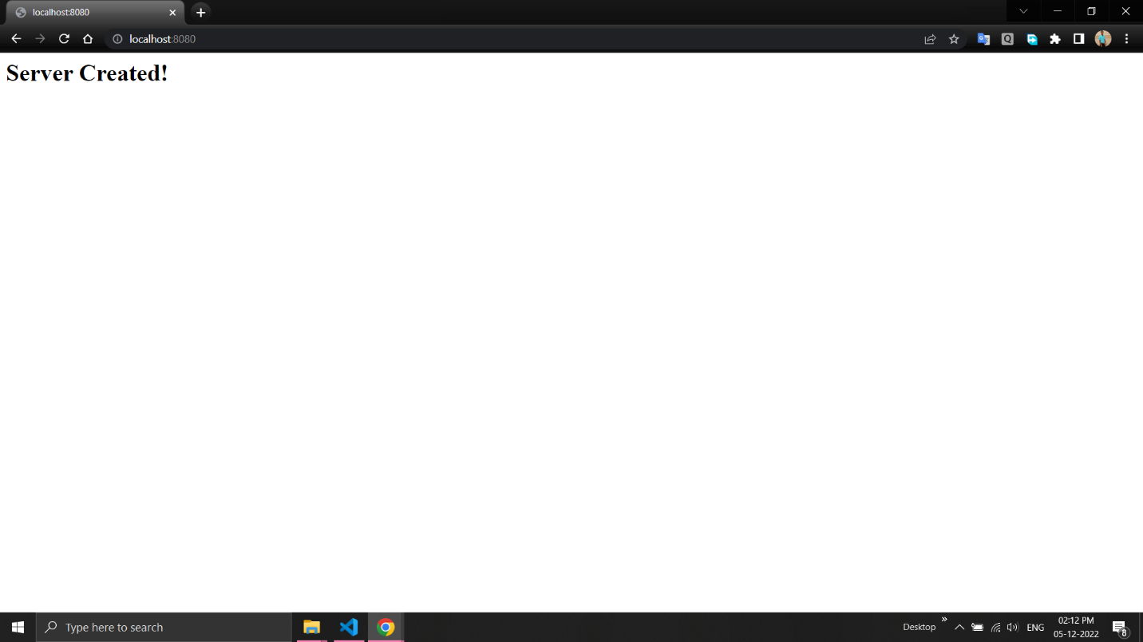

13. Using node js create a User Login System.

html-
<html>
<head>
<title>User login page</title>
<head>
<script>
function f(){
var validRegex =/^[a-zA-Z0-9.!#$%&'+/=?^_`{|}~-]+@[a-zA-Z0-9-]+(?:\.[a-zA-Z0-9-]+)$/;
var email=document.getElementById("email").value;
if(!validRegex.test(email))
alert("Invalid Email!");
else
alert("submitted succesfully");
return false;
}
</script>
</head>
<body>
<form name="login" onsubmit="f()">
<h1>Login here</h1>
email id:<input type="text" id="email"/><br><br>
password:<input type="password" id="password"><br><br>
<input type="submit" id="submit" value="submit">
</form>
</body>
</html>

javascript-
var http=require('http');
http.createServer(function(req,resp){
var fs=require("fs");
resp.writeHead(200,{'content-type':'text/html'});
var content= fs.readFileSync("login.html");
if(content){

resp.write(content);
}
else{
resp.write("404 error");
}

resp.end();
}).listen(6006);
//Output:

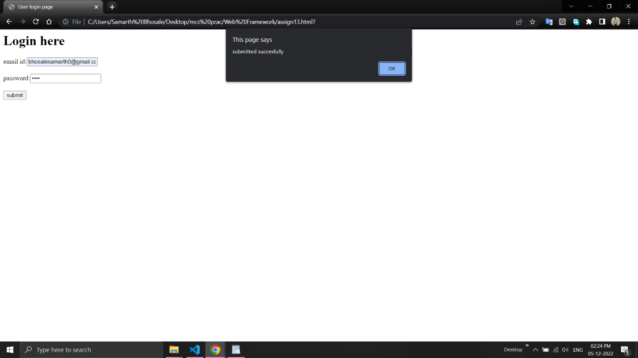

14. Using node js create an eLearning System.

html –
<html>
<head>
</head>
<body>
<center>
<h1>E-Learning</h1>

<h3>
<a href = "home.html">Home</a>
<a href = "team.html">Team</a>
<a href = "about.html">About</a>
<a href = "contact.html">Contact</a>
</h3>
</center>
</body>
</html>

javascript –
var fs=require("fs");
var http = require('http');
http.createServer(function(req,resp){
resp.writeHead(200,{"content-type":"text/html"});
var content=fs.readFileSync("elearningnew.html");
if(content)
resp.write(content);
else
resp.write("404 error");
resp.end()
}).listen(8080);

//Output:
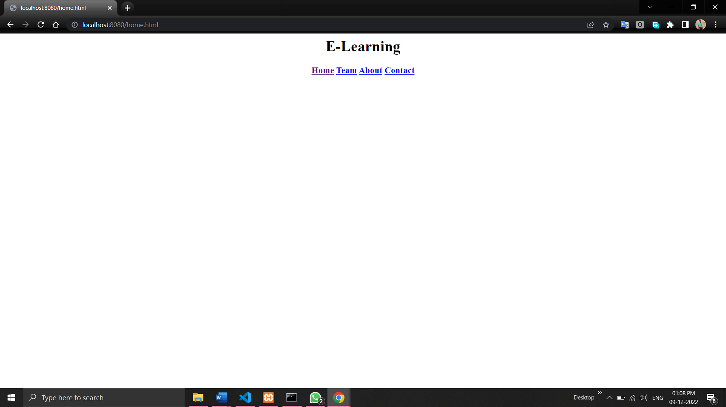

15. Using node js create a Recipe Book.

html –
<html>
<head>
<title>Recipe Book</title>
</head>
<body>
<center>
<h1>Recipe Book - Pasta</h1><br>
</center>
<h3>Ingredients</h3>
<p>Serves 2 people</p>
<ul>
<li>Veggies</li>
<li>Raw Pasta</li>
<li>Sauces</li>
<li>Oil</li>
<li>Herbs</li>
</ul>
<br>
<h3>Preparation</h3>
<ul>
<li>Take 2 cups water.</li>
<li>Boil the pasta half.</li>
<li>Fry the veggies.</li>
<li>Pasta is ready to serve.</li>
</ul>

</body>
</html>

Javascript –
var fs=require("fs");
var http = require('http');
http.createServer(function(req,resp){
resp.writeHead(200,{"content-type":"text/html"});
var content=fs.readFileSync("recipenew.html");
if(content)
resp.write(content);
else
resp.write("404 error");
resp.end()
}).listen(8080);

//Output:
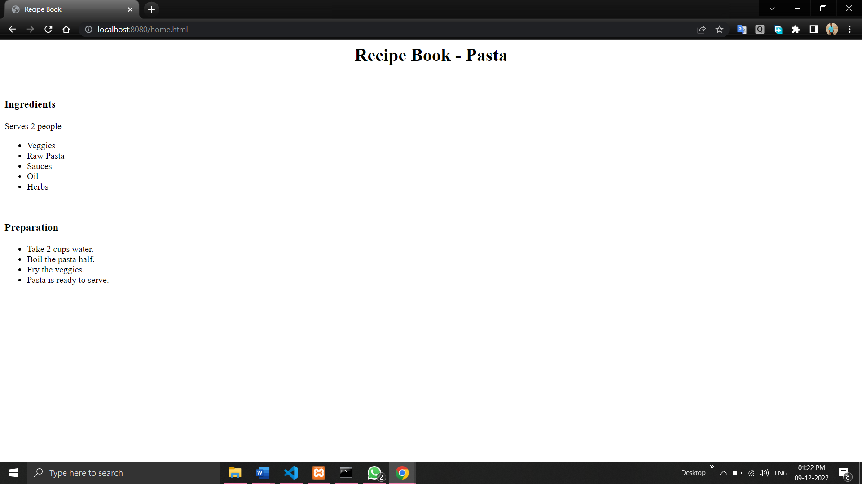

16. Write node js script to interact with the filesystem, and serve a web page from a file.
var express = require('express');
var app = express();
var PORT = 3000;

app.get('/', function(req, res){
res.download('hello.txt');
});

app.listen(PORT, function(err){
if (err) console.log(err);
console.log("Server listening on PORT", PORT);
});

//Output:
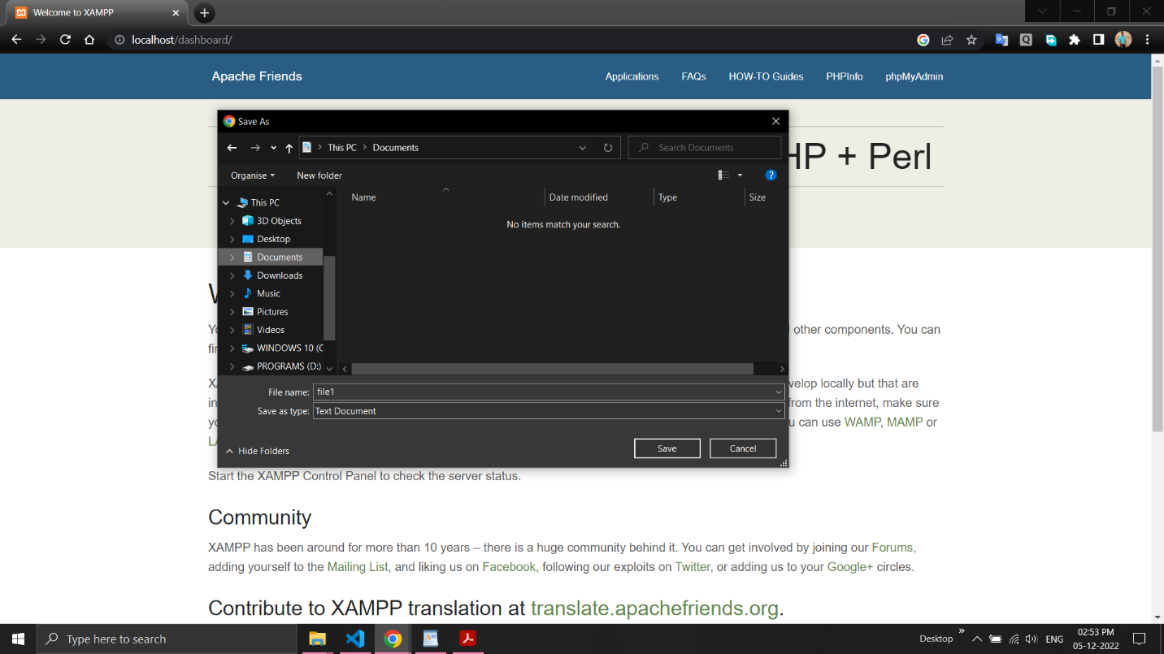

17. Write node js script to build Your Own Node.js Module. Use require (‘http’) module is a built-in Node module that invokes the functionality of the HTTP library to create a local server. Also use the export statement to make functions in your module available externally. Create a new text file to contain the functions in your module called, “modules.js” and add this function to return today’s date and time.
Modules.js –
module.exports.dt= new Date();

date.js -
var http = require('http');
var dt = require('./Modules');

http.createServer(function (req, res) {
res.writeHead(200, {'Content-Type': 'text/html'});
res.write("The date and time are currently: " + dt.myDateTime());
res.end();
}).listen(8080);

//Output:
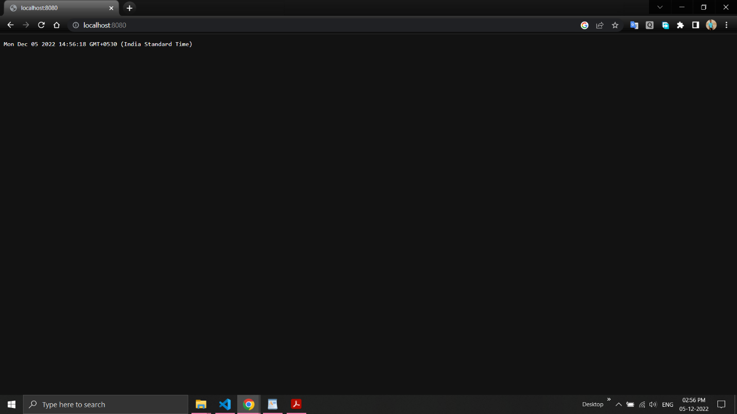

18. Create a js file named main.js for event-driven application. There should be a main loop that listens for events, and then triggers a callback function when one of those events is detected.
var events = require('events');
var myeventEmitter = new events.EventEmitter();
myeventEmitter.on('myevent', function Listener1(){
console.log('listener1 executed!');
});
myeventEmitter.on('myevent' ,function Listener2(a,b){
console.log('listener2 executed! parameter');
});
console.log(myeventEmitter.listeners('myevent'));
myeventEmitter.emit('myevent' ,10,20);

//Output:
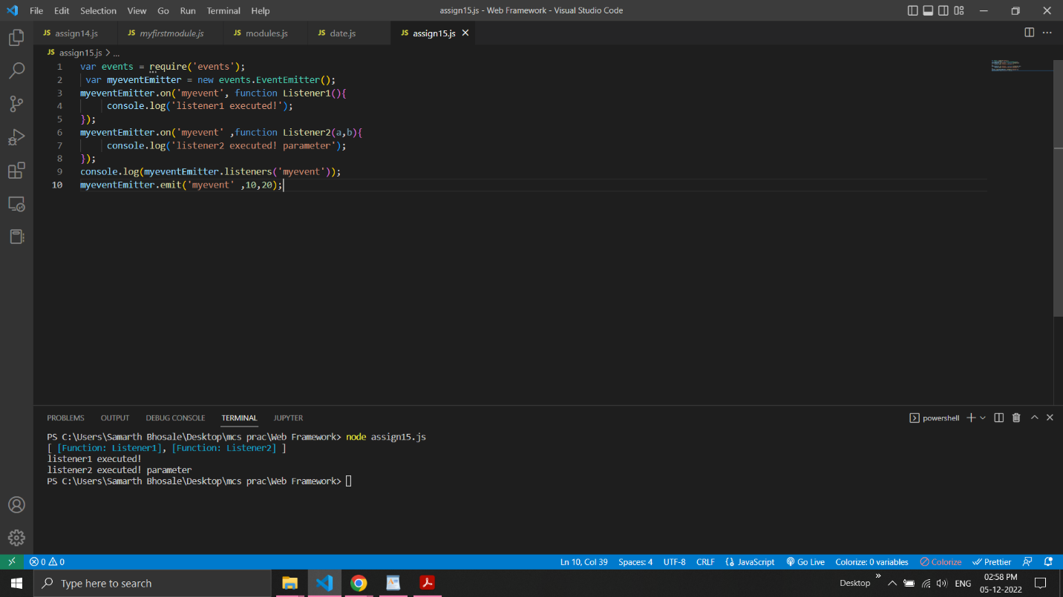

19. Write node js application that transfer a file as an attachment on web and enables browser to prompt the user to download file using express js.
var express = require("express");
var app = express();
app.get('/a/',function(req,res){
res.download('file2.txt');
});
app.listen(8051,function(err){
if(err)
console.log(err);
console.log("Server is listening..");
});

//Output:
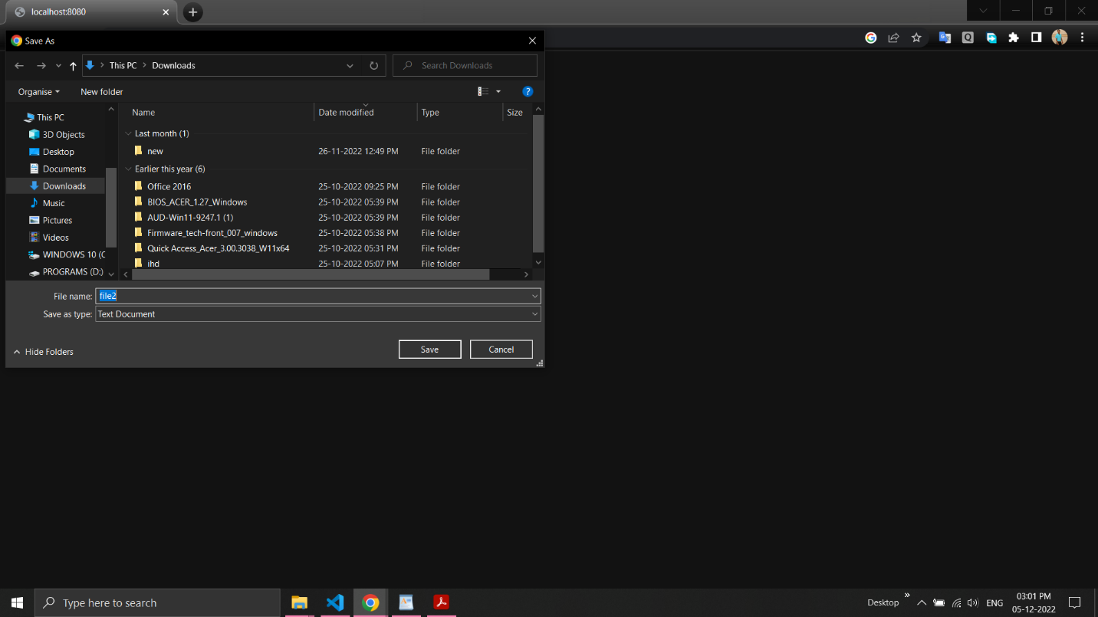

20.Create your Django app in which after running the server, you should see on the browser, the text “Hello! I am learning Django”, which you defined in the index view.

Views.py -
# -*- coding: utf-8 -*-
from __future__ import unicode_literals
from django.shortcuts import render
from django.http import HttpResponse
# Create your views here.
def index(req):
return render(req,"m.html")

urls.py -
"""myproj URL Configuration
The `urlpatterns` list routes URLs to views. For more information please see:
https://docs.djangoproject.com/en/1.11/topics/http/urls/
Examples:
Function views
1. Add an import: from my_app import views
2. Add a URL to urlpatterns: url(r'^$', views.home, name='home')
Class-based views
1. Add an import: from other_app.views import Home
2. Add a URL to urlpatterns: url(r'^$', Home.as_view(), name='home')
Including another URLconf
1. Import the include() function: from django.conf.urls import url, include
2. Add a URL to urlpatterns: url(r'^blog/', include('blog.urls'))
"""
from django.conf.urls import url
from django.contrib import admin

from myapp1.views import index
urlpatterns = [
url(r'^admin/', admin.site.urls),
url("/",index),
]
m.html -
<html>
<body>
<b> Hello I am Learning Django</b>
</body>
</html>
//Output –
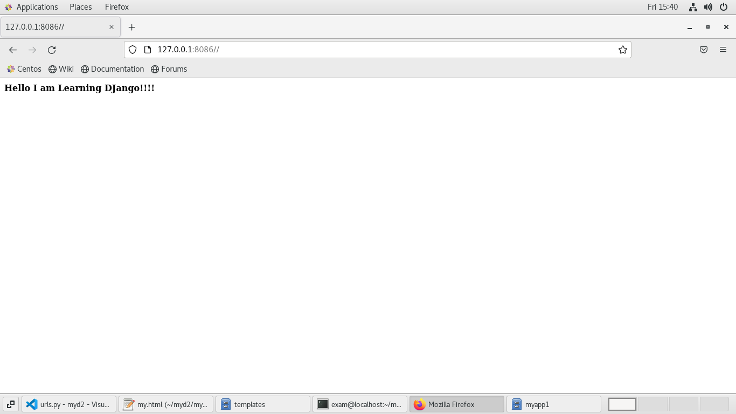

21.Design a Django application that adds web pages with views and templates.

views.py -
from django.shortcuts import render
from django.http import HttpResponse

def f1(req):
return render(req,"a.html")
def f2(req):
return render(req,"b.html")
def f3(req):
return render(req,"c.html")

urls.py -
from django.contrib import admin
from django.urls import path
from views.views import f1
from views.views import f2
from views.views import f3

urlpatterns = [
path('admin/', admin.site.urls),
path('first/',f1),
path('second/',f2),
path('third/',f3),
]
//Output-
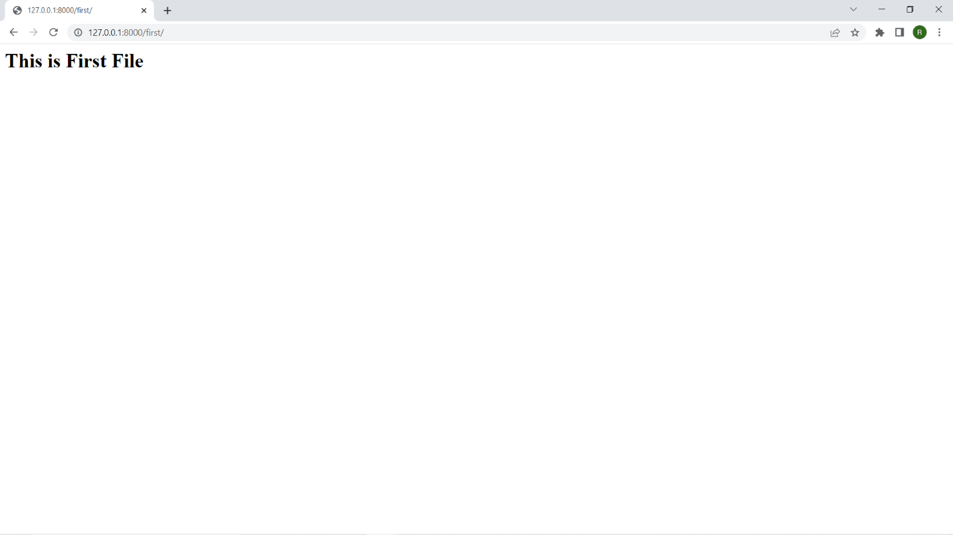

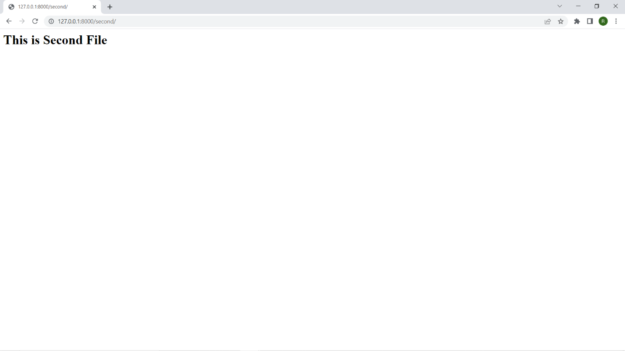
22.Develop a basic poll application (app).It should consist of two parts: a) A public site in which user can pick their favourite programming language and vote. b) An admin site that lets you add, change and delete programming languages.

models.py -
from django.db import models

class Question(models.Model):
question_text = models.CharField(max_length = 200)
pub_date = models.DateTimeField('date published')

def __str__(self):
return self.question_text

class Choice(models.Model):
question = models.ForeignKey(Question, on_delete = models.CASCADE)
choice_text = models.CharField(max_length = 200)
votes = models.IntegerField(default = 0)

def __str__(self):
return self.choice_text

views.py -
from django.template import loader
from django.http import HttpResponse, HttpResponseRedirect
from django.shortcuts import get_object_or_404, render,Http404
from django.urls import reverse
from .models import Question, Choice

def index(request):
latest_question_list = Question.objects.order_by('-pub_date')[:5]
context = {'latest_question_list': latest_question_list}
return render(request, 'polls/index.html', context)

# Show specific question and choices

def detail(request, question_id):
try:
question = Question.objects.get(pk = question_id)
except Question.DoesNotExist:
raise Http404("Question does not exist")
return render(request, 'polls/detail.html', {'question': question})

# Get question and display results

def results(request, question_id):
question = get_object_or_404(Question, pk = question_id)
return render(request, 'polls/results.html', {'question': question})

# Vote for a question choice

def vote(request, question_id):
# print(request.POST['choice'])
question = get_object_or_404(Question, pk = question_id)
try:
selected_choice = question.choice_set.get(pk = request.POST['choice'])
except (KeyError, Choice.DoesNotExist):
# Redisplay the question voting form.
return render(request, 'polls/detail.html', {
'question': question,
'error_message': "You didn't select a choice.",
})
else:
selected_choice.votes += 1
selected_choice.save()
# Always return an HttpResponseRedirect after successfully dealing
# with POST data. This prevents data from being posted twice if a
# user hits the Back button.
return HttpResponseRedirect(reverse('polls:results', args =(question.id, )))

urls.py -
from django.contrib import admin
from django.urls import path,include

urlpatterns = [
path('polls/', include('polls.urls')),
path('admin/', admin.site.urls),
]

admin.py -
from django.contrib import admin
# Register your models here.
from .models import Question, Choice

# admin.site.register(Question)
# admin.site.register(Choice)

admin.site.site_header = "Pollster Admin"
admin.site.site_title = "Pollster Admin Area"
admin.site.index_title = "Welcome to the Pollster Admin Area"

class ChoiceInLine(admin.TabularInline):
model = Choice
extra = 3

class QuestionAdmin(admin.ModelAdmin):
fieldsets = [(None, {'fields': ['question_text']}), ('Date Information', {
'fields': ['pub_date'], 'classes': ['collapse']}), ]
inlines = [ChoiceInLine]

admin.site.register(Question, QuestionAdmin)

index.html -
{% block content %}
<h1 class ="text-center mb-3">Poll Questions</h1>
{% if latest_question_list %}
{% for question in latest_question_list %}
<div class ="card-mb-3">
<div class ="card-body">
<p class ="lead">{{ question.question_text }}</p>
<a href ="{% url 'polls:detail' question.id %}" class ="btn btn-primary btn-sm">Vote Now</a>
</div>
</div>
{% endfor %}
{% else %}
<p>No polls available</p>
{% endif %}
{% endblock %}

Detail.html -
{% block content %}
<h1 class ="text-center mb-3">{{ question.question_text }}</h1>

{% if error_message %}
<p class ="alert alert-danger">
<strong>{{ error_message }}</strong>
</p>

{% endif %}

<form action ="{% url 'polls:vote' question.id %}" method ="post">
{% csrf_token %}
{% for choice in question.choice_set.all %}
<div class ="form-check">
<input type ="radio" name ="choice" class ="form-check-input" id ="choice{{ forloop.counter }}"
value ="{{ choice.id }}" />
<label for ="choice{{ forloop.counter }}">{{ choice.choice_text }}</label>
</div>
{% endfor %}
<input type ="submit" value ="Vote" class ="btn btn-success btn-lg btn-block mt-4" />
</form>
{% endblock %}

Results.html -
{% block content %}
<h2> Vote Submitted Successfully</h2>
{% endblock %}

//Output-
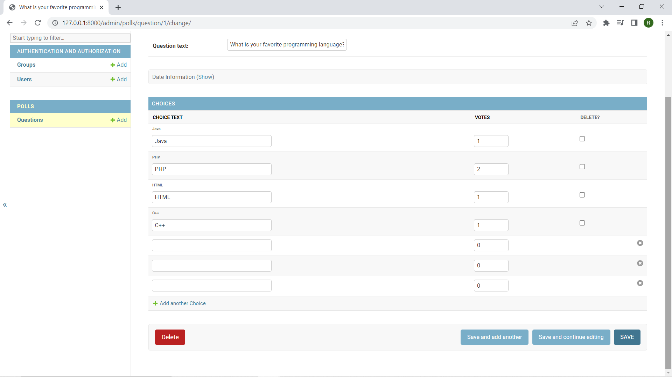
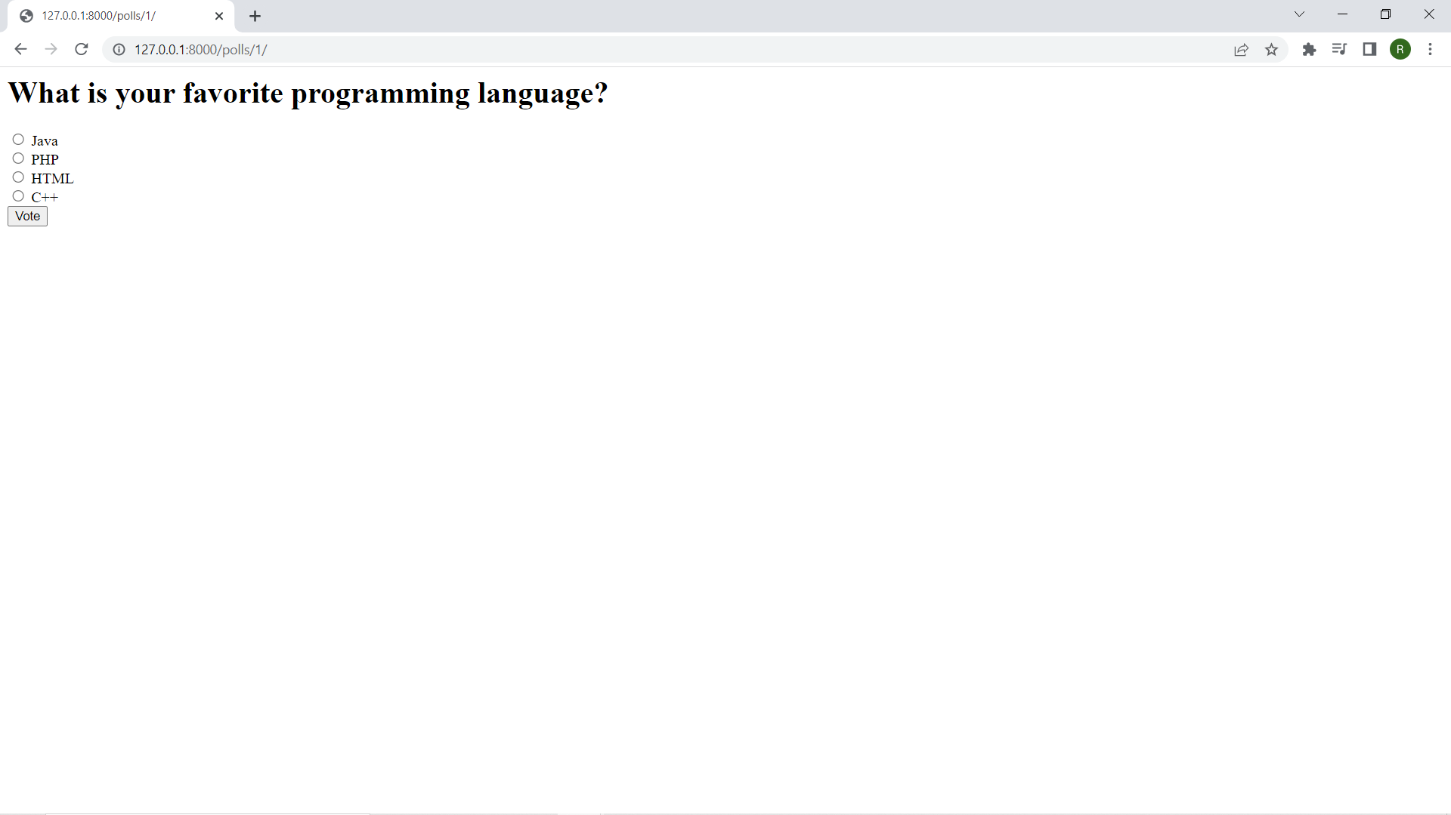
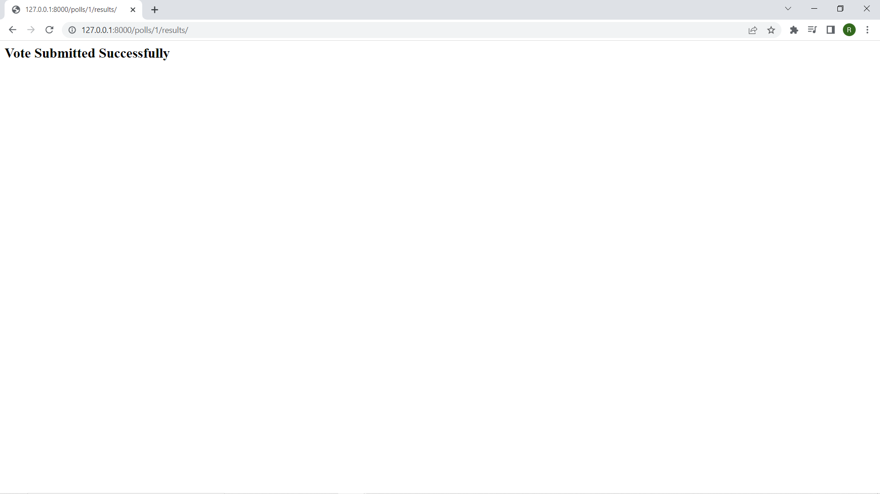

23. A public site in which user can pick their favourite programming language and vote.

views.py -
from django.template import loader
from django.http import HttpResponse, HttpResponseRedirect
from django.shortcuts import get_object_or_404, render,Http404
from django.urls import reverse
from .models import Question, Choice

def index(request):
latest_question_list = Question.objects.order_by('-pub_date')[:5]
context = {'latest_question_list': latest_question_list}
return render(request, 'polls/index.html', context)

# Show specific question and choices

def detail(request, question_id):
try:
question = Question.objects.get(pk = question_id)
except Question.DoesNotExist:
raise Http404("Question does not exist")
return render(request, 'polls/detail.html', {'question': question})

# Get question and display results

def results(request, question_id):
question = get_object_or_404(Question, pk = question_id)
return render(request, 'polls/results.html', {'question': question})

# Vote for a question choice

def vote(request, question_id):
# print(request.POST['choice'])
question = get_object_or_404(Question, pk = question_id)
try:
selected_choice = question.choice_set.get(pk = request.POST['choice'])
except (KeyError, Choice.DoesNotExist):
# Redisplay the question voting form.
return render(request, 'polls/detail.html', {
'question': question,
'error_message': "You didn't select a choice.",
})
else:
selected_choice.votes += 1
selected_choice.save()
# Always return an HttpResponseRedirect after successfully dealing
# with POST data. This prevents data from being posted twice if a
# user hits the Back button.
return HttpResponseRedirect(reverse('polls:results', args =(question.id, )))

urls.py -
from django.contrib import admin
from django.urls import path,include

urlpatterns = [
path('polls/', include('polls.urls')),
path('admin/', admin.site.urls),
]
index.html -
{% block content %}
<h1 class ="text-center mb-3">Poll Questions</h1>
{% if latest_question_list %}
{% for question in latest_question_list %}
<div class ="card-mb-3">
<div class ="card-body">
<p class ="lead">{{ question.question_text }}</p>
<a href ="{% url 'polls:detail' question.id %}" class ="btn btn-primary btn-sm">Vote Now</a>
</div>
</div>
{% endfor %}
{% else %}
<p>No polls available</p>
{% endif %}
{% endblock %}

Detail.html -
{% block content %}
<h1 class ="text-center mb-3">{{ question.question_text }}</h1>

{% if error_message %}
<p class ="alert alert-danger">
<strong>{{ error_message }}</strong>
</p>

{% endif %}

<form action ="{% url 'polls:vote' question.id %}" method ="post">
{% csrf_token %}
{% for choice in question.choice_set.all %}
<div class ="form-check">
<input type ="radio" name ="choice" class ="form-check-input" id ="choice{{ forloop.counter }}"
value ="{{ choice.id }}" />
<label for ="choice{{ forloop.counter }}">{{ choice.choice_text }}</label>
</div>
{% endfor %}
<input type ="submit" value ="Vote" class ="btn btn-success btn-lg btn-block mt-4" />
</form>
{% endblock %}

Results.html-
{% block content %}
<h2> Vote Submitted Successfully</h2>
{% endblock %}

//Output-

24.An admin site that lets you add, change and delete programming languages.

models.py -
from django.db import models

class Question(models.Model):
question_text = models.CharField(max_length = 200)
pub_date = models.DateTimeField('date published')

def __str__(self):
return self.question_text

class Choice(models.Model):
question = models.ForeignKey(Question, on_delete = models.CASCADE)
choice_text = models.CharField(max_length = 200)
votes = models.IntegerField(default = 0)

def __str__(self):
return self.choice_text

admin.py -
from django.contrib import admin
# Register your models here.
from .models import Question, Choice

# admin.site.register(Question)
# admin.site.register(Choice)

admin.site.site_header = "Pollster Admin"
admin.site.site_title = "Pollster Admin Area"
admin.site.index_title = "Welcome to the Pollster Admin Area"

class ChoiceInLine(admin.TabularInline):
model = Choice
extra = 3
class QuestionAdmin(admin.ModelAdmin):
fieldsets = [(None, {'fields': ['question_text']}), ('Date Information', {
'fields': ['pub_date'], 'classes': ['collapse']}), ]
inlines = [ChoiceInLine]

admin.site.register(Question, QuestionAdmin)

//Output-

25.Create your own blog using Django.

models.py -
from django.db import models
from django.contrib.auth.models import User
class myblog(models.Model):
title = models.CharField(max_length=200, unique=True)
slug = models.CharField(max_length=200, unique=True)

views.py -
from django.shortcuts import render
from blog.models import myblog
def myf(req):
model = myblog
context = {"reg":myblog.objects.all()}
return render(req,'blog.html',context)

urls.py -
from django.contrib import admin
from django.urls import path
from blog.views import myf
urlpatterns = [
path('admin/', admin.site.urls),
path('blog/',myf)
]

blog.html -
<!DOCTYPE html>
<html>
<head>
</head>
<body>

<div class="header">
<h2>Welcome to my Blog</h2>
</div>

<div class="row">
<div class="leftcolumn">
<div class="card">
<h2>Django</h2>
<h5>MSc. Computer Science Part 2</h5>
</div>
</div>
<div class="rightcolumn">
<div class="card">
<h2>Subjects :</h3>
<h4>SADP</h6>
<h4>Web Frameworks</h6>
<h4>Machine Learning</h6>
</div>
</div>
</div>
</body>
</html>

//Output-
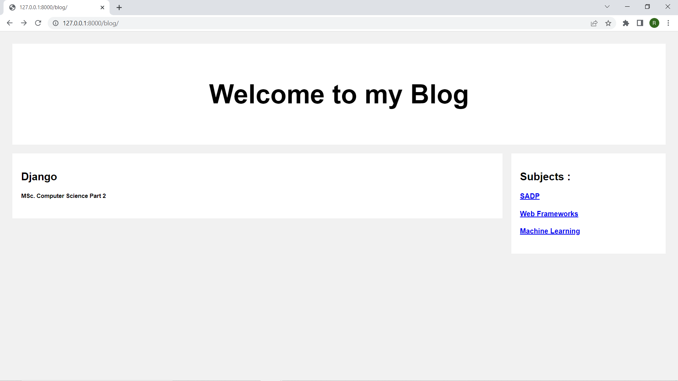

26. Create a clone of the “Hacker News” website.

urls.py –
from django.contrib import admin
from django.urls import path
from newclone.views import newclone
urlpatterns = [
path('admin/', admin.site.urls),
path('home/', newclone),
]

views.py –
from django.shortcuts import render

def newclone(req):
return render(req,'index.html')

index.html –
as per design.

//Output –
