**What is Vue.js?**

Vue js is front end javascript technology.

Vue js is a mixer of angular and react js.

It creates the SPA application

It included the router and statement.

**Vue js** is progressive javascript script used to create dynamic user interfaces.Vue js is very easy to learn.In order to work with Vue js you just need to add few dynamic features to a website.You don’t need to install any thing to use Vue js just need add Vue js library in your project. In the following you can find a list of features:

* Reactive Interfaces
* Declarative Rendering
* Data Binding
* Directives
* Template Logic
* Components
* Event Handling
* Computed Properties
* CSS Transitions and Animations
* Filters

**How to use Vue.js?**

There are different ways to include Vue.js in your web project:

* Use CDN by including <script> tag in HTML file
* Install using Node Package Manager (NPM)
* Install using Bower
* Use Vue-cli to setup your project
* In Vue js **v-bind** is used for one-way data flow or binding.
* In Vue.js **v-model** directive is used for two way data binding
* <div id="app">
* {{message}}
* <input v-model="message">
* </div>
* <script type="text/javascript">
* var message = 'Vue.js is rad';
* new Vue({ el: '#app', data: { message } });
* </script>

### Using Vue-cli?

### First, we need to install Vue-cli. The commend line interface is available as an NPM package. Make sure that Node.js and the npm command is available on your system and use the following command to install the Vue CLI globally on your local system:

### $ npm install -g vue-cli

### Having installed the client successfully the vue command becomes available. Now we're able to initiate a project by using this command in the following way:

**$ vue init webpack vueapp01**

 We're telling vue to initiate a new project and use the webpack template. We also give the project the name vueapp01. Executing the command brings up a few questions on the command line as you can see in the following screenshot:

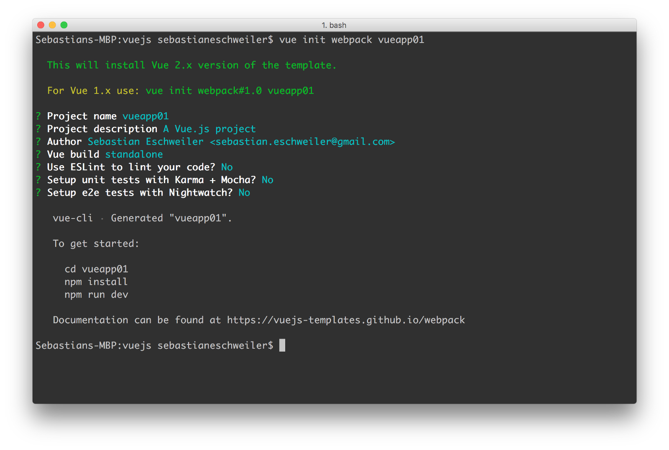

The project is created in the folder vueapp01. Change into that directory with the following command:

**$ cd vueapp01**

Start installing the dependencies by using npm again:

**$ npm install**

 After having completed the installation of packages you can start the web server in development mode by using npm in the following way:

**$ npm run dev**

This will start the server on port 8080 and the application output is displayed in the browser automatically:

Later, if you want to build for production you can use the following command instead. In this case a dist folder is created containing the files needed for productive deployment.

**$ npm run build**

### Project Structure

Let’s take a look at the initial project structure which is available in folder vueapp01:

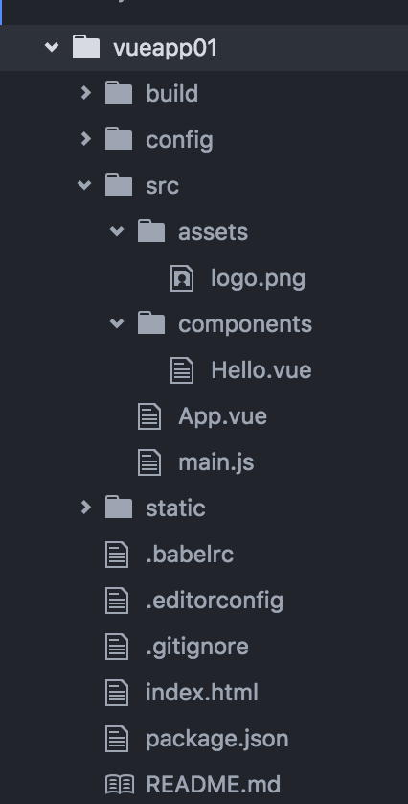

In the project root folder you can find files and folders. Let’s examine the most important ones. The package.json files contains all the dependencies of your project. By using the command **npm install** before we have made sure that the dependencies listed in package.json are installed into the node_modulesfolder of the project.

The file index.html contains the following HTML code:

<!DOCTYPE html>  
<html>  
 <head>  
 <meta charset="utf-8">  
 <title>vueapp01</title>  
 </head>  
 <body>  
 <div id="app"></div>  
 <!-- built files will be auto injected -->  
 </body>  
</html>

This file is the starting point of your application. Note that within the bodysection a <div> element is available which has the id property set to string app. This element is used as a placeholder for the output which is generated by Vue.js.   
   
 Next take a look at file main.js in folder src. That's the place where the Vue application is initialized:

import Vue from 'vue'  
import App from './App'

new Vue({  
 el: '#app',  
 template: '<App/>',  
 components: { App }  
})

On top of the file you can find two import statements:

* import Vue from 'vue': *Vue* is the main class of the framework
* import App from './App': *App* is the root component of out application

By using the *new* keyword a new instance of the main framework class *Vue* is created. The constructor takes an object as a parameter which contains three properties:

* el: By assigning the string *#app* to this property we're defining that the output of the Vue application should be rendered to the <div id="app"></div> element in *index.html*.
* template: The template contains the HTML code which is used to generate the output of the Vue.js application.
* components: List of Vue.js components which are used in the template.

The template only consists of one element: <App/>. Of course this is not a standard HTML element. This is the element which is assigned to App component. In order to be able to use <App/> in the template the App component is also listed in the object which is assigned to the componentsproperty.

 So let's see what's inside the App component implementation in file App.vue:

<template>  
 <div id="app">  
 <img src="./assets/logo.png">  
 <hello></hello>  
 </div>  
</template>

<script>  
import Hello from './components/Hello'

export default {  
 name: 'app',  
 components: {  
 Hello  
 }  
}  
</script>

<style>  
#app {  
 font-family: 'Avenir', Helvetica, Arial, sans-serif;  
 -webkit-font-smoothing: antialiased;  
 -moz-osx-font-smoothing: grayscale;  
 text-align: center;  
 color: #2c3e50;  
 margin-top: 60px;  
}  
</style>

As in every Vue.js 2 single-file component the App implementation is split up into three parts:

* <template></template>: Component's template code
* <script></script>: Component's script code
* <style></style>: Component' CSS code

Let’s focus on the the first two sections **template** and **script**.

The **script** section is making a default export of an object declaring the component named app. Again, the components property is used to declare that another component (Hello) is required by App. This subcomponent is used in the template code of app and implemented in file hello.vue in folder components. In order to be able to use the Hello component in App it’s also needed to include the corresponding import statement on top of the script section.  
   
 The implementation of component Hello looks like the following:

<template>  
 <div class="hello">  
 <h1>{{ msg }}</h1>  
 <h2>Essential Links</h2>  
 <ul>  
 <li><a href="https://vuejs.org" target="_blank">Core Docs</a></li>  
 <li><a href="https://forum.vuejs.org" target="_blank">Forum</a></li>  
 <li><a href="https://gitter.im/vuejs/vue" target="_blank">Gitter Chat</a></li>  
 <li><a href="https://twitter.com/vuejs" target="_blank">Twitter</a></li>  
 <br>  
 <li><a href="http://vuejs-templates.github.io/webpack/" target="_blank">Docs for This Template</a></li>  
 </ul>  
 <h2>Ecosystem</h2>  
 <ul>  
 <li><a href="http://router.vuejs.org/" target="_blank">vue-router</a></li>  
 <li><a href="http://vuex.vuejs.org/" target="_blank">vuex</a></li>  
 <li><a href="http://vue-loader.vuejs.org/" target="_blank">vue-loader</a></li>  
 <li><a href="https://github.com/vuejs/awesome-vue" target="_blank">awesome-vue</a></li>  
 </ul>  
 </div>  
</template>

<script>  
export default {  
 name: 'hello',  
 data () {  
 return {  
 msg: 'Welcome to Your Vue.js App'  
 }  
 }  
}  
</script>

<!-- Add "scoped" attribute to limit CSS to this component only -->  
<style scoped>  
h1, h2 {  
 font-weight: normal;  
}

ul {  
 list-style-type: none;  
 padding: 0;  
}

li {  
 display: inline-block;  
 margin: 0 10px;  
}

a {  
 color: #42b983;  
}  
</style>

The component configuration object is exported as default. This time the component configuration object contains a data method. This method returns an object which represents the component’s model. Properties defined in the model object can be used in the component’s template by using the interpolation syntax. In the example from above the model object has only one property: msg. The string which is assigned to this property is included in the component’s template by using:

<h1>{{ msg }}</h1>

 The interpolation syntax required double curly braces to include model data in the template.

### Using Standard Directives

Let’s adapt the Hello component implementation to learn more about the usage of Vue.js standard directives.

The v-for directive makes it possible to render an element multiple times based on source data. You can use this directive to iterate over an array and at the array data to the output. First add an array to the object which is returned by the data method:

users: [  
 {firstname: 'Sebastian', lastname: 'Eschweiler'},  
 {firstname: 'Bill', lastname: 'Smith'},  
 {firstname: 'John', lastname: 'Porter'}  
 ],

Then use the v-for directive to include a list in the output printing out the firstname and lastname value of each array element:

<div>  
 <ul>  
 <li v-for="user in users">  
 {{user.firstname}} {{user.lastname}}  
 </li>  
 </ul>  
 </div>

### v-model

The v-model directive creates a two-way binding on an input element or a component. Make sure to define a property in your data object which should be used as the binding target:

input_val: ''

Then use the directive to bind the value of an input element to that property:

<div>  
 <input type="text" v-model="input_val">  
</div>

With that binding established we’re getting two effects:

* everytime the user enters a value in the input field the value of *input_val* is updated accordingly
* If we change the value of *input_val* in our program the value which is displayed in the input element is updated as well

### v-text

By using the v-text directive the text content of an element is set. We can use it as an alternative to the {{ … }} syntax if the complete text content should be set. E.g. we can use this directive to output the input_val value to the user:

Input Value: <span v-text="input_val"></span>

### Summary

The complete code of the adapted Hello component implementation should now look like the following:

<template>  
 <div class="hello">  
 <h1>{{ msg }}</h1>  
 <hr />  
 <div>  
 <ul>  
 <li v-for="user in users">  
 {{user.firstname}} {{user.lastname}}  
 </li>  
 </ul>  
 </div>  
 <hr />  
 <div>  
 <input type="text" v-model="input_val">  
 </div>  
 <div>  
 Input Value: <span v-text="input_val"></span>  
 </div>  
 <hr />  
 <div>  
 <button class="btn btn-primary" v-on:click="counter++">You've clicked this button {{counter}} times!</button>  
 </div>  
 </div>  
</template>

<script>  
export default {  
 name: 'hello',  
 data () {  
 return {  
 msg: 'Welcome to Your Vue.js App',  
 users: [  
 {firstname: 'Sebastian', lastname: 'Eschweiler'},  
 {firstname: 'Bill', lastname: 'Smith'},  
 {firstname: 'John', lastname: 'Porter'}  
 ],  
 input_val: '',  
 counter: 0  
 }  
 }  
}  
</script>

<!-- Add "scoped" attribute to limit CSS to this component only -->  
<style scoped>  
h1, h2 {  
 font-weight: normal;  
}  
ul {  
 list-style-position: inside;  
}  
a {  
 color: #42b983;  
}  
</style>

**Vue Methods:**

beforeCreate() : This method is called synchronously after the Vue instance has just been initialized, before data observation and event/watcher setup.

created() : This method is called synchronously after the Vue instance is created. Data observation, computed properties, methods and event callbacks have already been set up at this stage but the mounting phase has not started yet.

beforeMount() : This method is called right before the component is mounted. So it is called before the render method is executed.

mounted() : This method is called after the component has just been mounted.

beforeUpdate() : This method is called when the data changes, before the virtual DOM is re-rendered and patched.

updated() : This method is called after a data change causes the virtual DOM to be re-rendered and patched.

activated() : This method is called when a kept-alive component is activated.

deactivated() : This method is called when a kept-alive component is deactivated.

beforeDestroy() : This method is called right before a Vue instance or component is destroyed. At this stage the instance is still fully functional.

destroyed() : This method is called after a Vue instance or component has been destroyed. When this hook is called, all directives of the Vue instance have been unbound, all event listeners have been removed, and all child Vue instances have also been destroyed.

console.log(new Date(2012,11,10) < new Date(2012, 11, 9))

take updated value and add 24 hour to that and get that value and compare with current time