Lab: Unprotected Admin Functionality
🧪 Lab Overview
Lab Name: Unprotected admin functionality
Difficulty: Apprentice
Status: Solved
This lab contains an unprotected admin panel. The objective of the lab is to find the admin panel and delete the user carlos.

🧠 How I Approached the Problem
My approach was to first explore the application and understand the available functionalities. I checked the product pages and account functionality to look for possible clues about administrative access.
When the normal login attempt did not work, I explored other possibilities. Since the lab description mentioned an unprotected admin panel, I checked the robots.txt file for potentially hidden or disallowed paths. This revealed the /administrator-panel path.
After accessing the administrator panel, I was able to view the available users and delete the target user carlos, which successfully solved the lab.

📸 Screenshot-by-Screenshot Explanation
Screenshot 1: Lab Description
This screenshot shows the details of the Unprotected admin functionality lab.
The lab description explains that the application contains an unprotected admin panel. The objective is to solve the lab by deleting the user carlos.
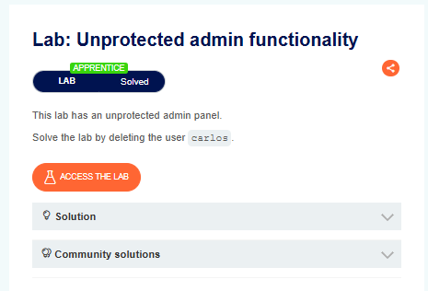
Screenshot 2: Accessing the Lab
I clicked Access the Lab, which opened the application's home page.
The home page displayed different products. Since the objective was to delete the user carlos, I began exploring the application to identify any functionality related to administration or user management.
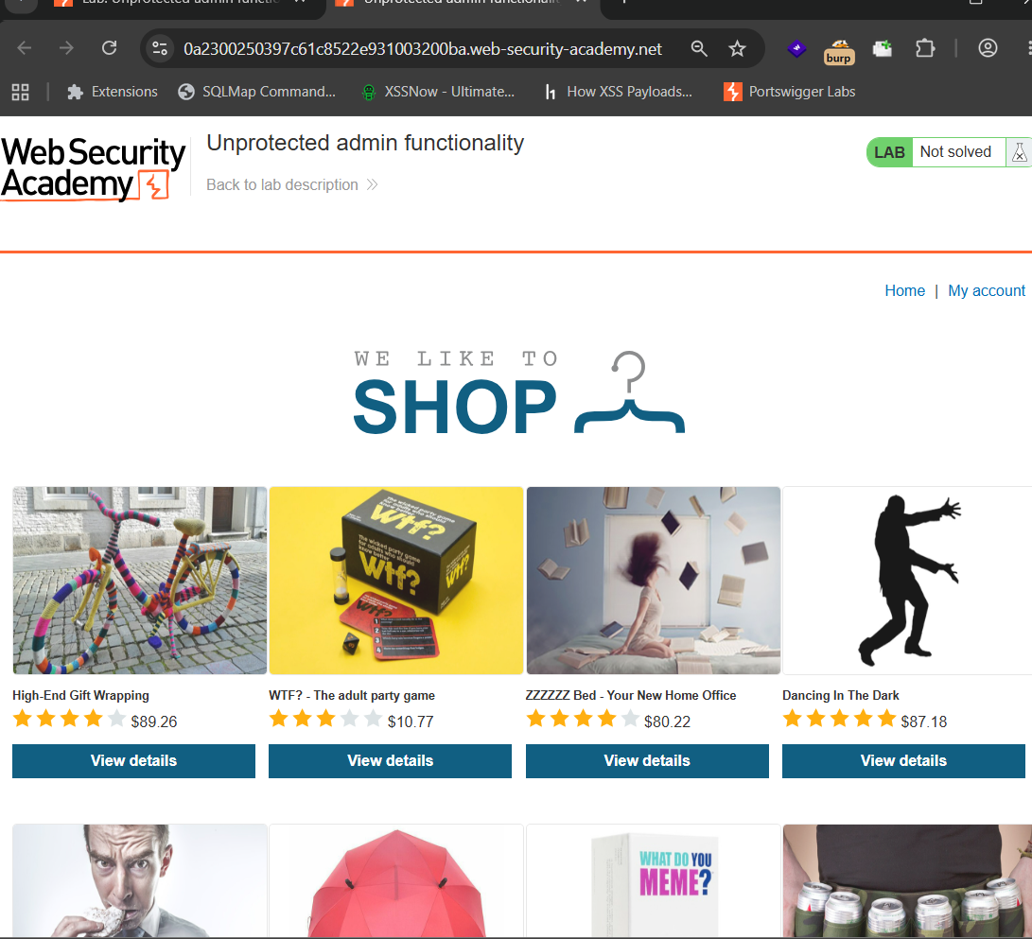

Screenshot 3: Exploring Product Details
While exploring the home page, I noticed that every product had a View details button.
I clicked on one of the product details pages to check whether it contained any useful information or clues related to the admin functionality.


Screenshot 4: Checking the Product Page
After opening the product page, I examined the available information.
However, I did not find any useful clues related to the admin panel or user management. Therefore, I clicked Return to list and continued exploring other parts of the application.

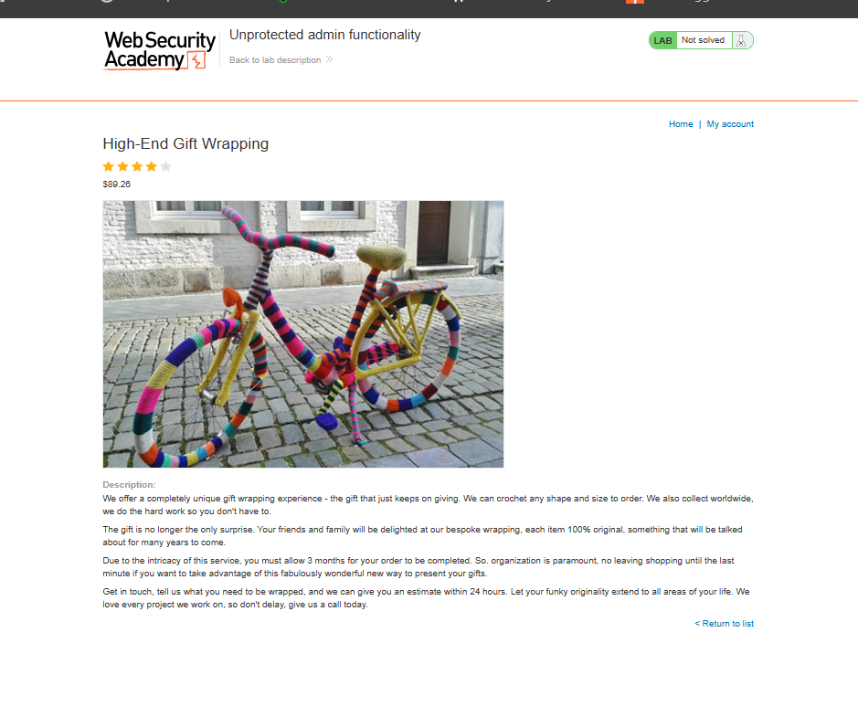
Screenshot 5: Exploring the My Account Functionality
After returning to the home page, I noticed the My account option.
To understand what functionality was available, I clicked on My account.
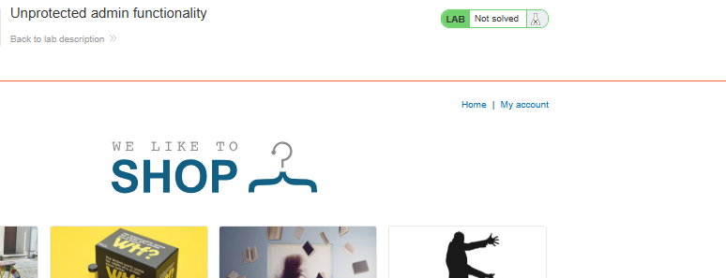
Screenshot 6: Login Page
The My account option redirected me to a login page.
I checked whether authentication could provide access to additional functionality, such as an administrative panel.

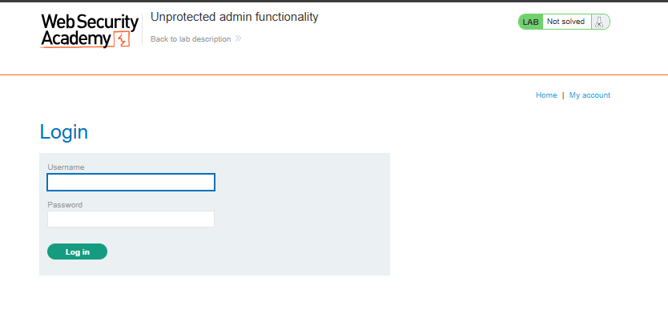
Screenshot 7: Testing Login Credentials
I entered the following credentials:
Username: admin
Password: password
I then attempted to log in to check whether these common credentials would provide administrative access.
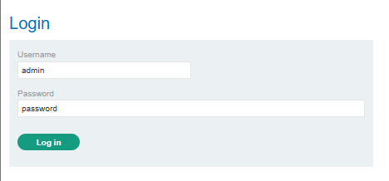
Screenshot 8: Login Attempt Failed
The login attempt failed, and the application displayed an Invalid username or password message.
This indicated that the credentials I tested were incorrect, so I continued investigating other possible ways to locate the admin panel.

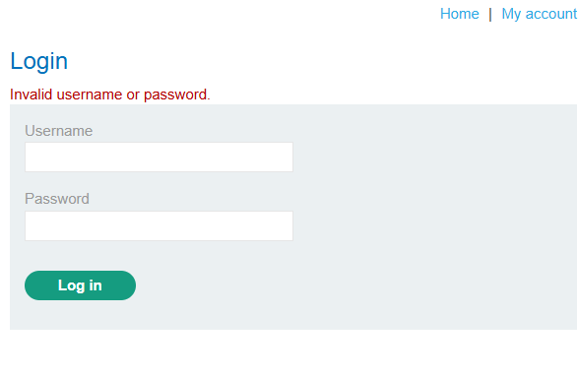
Screenshot 9: Inspecting the Login Request
I captured and examined the login request to understand how the authentication process was working.
I also checked for possible hidden paths or useful information related to the admin functionality. However, I did not find the administrator panel path through this approach.
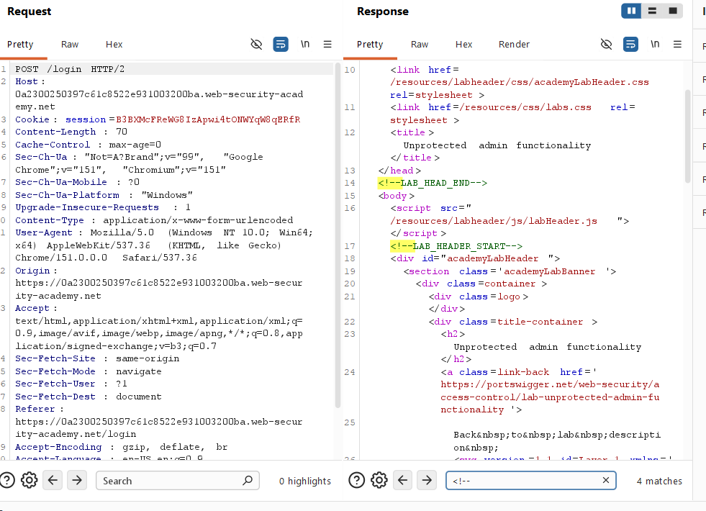
Screenshot 10: Checking robots.txt
Since the lab description specifically mentioned an unprotected admin panel, I considered that the admin functionality might exist at a hidden or unlinked path.
I checked the following location:
/robots.txt
The robots.txt file revealed the following path:
/administrator-panel
This gave me a possible location for the unprotected admin panel.
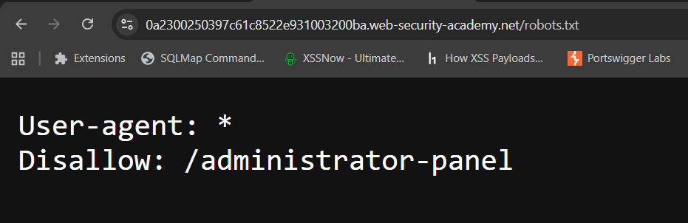
Screenshot 11: Accessing the Administrator Panel
I navigated to:
/administrator-panel
This successfully provided access to the administrator panel without requiring valid administrator credentials.
The page displayed the available users and provided a Delete option for each user.
To understand the functionality, I first deleted the user wiener.
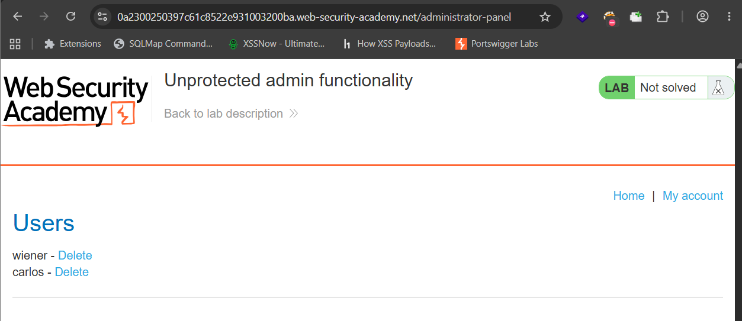
Screenshot 12: Deleting the wiener User
After clicking the Delete option for the wiener user, the application displayed a confirmation message indicating that the user had been successfully deleted.
This confirmed that the administrator panel allowed user deletion without proper access protection.
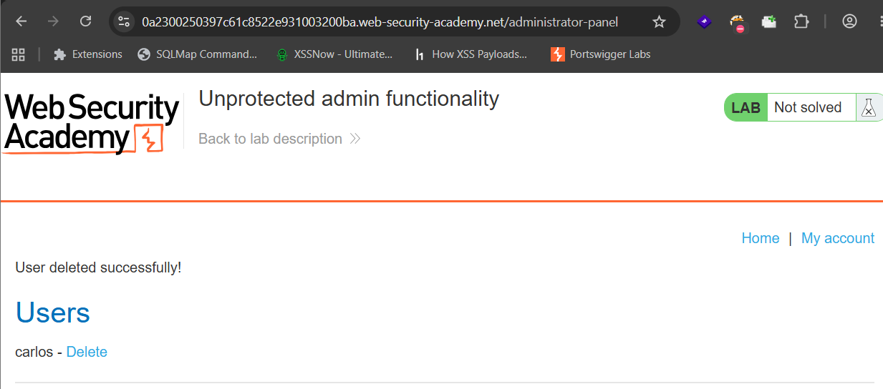
Screenshot 13: Deleting the Target User carlos
Finally, I clicked Delete for the target user carlos.
The application confirmed that the user was successfully deleted, and the lab status changed to Solved.
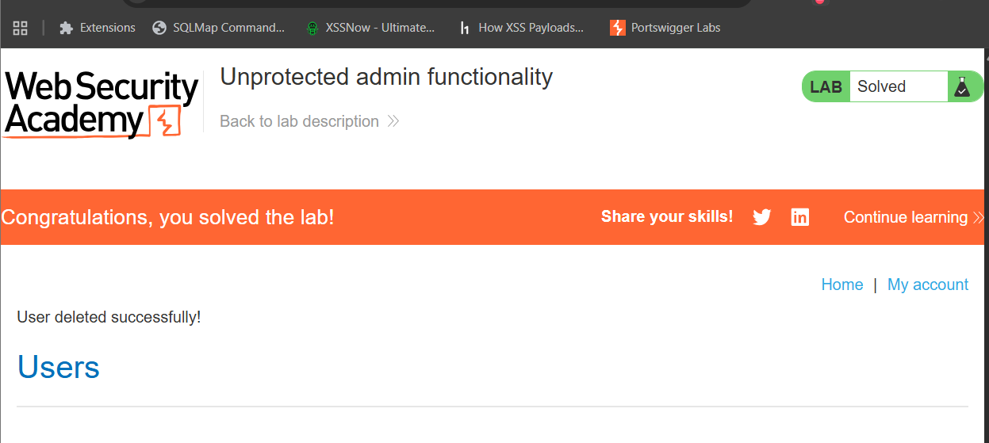
🔍 Different Possibilities I Considered
During the lab, I explored several possible approaches:
- Checking the product pages for hidden functionality or clues.
- Exploring the My account functionality.
- Testing common administrator credentials.
- Inspecting the login request and application source.
- Checking robots.txt for hidden or disallowed paths.
- Accessing the discovered /administrator-panel path.
- The robots.txt approach successfully revealed the location of the admin panel.

⚡ How the Vulnerability Was Confirmed
The vulnerability was confirmed when I accessed:
/administrator-panel
without authenticating as an administrator.
The panel allowed access to user management functionality and provided the ability to delete users. This demonstrated that sensitive administrative functionality was exposed without proper access control.

🎯 Root Cause
The root cause of the vulnerability was missing access control on the administrator panel.
The application exposed the administrative functionality at a predictable path:
/administrator-panel
Although the path appeared in robots.txt, restricting a path through robots.txt does not provide security. The server should independently verify whether a user is authorized before granting access to sensitive functionality.

🛡️ Remediation
To prevent this vulnerability:
- Implement proper authentication for administrative functionality.
- Enforce server-side authorization checks.
- Ensure only authorized administrators can access the admin panel.
- Do not rely on hidden URLs or robots.txt to protect sensitive functionality.
- Apply access-control checks to every sensitive action, including user deletion.
- Regularly test applications for broken or missing access controls.

📚 Key Learning
Through this lab, I learned that:
- Hidden functionality is not the same as secured functionality.
- robots.txt can reveal interesting paths during authorized security testing.
- Administrative functionality must always have proper authentication and authorization.
- Access control must be enforced on the server side.
- Simply hiding an administrative URL does not protect it.
- Sensitive actions, such as deleting users, require proper authorization checks.

🎓 My Biggest Takeaway
My biggest takeaway from this lab is that security through obscurity is not a reliable security control.
Even if an administrative panel is not linked directly from the application, an attacker may still discover its location. Therefore, sensitive functionality must always verify whether the requesting user has the required permissions.

🏁 Conclusion
In this lab, I successfully identified an unprotected administrator panel by exploring the application and checking the robots.txt file.
The discovered /administrator-panel path allowed access to administrative functionality without proper authorization. After accessing the panel, I deleted the target user carlos, which successfully solved the lab.

🧠 Learning Summary
Vulnerability: Unprotected administrative functionality
Category: Broken Access Control / Missing Access Control
Discovery Method: Application exploration and robots.txt
Affected Functionality: Administrator panel and user deletion
Impact: Unauthorized users could access administrative functions and delete user accounts
Lab Objective: Delete the user carlos
Result: Successfully solved

🔐 Vulnerability Type
Unprotected Admin Functionality / Broken Access Control
This vulnerability occurs when sensitive administrative features are accessible without proper authentication or authorization.

