Lab 01: Reflected XSS into HTML Context with Nothing Encoded
Platform: PortSwigger Web Security Academy
Difficulty: Apprentice
Vulnerability: Reflected Cross-Site Scripting (XSS)

🧪 Lab Overview
This lab contains a simple Reflected Cross-Site Scripting (XSS) vulnerability in the application's search functionality.
The objective of the lab was to identify the vulnerable input and perform a cross-site scripting attack that calls the alert() function.
Lab Name: Reflected XSS into HTML context with nothing encoded

🧠 How I Approached the Problem
Instead of directly trying an XSS payload, I followed a step-by-step testing approach.
My approach was:
Identify the input field
↓
Test normal text
↓
Check whether the input is reflected
↓
Test HTML input
↓
Inspect where the input appears
↓
Test JavaScript execution
↓
Confirm the vulnerability

📸 Screenshot 1: Understanding the Lab
The first screenshot shows the lab information provided by PortSwigger Web Security Academy.
The lab is titled:
Reflected XSS into HTML context with nothing encoded
The objective was to find the reflected XSS vulnerability in the search functionality and trigger the alert() function.
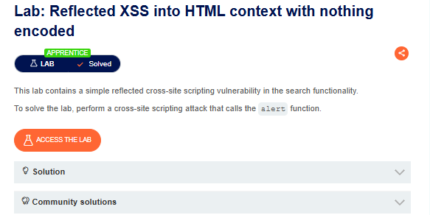
📸 Screenshot 2: Identifying the Search Functionality
After accessing the lab, I explored the home page and identified the search field.
Since the search functionality accepts user-controlled input, I selected it as the first input point for testing.
At this stage, my main question was:
Does the application reflect my search input back into the response?
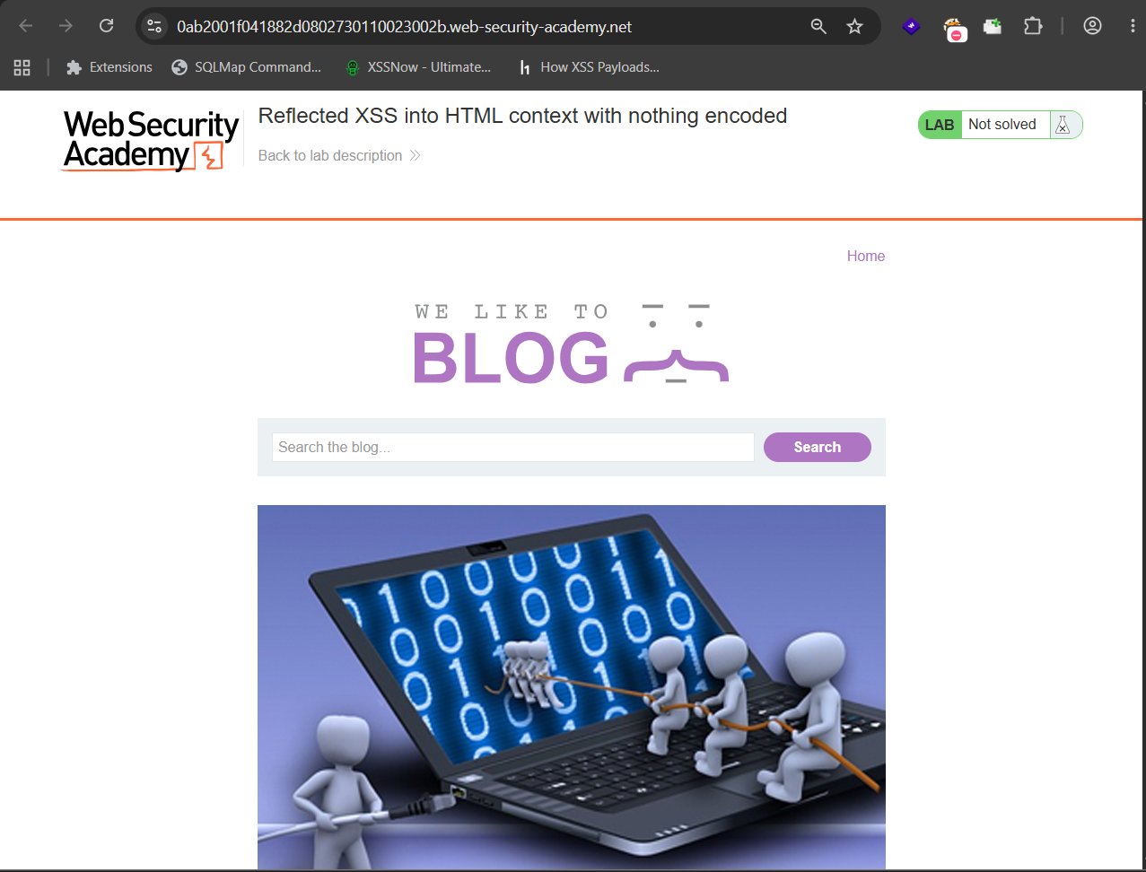
📸 Screenshot 3: Testing Normal Input
To begin testing, I entered a normal text value:
test
into the search field.
The purpose of this test was to check whether the application accepted my input and whether that input appeared anywhere in the application's response.


📸 Screenshot 4: Confirming Input Reflection
After submitting the search request, I observed that the text "test" was displayed on the page.
This confirmed that the application was taking my user-controlled input and reflecting it back in the response.
This was an important observation because reflected user input can become dangerous if it is inserted into the page without proper output encoding.
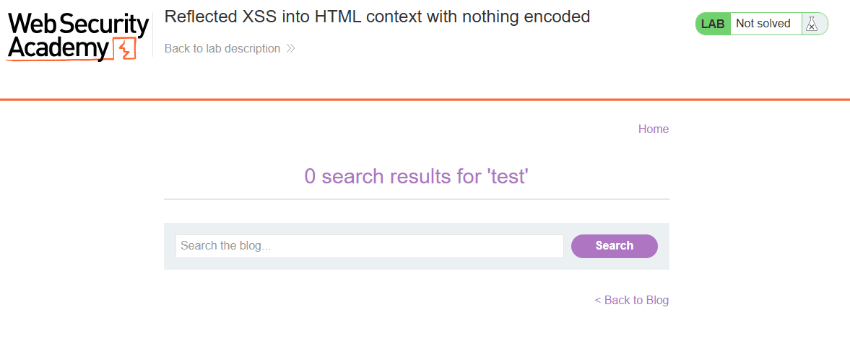
📸 Screenshot 5: Testing HTML Input
After confirming that normal input was reflected, I wanted to understand how the application handled HTML tags.
I entered the following input into the search field:
<h1>test</h1>
The purpose of this test was to determine whether the application treated my input as:
- Plain text, or
- Actual HTML
This step helped me investigate how the application handled special characters and HTML tags.
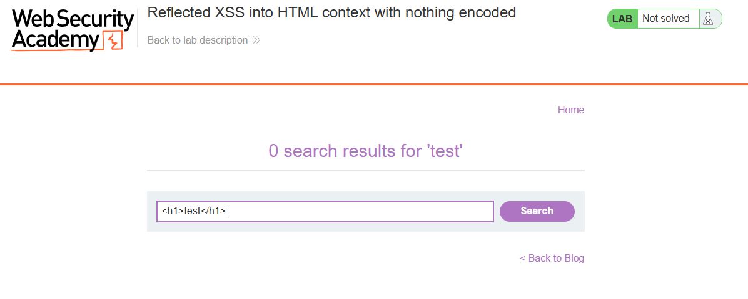
📸 Screenshot 6: Inspecting the Source Code
The <h1>test</h1> input was not displayed on the page in the same way as the normal text.
To understand what happened to my input, I inspected the page using the browser's developer tools.
While inspecting the HTML, I found my input:
<h1>test</h1>
present in the page's HTML.
This showed that the application was reflecting my user-controlled input into the HTML response.
At this point, I considered the possibility that if HTML input was being reflected without proper encoding, it might also be possible to inject executable JavaScript.
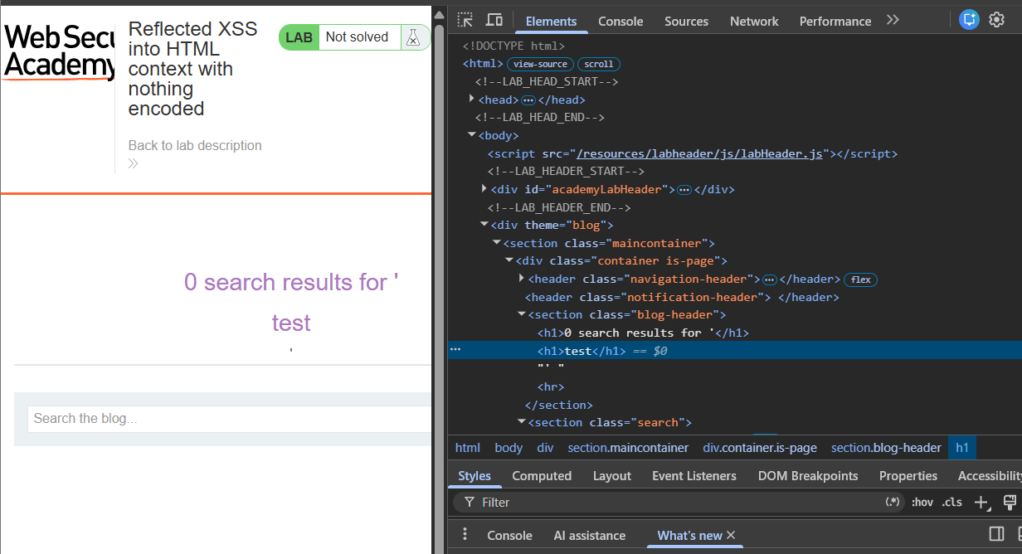
🔍 Different Possibilities I Considered
During the testing process, I considered the following questions:
- Is my input reflected back in the response?
- Where exactly is my input being reflected?
- Is the application treating my input as plain text or HTML?
- Are special characters such as < and > being encoded?
- Can HTML tags be injected into the reflected location?
- If HTML is interpreted, can JavaScript also be executed?
My testing process was:
Normal Text
↓
Check Reflection
↓
HTML Input
↓
Inspect the HTML Context
↓
Test JavaScript Execution
↓
Verify the Result
This approach helped me understand the application's behavior instead of immediately trying random payloads.
📸 Screenshot 7: Injecting the XSS Payload
After confirming that my HTML input was reflected in the page source, I tested whether JavaScript execution was possible.
I entered the following XSS payload into the search field:
<script>alert(1)</script>
The purpose of this test was to determine whether the browser would interpret the injected <script> tag and execute the JavaScript code.
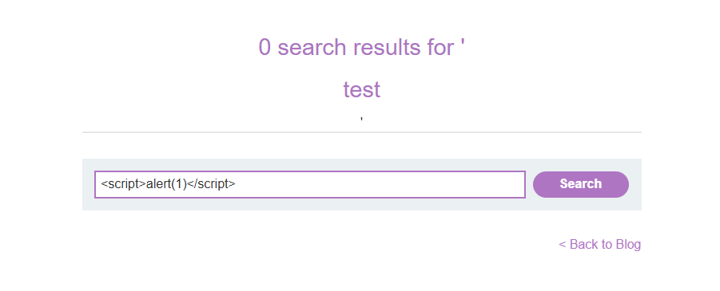
📸 Screenshot 8: Confirming the XSS Vulnerability
After submitting the payload, the injected JavaScript was successfully executed.
An alert popup appeared displaying:
1
This confirmed that the application was vulnerable to Reflected Cross-Site Scripting (XSS).
The browser interpreted the user-controlled input as executable code instead of treating it as plain text. The successful alert(1) popup confirmed the vulnerability and solved the lab.
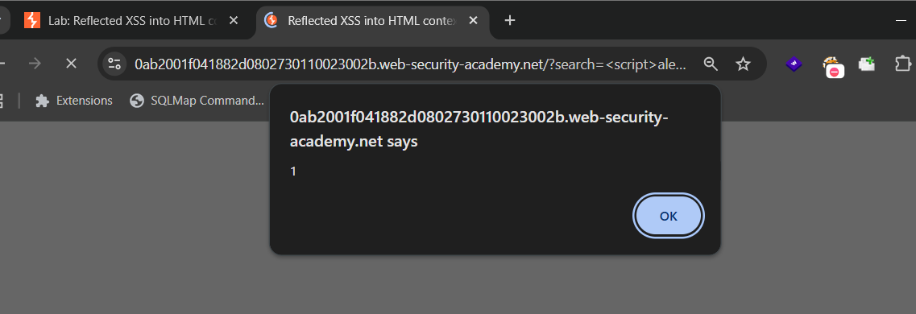
⚡ How the Vulnerability Was Confirmed
The vulnerability was confirmed by successfully executing the following payload:
<script>alert(1)</script>
The application's search functionality reflected the payload into the HTML response.
Because the input was not properly encoded, the browser interpreted the <script> tag as executable code and executed:
alert(1)
The alert popup displaying 1 confirmed successful JavaScript execution and proved the presence of a reflected XSS vulnerability.
🎯 Root Cause
The vulnerability occurred because the application included user-controlled input directly in the HTML response without properly encoding it.
As a result, HTML tags and JavaScript supplied through the search functionality could be interpreted by the browser instead of being displayed as harmless text.
The vulnerable flow can be understood as:
User Input
↓
Search Functionality
↓
Application Response
↓
Input Reflected Without Proper Encoding
↓
Browser Interprets Injected Code
↓
JavaScript Executes
🛡️ Remediation
To prevent this type of XSS vulnerability:
1. Context-Aware Output Encoding
User-controlled data should be properly encoded before being inserted into an HTML response.
For example, special characters should be treated as text rather than executable HTML.
2. Treat User Input as Data
Untrusted input should never be directly inserted into HTML or JavaScript contexts without appropriate handling.
3. Use Secure Frameworks and Templating Systems
Modern frameworks and templating systems can automatically escape user-controlled content when used correctly.
4. Avoid Unsafe HTML Insertion
Developers should avoid directly inserting untrusted input into the page as HTML.
5. Input Validation
Input validation can help reduce unnecessary or unexpected input, although it should not be the only defense against XSS.
6. Content Security Policy
A properly configured Content Security Policy (CSP) can provide an additional layer of protection.
The main remediation is:
Encode untrusted user-controlled output according to the context where it is displayed.
📚 Key Learning
This lab taught me that identifying XSS is not only about memorizing a payload.
The important part is understanding how the application processes user input.
My learning process from this lab was:
1. Identify an input point
↓
2. Test with normal text
↓
3. Check whether the input is reflected
↓
4. Test HTML input
↓
5. Inspect where the input appears
↓
6. Understand the HTML context
↓
7. Test whether JavaScript execution is possible
↓
8. Confirm the vulnerability
↓
9. Understand the root cause
↓
10. Recommend remediation
My Biggest Takeaway
Before testing an XSS payload, first understand where and how your input is reflected. The output context plays an important role in determining how an XSS vulnerability can occur.
Conclusion
This lab demonstrated a basic Reflected XSS vulnerability in a search functionality.
By progressively testing:
Normal Input
↓
HTML Input
↓
Inspecting the HTML
↓
XSS Payload
↓
Alert Popup
I was able to understand how user-controlled input was reflected into the application's response without proper encoding, ultimately allowing JavaScript execution.
This lab reinforced an important web security principle:
Never trust user-controlled input, and always apply context-appropriate output encoding before displaying it in a web page.

