🔐 Lab 02: Stored XSS into HTML Context with Nothing Encoded
Platform: PortSwigger Web Security Academy
Difficulty: Apprentice
Vulnerability: Stored Cross-Site Scripting (XSS)

🧪 Lab Overview
This lab contains a Stored Cross-Site Scripting (XSS) vulnerability in the comment functionality.
The application allows users to submit comments on blog posts. These comments are stored by the application and displayed when the blog post is viewed.
The objective of the lab was to submit a comment containing JavaScript that calls the alert() function when the blog post is viewed.
The lab name is:
Stored XSS into HTML context with nothing encoded
The main objective was to understand how user-controlled input submitted through the comment section was handled, stored, and later displayed.

🧠 How I Approached the Problem
Instead of directly assuming that the comment functionality was vulnerable, I followed a step-by-step testing approach.
My approach was:
Access the Lab
↓
Explore the Home Page
↓
Identify a Blog Post
↓
Open the View Post Page
↓
Find the Comment Section
↓
Test HTML Input
↓
Check Whether the Comment Is Stored
↓
Observe How the Input Is Displayed
↓
Test an XSS Payload
↓
Revisit the Blog Post
↓
Refresh the Page
↓
Confirm Persistent JavaScript Execution
The important thing I wanted to understand was:
Does the application store my comment and later display it without proper output encoding?

📸 Screenshot 1: Understanding the Lab
The first screenshot shows the lab information provided by PortSwigger Web Security Academy.
The lab is titled:
Stored XSS into HTML context with nothing encoded
The lab description explains that the application contains a Stored Cross-Site Scripting vulnerability in the comment functionality.
The objective was to submit a comment containing JavaScript that calls the alert() function when the blog post is viewed.
This gave me the initial understanding that the main area to investigate was the comment functionality.
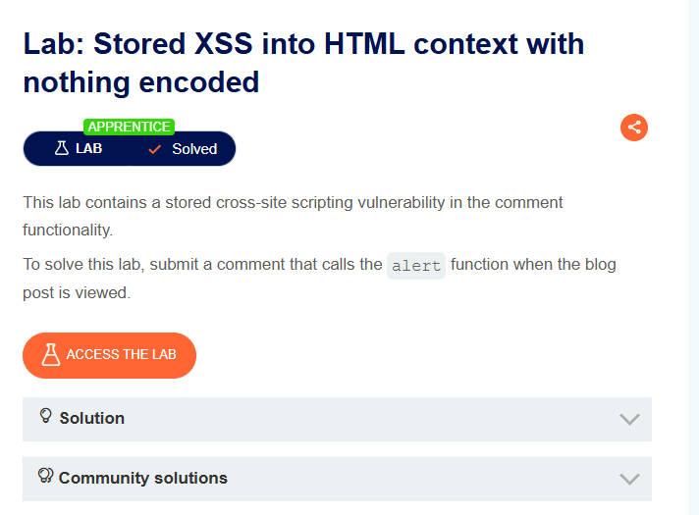
📸 Screenshot 2: Accessing the Lab
After clicking Access the Lab, the application opened the home page.
At this stage, I started exploring the available functionality to identify possible user-controlled input points.
Since the lab description mentioned a vulnerability in the comment functionality, I needed to locate a blog post where comments could be submitted.

📸 Screenshot 3: Identifying the View Post Option
I scrolled through the web page and explored the available options.
During this process, I found the View Post option.
Since comments are usually associated with individual blog posts, I clicked on View Post to explore the page and check whether it contained a comment functionality.
My next question was:
Does this blog post allow users to submit comments that may later be displayed to other users?
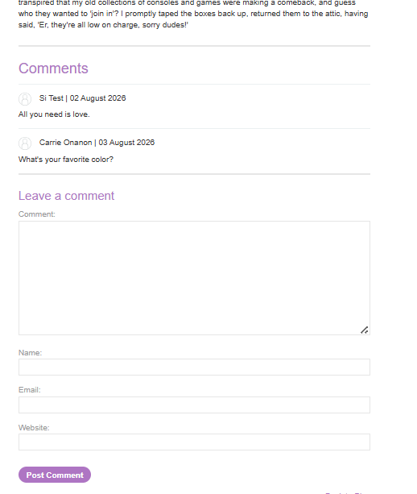
📸 Screenshot 4: Finding the Comment Section and Testing HTML Input
After entering the blog post through the View Post option, I scrolled down to explore the page.
I found a comment section where users could submit their comments.
At this point, I considered that any comment submitted through this functionality might be stored by the application and later displayed when the blog post was viewed.
To understand how the application handled HTML input, I entered the following text into the comment field:
<h1>Cyber Security</h1>
The purpose of this test was to determine whether the application would treat my input as:
- Plain text, or
- Actual HTML
This was an important step because it helped me understand whether special characters and HTML tags were being properly sanitized or encoded. 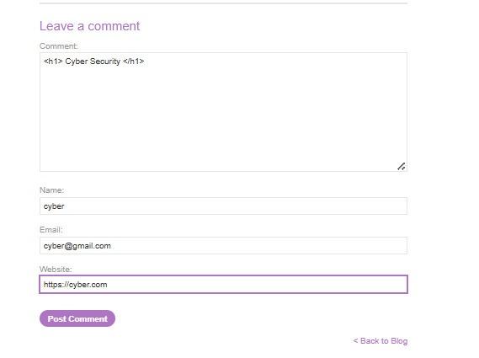
📸 Screenshot 5: Submitting the Comment
After entering the HTML input, I clicked the Post Comment button.
The application displayed the message:
Thank you for your comment!
This indicated that the application had successfully accepted and processed my comment.
At this stage, I wanted to verify whether the submitted input had been stored and how it would be displayed when the comment section was viewed again. 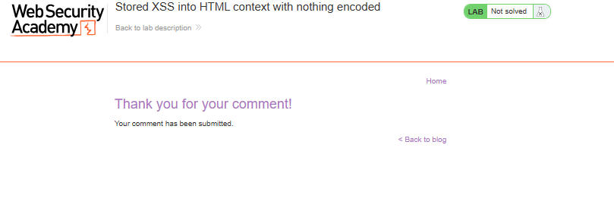
📸 Screenshot 6: Confirming the Stored HTML Input
When I returned to the comment section, I found that the text I submitted was displayed in the comments.
The HTML input:
<h1>Cyber Security</h1>
was interpreted by the browser instead of being displayed as harmless plain text.
This indicated that the HTML tags were not properly encoded or sanitized before being displayed.
This was an important observation because if user-controlled HTML could be interpreted by the browser, I considered the possibility that JavaScript might also be executed.
At this point, the application behavior suggested the following flow:
User Input
↓
Comment Submitted
↓
Comment Stored
↓
Stored Comment Displayed
↓
Browser Interprets HTML
This led me to investigate whether the same behavior could result in a Stored XSS vulnerability.
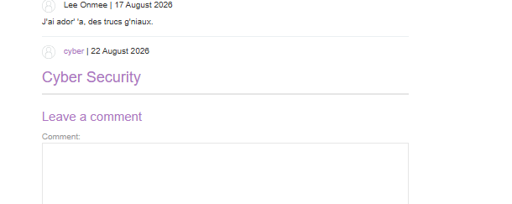
🔍 Different Possibilities I Considered
During the testing process, I considered the following questions:
- Is my comment accepted by the application?
- Is the submitted comment stored?
- Does the comment remain available when the page is viewed again?
- Is my input displayed as plain text or interpreted as HTML?
- Are special characters such as < and > properly encoded?
- Can HTML tags be injected into the comment section?
- If HTML is interpreted, can JavaScript also be executed?
- Does the payload execute again when the blog post is revisited or refreshed?
My testing process was:
Identify Comment Functionality
↓
Submit HTML Input
↓
Check Whether the Comment Is Stored
↓
View the Stored Comment
↓
Observe HTML Interpretation
↓
Test JavaScript Payload
↓
Return to the Blog
↓
Verify JavaScript Execution
↓
Refresh the Page
↓
Confirm Persistent Execution
This approach helped me understand the application's behavior instead of immediately submitting an XSS payload.

📸 Screenshot 7: Injecting the XSS Payload
After observing that my HTML input was interpreted by the browser, I tested whether JavaScript execution was also possible.
I entered an XSS payload into the comment field intended to trigger an alert displaying:
Hacked
The purpose of this test was to determine whether the application would store the JavaScript payload and later allow the browser to execute it when the stored comment was displayed.
After entering the payload, I clicked the Post Comment button.
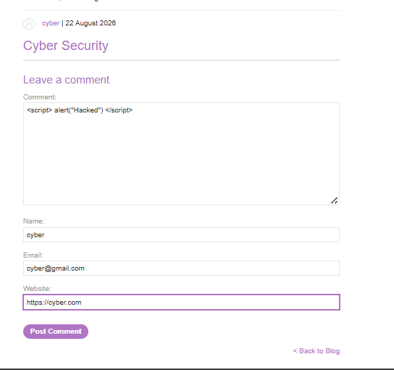

📸 Screenshot 8: Confirming the Comment Submission
After clicking the Post Comment button, the application displayed the message:
Thank you for your comment!
This confirmed that the application had accepted the submitted comment.
However, because this was a Stored XSS test, the important step was not only submitting the payload.
I needed to check what would happen when the stored comment was later loaded and displayed.
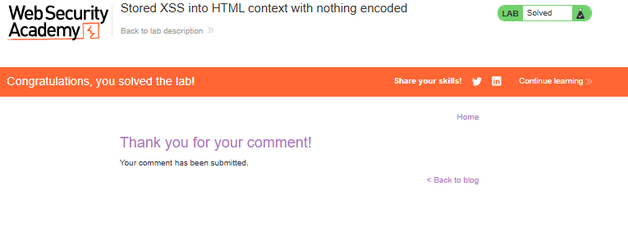
📸 Screenshot 9: Confirming the XSS Execution
After submitting the payload, I clicked the Back to Blog button.
When the stored comment was displayed, a popup appeared showing:
Hacked
This confirmed that the JavaScript contained in the stored comment was executed by the browser.
The application had:
Accepted the Input
↓
Stored the Input
↓
Displayed the Stored Input
↓
Browser Interpreted the Code
↓
JavaScript Executed
This confirmed the presence of a Stored Cross-Site Scripting (XSS) vulnerability.
. 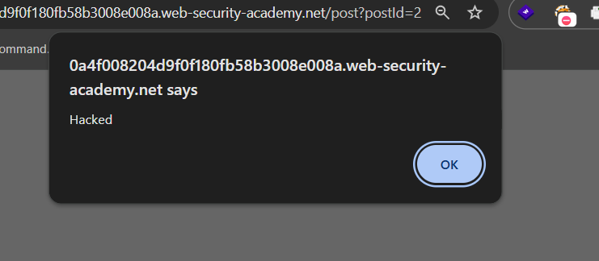
📸 Screenshot 10: Testing Whether the XSS Was Persistent
To further verify the behavior, I refreshed the page.
The purpose of this test was to determine whether the payload had only executed once or whether it remained stored and continued to execute whenever the vulnerable content was loaded.
This is an important characteristic of Stored XSS because the malicious input is saved by the application.
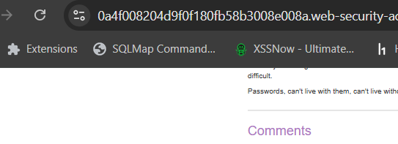
📸 Screenshot 11: Confirming Persistent Stored XSS
After refreshing the page, the popup displaying:
Hacked
appeared again.
This confirmed that the payload remained stored and was executed again whenever the vulnerable page was loaded.
Therefore, the vulnerability was confirmed as:
Stored Cross-Site Scripting (Stored XSS)
The important observation was that the malicious input did not disappear after the initial submission.
Instead, it remained stored by the application and continued to execute when the stored content was displayed.
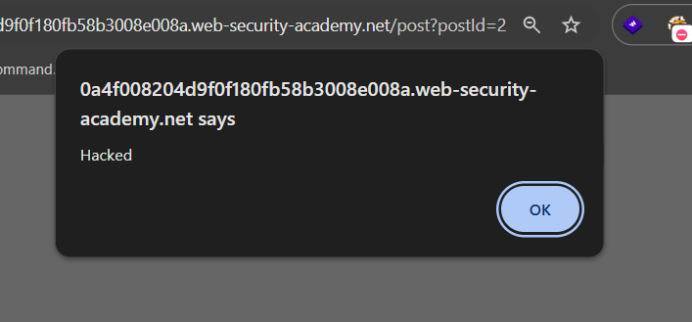
⚡ How the Vulnerability Was Confirmed
The vulnerability was confirmed by submitting an XSS payload through the comment functionality.
The application accepted the comment and displayed:
Thank you for your comment!
When the stored comment was later displayed, JavaScript was executed and a popup appeared showing:
Hacked
I then refreshed the page to verify whether the behavior was persistent.
After refreshing, the popup appeared again.
This confirmed that:
The input was stored
↓
The stored input was displayed
↓
The browser interpreted the injected code
↓
JavaScript executed
↓
The payload executed again after refresh

This behavior confirmed a Stored Cross-Site Scripting vulnerability.
🎯 Root Cause
The vulnerability occurred because the application accepted user-controlled input through the comment functionality, stored it, and later displayed it in an HTML context without proper output encoding.
The vulnerable flow can be understood as:
User-Controlled Comment
↓
Comment Submission
↓
Application Stores the Input
↓
Stored Comment Retrieved
↓
Input Displayed Without Proper Encoding
↓
Browser Interprets the Input
↓
JavaScript Executes
The main security issue was that untrusted user input was treated as HTML rather than being safely displayed as text.
The fact that the input was stored in the application did not make it trusted.
Stored user-controlled data must still be treated as untrusted data whenever it is displayed.

🛡️ Remediation
To prevent this type of Stored XSS vulnerability, the following security measures should be implemented.
1. Context-Aware Output Encoding
User-controlled comments should be properly encoded before being inserted into an HTML page.
Special characters such as:
< > " '
should be displayed as text rather than being interpreted as HTML or executable code.
This is the primary defense against XSS.

2. Treat Stored Data as Untrusted
Data should not automatically be considered safe simply because it has been stored in a database.
The secure flow should be:
User Input
↓
Stored in Database
↓
Still Considered Untrusted
↓
Encode Before Displaying
Every time user-controlled data is displayed, it should be handled according to the output context.

3. Use Secure Frameworks and Templating Systems
Modern frameworks and templating systems can automatically escape user-controlled content.
Developers should use these security features correctly and avoid bypassing automatic output encoding.
This helps prevent browsers from interpreting user input as executable HTML or JavaScript.

4. Avoid Unsafe HTML Rendering
Applications should avoid directly inserting untrusted user input into HTML.
User-controlled comments should be displayed as text unless there is a specific and securely implemented requirement to allow limited HTML.

5. Input Validation
Input validation can help restrict unexpected input and enforce expected formats.
However:
Input validation alone is not a complete defense against XSS.
Proper context-aware output encoding is still required.

6. Content Security Policy
A properly configured Content Security Policy (CSP) can provide an additional layer of protection.
CSP can help reduce the impact of certain XSS vulnerabilities by restricting where scripts can be loaded or executed from.
However, CSP should be considered a defense-in-depth measure and not a replacement for proper output encoding.
The main remediation is to properly encode untrusted user-controlled output according to the context where it is displayed.

📚 Key Learning
This lab helped me understand the difference between Reflected XSS and Stored XSS.
Reflected XSS
In Reflected XSS, the user-controlled input is typically reflected immediately in the application's response.
User Input
↓
Application Response
↓
Input Reflected
↓
Possible JavaScript Execution
Stored XSS
In Stored XSS, the user-controlled input is first stored by the application and later displayed.
User Input
↓
Application Stores Input
↓
Input Remains Stored
↓
Page Is Viewed Later
↓
Stored Input Is Displayed
↓
Possible JavaScript Execution
Through this lab, I learned about:
- Stored Cross-Site Scripting (XSS)
- Persistent storage of user-controlled input
- Comment functionality as a potential input point
- Testing HTML input before testing JavaScript execution
- How browsers interpret unencoded HTML
- The difference between Reflected XSS and Stored XSS
- Why stored data should still be considered untrusted
- Context-aware output encoding
- Persistent JavaScript execution
- The importance of testing the application after refreshing or revisiting a page

🎓 My Biggest Takeaway
User-controlled input does not become safe simply because it has been stored in a database. The data must still be properly handled and encoded whenever it is displayed.
Another important lesson from this lab was:
Understanding the complete flow of user input—from submission, to storage, to display—is essential when testing for Stored XSS vulnerabilities.
🏁 Conclusion
This lab demonstrated a Stored Cross-Site Scripting (XSS) vulnerability in a blog comment functionality.
By progressively testing:
Explore the Application
↓
Identify the Comment Section
↓
Test HTML Input
↓
Confirm the Input Is Stored
↓
Observe HTML Interpretation
↓
Submit an XSS Payload
↓
Return to the Blog
↓
Observe JavaScript Execution
↓
Refresh the Page
↓
Confirm Persistent Execution
I was able to understand how user-controlled input was stored and later displayed without proper output encoding.
This ultimately allowed the browser to interpret and execute injected JavaScript.
This lab reinforced an important web security principle:
Never trust user-controlled input, even after it has been stored. Always apply context-appropriate output encoding before displaying it in a web page.

