**NEXUS**

**PROJECT - 1**

**IRIS DATA ANALYSIS**

Introduction:

The dataset consists of 150 samples of iris flowers, each belonging to one of three species: setosa, versicolor, or virginica. Each sample has four features: sepal length, sepal width, petal length, and petal width.

Data Exploration:

**Dataset Overview:**

Begin by loading and inspecting the dataset to understand its structure, shape, and basic statistics.

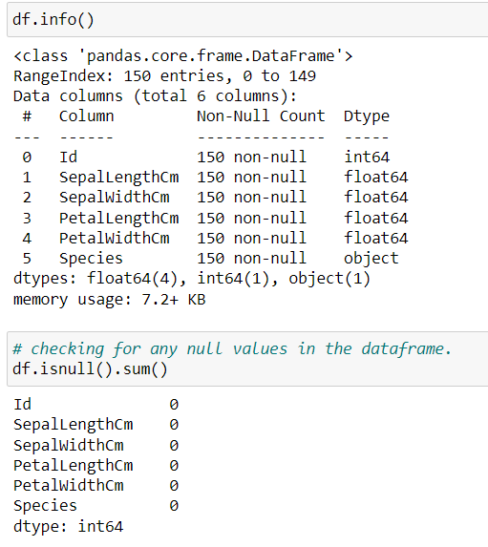

**Data Cleaning:**

Check for missing values, duplicate entries, or any anomalies in the data. Handle them appropriately.al width.

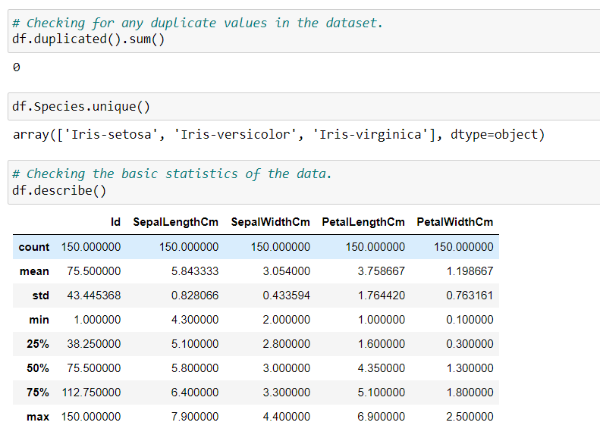

Descriptive Statistics:

* Calculate and visualize basic statistical measures for each feature, such as mean, median, standard deviation, and quartiles.
* Use histograms and box plots to visualize the distribution of each feature and identify potential outliers.

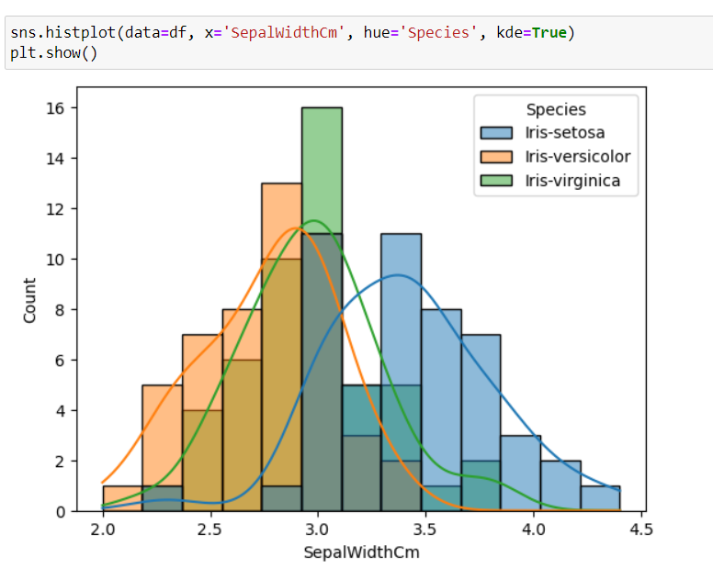

Correlation Analysis:

Implementing Correlation analysis to understand the relationship between several parameters.

