**NEXUS**

**PROJECT-3**

**TWITTER SENTIMENT ANALYSIS**

Introduction:

Twitter Sentiment Analysis is a data analytics project that involves analyzing a dataset of tweets to determine the sentiment expressed in each tweet—whether it is positive, negative, or neutral. The project aims to gain insights into public opinions, trends, and sentiments shared on Twitter, utilizing data analytics techniques.

Data Exploration:

The Twitter dataset was successfully loaded into a Python environment, specifically a Jupyter Notebook. The initial examination revealed that the dataset contains 1600000 rows and 6 columns. Further exploration of data types and basic statistics provided a foundational understanding of the dataset.

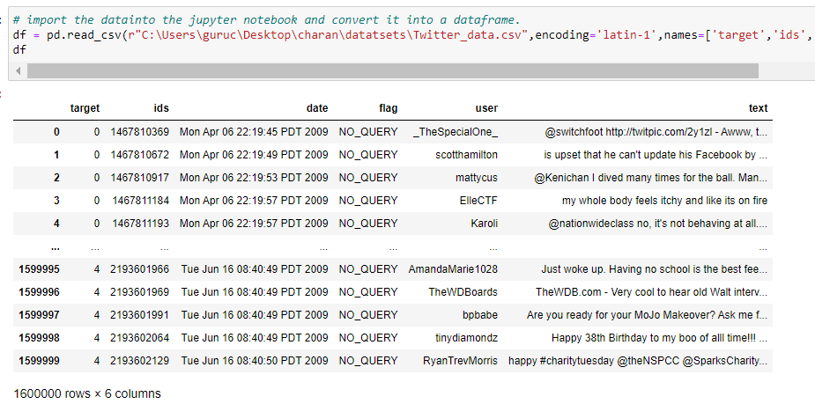

Data Cleaning:

Performing data cleaning tasks to handle missing values, duplicate entries, and irrelevant information.

Ensuring data quality by addressing any anomalies or inconsistencies in the dataset.

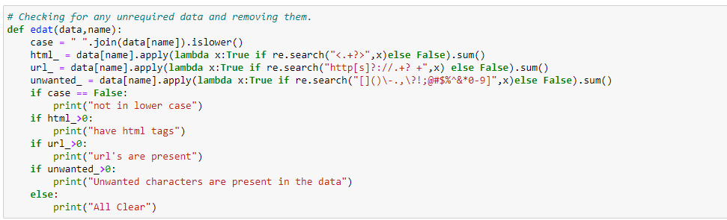

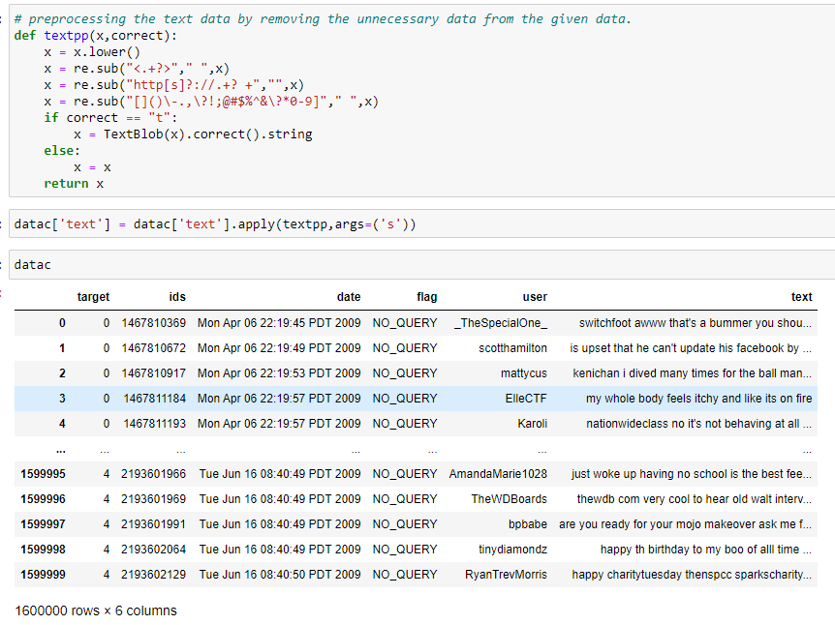

Sentiment Distribution:

Visualizing the distribution of sentiment labels (positive, negative, neutral) in the dataset.

Analyzing the balance of sentiment classes to understand potential biases.

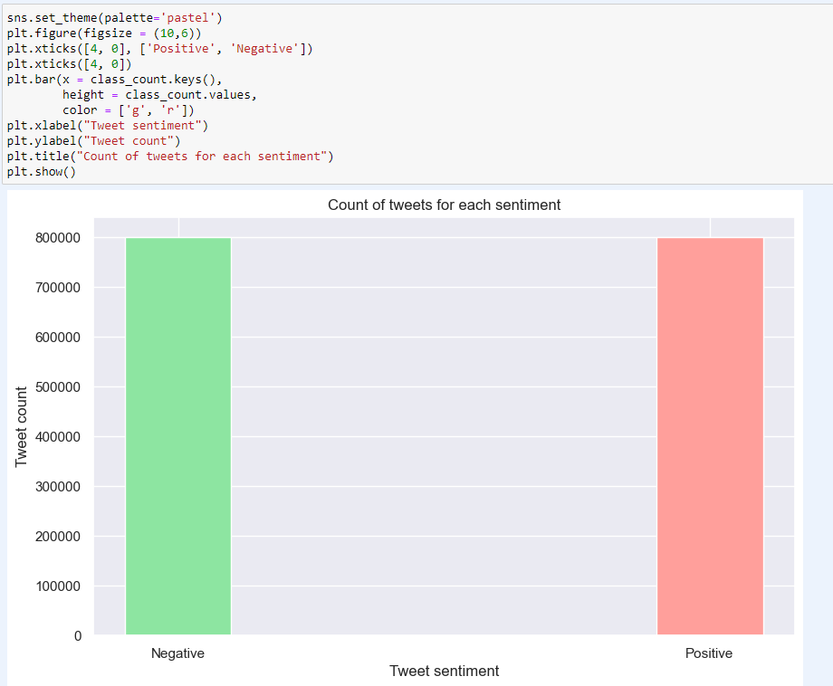

Word Frequency Analysis:

Analyzing the frequency of words in tweets to identify common terms and themes.

Creating word clouds or bar charts to visualize the most frequent words in positive and negative sentiments.

* Most frequent words occurring in Positive Tweets

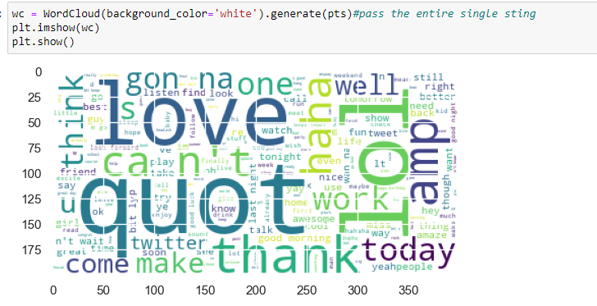

* Most frequent words occurring in Negative Tweets.

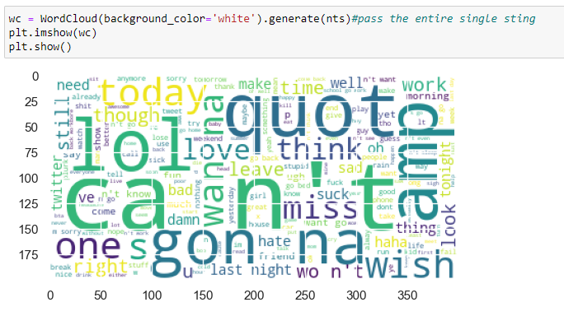

Sentiment Prediction Mosdsel:

Conducting exploratory data analysis to gain initial insights into tweet patterns, sentiment distributions, and temporal trends.

Utilizing visualizations (e.g., histograms, word clouds) to represent key aspects of the dataset.

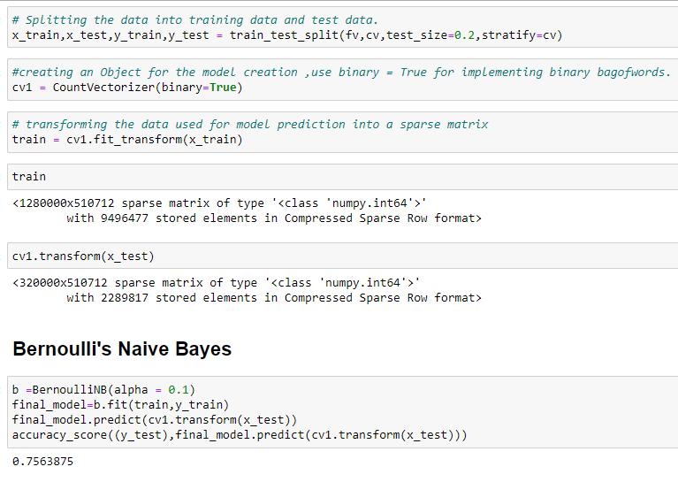

F1_Score:

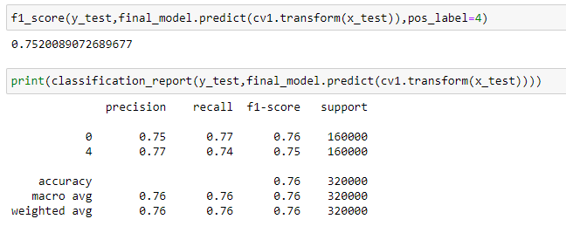

Confusion Matrix:

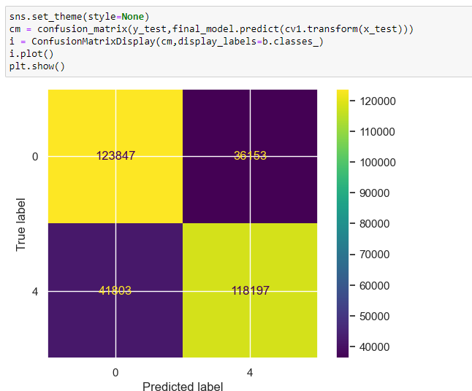

Conclusion:

From the above analysis we can categorize the input tweets of users into positive or negative easily.