**NEXUS**

**PROJECT - 2**

**WEATHER DATA ANALYSIS**

Introduction:

The Weather Analysis project aims to explore and analyze the weather dataset, emphasizing data preparation using Python. In this initial phase, our focus is on loading, cleaning, and preprocessing the dataset to ensure its suitability for advanced analysis in subsequent stages.

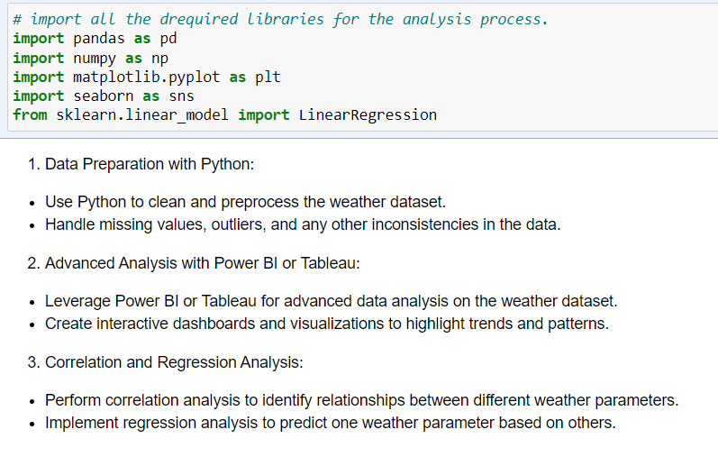

Data Preparation with Python:

**Data Loading and Overview:**

The weather dataset was successfully loaded into a Python environment, specifically a Jupyter Notebook. The initial examination revealed that the dataset contains 366 rows and 22 columns. Further exploration of data types and basic statistics provided a foundational understanding of the dataset.

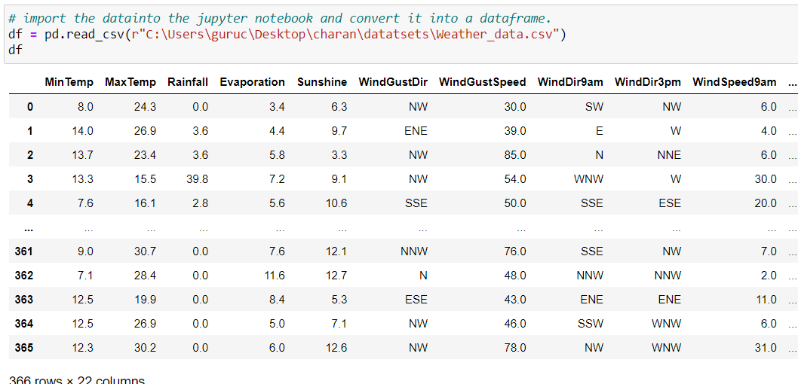

**Missing Values Handling:**

Upon investigation, it was found that the dataset contains missing values in various columns. Utilizing appropriate techniques, such as imputation or deletion, these missing values were addressed to enhance the dataset's completeness. 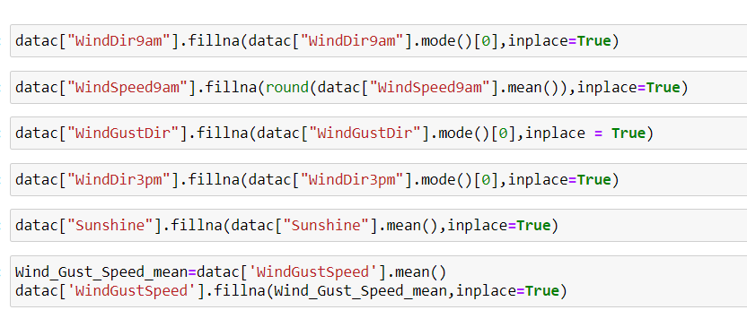

**Outlier Detection and Treatment:**

To ensure the integrity of the dataset, outliers were identified using statistical methods or visualizations. Subsequently, suitable approaches were implemented to handle these outliers, promoting a more accurate representation of the weather data.

Exploratory Data Analysis:

Perform initial exploration of the data to understand its structure and characteristics. Use summary statistics, visualizations (histograms, scatter plots), and data distribution analyses to uncover patterns and trends.

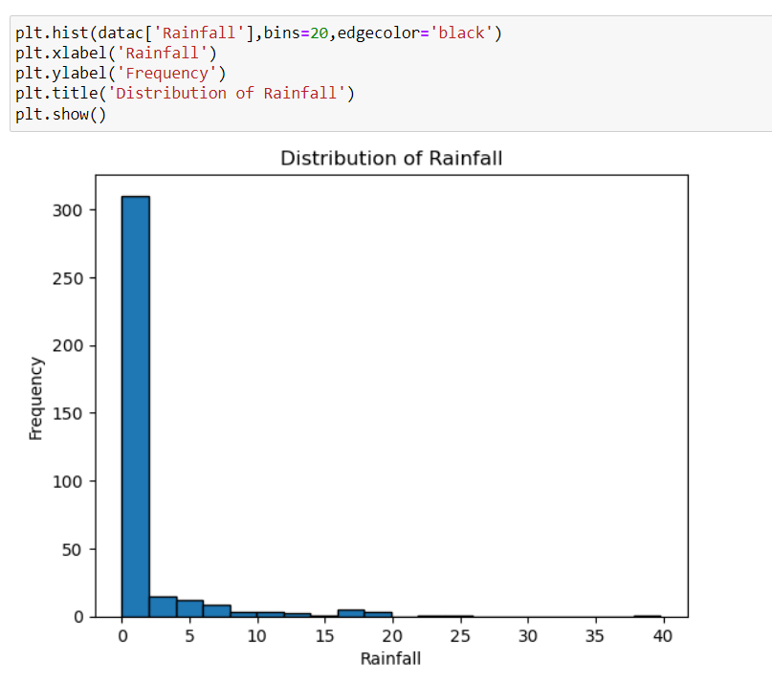

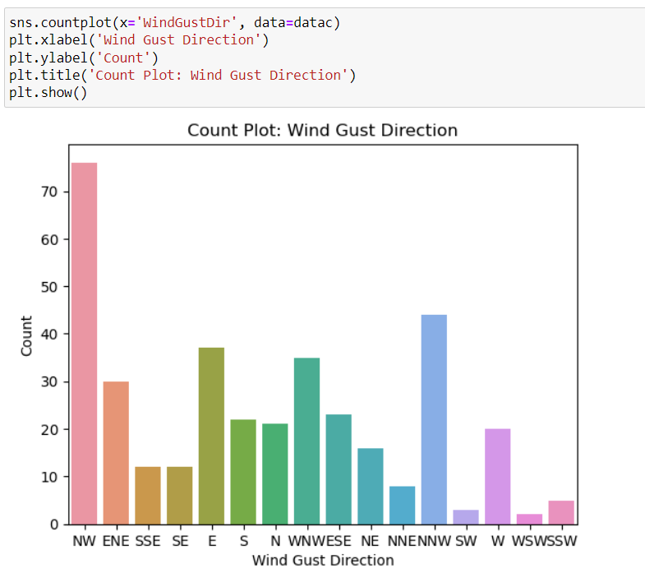

Correlation and Regression Analysis:

**Correlation Analysis:**

Correlation analysis helps in identifying patterns and trends in data. By assessing the relationships between variables, we can gain insights into how changes in one variable may be associated with changes in another.

In summary, correlation analysis is a versatile tool that provides a quantitative measure of relationships between variables, making it a valuable asset in various fields for data exploration, decision-making, and predictive modeling.

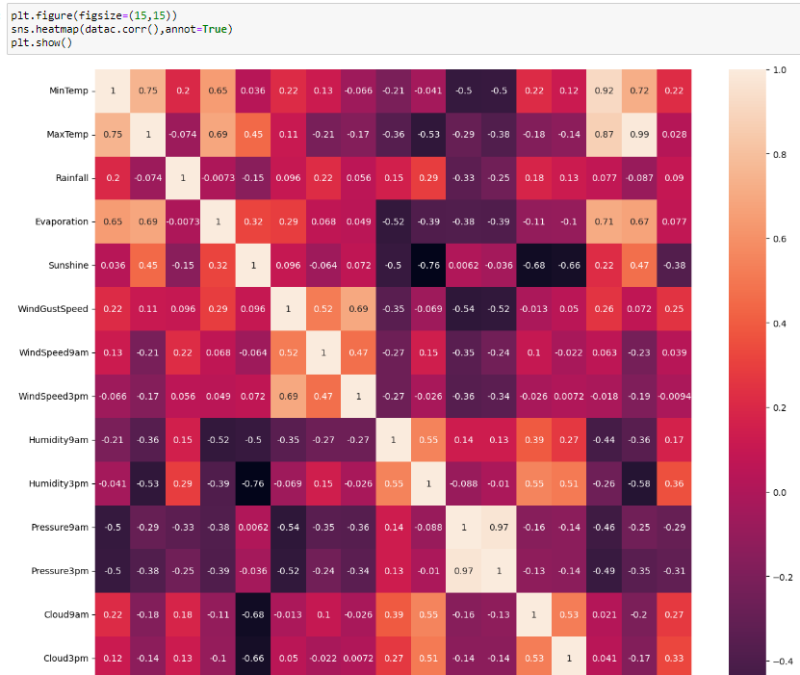

**Regression Analysis:**

Additionally, regression analysis will be implemented to predict one weather parameter based on others. This predictive modeling approach will enhance our understanding of how specific weather parameters influence each other, contributing to a more comprehensive analysis of the dataset.

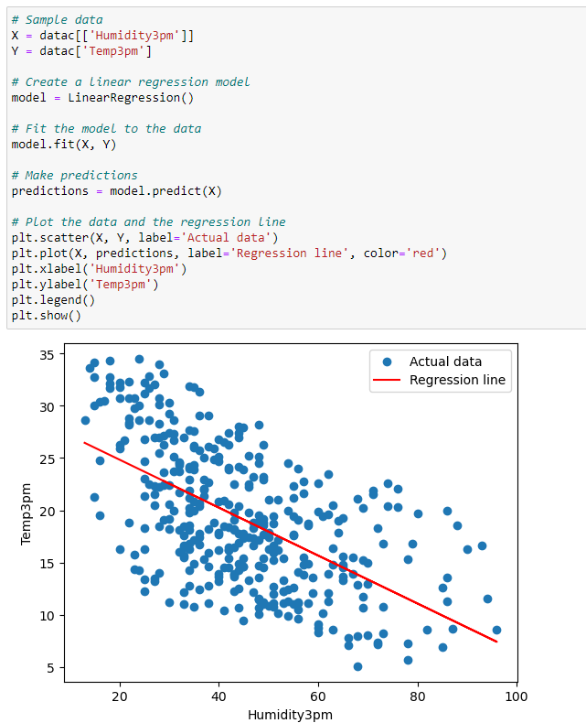

Conclusion**:**

The dataset is now well-prepared for advanced analysis, and upcoming phases will delve into creating interactive visualizations and conducting correlation and regression analyses. This project not only enhances technical skills but also fosters a deeper understanding of weather data and its applications.

This report serves as a comprehensive overview of the progress made in the first phase of the Weather Analysis project, setting the stage for more in-depth exploration and analysis in subsequent phases.