**Ex.no: Date:**

**Javascript Asynchronous Functions**

**Aim:**

To create simple webpage using javascript asynchronous functions.

**Program:**

<!DOCTYPE html>

<html lang="en">

<head>

<meta charset="UTF-8">

<meta name="viewport" content="width=device-width, initial-scale=1.0">

<title>Rock Paper Scissors Game</title>

<style>

body {

display: flex;

justify-content: center;

align-items: center;

height: 100vh;

margin: 0;

background-color: rgb(247, 244, 244);

}

#game-container {

display: flex;

flex-direction: row;

align-items: center;

}

img {

width: 300px;

height: 300px;

cursor: pointer;

}

#result {

text-align: center;

margin-top: 20px;

font-size: 28px;

}

</style>

</head>

<body>

<div id="game-container">

<img id="rock" src="stone.png" alt="Rock">

<img id="paper" src="paper.png" alt="Paper">

<img id="scissors" src="scissor.png" alt="Scissors">

</div>

<div id="result">Choose Rock, Paper, or Scissors...</div>

<script>

const choices = ["rock", "paper", "scissors"];

function computerChoice() {

return choices[Math.floor(Math.random() * 3)];

}

function getResult(playerChoice, compChoice) {

if (playerChoice === compChoice) return "It's a tie!";

if ((playerChoice === "rock" && compChoice === "scissors") ||

(playerChoice === "paper" && compChoice === "rock") ||

(playerChoice === "scissors" && compChoice === "paper")) {

return "You win!";

} else {

return "Computer wins!";

}

}

async function playGame(playerChoice) {

const compChoice = computerChoice();

const result = getResult(playerChoice, compChoice);

document.getElementById("result").textContent = `Computer chose ${compChoice}. ${result}`;

await delay(2000);

document.getElementById("result").textContent = "Choose Rock, Paper, or Scissors...";

}

function delay(ms) {

return new Promise(resolve => setTimeout(resolve, ms));

}

document.getElementById("rock").addEventListener("click", () => playGame("rock"));

document.getElementById("paper").addEventListener("click", () => playGame("paper"));

document.getElementById("scissors").addEventListener("click", () => playGame("scissors"));

</script>

</body>

</html>

**Output:**

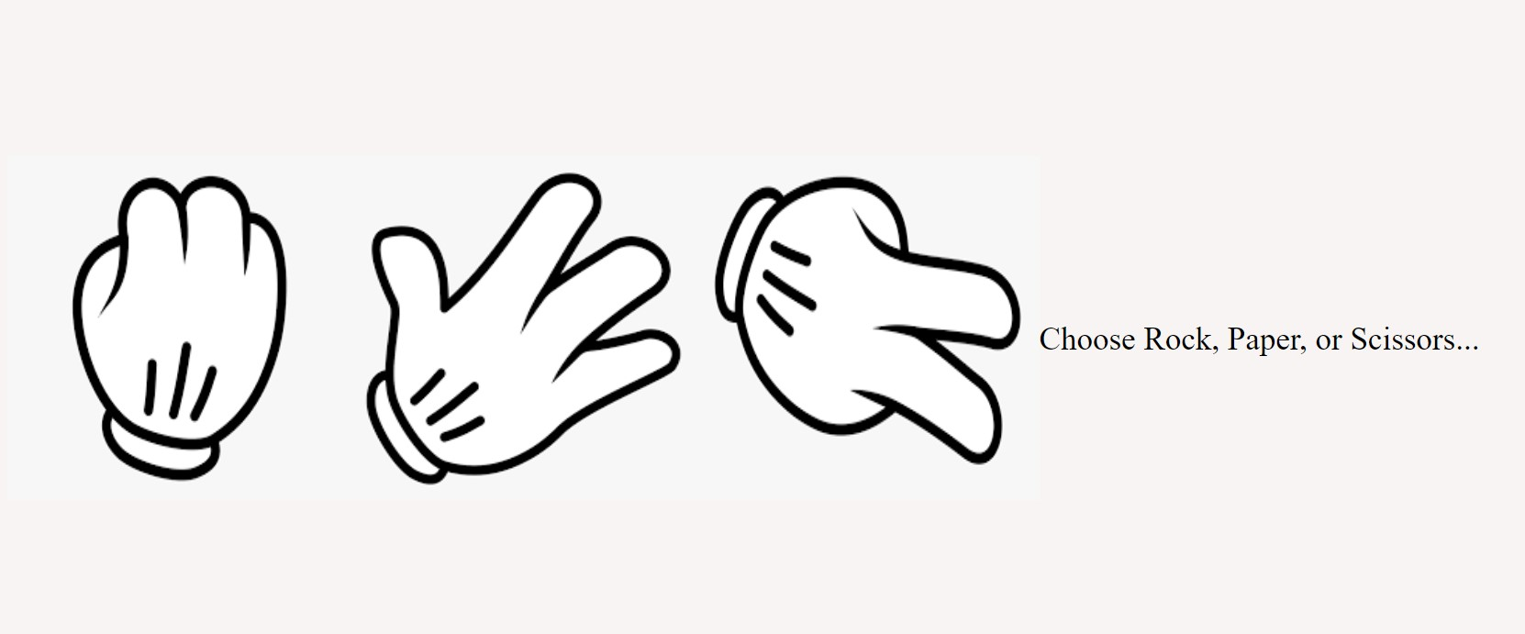

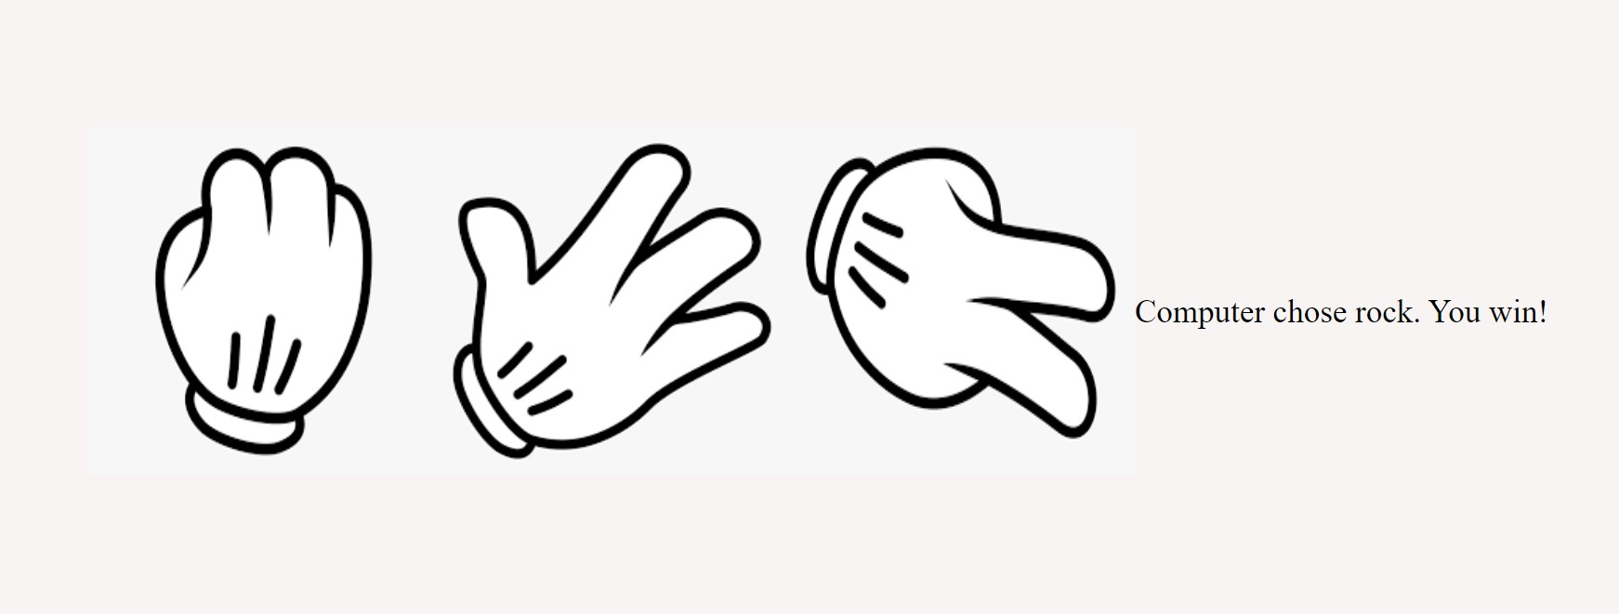

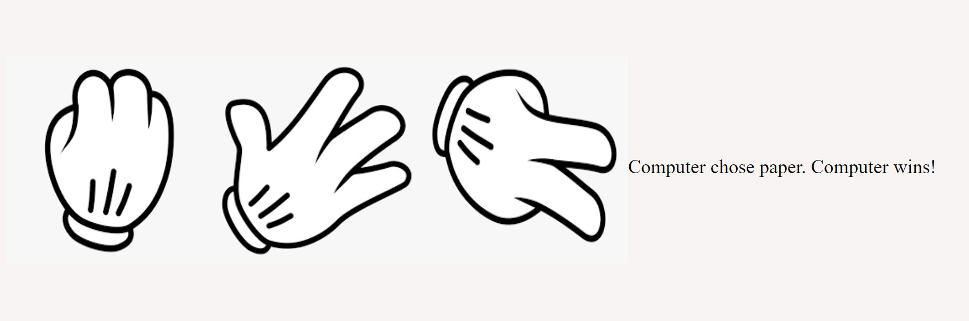

|  |  |
| --- | --- |
| **Class performance** |  |
| **Record** |  |
| **Viva** |  |
| **Total** |  |

**Result:**

Thus the simple webpage using javascript asynchronous functions have been implemented and the output is verified successfully.