4/27/2026
Ali Ahsan
Cyberstar
Task Report
AD Domain Dominance



CyberStar RED TEAMING

INTERSHIP TASK REPORT

Name | Ali Ahsan
Roll No | CSI-B1-427
Internship Program | Cybersecurity Red Teaming
Task Title | AD Domain Dominance
Instructor | Umar Niaz

Content:
- Task 1# LLMNR/NBT-NS Poisoning-Initial Credential Theft
- Technical Background
- Attack Execution
- Hash Cracking

- Task 2# Active Directory Enumeration-Bloodhound & ACL
- Technical Background
- SharpHound Data Collection
- BloundHound Analysis & Attack Path

- Task 3# DCSync Attack-Credential Dumping
- Technical Background
- Krbtgt Hash Cracking
- Extracted Credentials Summary

- Task 4# Golden Ticket Attack-Kerberos Forgery
- Technical Background
- Golden Ticket Forgery
- Domain Controller Access Verification

- Artifact Analysis
- Persistence Strategy
- Security Recommendation

Summary
This report documents a full-scope Active Directory (AD) red team engagement conducted against the CORP.LOCAL domain. The engagement simulated a realistic adversary attack chain — from initial network-level credential theft to complete Domain Controller compromise and persistent access establishment.
Starting with zero domain privileges, the engagement progressed through four sequential attack phases: LLMNR/NBT-NS poisoning for initial credential capture, Active Directory enumeration via BloodHound, DCSync for credential dumping, and Kerberos Golden Ticket forgery for long-term persistence.

Result
Full Domain Compromise was achieved. The attacker obtained Domain Administrator privileges, extracted all credential hashes from the CORP.LOCAL domain, and established ticket-based persistence that survives password resets-rendering the domain completely under attacker control.

Finding | Severity | Status
LLMNR/NBT-NS Poisoning enabled — NTLMv2 hash captured | Critical | Exploited
Domain credentials cracked via dictionary attack | High | Exploited
BloodHound path from TESTUSER to Domain Admins confirmed | High | Confired
DCSync executed — KRBTGT hash extracted | Critical | Exploited
Golden Ticket forged — 10-year persistence established | Critical | Exploited

Attack Chain Overview

Phase | Technique | Tool | Result
01 | LLMNR/NBT-NS Poisoning | Responder | NTLMv2 Hash Captured
02 | Hash Cracking | Hashcat (-m 5600) | Plaintext: Password123
03 | AD Enumeration | SharpHound + BloodHound | Attack Path Identified
04 | DCSync Attack | Mimikatz | KRBTGT Hash Extracted
05 | Golden Ticket Forgery | Mimikatz kerberos::golden | 10-Year TGT Forged
06 | Domain Access | Pass-the-Ticket | DC C$ Accessed

The attack chain below represents the complete kill-chain from initial unauthenticated network access to persistent Domain Administrator access-achieved without any vulnerability exploit, relying entirely on protocol weaknesses and misconfigured permissions inherent to default Active Directory environments.

Task 1# LLMNR/NBT-NS Poisoning-Initial Credential Theft

Technical Background:
Link-Local Multicast Name Resolution (LLMNR) and NetBIOS Name Service (NBT-NS) are legacy Windows fallback protocols that activate when DNS fails to resolve a hostname. Rather than returning an error, Windows broadcasts the query to the entire local subnet — allowing any host to respond and claim to be the target. An attacker running Responder on the same network intercepts these broadcasts, responds as the requested host, and forces the victim machine to authenticate — handing over an NTLMv2 challenge-response hash.
Attack Execution:
Responder was launched on the Kali attacker machine to listen on all relevant ports.

Command:

sudo responder -I eth0 -dwv

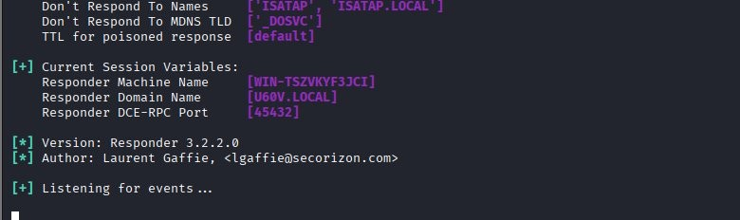

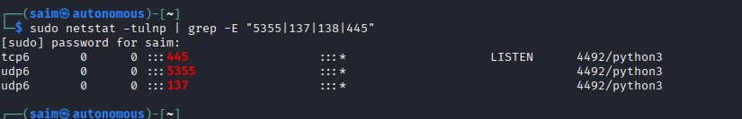



On the Windows victim machine, a fake UNC path was entered in the Run dialog to trigger LLMNR broadcast

\\fake-share

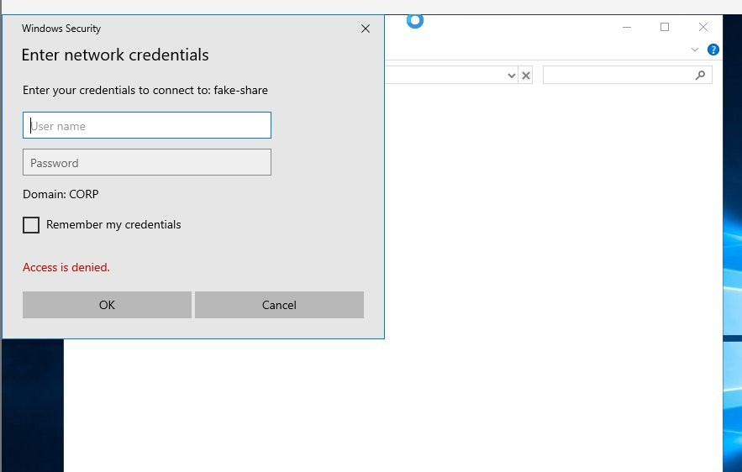

Responder poisoned the broadcast response and captured the NTLMv2 hash from CORP\Administrator

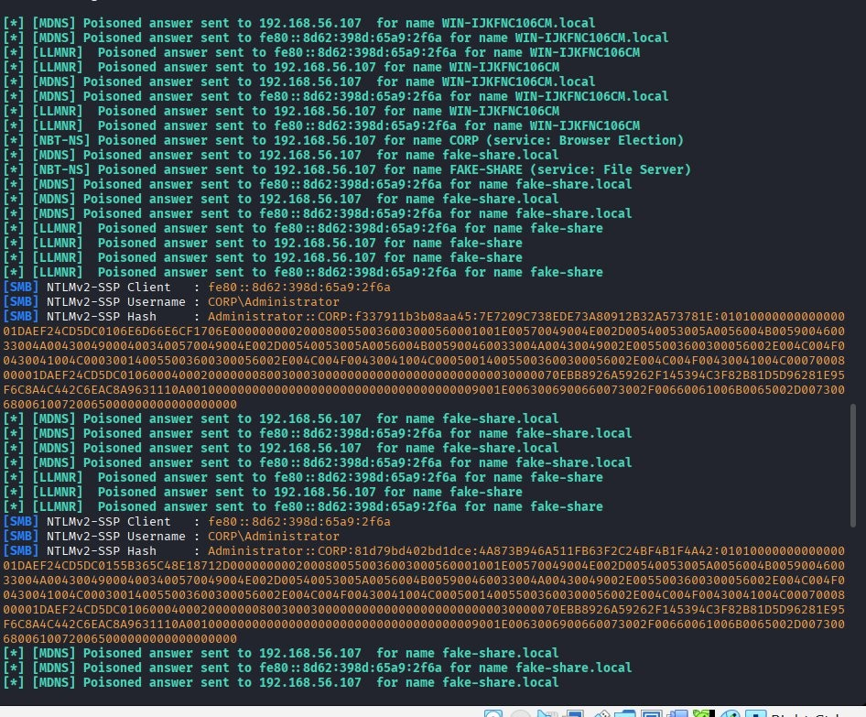

Hash Cracking
The captured NTLMv2 hash was saved and submitted to Hashcat using mode 5600 (NetNTLMv2) against the rockyou.txt wordlist. Two hash attempts were made one succeeded with Status: Cracked, while the Administrator hash exhausted the wordlist.

Command:

hashcat -m 5600 hash.txt /usr/share/wordlists/rockyou.txt --force

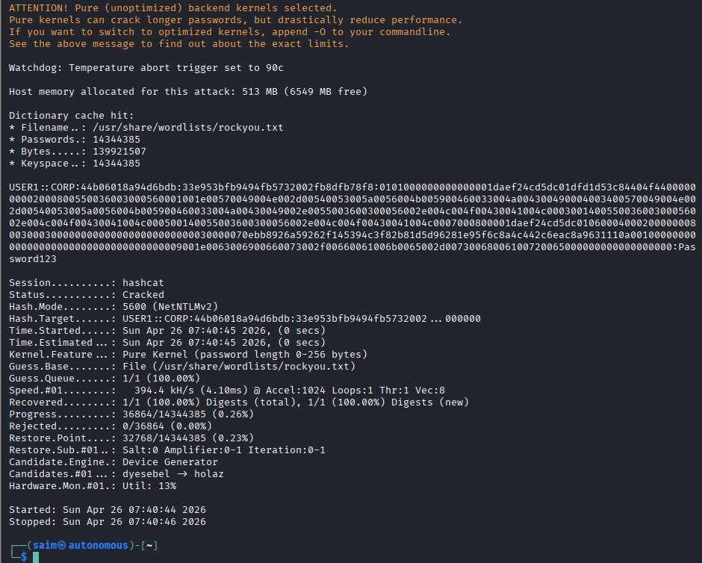

Task 2# Active Directory Enumeration-Bloodhound & ACL

Technical Background
BloodHound is an Active Directory reconnaissance tool that maps relationships between AD objects (users, groups, computers, GPOs) using graph theory to find privilege escalation paths that would be impossible to detect manually. SharpHound is its data collector, run on a Windows domain-joined machine to gather LDAP data and produce a ZIP importable into BloodHound's Neo4j graph database.

SharpHound Data Collection
SharpHound v2.12.0 was executed on the Windows Domain Controller with full collection mode (-c All) to enumerate all AD objects, sessions, ACLs, and group memberships.

Command:

.\SharpHound.exe -c All --outputdirectory C:\Users\Administrator\Desktop\

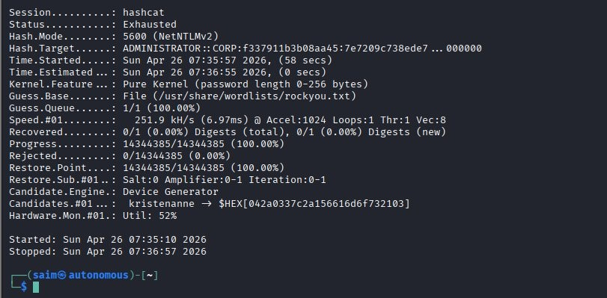

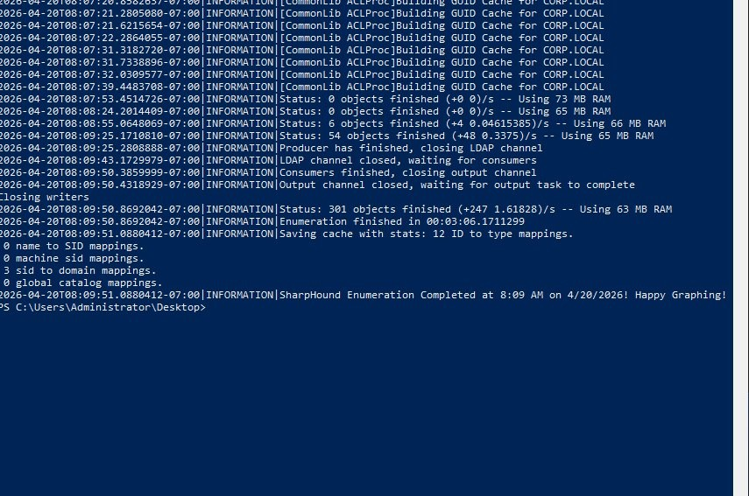

BloundHound Analysis & Attack Path
The SharpHound ZIP was imported into BloodHound running on Kali (Neo4j backend). A pathfinding query was executed to find the shortest privilege escalation path from TESTUSER@CORP.LOCAL to DOMAIN ADMINS@CORP.LOCAL.

MATCH p=shortestPath((u:User {name:"TESTUSER@CORP.LOCAL"})
-[*1 .]->(g:Group {name:"DOMAIN ADMINS@CORP.LOCAL"})) RETURN p

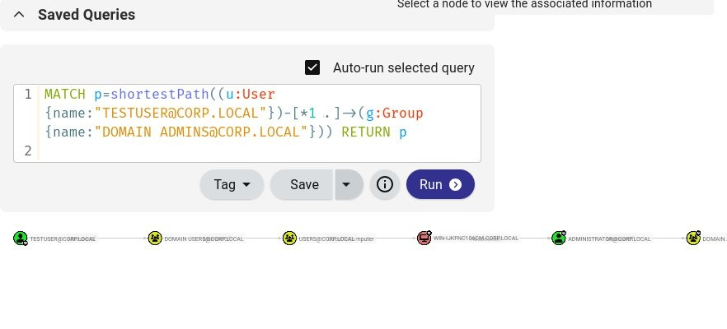

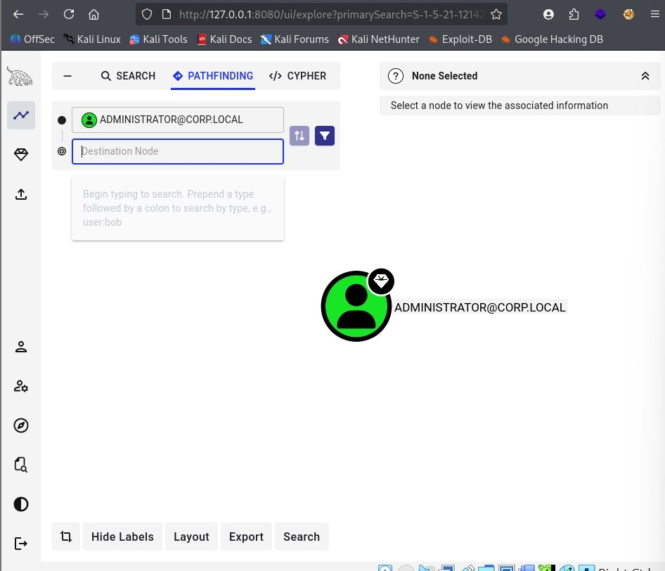

Result
BloodHound revealed a multi-hop privilege path from the low-privileged Testuser through domain group memberships to Administrator and ultimately to Domain Admins. This path required no exploit only standard AD relationship traversal.
Task 3# DCSync Attack-Credential Dumping

Technical Background
DCSync is an attack technique that abuses the Directory Replication Service (DRS) protocol. A Domain Controlleruses replication to synchronize data with other DCs-an account with DS-Replication-Get-Changes-All rights can mimic this process and request password hashes for any account directly from a DC, without ever touching the NTDS.dit file on disk. Mimikatz implements this via the lsadump::dcsync module.

Krbtgt Hash Cracking
With Domain Admin privileges, Mimikatz was used to perform DCSync and extract the KRBTGT account- the master Kerberos encryption key for the entire domain. This is the highest-value credential in any AD environment.

Command:

mimikatz # privilege::debug

mimikatz # lsadump::dcsync /domain:corp.local /user:krbtgt

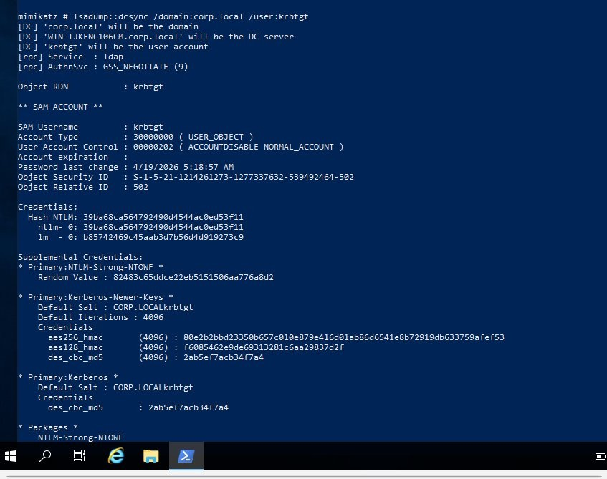

Extracted Credentials Summary

Account | Rid | Hash Ntlm | Significance
krbtgt | 502 | 39ba68ca...53f11 | Kerberos TGT Signing Key — CRITICAL
Administrator | 500 | Extracted via DCSync | Domain Admin Account
CORP.LOCAL domain | — | All hashes accessible | Full domain compromise

Task 4# Golden Ticket Attack-Kerberos Forgery

Technical Background
A Golden Ticket is a forged Kerberos Ticket Granting Ticket (TGT) signed with the KRBTGT account's NTLM hash. Because every Kerberos TGT in the domain is validated using this same key, a forged ticket is indistinguishable from a legitimate one — granting its bearer Domain Administrator access to any service in the domain for the ticket's lifetime (up to 10 years). The ticket is injected directly into memory using Pass-the-Ticket (PtT), requiring no password.

Golden Ticket Forgery
Using the KRBTGT hash and Domain SID extracted via DCSync.

mimikatz # kerberos::golden

/domain:corp.local

/sid:S-1-5-21-1214261273-1277337632-539492464

/krbtgt:39ba68ca564792490d4544ac0ed53f11

/user:Administrator

/id:500

/ptt

mimikatz # kerberos::golden

/domain:corp.local

/sid:S-1-5-21-1214261273-1277337632-539492464

/krbtgt:39ba68ca564792490d4544ac0ed53f11

/user:Administrator

/id:500

/ptt

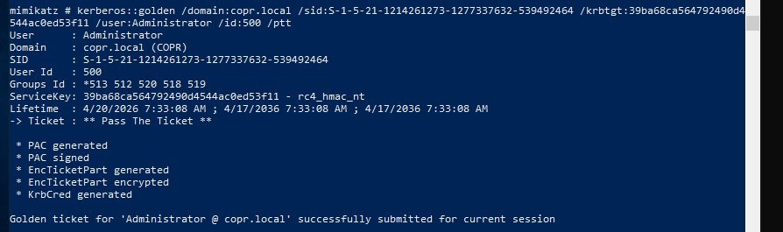

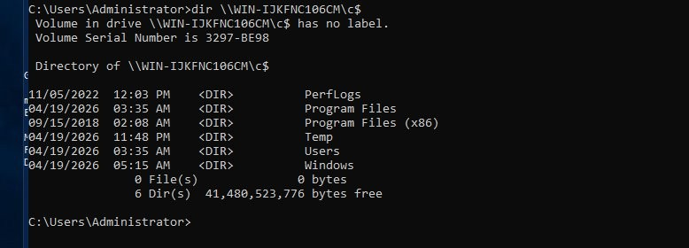

Domain Controller Access Verification
With the Golden Ticket injected into the current session, the attacker accessed the Domain Controller's administrative share (C$)-confirming full unrestricted Domain Administrator access.

Command:

dir \\WIN-IJKFNC106CM\c$

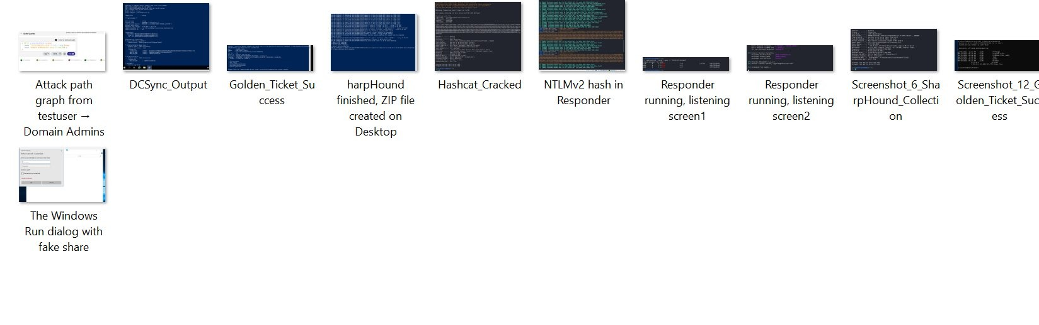

- Artifact Analysis
The Golden Ticket is the most powerful persistence artifact in Active Directory. The following table breaks down each component of the forged ticket and its significance.

Field | Value | Significance
User | Administrator | Impersonates Domain Admin-any user name works
Domain | corp.local (COPR) | Targets the CORP.LOCAL Kerberos
SID | S-1-5-21-1214261273-...-539492464 | Correct domain SID — ticket passes SID validation
User ID | 500 | RID 500 = built-in Administrator — highest privilege
Groups ID | *513 512 520 518 519 | Domain Users, Admins, Schema Admins
ServiceKey | 39ba68ca...0ed53f11 — rc4_hmac_nt | Signed with KRBTGT NTLM hash
Lifetime | 4/20/2026  4/17/2036 | 10-year validity- survives password resets
Injection | Pass-the-Ticket (/ptt) | Lives in memory — no files on disk

Why the Golden Ticket is "God Mode": The Domain Controller validates TGTs using only the KRBTGT password hash-it has no record of which tickets it issued. A forged ticket signed with the correct KRBTGT hash is therefore completely valid from the DC's perspective. Even if the Administrator account password is changed, the Golden Ticket remains valid. The only way to invalidate it is to rotate the KRBTGT password twice.

Persistence Strategy
The following persistence mechanisms were established or are available following full domain compromise. These ensure continued access even if defenders detect and respond to the initial intrusion.

Mechanism | SURVIVES PASSWORD RESET? | DETECTION DIFFICULTY
Golden Ticket (KRBTGT Hash) Forged TGT With 10-Year Lifetime | YES-Until KRBTGT Rotated TW | High-Looks Like Legitimate Kerber
Silver Ticket (Machine Account Hash) Forged TGS For Specific Service | YES-Until Machine Account Ro | HIGH-Never Contacts DC
Dcsync Rights Via ACL  DS-Replication Rights on Domain Object | YES-Survives All Password Ch | Medium-ACL Change Logged
Skeleton Key  Patches Lsass To Accept Master Password | No-Lost on Dc Reboot | Low-Lsass Patch Detectable
Admin SD Holder Backdoor  grants persistent admin rights via SDProp | YES — auto-restored every 60 mi | Medium-SDProp mechanism

Recommendation for Blue Team
The Golden Ticket attack persists until the KRBTGT account password is reset twice consecutively (two resets within the ticket lifetime). A single reset is insufficient because the DC retains the previous password hash for backward compatibility. After double rotation, all outstanding Golden Tickets-including the forged one-become invalid.

Security Recommendation

- Disable LLMNR and NBT-NS
LLMNR and NBT-NS provide zero legitimate business value in modern environments and are a primary initial access vector for credential theft. Disable both via Group Policy immediately.
    - GPO: Computer Config Admin Templates  Network  DNS Client Turn off Multicast Name Resolution
→ ENABLED
    - GPO: Computer Config Admin TemplatesNetworkLanman Workstation  Enable insecure guest logons  DISABLED
    - Registry: HKLM\SYSTEM\CurrentControlSet\Services\NetBT\Parameters  NodeType = 2
    - Deploy WPAD entries in DNS to prevent WPAD hijacking via the same vector

- Rotate KRBTGT Password Twice Immediately
The KRBTGT hash has been extracted during this engagement. Any forged Golden Tickets created with this hash remain valid until the KRBTGT password is rotated twice. Schedule regular KRBTGT rotation as an ongoing security control.
    - Use Microsoft's New-KrbtgtKeys.ps1 script for safe rotation
    - Rotate KRBTGT password  wait 10 hours (replication)  rotate again
    - Monitor for Kerberos tickets with lifetimes exceeding 10 hours (anomaly)
    - Establish quarterly KRBTGT rotation schedule (Microsoft recommendation)

- Implement Tiered Administration Model
Domain Admin accounts should NEVER be used for routine administration or logged into workstations. The Tier 0/1/2 model isolates privileged credentials to their appropriate trust boundaries, preventing credential theft from lower-tier machines.
- Tier 0: Domain Controllers only-only KRBTGT and DA accounts
- Tier 1: Member Servers-server admins cannot log into workstations
- Tier 2: Workstations-helpdesk accounts cannot touch servers
- Enforce via Authentication Policy Silos in AD
- Enable Protected Users security group for all Tier 0 accounts

- Harden ACLs and Audit Dangerous Permissions
BloodHound identified privilege escalation paths through AD object permissions. Regular ACL auditing using BloodHound in a Blue Team capacity can identify and eliminate these paths before attackers exploit them.
- Run BloodHound quarterly as a Blue Team control-export and review all attack paths
- Remove GenericWrite, WriteDACL, AllExtendedRights from non-admin accounts
- Restrict DCSync rights (DS-Replication-Get-Changes-All) to DC computer accounts only
- Enable object-level auditing on high-value AD objects (AdminSDHolder, Domain object)

