4/12/2026
Ali Ahsan
Cyberstar
Task Report
Lateral Movement & Network Pivoting



CyberStar RED TEAMING
INTERSHIP TASK REPORT

Name | Ali Ahsan
Roll No | CSI-B1-427
Internship Program | Cybersecurity Red Teaming
Task Title | Lateral Moment & Network Pivoting
Instructor | Umar Niaz

Content:
- Task 01 — Internal Network Discovery
- Task 02 — Pivoting & Tunneling
- Task 03 — Credential Dumping & Harvesting
- Task 04 — Lateral Movement Techniques

Task 01 — Internal Network Discovery
After gaining initial access to Metasploitable 2 via the vsftpd 2.3.4 backdoor exploit, a Meterpreter session was established from Kali. The shell command dropped into a native Linux shell on the compromised host, enabling native OS tools for internal reconnaissance.
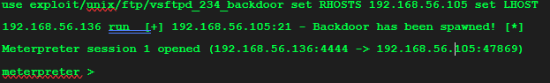
Inside the shell on Machine 1, the following commands were executed to map the internal network.
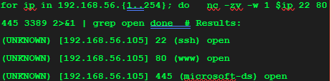

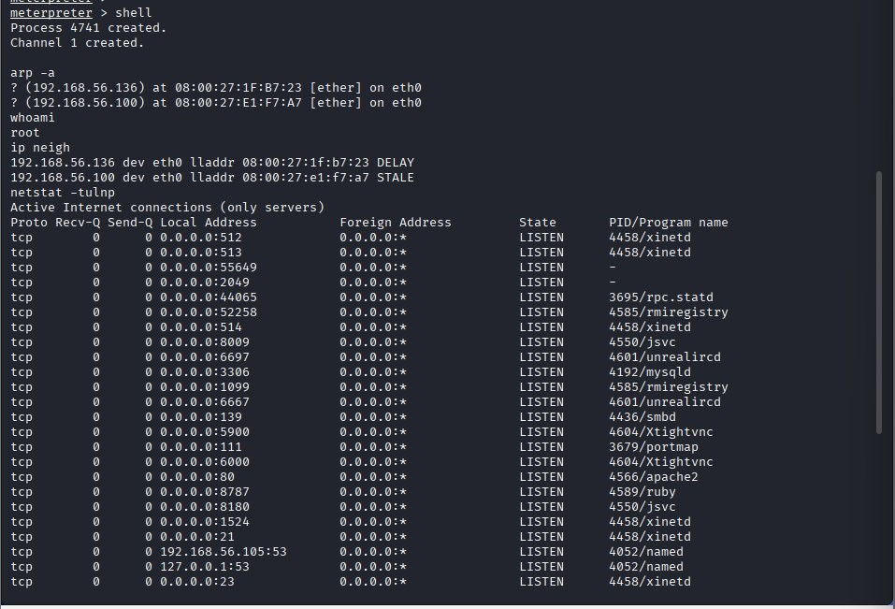

A Bash loop with netcat was used to scan all 254 IPs in the subnet for common ports. The -w 1 flag sets a 1-second timeout per connection for speed.
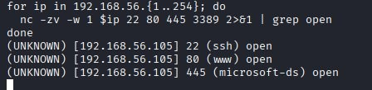

Task 02 — Pivoting & Tunneling
With the internal network mapped, a SOCKS proxy tunnel was established through Machine 1, allowing kali's tools to reach Machine 2 (not directly accessible). This was done using SSH Dynamic Port Forwarding combined with Proxy chains.

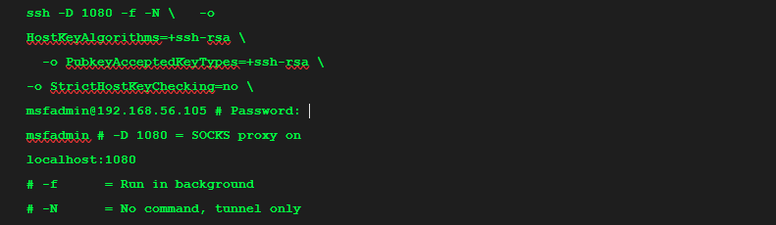

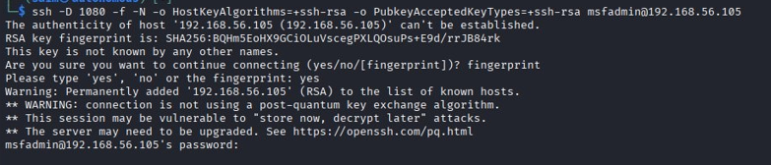

The /etc/proxychains.conf file was configured to route all tool traffic through the SOCKS5 proxy.
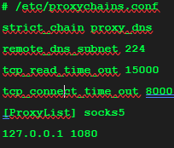

Nmap was run through Proxychains to verify traffic was routing through Machine1.
-sT (TCP connect) must be used — SYN scan (-sS) does not work over SOCKS
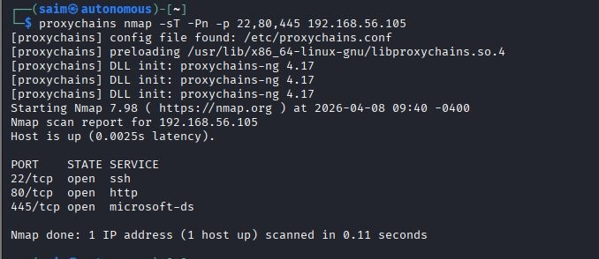

Task 03 — Credential Dumping & Harvesting
With pivoting established, credentials were extracted from Machine 1 (Metasploitable 2) for reuse on Machine 2. This demonstrates the core concept: passwords found on Machine A often work on Machine B.
Root access on Metasploitable 2 was used to read /etc/shadow, which stores hashed passwords for all system users
Cat/etc/shadow
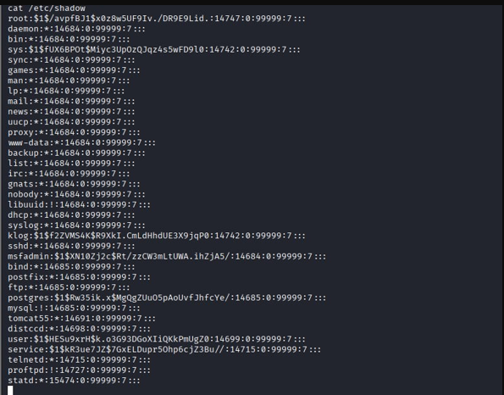
The extracted hashes were saved to hash.txt on Kali and cracked offline using John the Ripper with the rockyou.txt wordlist.
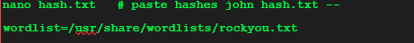
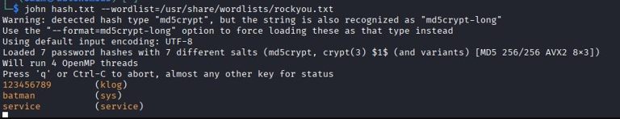
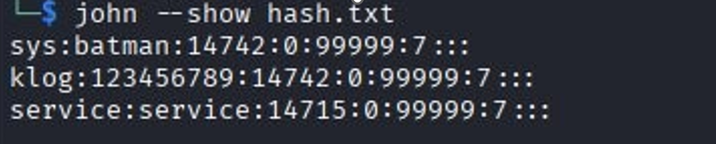
Output
Username | Cracked Password
sys | batman
klog | 123456789
root | pending - longer wordlist needed
msfadmin | pending - longer wordlist needed

Task 04 — Lateral Movement Techniques
Using the harvested credentials, lateral movement was performed by SSH-ing into Metasploitable2 as different user accounts. This simulates how attackers reuse credentials to move between machines on the same internal network.
Mfsadmin Account:
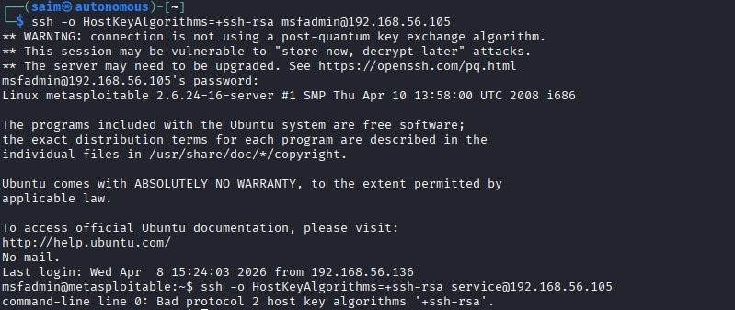

Service Account:
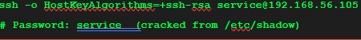
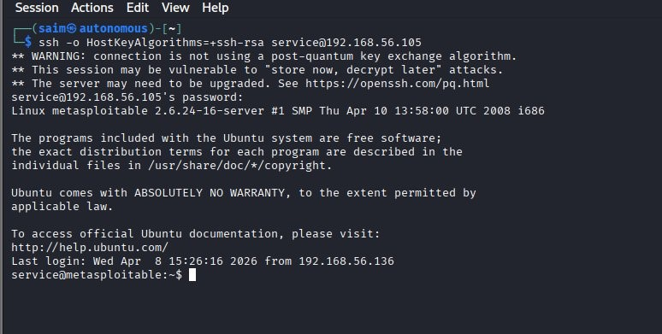

Pass The Hash:
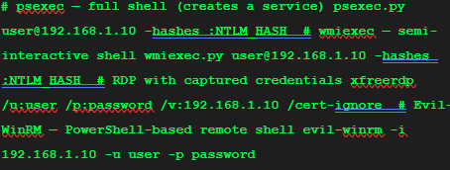

Recommendation:
Based on the techniques demonstrated in this lab, the following defensive controls are recommended to prevent lateral movement and network pivoting in real-world environments.

- SIEM/EDR Monitoring
Deploy detection for unusual internal authentication patterns, lateral movement tools (psexec, wmiexec), and internal port scanning from workstations.
- Disable Unnecessary Services
Metasploitable had FTP, Telnet, SMB, VNC and many other unnecessary services running. Apply minimum attack surface — disable all services not explicitly required.
- Credential Hygiene
Enforce strong unique passwords and prevent reuse across machines. The cracked passwords are trivially weak and would be cracked in seconds in real attacks.
- Network Segmentation
Divide the network into isolated VLANs. Workstations should not communicate directly with servers unless explicitly required. This limits an attacker's ability to pivot freely after initial access.
- Privileged Access Management
Enforce least privilege. Limit which accounts can log into which machines. Use bastion/jump hosts for administrative access to sensitive systems.
- Multi-Factor Authentication
Enable MFA for SSH, RDP, WinRM, and VPN. Even if credentials are stolen, MFA blocks unauthorized logins.
- Disable Legacy Protocols
Disable LLMNR, NBT-NS, and SMBv1 which are commonly abused for credential capture and relay attacks. These protocols are rarely needed in modern environments.

Learning Object:
This week's lab provided hands-on experience with one of the most critical phases of a real-world cyberattack: lateral movement. Starting from a single compromised host (Metasploitable 2), it was demonstrated how an attacker can systematically discover the internal network, establish tunnels to bypass network restrictions, harvest credentials, and move laterally to additional targets.
The key lesson is that initial access is merely the beginning. The true impact of a breach comes from lateral movement — reaching domain controllers, databases, and other high-value targets deep within the network. Defenders must assume breach and implement controls that detect and limit lateral movement, not just prevent initial access.

