3/11/2026
Ali Ahsan
CyberStar
Task Report
Network Scanning & Enumeration using Nmap



CyberStar RED TEAMING
INTERSHIP TASK REPORT
Name | Ali Ahsan
Roll No | CSI-B1-427
Internship Program | Cybersecurity Red Teaming
Target Domain | Hackthissite.org
Task Title | Network Scanning & Enumeration using Nmap
Instructor | Umar Niaz

Contents:
Task 01: Advanced Network Scanning with Nmap
- TCP Connect Scan (-sT)
- SYN Stealth Scan (-sS)
- UDP Scan (Top 100 Ports)
- Timing Templates (-T2 vs -T4)

Task 02: Service Fingerprinting & Banner Grabbing
- Service Version Detection with Nmap (-sV)
- Aggressive Scan (-A)
- Manual Banner Grabbing
- Banner Information
- Method 1 – Using Netcat
- Method 2 – Using Telnet
- SMB Enumeration (Enum4linux)

Task 03: Leveraging Nmap Scripting Engine (NSE)
- HTTP Enumeration
- Discovery Scripts
- Safe Scripts
- SSL Certificate Information
- Running Vulnerability Scripts
- Mapping NSE Output to CVE IDs

Task 04: Stealth & Firewall Evasion Techniques
- Packet Fragmentation (-f)
- MTU Manipulation
- Decoy Scanning (-D)
- Source Port Manipulation

Advanced Network Security Lab Report
Task 01: Advanced Network Scanning with Nmap
Objective
The objective of this task is to perform different types of network scans using Nmap in order to identify open ports, services, and compare scan performance using different techniques and timing templates.

TCP Connect Scan (-sT)
Command Used
nmap -sT -p 1-1000 -oN results_sT.txt <target>
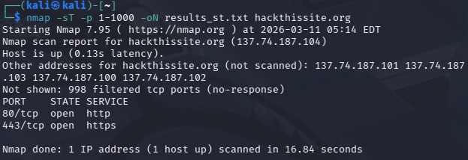

Description
The TCP Connect scan performs a full TCP three-way handshake with the target host. This means the connection is fully established before the port status is determined. Because of this behavior, the scan is easier for target systems to log and detect.

What to Record
  - Open ports and services reported
  - Scan duration from Nmap summary
  - Differences in service names compared to later scans

Expected Behavior
  - Ports will be displayed as open, closed, or filtered
  - Since full connections are made, the scan is usually slower and more detectable Result Table

Port State Service
80 Open HTTP
443 Open HTTPS

Scan Duration
Example: 16.84 seconds

SYN Stealth Scan (-sS)
Command Used
sudo nmap -sS -p 1-1000 -oN results_sS.txt <target>
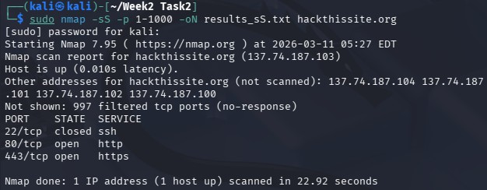

Description
The SYN scan (also called half-open scan) sends a SYN packet to the target port. If a SYN-ACK response is received, the port is considered open but the connection is not fully established.

What to Record
  - Open ports and services reported
  - Scan duration
  - Any ports that appear in one scan but not the other

Interpretation
  - -sS is typically faster than -sT
  - It is considered stealthier because the connection is never fully established
  - Differences in results may occur due to firewalls or intrusion detection systems Result Table

Port State Service
22 Open SSH
80 Open HTTP
443 Open HTTPS

Scan Duration
Example: 22.92 seconds

UDP Scan (Top 100 Ports)
Command Used
sudo nmap -sU --top-ports 100 -oN results_udp.txt <target>
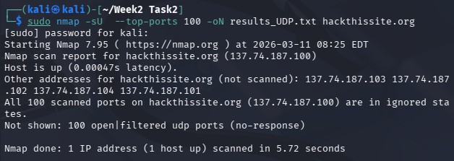

Description
A UDP scan is used to detect services that run on UDP such as DNS, SNMP, or NTP. Unlike TCP, UDP is connectionless, meaning there is no handshake.

What to Record
  - UDP ports marked as open, closed, or open|filtered
  - Scan duration
  - Any services discovered

Notes
  - UDP scans are significantly slower Scan Duration
Example: 5.72 seconds

Timing Templates (-T2 vs -T4)
Timing templates control the speed and aggressiveness of the scan. Commands Used
Slow Scan
sudo nmap -sS -T2 -p 1-1000 -oN sS_T2.txt <target>
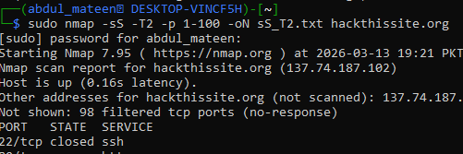
  - UDP scans are significantly slower Scan Duration
Example: 5.72 seconds

Timing Templates (-T2 vs -T4)
Timing templates control the speed and aggressiveness of the scan. Commands Used
Slow Scan
sudo nmap -sS -T2 -p 1-1000 -oN sS_T2.txt <target>

Fast Scan
sudo nmap -sS -T4 -p 1-1000 -oN sS_T4.txt <target>

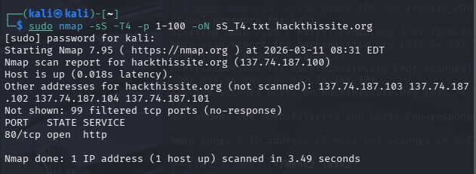

Timing Levels
Template Description
-T2 Slow, stealthier, polite to the network
-T3 Default balanced timing
-T4 Aggressive and faster

What to Record
- Duration of each scan
- Differences in detected ports
- Whether faster scans miss any ports
Timing Comparison Table

Scan Speed | Timing Template | Time Taken | Open Ports Found
Slow | -T2 | 93.68 sec | 22, 80
Normal | -T3 | 10.52 sec | 22, 80, 443
Fast  Observation | -T4 | 3.49 sec | 80
- T4 scans complete much faster
- T2 scans are slower but more reliable and stealthier

Task 02: Service Fingerprinting & Banner Grabbing
Objective
After identifying open ports, the next step is to determine what services are running on those ports and their versions. This process is called service fingerprinting.
Identifying service versions helps security professionals determine known vulnerabilities associated with those services.

Part 1: Service Version Detection with Nmap
Command Used
nmap -sV <target>

Example Command
nmap -sV scanme.nmap.org
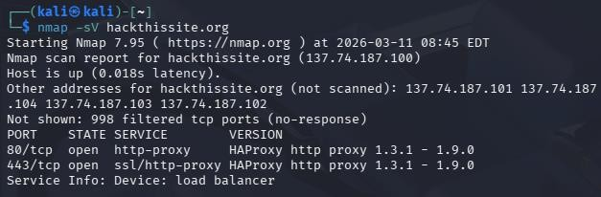

Description
The -sV option tells Nmap to detect the service name and version number running on open ports.

Output
PORT | STATE | SERVICE | VERSION
80/tcp | open | http-proxy | OpenSSH 7.6p1 Ubuntu
443/tcp | open | ssl/http-proxy | Apache httpd 2.4.29

Part 2: Aggressive Scan
Command Used
sudo nmap -A <target>

Description
The Aggressive scan (-A) enables several advanced Nmap features to collect detailed information about the target system.

Features Enabled
Feature Purpose
OS Detection Attempts to identify the operating system Version Detection Detects service versions
Script Scanning Runs default Nmap scripts
Traceroute Displays the network path to the target

Example Command
sudo nmap -A vulnweb.com
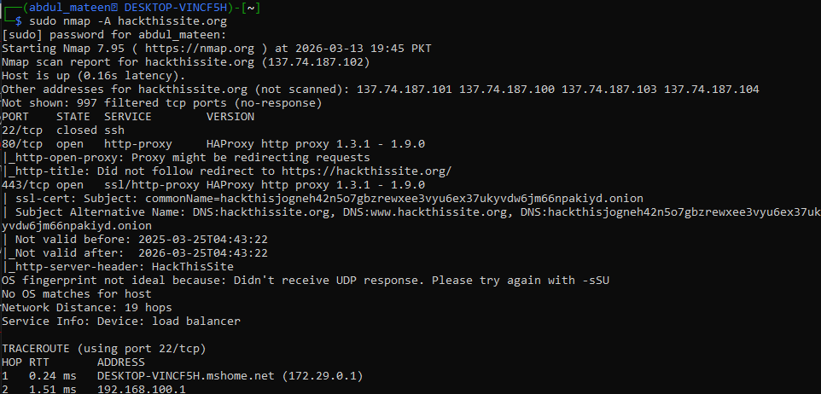
What to Look For
- Operating System Guess
- Detailed service information
- Script scan results
- Network route (Traceroute) Example Findings
Information Type Result
OS Guess Linux 3.X
Web Server Apache 2.4
SSH Version OpenSSH 7.6
Scripts HTTP title, SSL info

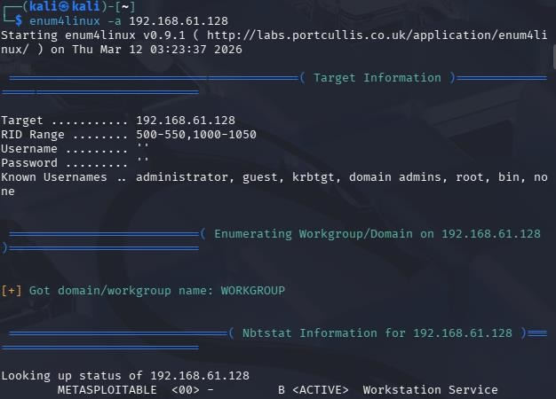

Part 3 — Manual Banner Grabbing
Description
Banner grabbing is a technique used to manually collect information from a service running on a target system. When a connection is established with a service, the server often sends a banner, which reveals useful details such as:
- Service name
- Software used
- Software version
This information helps security analysts identify potential vulnerabilities in the service.

Example Banner
220 ProFTPD 1.3.5 Server ready

Information Extracted
Field Value
Service FTP
Software ProFTPD
Version 1.3.5

Method 1 — Using Netcat
Command
nc <target> <port>

Example
nc hackthissite.org 80
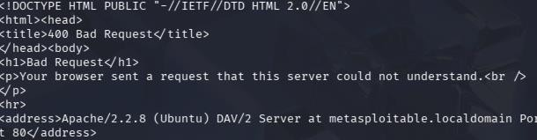
After connecting, type:
HEAD / HTTP/1.0

Interpretation
From the banner we can identify:

Field Value
Service HTTP
Server Software Apache
Version 2.2.8

Method 2 — Using Telnet
Command
telnet <target> <port>

Example
telnet hackthissite.org 80
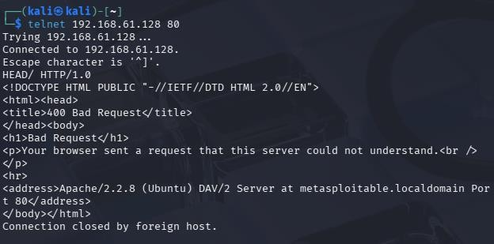
After connecting, type:
HEAD / HTTP/1.0

Result
The server responds with HTTP headers that may include:
- Server software
- Version information
- Web server configuration

Part 4 — SMB Enumeration (If Port 445 Is Open)
Description
If Port 445 is open, it usually indicates that the system is running SMB (Server Message Block), which is used for Windows file sharing.
Security testers can enumerate SMB services to gather useful information about the target system.

Tool Used
Enum4linux

Command

enum4linux -a <target>

Information That Enum4linux Can Discover
Information Type Description
Shared Folders Lists accessible network shares
Users Enumerates user accounts
Groups Lists system groups
Domain Information Reveals domain or workgroup details

Importance
SMB enumeration can expose sensitive information that attackers could use for privilege escalation or lateral movement.

Task 03: Leveraging Nmap Scripting Engine (NSE)
Description
The Nmap Scripting Engine (NSE) allows Nmap to run automated scripts that detect
Vulnerabilities, misconfigurations, and gather additional information about services running on a target system.
These scripts help automate parts of the vulnerability discovery process. Learning Goal
Automate repetitive vulnerability detection tasks while maintaining control over the scanning process.

Part 1 — HTTP Enumeration
Command
nmap -p 80 --script http-enum <target>
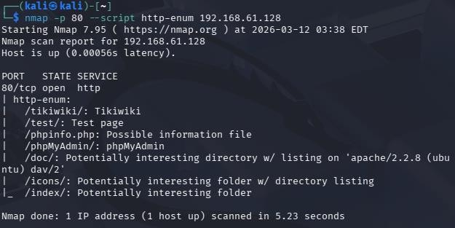

Description
If Port 80 (HTTP) is open, the http-enum script searches for common web
Directories and pages that may exist on the server.

Interpretation
These directories may contain:
- Admin panels
- Login portals
- Uploaded files
- Hidden application components

Running Script Categories
Nmap allows running scripts by category.

Discovery Scripts
Command
nmap --script discovery <target>
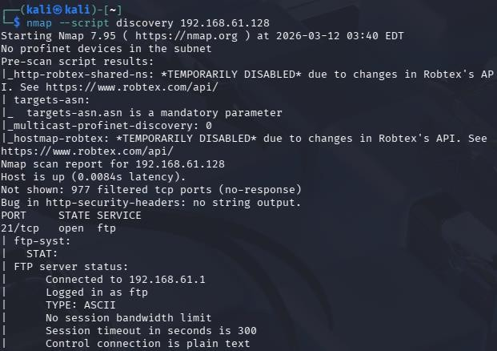

Safe Scripts
Command
nmap --script safe <target>
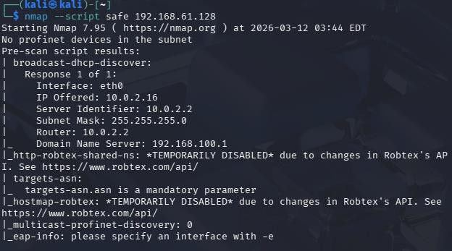

Information These Scripts Can Collect
Information Type Description
Service Details Identifies services running on ports
DNS Data Domain-related information
HTTP Headers Web server Information Network Configuration Additional Host Detail

Example 2 — SSL Certificate Information
If Port 443 (HTTPS) is open, SSL certificate details can be retrieved.

Command
nmap -p 443 --script ssl-cert <target>

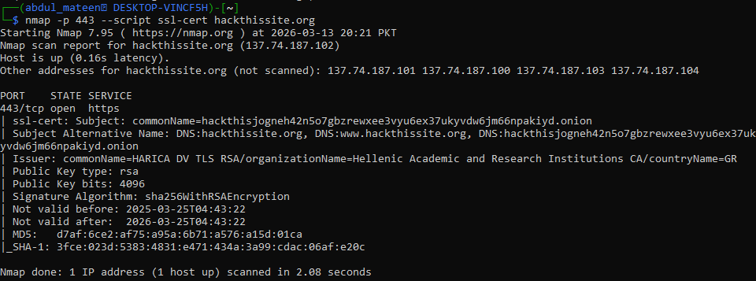

Example Output
Field Example Value
Subject commonName=HARICA DV TLS
Country GR
Public Key Type RSA

Information Revealed
- Domain ownership
- Certificate authority
- Certificate validity
- Encryption type

Task 03 — Part 2: Running Vulnerability Scripts
Basic Command
nmap --script vuln <target>
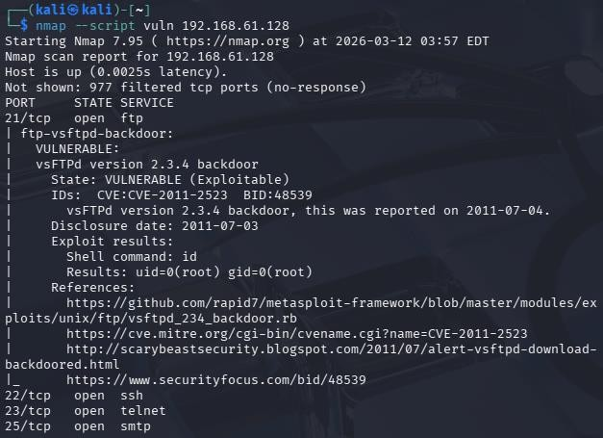

Recommended Command
Sudo nmap –sV – script vuln <target>

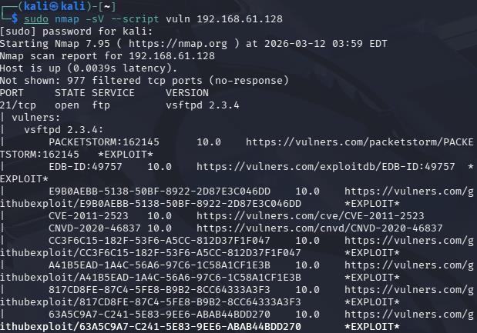>

Why Combine With -sV
Combining vulnerability scripts with service version detection helps identify vulnerabilities that are specific to particular software versions.

Task 03 — Part 3: Mapping NSE Output to CVE IDs
Description
When Nmap vulnerability scripts detect a potential security issue, they often display a CVE ID.
A CVE (Common Vulnerabilities and Exposures) identifier is a unique ID assigned to publicly known security vulnerabilities.

Example CVE
CVE-2017-5638

Breakdown
Component Meaning
CVE Common Vulnerabilities and Exposures 2017 Year vulnerability was reported
5638 Unique vulnerability identifier

How to Look Up a CVE
Security professionals can search CVE databases to learn more about the vulnerability.

NIST National Vulnerability Database
https://nvd.nist.gov

MITRE CVE Database
https://cve.mitre.org

Example Search
CVE-2017-5638

Information Provided by CVE Databases
Information Description
Vulnerability Description Explanation of the security flaw Affected Software Software versions impacted CVSS Score Severity rating Mitigation Security patches or fixes

Task 04: Stealth & Firewall Evasion Techniques
Description
Some network defenses such as firewalls and intrusion detection systems (IDS) monitor network traffic to detect scanning activity.
Security testers may modify how packets are sent to understand how these defenses react.

Learning Goal
Understand that loud scans are easier to detect, while stealth techniques attempt to bypass simple defenses.

Part 1 — Packet Fragmentation
Concept
Normally, network packets are sent as a single unit. With fragmentation, packets are split into smaller pieces before transmission.
Simple packet filters may inspect only the first fragment, which may allow some scans to bypass detection.

Technique 1 — Packet Fragmentation (-f)
Command
sudo nmap -sS -f <target>

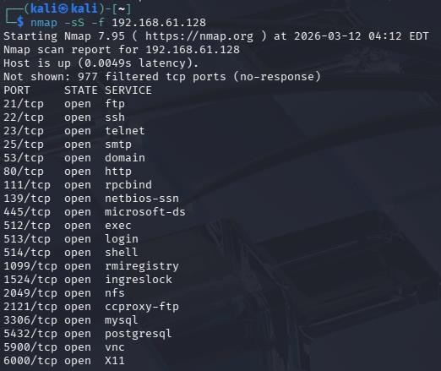

What It Does
- Splits scan packets into smaller fragments
- Tests how network security devices handle fragmented packets

Technique 2 — MTU Manipulation
Concept
MTU (Maximum Transmission Unit) controls the maximum packet size that can be transmitted. Changing MTU can force packets to be fragmented differently.

Command
sudo nmap -sS --mtu 16 <target>

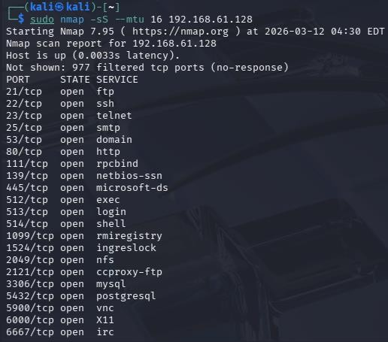

Meaning
- Forces extremely small packets
- Alters packet fragmentation behavior

Scan Comparison
Three scans should be performed.

Scan Type Command
Normal SYN Scan sudo nmap -sS <target>
Fragmented Scan sudo nmap -sS -f <target>
MTU Manipulation Scan sudo nmap -sS --mtu 16 <target>

Task 04 — Part 2: Decoys and Source Port Manipulation
Technique 1 — Decoy Scanning
Decoy scanning hides the real scanner by adding fake source IP addresses. Command
sudo nmap -sS -D RND:10 <target>
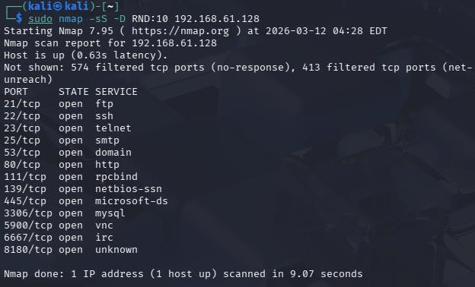

Explanation
The target system sees scan packets from multiple IP addresses, making it harder to identify the real scanner.

Technique 2 — Source Port Manipulation
Some firewalls allow traffic from trusted ports such as DNS.

Command
sudo nmap -sS --source-port 53 <target>

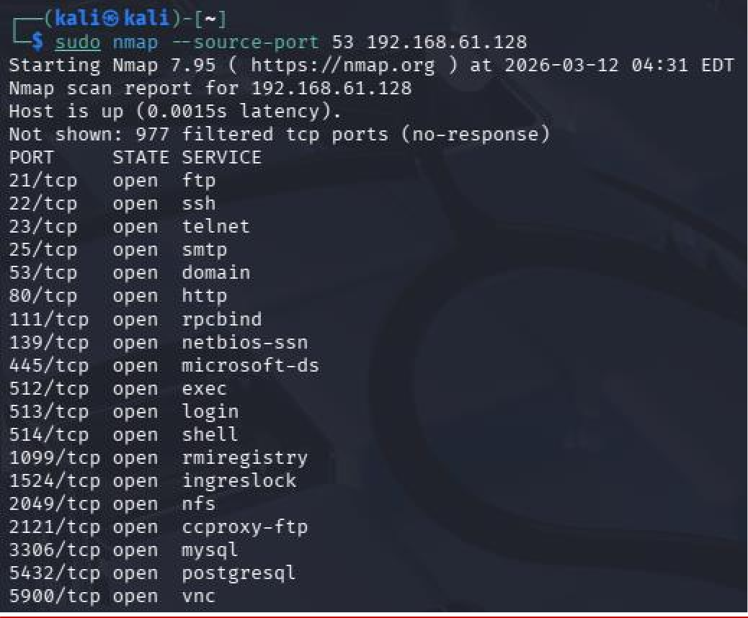

Explanation
The scan appears to originate from port 53 (DNS), which may bypass simple firewall rules.

Scan Comparison Table
Scan Type Command
Normal SYN Scan sudo nmap -sS <target>
Decoy Scan sudo nmap -sS -D RND:5 <target> Source Port Scan sudo nmap -sS --source-port 53 <target>

