Assignment – 1

Title: To study and implement McCulloch-Pitts (MP) Model in MATLAB.

Theory:
McCulloch-Pitts Model Architecture-

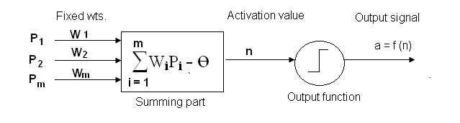

In McCulloch -Pitts (MP) model the actuation (n) is given by a weighted sum of its input values (Pi) & a bias term (Ө). The output signal (a) is typically a non-linear function: f (n) of the actuation value n.
The following equation describes the operation of an MP model.

Actuation:
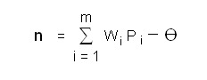

Output signal: a = f (n)

Three commonly used nonlinear functions are binary ramp & sigmoid, although only the binary function was used in original MP model. Network consisting of MP neurons with binary (on-off) output signals can be configured to perform several logical functions.

Following figures shows some logical circuits using the MP model: -

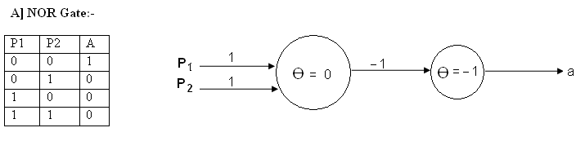

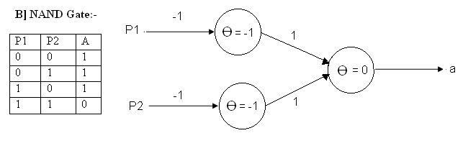

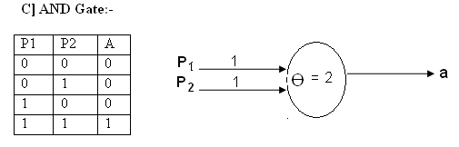

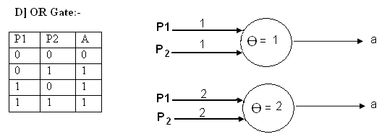

In all above models a binary output function is used with the following logic:

f (n) = 1 , n ≥ 0

f (n) = 0, n < 0

The Firing rule for these models is defined as,

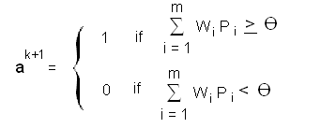

If the input is applied at time instant k, the output is available a unit time later i.e at instant k+1

Algorithm:

1. Decide the no of inputs to a McCulloch-Pitts model.
2. Take the inputs from the user
3. Check whether the inputs are binary or not
4. If inputs are not in proper form (binary) ask the user to enter correct inputs.
5. Ask the user to enter choice of gate

a) AND
b) OR
c) NAND
d) NOR

6. Depending upon no of inputs & gate function required calculate the weights & bias.
7. Calculate the output of neuron.

FAQs:
- Define Artificial Neural Network.

- State the requirements of McCulloch-Pitts Model.

- What are the applications of Mcculloch-Pitts Model?

- What are the drawbacks of McCulloch-Pitts Model?

- Define the transfer function used in McCulloch-Pitts Model.

