**Assignment-9a**

**Title:** To study and implement Mamdani Fuzzy Model in MATLAB.

**Theory:**

The Mamdani fuzzy inference system was proposed as the first attempt to control a steam engine and boiler combination by a set of linguistic control rules obtained from experienced human operators.

As an illustration of this model we would consider an example in which two input linguistic variables, Temperature (T) and Pressure (P) are considered with following membership functions:

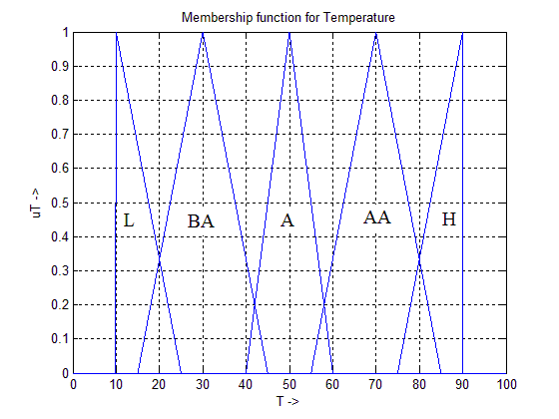Figure 1: Temperature MF.

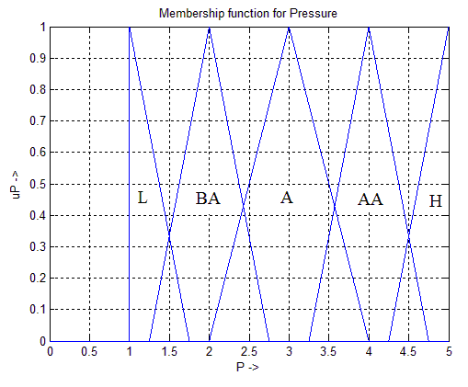 Figure 2: Pressure MF.

Legend: L: Low, BA: Below Average, A: Average, AA: Above Average, H: High.

The output linguistic variable is Heater Power (HP) whose membership functions are given as follows:

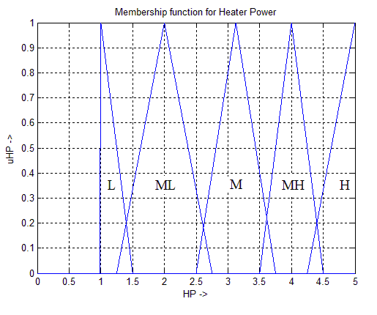Figure 3: Heater Power MF

Legend: L: Low, ML: Medium Low, M: Medium, MH: Medium High, H: High.

Let us consider only **two rules from the Rule Base**:

R1: If the Temperature is BELOW AVERAGE and Pressure is BELOW AVERAGE, then Heater Power is MEDIUM HIGH.

R2: If the Temperature is LOW and Pressure is LOW then Heater Power is HIGH.

Note: There exist 25 such rules in the Rule Base corresponding to:

5 (Ranges of Temperature) X 5 (Ranges of Pressure).

Now, let us consider a **fact** that is given as input to the fuzzy inference system:

T = 22.5o C (T falls in two ranges, L and BA).

P = 1.5 atm (P falls in two ranges, L and BA).

For this input **Mamdani fuzzy inference** system will work as follows:

**Rule 1 Inference:**

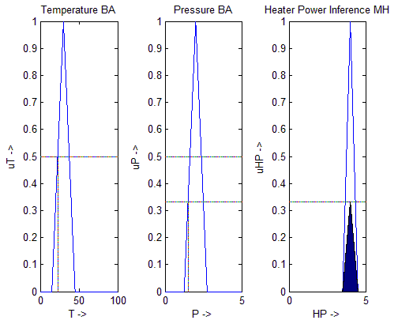

Figure 4.

🡺Inference MF(shaded)

= uHPMH (new)

= 0.3333 x uHPMH

uPBA (1.5) = 0.3333

uTBA (22.5) = 0.5

min (0.5, 0.3333) = 0.3333

**Rule 2 Inference:**

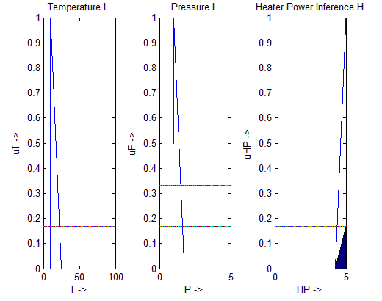

Figure 5.

uTL (22.5) = 0.16667

🡺Inference MF (shaded)

= uHPH (new)

= 0.1667 x uHPH

uPL (1.5) = 0.3333

min (0.1667, 0.3333) = 0.1667

**Resultant Fuzzy reasoning:** 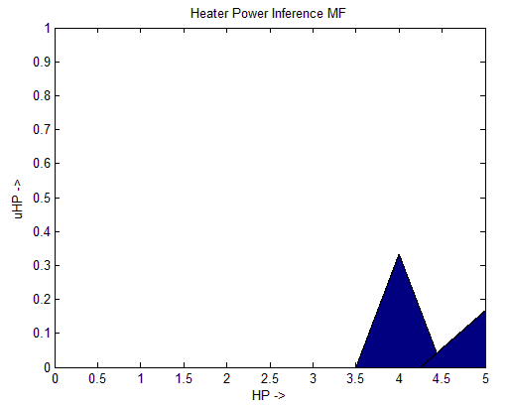 Figure 6.

**Defuzzification Step:**

Area (uHPMH) = ½ x 1 x 1 = 0.5

Area (uHPH) = 2 x ( ½ x 0.75 x 1 ) = 0.75

Centre (uHPMH) = 4

Centre (uHPH) = 5

uHPMH (new) = 0.3333

uHPH (new) = 0.1667

**Centroid =**

**[ uHPMH (new) x Area (uHPMH) x Centre (uHPMH) + uHPH (new) x Area (uHPH) x Centre (uHPH) ] =**

**[uHPMH (new) x Area (uHPMH) + uHPH (new) x Area (uHPH) ]**

[ 0.3333 x 0.5 x 4 + 0.1667 x 0.75 x 5 ] = **4.4287 W**

[ 0.3333 x 0.5 + 0.1667 x 0.75 ]

**Conclusion:**

Thus, we have derived a **heater power** required to maintain the temperature and pressure is **4.4287 W** when the temperature reading of the boiler is 22.5o C and pressure reading is 1.5 atm.