**Assignment -2**

**Title:** To implement AND gate using Perceptron network (with and without neural network toolbox).

**Theory:**

* An Multilayer perceptron is a network of simple neurons called perceptrons. The perceptron computes a single output from multiple real-valued inputs by forming a linear combination according to its input weights and then possibly putting the output through some nonlinear activation function. Mathematically this can be written as

|  |  |
| --- | --- |
| $\displaystyle y = \varphi( \sum\limits_{i=1}^n w_i x_i + b ) = \varphi( \mathbf{w}^T \mathbf{x}+ b )$ |  |

where w denotes the vector of weights, x is the vector of inputs, b is the bias and Φ is the activation function.

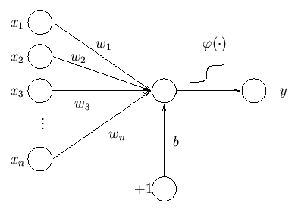

Figure1. Signal Flow Graph for Perceptron

* **Derivation of Perceptron Law-**

Let ‘t’ be the target, ‘a’ be the actual output, ‘w’ be the weight on link and ‘b’ is the bias.

If t=1 and a=0 then Wnew=Wold+P; ------(1)

If t=0 and a=1 then Wnew=Wold-P; ------(2)

If t=a then Wnew=Wold; ------(3)

Let error, e=t-a

Wnew=Wold+e\*P.

Let n be the learning rate.

Such that

Wnew=Wold+n\*e\*P.

**Algorithm:**

Initialize weights and bias (for simplicity set weights and bias to be zero).

Set learning parameter n (0<n<=1).

**Step 1.** While stopping condition is false do step 2-6.

**Step 2.** For each training pair P:t do step 3-5.

**Step 3.** Apply an input pattern P for which target output is ‘t’.

**Step 4.** Compute response of output unit

n=b+∑W\*P;

a=1; if ∑W\*P>=θ

=0; if ∑W\*P<θ

**Step 5.** Update weights and bias if an error occurred for this pattern.

If a≠t;

W(m+1)=W(m)+n\*e(m)\*P(m);

where e(m)=t(m)-a(m);

t(m) is desired output.

a(m) is actual output.

**Step 6.** Test stopping condition.

If no weights changed in Step 2,**STOP** else **CONTINUE.**

**FAQ’s-**

1. Define Linearly Separable Data.
2. Explain Perceptron Convergence Theorem.
3. Write limitations of Perceptron.
4. Explain Perceptron Representation Problem.
5. Explain the need of Multilayer Network.
6. How long should execute iterative process. What is termination criteria if samples are not linearly separable?
7. What is the appropriate value of ŋ(eta)?