**Assignment -5**

**Title:** To study and implement **Kohonen’s** **Self Organizing Maps (SOM)** algorithm for Character Recognition in MATLAB.

**Theory:**

* Self Organizing Maps are a data visualization technique invented by Prof. Kohonen, which reduces the dimension of data through the use of self organizing neural networks. Human beings can’t visualize high dimensional data. The way SOMs go about reducing dimensions is by producing a map of usually 1 or z dimensions, which plot the similarities of the data by grouping similar data together.
* The goal is to train the network so that nearby outputs corresponds to nearby inputs.
* The locations of the neurons are so tuned (i.e. winning neurons) become ordered and meaningful co-ordinate system for the input features is created on the lattice. The SOM thus forms the required topographic map of input patterns.

**Algorithm:**

* Select network topologies to determine which nodes are adjacent to each others.
* Initialize weights to small random values.
* Initialize current neighborhood distance D(t) to a positive integer.
* While computational bounds are exceeded do the following.
* Select an input pattern ii
* Compute the square of Euclidean distance from the weight vector (Wj) associated with each output node .
* Select the output node j* with minimum Euclidean distance.
* Update weights to all nodes with a topological distance of D(t) from j* using the update rule.

**Wj(t+1) = Wj(t) + η(t)*( ii(t) - Wj(t) )**

Increment t, end while

In character recognition application, one is given with “T” and “L” with their all four rotation (900 shifts) as input to SOM.

“T” and “L” are given as input in matrix (consider 9x9 matrix) form as below

1. T1 2. T2

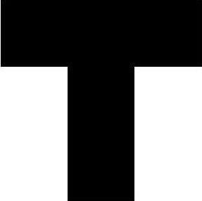 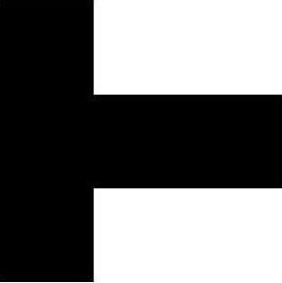

**Fig.1. T1 Fig.2. T2**

**T1=**[zeros(3,9);ones(6,3) zeros(6,3) ones(6,3)]

**T2=**[zeros(3,3) ones(3,6);zeros(3,9);zeros(3,3) ones(3,6)];

3.T3 4. T4

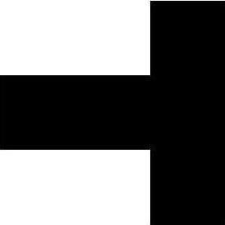 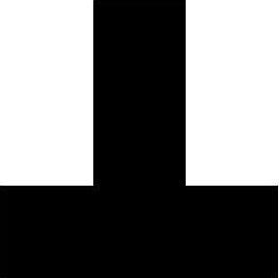

**Fig.3.T3 Fig.4.T4**

**T3=**[ones(3,6) zeros(3,3);zeros(3,9);ones(3,6) zeros(3,3)];

**T4**=[ones(6,3) zeros(6,3) ones(6,3);zeros(3,9)];

1. L1 2. L2

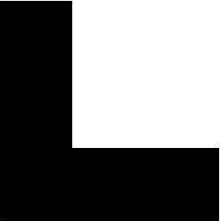 

Fig.5.L1 Fig.6.L2

3.L3 4.L4

** **

**Fig.7.L3 Fig.8.L4**

L1= [zeros(6,3) ones(6,6);zeros(3,9)];

L2**=**[ones(6,6) zeros(6,3);zeros(3,9)];

L3=[zeros(3,9);ones(6,6) zeros(6,3)];

L4**=**[zeros(3,9);zeros(6,3) ones(6,6)];

So, input will have 81 neurons and the size of input matrix will be 8x81.

**FAQ** **:**

1. Define the goal of SOM?
2. Explain the importance of U-matrix?
3. Why SOM is called topology preserving map?
4. List various topologies used in SOM.
5. List the various distance matrices.