**Assignment-9b**

**Title:** To study and implement SUGENO Fuzzy Model in MATLAB.

**Theory:**

The Sugeno Fuzzy Model was proposed by Takgi, Sugeno and Kang in an effort to develop a systematic approach to generating fuzzy rules from a given input-output data set. A typical fuzzy rule in a Sugeno fuzzy model has the form

**If x is A and y is B then z=f (x, y)**

Where A and B are fuzzy sets in the antecedent, while z=f (x, y) is a crisp function in the consequent. Usually f (x, y) is a polynomial in the input variables x and y, but it can be any function as long as it can appropriately describe the output of the model within the fuzzy region specified by the antecedent of the rule.

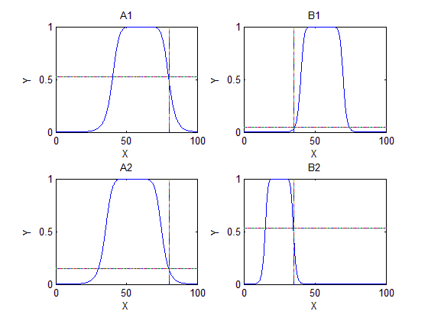

The Sugeno Fuzzy Model

**z1 = p1 x+q1 y+r1**

**z2 = p2 x+q2 y+r2**

**z = w1 z1+w2 z2**

**w1+w2**

The figure shows the fuzzy reasoning procedure for a first order Sugeno fuzzy model. Since each rule has a crisp output, the overall output is obtained via **weighted average**. Since the only fuzzy part of a Sugeno model is its antecedent, it is easy to demonstrate the distinction between a set of fuzzy rules and nonfuzzy ones.

Consider a classic problem of small and large numbers

Let the set of small and large numbers be given by following representation

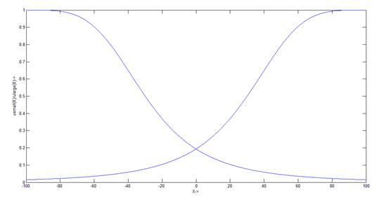

The set of rules for z is defined as

**Z1= -X+Y+1**

**Z2= -Y+3**

**Z3= -X+3**

**Z4= X+Y+2**

Hence we know that,

**Zo = ( ∑ ( Zi * αi ) ) / ∑ Zi**

Consider the inputs X = 2.1 and Y = 23

Z1 = 21.9

Z2 = -20

Z3 = 0.9

Z4 = 27.1

We know that

α1 = min (µsmall(x), µsmall(y))

α2 = min (µsmall(x), µlarge(y))

α3 = min (µlarge(x), µsmall (y))

α4 = min (µsmall(x), µlarge(y))

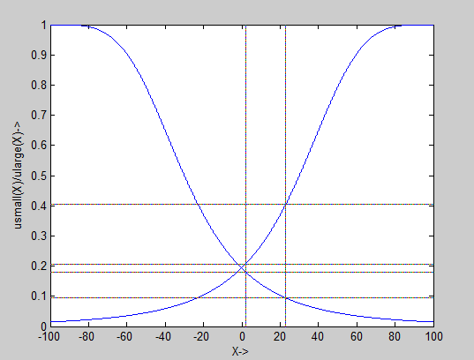

hence,

α1 = 0.0554

α2 = 0.0554

α3 = 0.0673

α4 = 0.0673

hence,

**Zo = 7.9898**