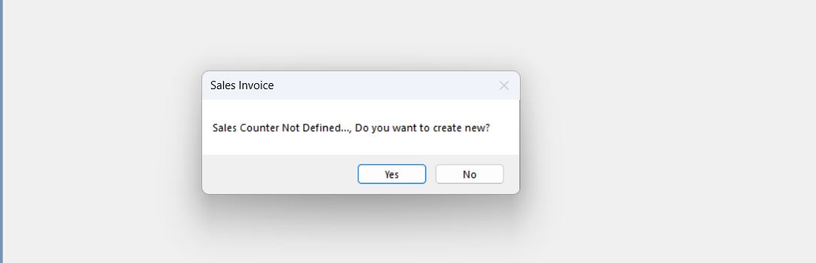

When I click the sales invoice this should appears first then I click yes it takes sales counter master in that header it should take the default name as the system name or admin
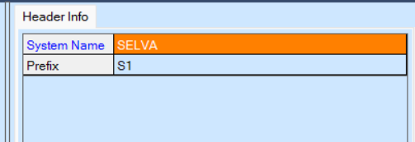

In sales invoice Scan or search item it should work in scanning the bar code also you missed some of the filed names and make the table esay screachable and it should work on Detail section grid should allow user to resize, next time should open as he has last event. System wise grid should be saved.
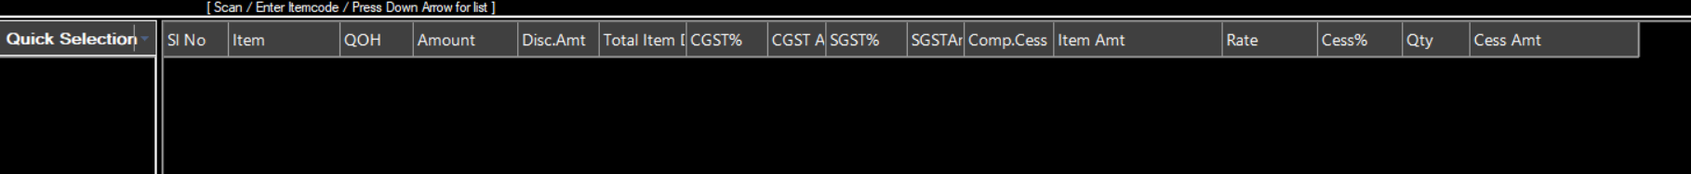

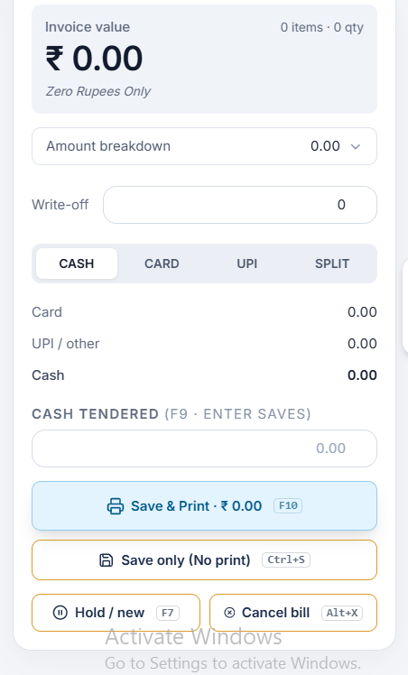allow to edit only the paymode after the items is filled by the user then map to this payment option

Previous purchase bills in this I need you to show the past 10 day bill and keep an filed in global setting to edit the day option

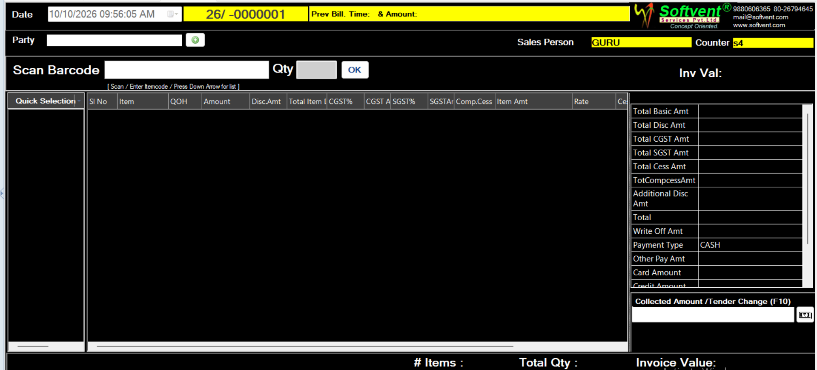
Make this as shown in this ivalue grid instead of scrolling down to see the amount

