**Problem Statement and Project Plan**

**Create a chatbot using python**

**Team leader name: Harini R S ( au813821244025)**

**Team member 1: Guru Ratchitha S (au813821244023)**

**Team member 2: Dharani S (au813821244018)**

**Team member 3: Harshini S (au813821244027)**

**Introduction:**

Create a Python chatbot for exceptional customer service. Using NLP, it understands user queries, maintains coherent conversations, and integrates seamlessly. Define objectives, collect data, manage dialog, integrate, train, test, gather user feedback, and ensure security. A focus on personalization and scalability maximizes customer satisfaction.

**Problem Definition:**

The challenge is to create a chatbot in Python that provides exceptional customer service, answering user queries on a website or application. The objective is to deliver high-quality support to users, ensuring a positive user experience and customer satisfaction.

**Solution:**

Creating a website with chatbot using NLP in python

NLP:

Natural Language Processing (NLP) plays a central role in chatbots, enabling them to comprehend and respond to human language. NLP equips chatbots with the ability to understand user intents, extract meaningful information, maintain context in conversations, and provide accurate and contextually relevant responses, resulting in more effective and human-like interactions.

**Design Thinking:**

Here's how NLP can be applied to chatbot using python:

1.Functionality: Identifying the scope of abilities starts with empathizing with users to understand their pain points and requirements, a key step in design thinking.

2.User Interface: Designing a user-friendly interface is a crucial aspect of design thinking, as it prioritizes user experience and usability.

3.Natural Language Processing (NLP): Implementing NLP techniques is part of the ideation and prototyping phase, where you experiment with solutions to meet user needs.

4.Responses: Planning responses aligns with the ideation and testing phases, where we generate ideas and test them to see if they meet user expectations.

5.Integration: We are integrating our chatbot into the website for easy access by everyone through a link.

6.Testing and Improvement: Continuous testing and refinement are at the core of design thinking, emphasizing iterative development and learning from use feedback.

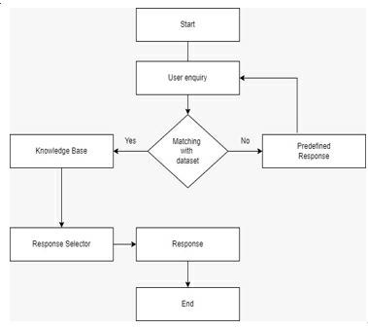

**Dataset Link:**[**https://www.kaggle.com/datasets/grafstor/simple-dialogs-for-chatbot**](https://www.kaggle.com/datasets/grafstor/simple-dialogs-for-chatbot)