**CREATE A CHATBOT USING PYTHON**

**TEAM MEMBER**

**name: GURU RATCHITHA S**

**NM_id : au813821244023**

Phase-4 submission document

Project Title: create a chatbot using python

phase 4: Development part

INTRODUCTION:

To create a chatbot for exceptional customer service. This chatbot defines the objective, collect data, manage dialog, integrate, train, test, gathers user’s feedbacks and ensure security. We created our chatbot using python .

Here, we used natural language processing(NLP).It is a machine learning technology that gives computers the ability to interpret, manipulate, and comprehend human language.

My Python-based chatbot is elevated with the NLTK library, a robust tool for natural language processing. Featuring a user-friendly interface, it facilitates seamless communication and holds immense potential across diverse applications, making it an exciting project with the power to redefine human-computer interaction.

GIVEN DATA SET:

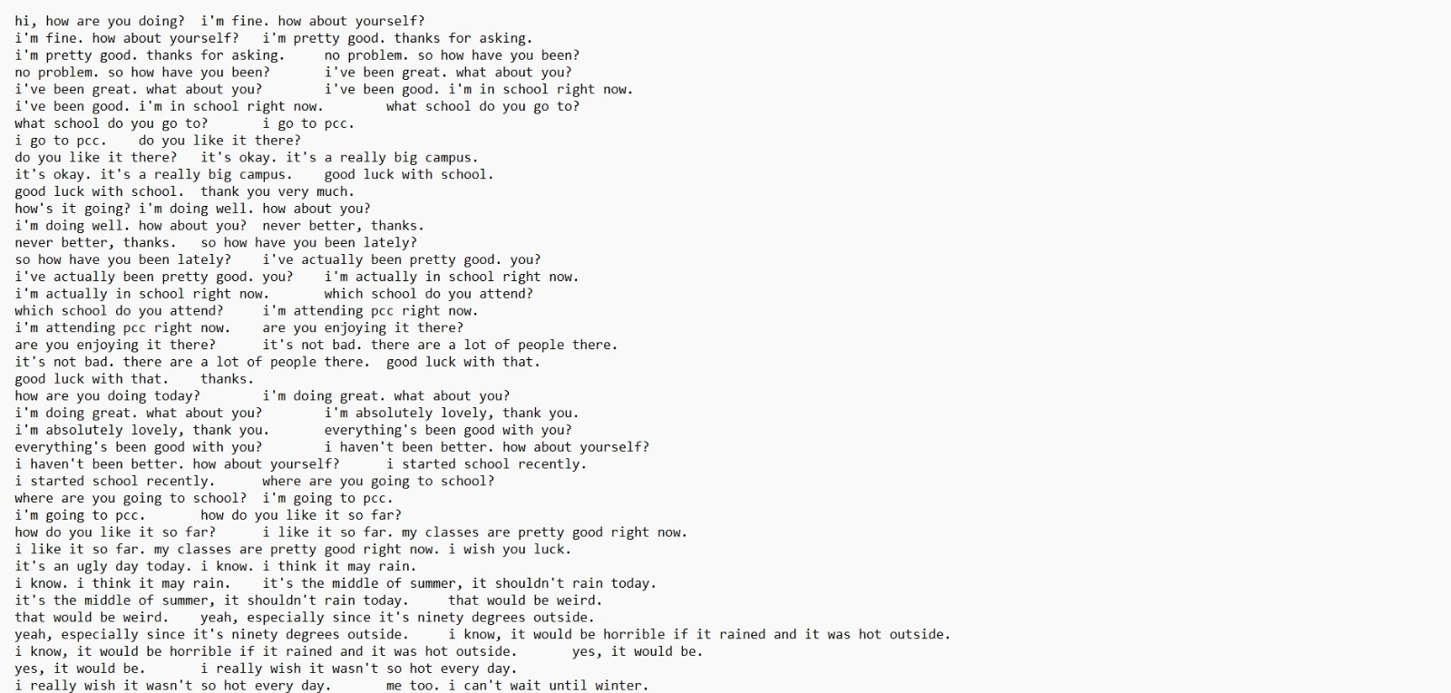

**Dataset Link:**[**https://www.kaggle.com/datasets/grafstor/simple-dialogs-for-chatbot**](https://www.kaggle.com/datasets/grafstor/simple-dialogs-for-chatbot)

OVERVIEW OF THE PROCESS:

The following is an overview of the process of building a houseprice prediction model by feature selection, model training, andevaluation:

1. Prepare the data: This includes cleaning the data, removingoutliers, and handling missing values.

2. Perform feature selection: This can be done using a variety ofmethods, such as correlation analysis, information gain, and recursivefeature elimination.

3. Train the model: There are many different machine learningalgorithms that can be used for house price prediction. Some popularchoices include linear regression, random forests, and gradient boostingmachines.

PROCEDURE:

Feature selection:

1. Dataset Selection: Given dataset are used that provided by the Kaggle.

2. Preprocessing: Clean and preprocess the dataset to remove noise, irrelevant information, and ensure consistency.

3. Training Algorithms: Implement machine learning algorithms to train the chatbot on the dataset, enabling it to understand patterns and context.

4.Context Management: Develop mechanisms to manage and maintain context during conversations, ensuring coherent and relevant interactions.

5. Dynamic Learning: Allow the chatbot to dynamically learn from user interactions and update its knowledge base for continuous improvement.

6.Validation and Testing: Divide the dataset into training, validation, and test sets to assess the chatbot's performance and generalization.

CODE FOR CHATBOT:

In these phase we develop a chatbot and give a training with the dataset that given above .We attached a sample output for the for the data that the customer given query.

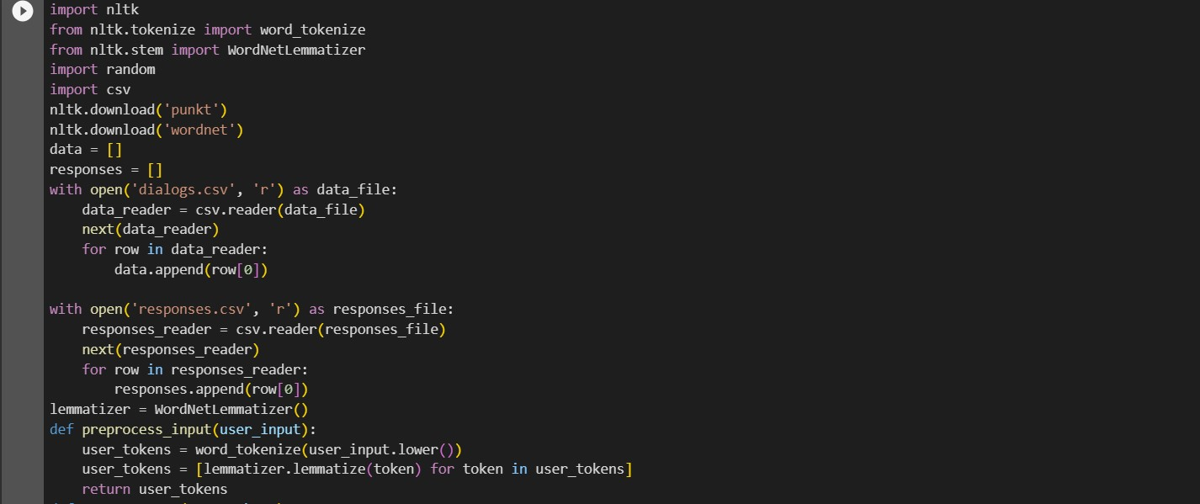

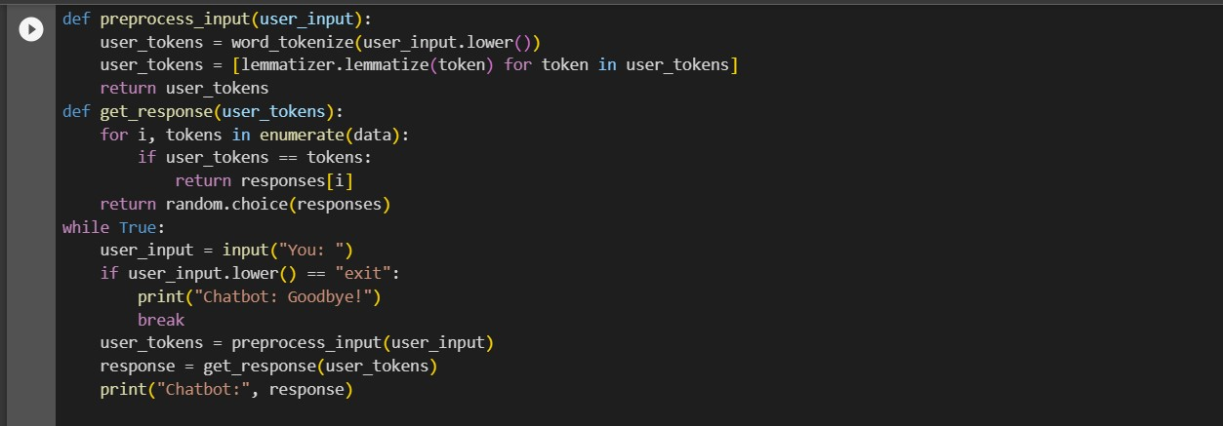

OUTPUT:

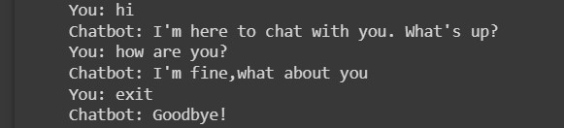

CONCLUSION:

Creating a simple chatbot in Python using NLTK involves preprocessing user input, defining responses, and implementing a basic conversation loop. Data can be read from CSV files for easy management. The NLTK library assists with tokenization and lemmatization. Responses can be tailored to specific inputs, allowing the chatbot to engage in natural conversations with users..