

SARANATHAN COLLEGE OF ENGINEERING

Venkateshwara Nagar, Panjappur, Trichy-12

**NALAIYA THIRAN**

**PROJECT TITLE** -- Creating Chatbot using Python

**DOMAIN**  -- Artificial Intelligence

**TEAM ID** --

**TEAM LEADER :**

HARINI R S -- 813821244025

**TEAM MEMBERS**

GURU RATCHITHA S -- 813821244023

DHARANI S -- 813821244018

HARSHINI S -- 813821244027

**GITHUB LINK: https://github.com/GuruRatchitha/AI_8138_5**

|  |  |  |
| --- | --- | --- |
| **S.NO** | **TABLE OF CONTENT** | **PG.NO** |
| 1 | INTRODUCTION |  |
| 1.1 | PROJECT OVERVIEW |  |
| 1.2 | PURPOSE |  |
| 2 | LITERATURE SURVEY |  |
| 2.1 | EXISTING PROBLEM |  |
| 3 | PROBLEM STATEMENT |  |
| 4 | TOOLS USED |  |
| 5 | DESIGN THINKING |  |
| 6 | FEATURE SELECTION |  |
| 7 | FLOWCHART OF THE PROCESS |  |
| 8 | CODE’s FOR THE ENTIRE PROCESS |  |
| 8.1 | DATA PRE-PROCESSING |  |
| 8.2 | CHATBOT CODE |  |
| 8.3 | FRONTEND CODE |  |
| 8.3.1 | FRONT HTML |  |
| 8.3.2 | SIGNUP HTML & CSS |  |
| 8.3.3 | LOGIN HTML & CSS |  |
| 8.3.4 | CSS OF STYLE |  |
| 8.4 | BACKEND CODE |  |
| 9 | STEPS TO USE CHATBOT |  |
| 10 | FUTURE SCOPE |  |
| 11 | ADVANTAGES |  |
| 12 | DISADVANTAGES |  |
| 13 | RESULT |  |
| 14 | CONCLUSION |  |

**ABSTRACT**:

In the digital age, providing exceptional customer service is paramount to ensuring user satisfaction and loyalty. The development of a chatbot using Python, equipped with carefully curated data sets, has emerged as a promising solution to tackle this challenge. This paper explores the creation of a Python-based chatbot that leverages data sets to deliver high-quality customer service, answering user queries on a website or application.

The problem definition at the core of this endeavor is to design a chatbot capable of offering exceptional customer service. This chatbot should address user inquiries efficiently, ensuring a positive user experience, and ultimately, customer satisfaction. It is an essential component in the realm of artificial intelligence and plays a pivotal role in bridging the gap between businesses and their clientele.

The methodology outlined in this paper underscores the importance of data-driven development. A well-structured data set is crucial for enabling the chatbot to understand and respond effectively to user queries. The paper discusses the process of data collection, preprocessing, and integration, focusing on Python libraries like pandas and NumPy to manage and manipulate the data effectively. The utilization of machine learning algorithms in Python, particularly Natural Language Processing (NLP) libraries like NLTK and spaCy, is emphasized for enhancing the chatbot's language understanding capabilities.

Incorporating intent recognition is a crucial aspect of the chatbot's functionality. The paper highlights Python's Dialogflow API and showcases its integration to enable the chatbot to understand the context and intent behind user queries, allowing for more context-aware and relevant responses.

To address the challenge of delivering exceptional customer service, the paper delves into creating a dynamic response system for the chatbot. Python's extensive libraries for text generation, such as GPT-3, are examined to generate human-like responses that engage users effectively.

The deployment of the chatbot in real-world scenarios is also discussed, with an emphasis on Python frameworks like Flask or Django for creating web-based chatbot interfaces. The paper explores the integration of the chatbot with websites and applications, ensuring that users can access it seamlessly.

Security and privacy are paramount in customer service chatbots. The paper examines authentication and authorization mechanisms in Python, reinforcing the importance of data privacy and secure interactions between users and the chatbot.

The paper closes with insights into the potential for further improvements and enhancements of the chatbot. Suggestions include the integration of sentiment analysis to gauge user satisfaction and continuous learning mechanisms to adapt to evolving user needs and preferences.

In conclusion, the creation of a Python-powered chatbot, backed by carefully curated data sets, is a significant step toward providing exceptional customer service. The paper provides a detailed guide for developing a chatbot that addresses user queries efficiently, enhancing user experience, and ensuring customer satisfaction. Leveraging Python's robust ecosystem for data management, NLP, and text generation, this chatbot offers businesses a powerful tool to interact with their clientele and provide top-notch support in the realm of artificial intelligence. The future holds exciting possibilities for chatbot development, and Python stands as a versatile and reliable programming language to meet these challenges head-on.

**1) INTRODUCTION**:

In the fast-evolving landscape of artificial intelligence, chatbots have emerged as a powerful application, revolutionizing the way businesses and individuals interact with technology. This project sets out to explore the development of a chatbot using Python, one of the most versatile and widely adopted programming languages in the field of AI. The chatbot, which we aim to create, will serve as a virtual conversational agent capable of understanding and responding to natural language, thereby providing a seamless and interactive experience to users.

The significance of this endeavor lies in the growing demand for intelligent, automated solutions that can handle diverse tasks, from customer support to information retrieval, across various industries. By leveraging Python's rich ecosystem of libraries and frameworks, we will harness the potential of natural language processing, machine learning, and data analysis to construct a chatbot that can adapt, learn, and evolve over time.

Through this project, we aim to demonstrate not only the technical prowess of Python in AI but also the practical benefits that chatbots can bring to businesses and end-users alike. Our journey will encompass the intricate challenges of NLP, context handling, and AI-driven conversational experiences, all of which are fundamental to the creation of an effective chatbot. As we delve deeper into the intricacies of AI, we will uncover the potential for chatbots to streamline information access, improve user engagement, and even extract valuable insights from user interactions, making this project not only a technical pursuit but also a glimpse into the future of human-computer interaction.

**1.1) Project Overview:**

This project involves the development of a chatbot using Python to facilitate human-computer interactions. The chatbot will be designed to understand and respond to user queries in a natural language using natural language processing (NLP) techniques. It will provide assistance, information, and engagement in a user-friendly manner, catering to a diverse range of user needs. The project will leverage Python's rich libraries, such as NLTK and spaCy, to enhance the chatbot's language understanding capabilities. The ultimate goal is to create a functional, intelligent, & versatile chatbot that can be deployed across various platforms & domains to enhance user experiences.

**1.2) Purpose:**

**1. Automating Customer Support:**

**Content:** One of the primary purposes of creating a chatbot using Python is to automate customer support services. AI-powered chatbots can handle frequently asked questions, resolve common issues, and provide instant assistance to customers, reducing the workload on human support agents.

**2. Enhancing User Engagement:**

**Content:** Chatbots are valuable tools for enhancing user engagement on websites and applications. They can provide personalized recommendations, interactive experiences, and dynamic content, increasing user satisfaction and retention.

**3. Data Analysis and Insights:**

**Content:** Chatbots can collect and analyse user interactions, extracting valuable insights from conversational data. Python's data processing capabilities allow for the extraction of trends, sentiment analysis, and user behaviour patterns to inform business decisions.

**4. Streamlining Information Retrieval:**

**Content:** Python-based chatbots can efficiently retrieve information from databases or external sources, simplifying information retrieval processes for users. They can provide instant access to product details, FAQs, and relevant data.

**5. AI-Powered Conversational Experiences:**

**Content:** Python-powered chatbots can create AI-driven conversational experiences by utilizing natural language processing (NLP) and machine learning. They can understand user intent, engage in meaningful dialogues, and adapt their responses, delivering more human-like interactions. Incorporating Python into chatbot development enables the integration of AI capabilities for automating support, improving user engagement, extracting insights from user data, streamlining information retrieval, and creating dynamic conversational experiences.

**2) LITERATURE SURVEY:**

**2.1) Existing Problem:**

1)Natural Language Understanding (NLU): Developing chatbots that can accurately understand and interpret user input, especially in complex or context-dependent conversations, remains a challenge.

2)Context Handling: Maintaining context and continuity in conversations is a significant issue. Chatbots often struggle to remember previous interactions & provide contextually relevant responses.

3)Personalization: Tailoring chatbot responses to individual user preferences and behaviours is challenging, as it requires effective data management and machine learning algorithms.

4)Limited Domain Knowledge: Chatbots may lack domain-specific knowledge and struggle to provide detailed or accurate information in specialized fields like medicine, law, or finance.

5)Emotional Intelligence: Creating chatbots that can understand and respond to user emotions, such as empathy or frustration, is a complex problem in human-computer interaction.

6)Integration and Scalability: Integrating chatbots with various platforms, databases, and APIs, while ensuring scalability and performance, poses technical challenges.

7)Data Privacy and Security: Maintaining user data privacy and security while using chatbots to handle sensitive information is a growing concern.

8)Multimodal Interaction: Developing chatbots that can handle voice, text, and visual inputs and provide coherent responses across different modalities is a research challenge.

9)Ethical and Bias Issues: Ensuring that chatbots are designed & trained ethically and do not perpetuate biases is a critical problem in AI chatbot development.

10)User Acceptance and Trust: Building chatbots that users trust and are comfortable interacting with is a psychological and design challenge.

These are some of the key problems that researchers & developers face when creating chatbots using Python, and addressing these challenges is essential for the continued advancement of chatbot technology.

**3) PROBLEM STATEMENT:**

The challenge is to create a chatbot in Python that provides exceptional customer service, answering user queries on a website or application. The objective is to deliver high-quality support to users, ensuring a positive user experience and customer satisfaction.

**Dataset Link**: <https://www.kaggle.com/datasets/grafstor/simple-dialogs-for-chatbot>

**4) TOOLS USED:**

**1) Python:**

Python is the primary programming language for chatbot development due to its extensive libraries and frameworks for natural language processing (NLP) and machine learning.

**2)IDE (Integrated Development Environment):**

IDEs like PyCharm, Visual Studio Code, or Jupyter Notebook provide a comfortable and efficient environment for coding and debugging.

**3)Natural Language Processing Libraries:**

NLTK (Natural Language Toolkit)is a popular library for working with human language data and implementing NLP tasks.

spaCy is another powerful library for NLP that offers pre-trained models and linguistic features.

**4)Machine Learning Frameworks:**

TensorFlow and Keras: These are widely used for training and deploying machine learning models in chatbots.

PyTorch: PyTorch is another popular framework for deep learning and NLP applications.

**5)Chatbot Frameworks:**

Rasa:Rasa is an open-source chatbot framework that provides tools and libraries for building conversational AI.

Dialogflow:Google's Dialogflow is a cloud-based chatbot development platform that integrates with Python.

**6)Version Control:**

Tools like Git and GitHub are essential for collaboration, version control, and code management.

**7)Database Management:**

Databases like SQLite, MySQL, or PostgreSQL may be used to store and manage chatbot-related data.

**8)Web Frameworks:**

If your chatbot is intended for web deployment, web frameworks like Flask or Django can be used to build the web interface.

**9)APIs and Web Services:**

For accessing external data and services, you may need to interact with various APIs and web services.

**10)Cloud Platforms:**

Cloud services like AWS, Azure, or Google Cloud provide scalability and hosting solutions for chatbot deployment.

**11)User Interface (UI) Design Tools:**

Design tools like Figma or Adobe XD can be used for designing the user interface if your chatbot has a graphical interface.

**12)Text-to-Speech (TTS) and Speech-to-Text (STT) Tools:**

If your chatbot involves voice interactions, you may need TTS and STT tools like Google Text-to-Speech or Mozilla DeepSpeech.

**13)Testing and Debugging Tools:**

Tools like Postman or curl for API testing, as well as debugging tools like pdb for Python debugging.

**14)Project Management and Collaboration Tools:**

Tools like Trello, Slack, or Asana for project management, communication, and collaboration.

**15)Continuous Integration/Continuous Deployment (CI/CD) Tools:**

CI/CD tools like Jenkins or Travis CI for automating deployment and testing processes.

By incorporating these tools and software into your chatbot creation process, you can effectively develop, test, and deploy a Python-based chatbot that leverages AI for natural language understanding and interaction.

**5) DESIGN THINKING:**

Here's how NLP can be applied to chatbot using python:

1.Functionality: Identifying the scope of abilities starts with empathizing with users to understand their pain points and requirements, a key step in design thinking.

2.User Interface: Designing a user-friendly interface is a crucial aspect of design thinking, as it prioritizes user experience and usability.

3.Natural Language Processing (NLP): Implementing NLP techniques is part of the ideation and prototyping phase, where you experiment with solutions to meet user needs.

4.Responses: Planning responses aligns with the ideation and testing phases, where we generate ideas and test them to see if they meet user expectations.

5.Integration: We are integrating our chatbot into the website for easy access by everyone through a link.

6.Testing & Improvement: Continuous testing and refinement are at the core of design thinking, emphasizing iterative development and learning from use feedback.

**6)** **FEATURE SELECTION:**

**1) Natural Language Understanding (NLU):**

Intent recognition: Identify the user's intent to provide relevant responses.

Named entity recognition (NER): Extract and process entities such as names, dates, and locations from user input.

Sentiment analysis: Determine the emotional tone of user messages for more personalized responses.

**2)Conversational Flow:**

Dialog management: Create and maintain context to ensure coherent and context-aware conversations.

Multiturn conversations: Support interactions that span multiple messages to handle complex user requests.

**3)User Authentication and Profiles:**

User authentication: Enable users to log in for personalized experiences.

User profiles: Store and retrieve user information to customize interactions.

**4)Data Retrieval and Integration:**

Data retrieval from databases or external APIs: Access and provide real-time data and information to users.

API integration: Connect with external services for tasks like weather updates or e-commerce product searches.

**5)Multimodal Capabilities:**

Voice input and output: Enable speech-based interaction with the chatbot.

Image and video processing: Handle visual inputs and generate visual outputs, particularly useful for e-commerce and content-related chatbots.

**6)Rich Media Support:**

Emojis, GIFs, and stickers: Incorporate multimedia elements to make conversations more engaging.

**7)User Feedback and Learning:**

Feedback collection: Allow users to rate chatbot responses and provide feedback.

Continuous learning: Implement machine learning models to adapt and improve over time.

**8)Integration with Knowledge Bases:**

Knowledge base access: Utilize external knowledge bases to provide detailed information on specific topics or industries.

**9)Error Handling and Fallback Responses:**

Error detection and recovery: Identify and gracefully recover from misunderstandings or user errors.

Fallback responses: Provide informative fallback responses when the chatbot is uncertain.

**10)Security and Privacy:**

User data protection: Implement data encryption and user data privacy measures.

Role-based access control: Restrict access to certain features based on user roles.

**11)Analytics and Reporting:**

Analytics integration: Track user interactions and chatbot performance for insights and improvements.

Reporting: Generate reports on chatbot usage and effectiveness.

**12)Customization and Branding:**

Customizable responses and greetings: Allow businesses to tailor the chatbot's personality and responses to align with their brand.

**13)Third-Party Integrations:**

Integrations with messaging platforms: Enable chatbot deployment on various messaging apps such as Facebook Messenger, WhatsApp, or Slack.

**14)Testing and Debugging Tools:**

Debugging console: Implement tools for testing and debugging chatbot responses during development.

**15)Ethical Considerations:**

Bias mitigation: Integrate features that reduce biases in the chatbot's responses.

User consent mechanisms: Implement features that seek user consent for data processing.

Carefully selecting and implementing these features in your chatbot project will determine its functionality, user experience, and success in delivering the desired conversational AI capabilities.

**7) FLOWCHART OF THE PROCESS:**

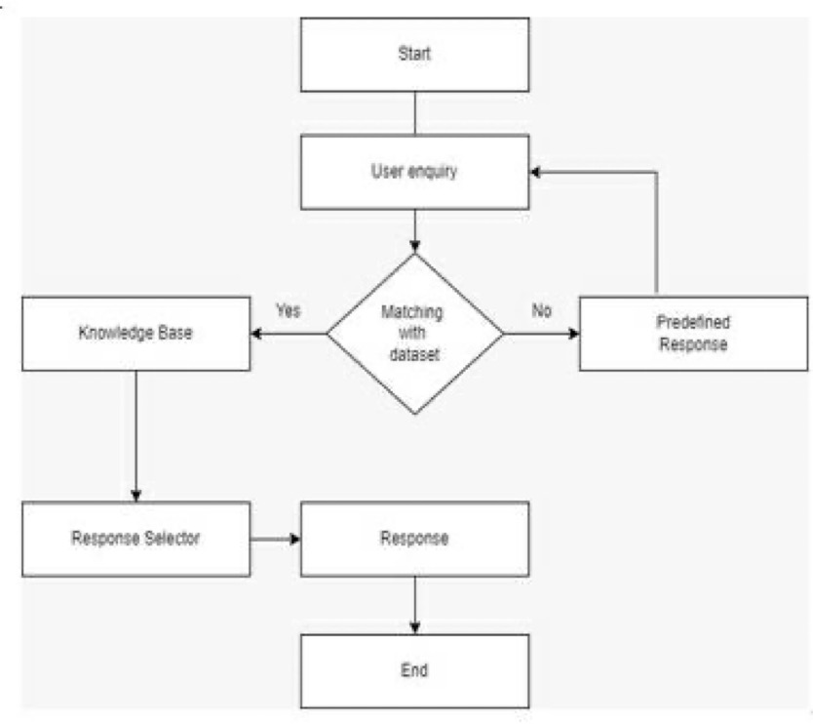

**8) CODE’s FOR THE ENTIRE PROCESS:**

**8.1) DATA PRE-PROCESSING:**

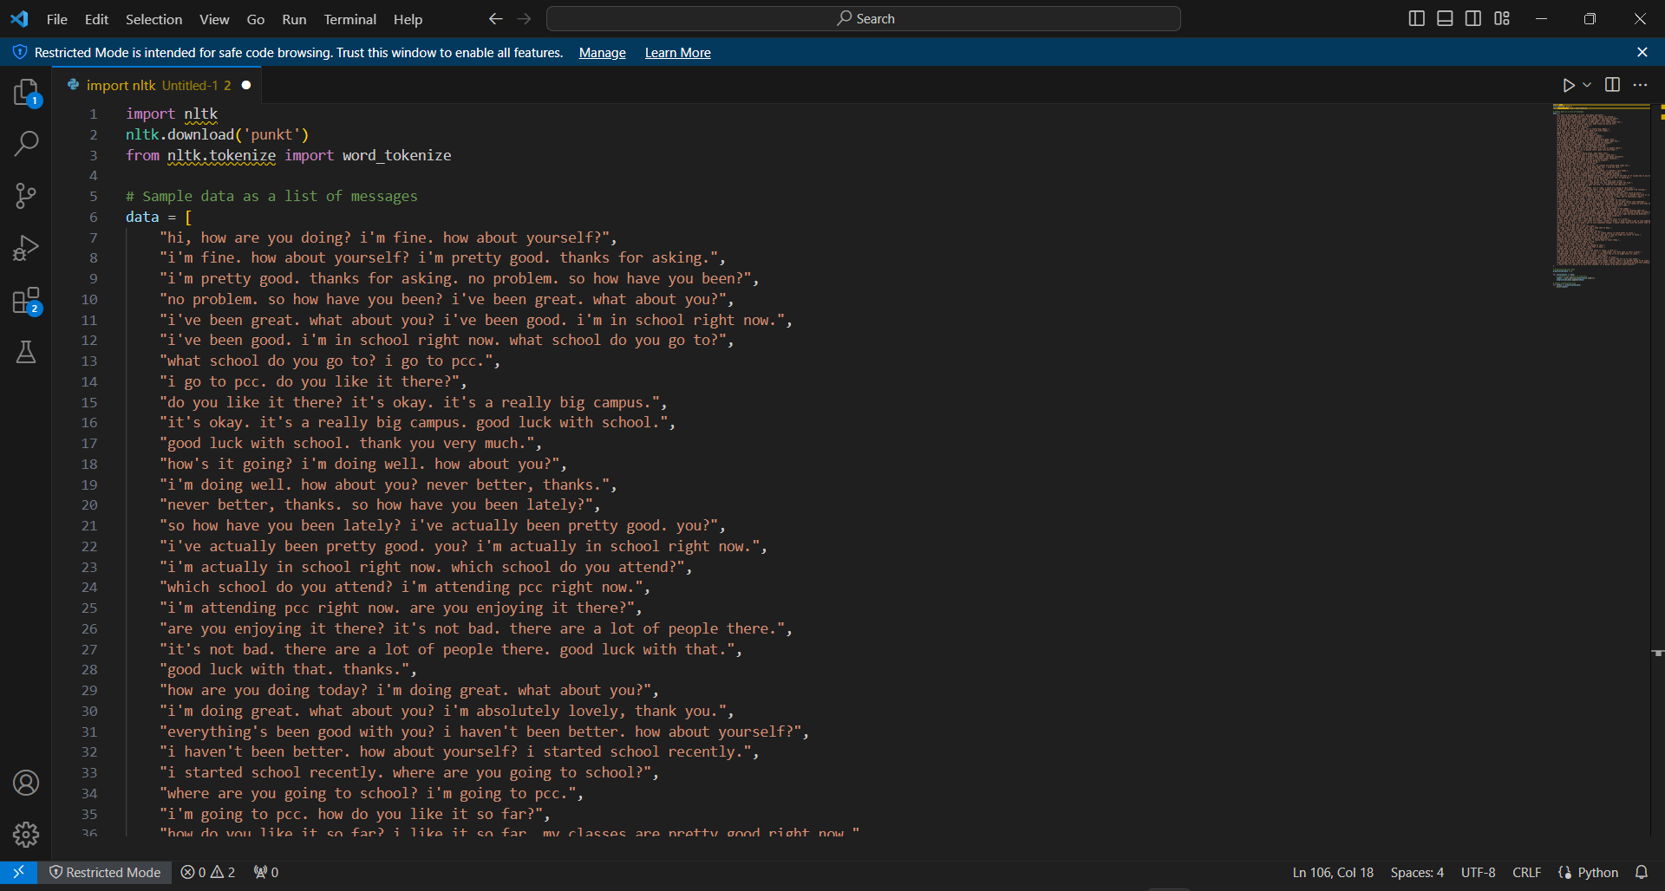

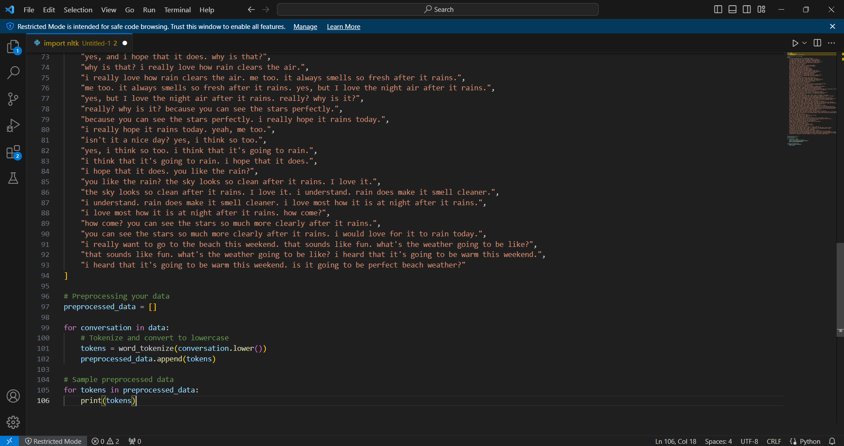

**OUTPUT / PROCESSED DATA:**

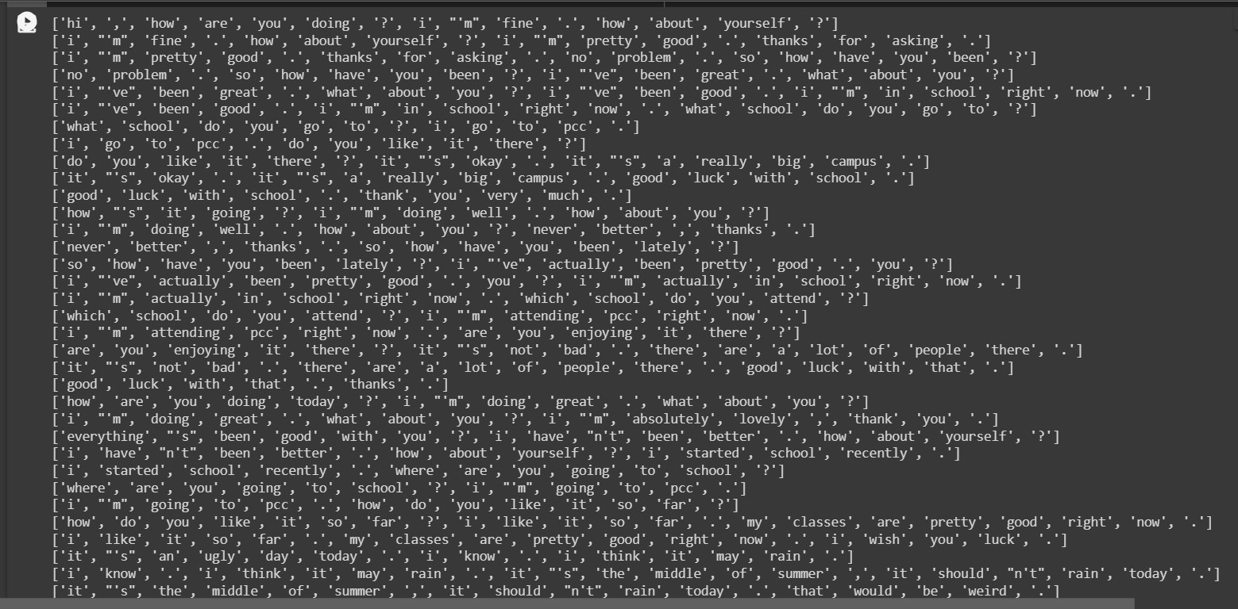

**8.2) CHATBOT CODE:**

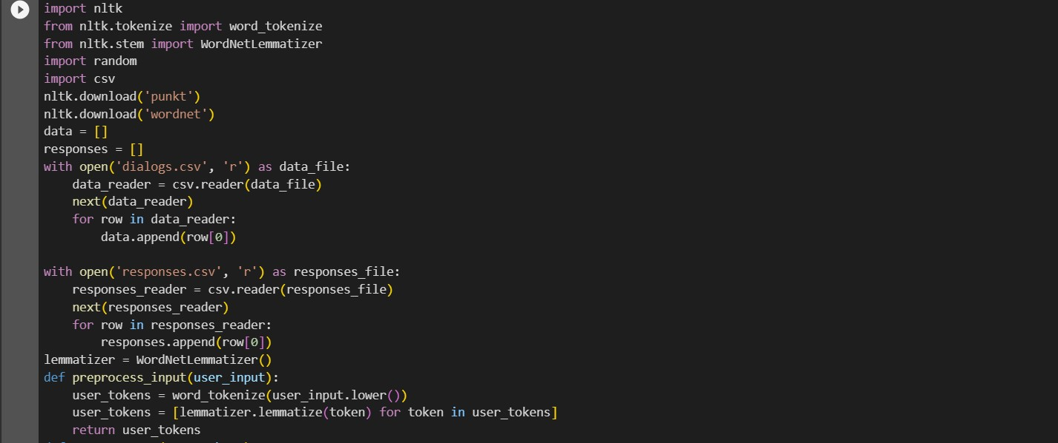

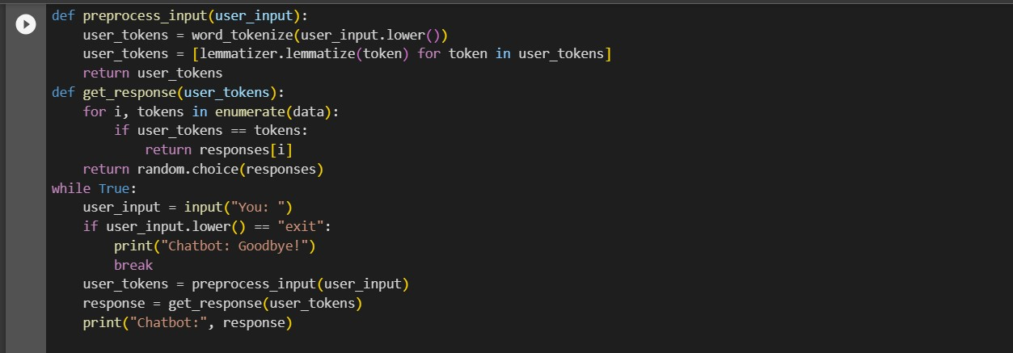

**OUTPUT OF CHATBOT CODE:**

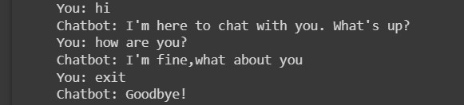

**8.3) FRONTEND CODE:**

**8.3.1) Front HTML:**

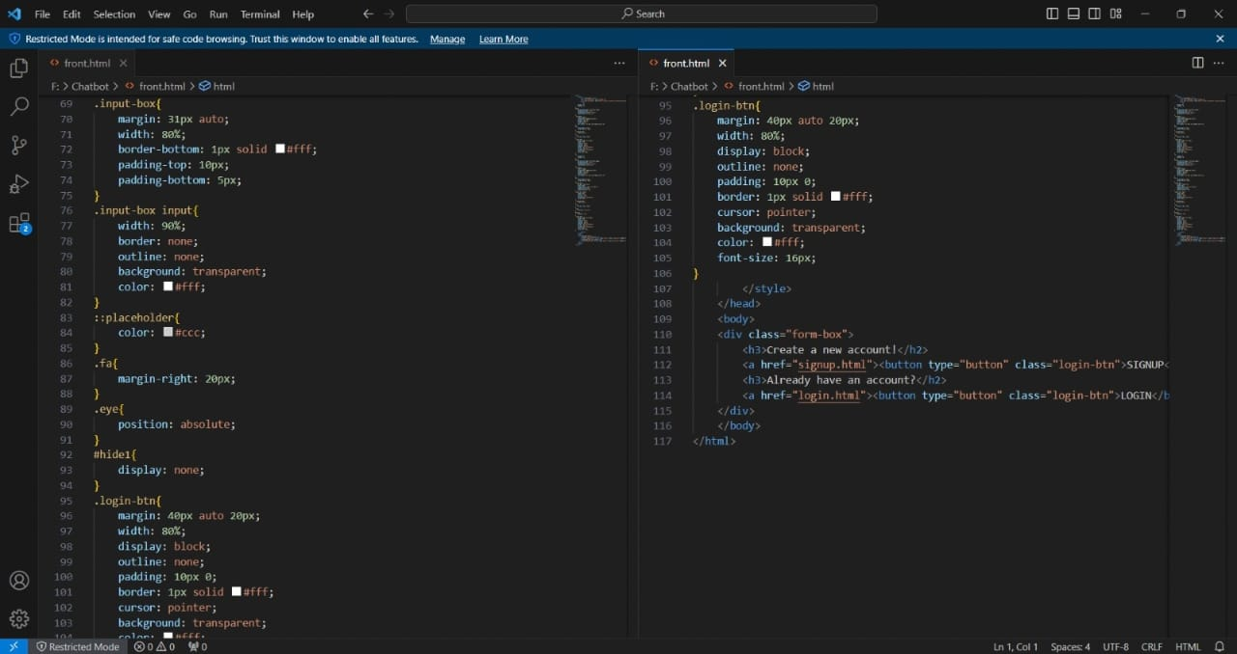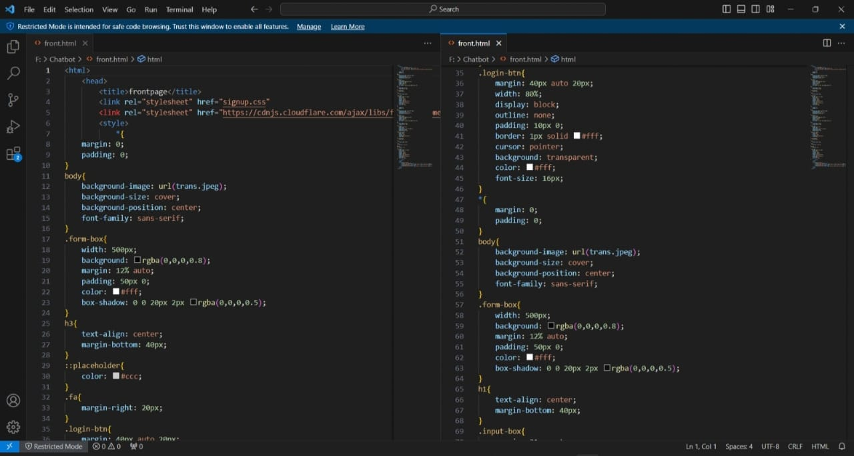

**Front Page Output:**

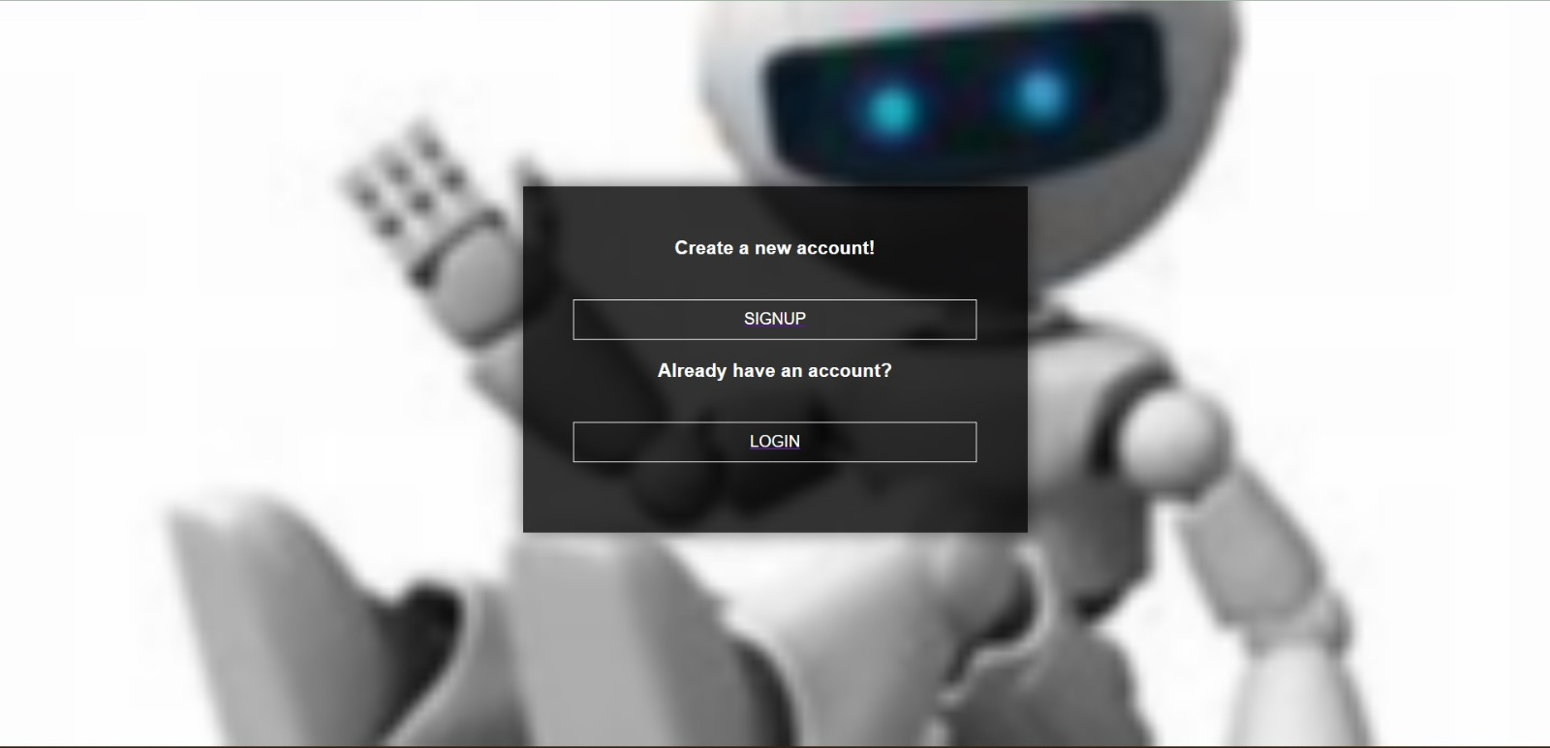

**8.3.2) Signup HTML & CSS:**

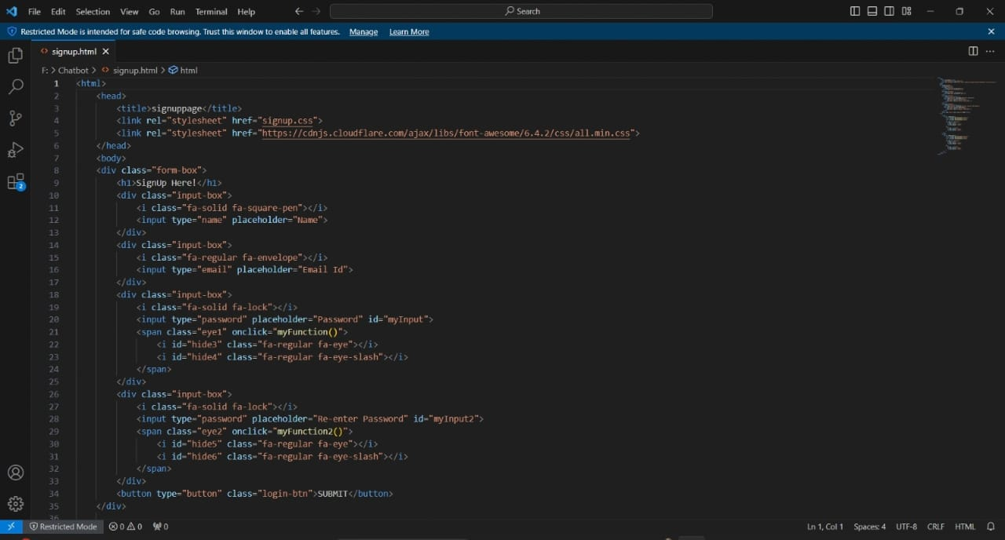

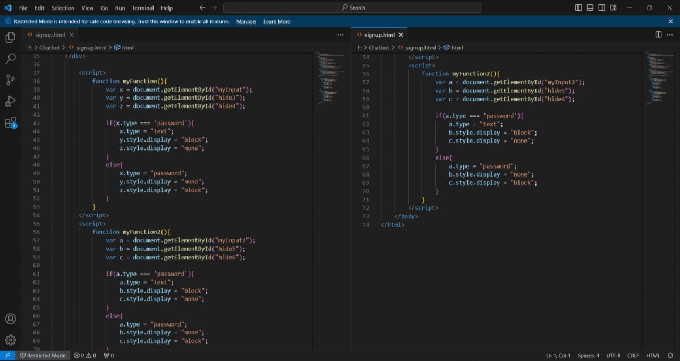

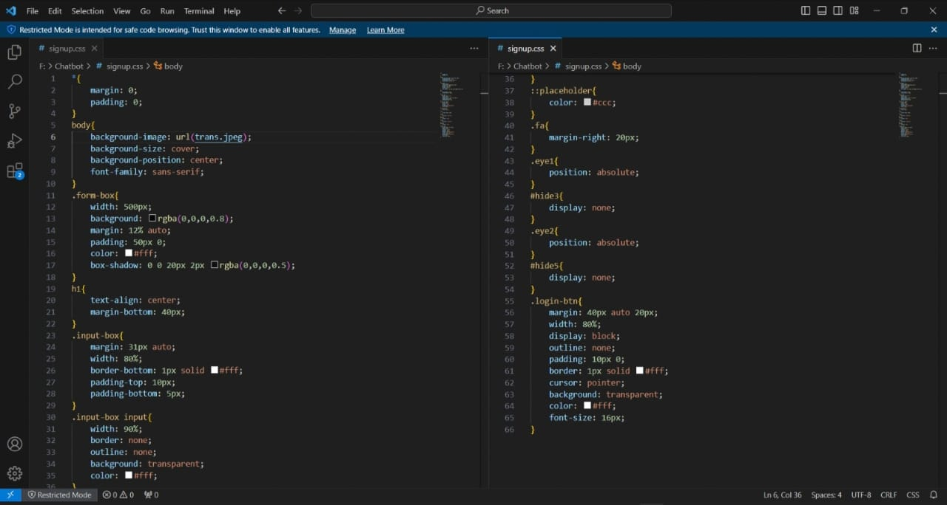

**Output of Signup Page:**

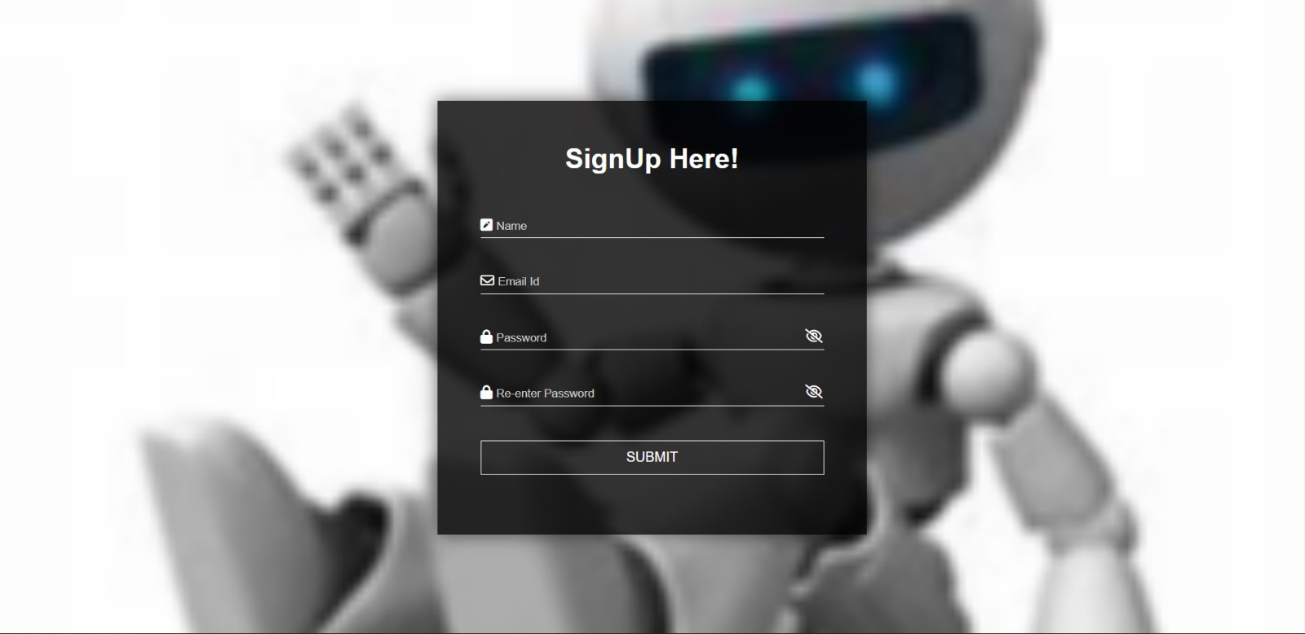

**8.3.3) Login HTML & CSS:**

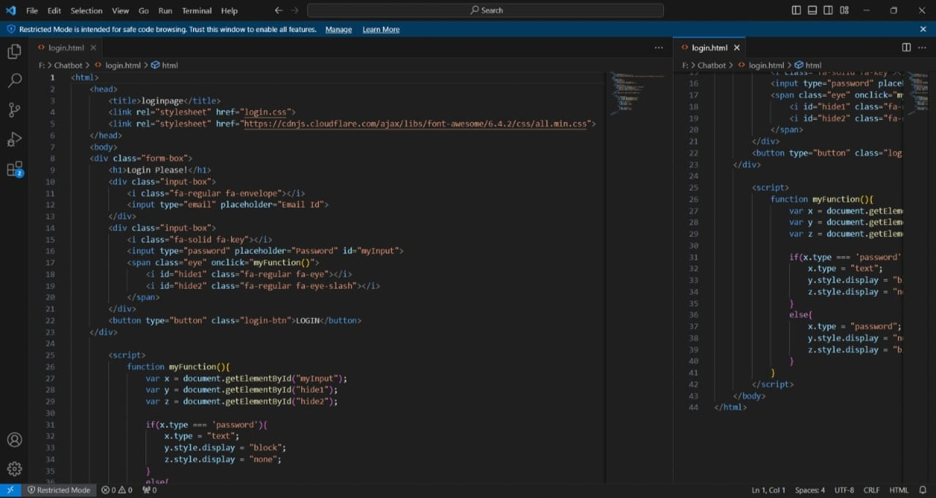

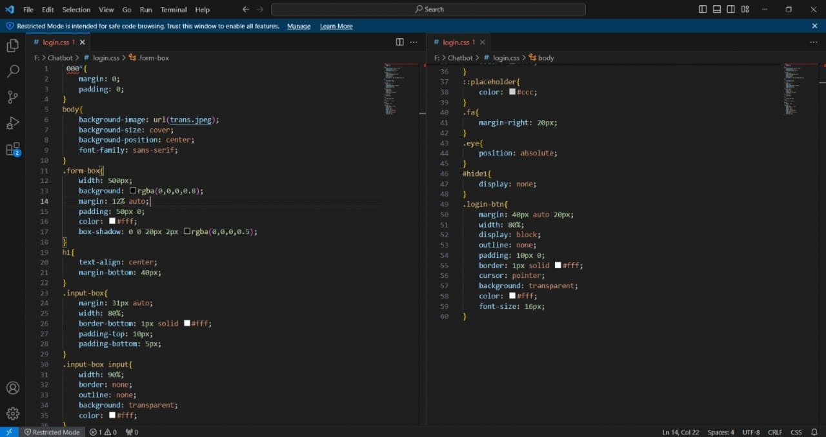

**Output of Login Page:**

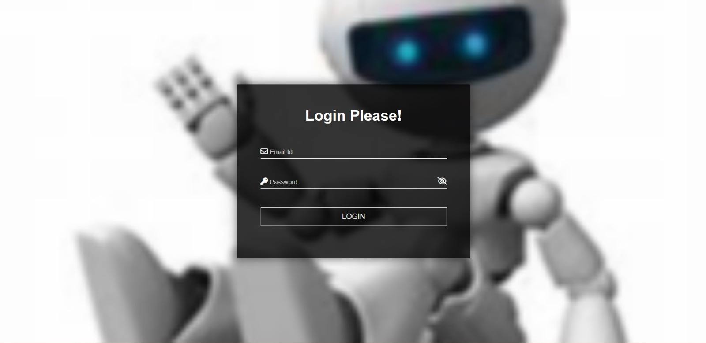

**8.3.4) CSS Of Style:**

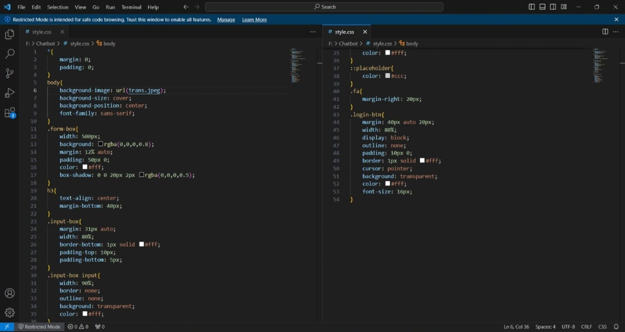

**8.4) BACKEND CODE:**

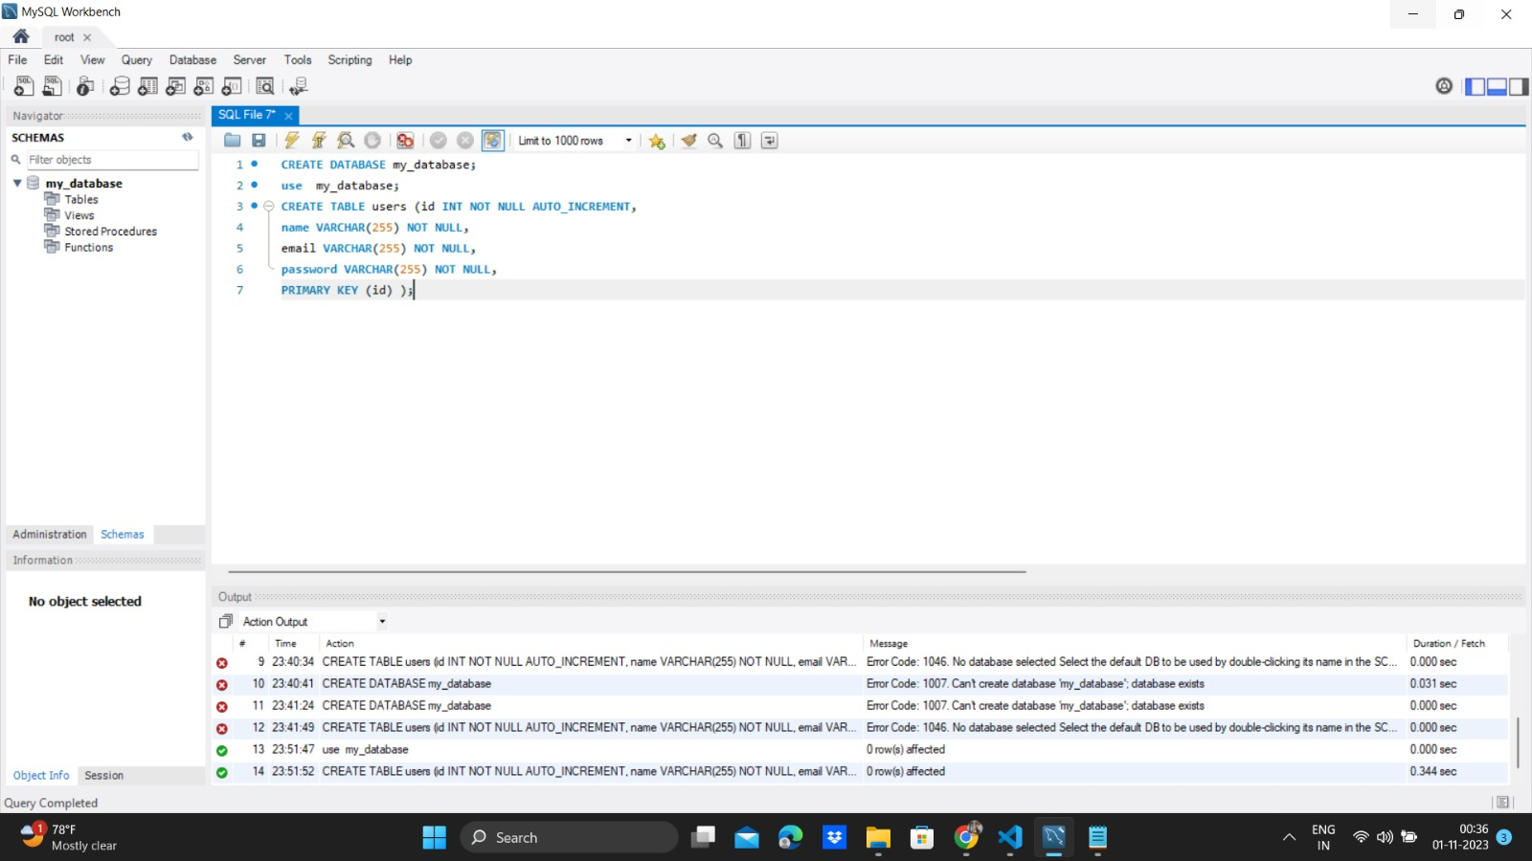

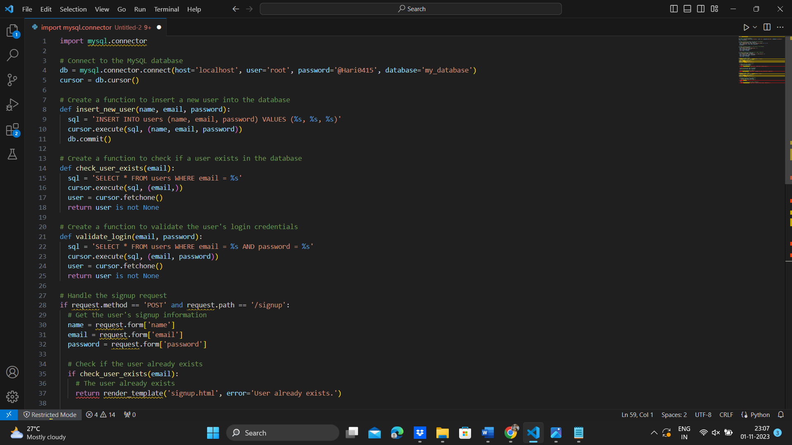

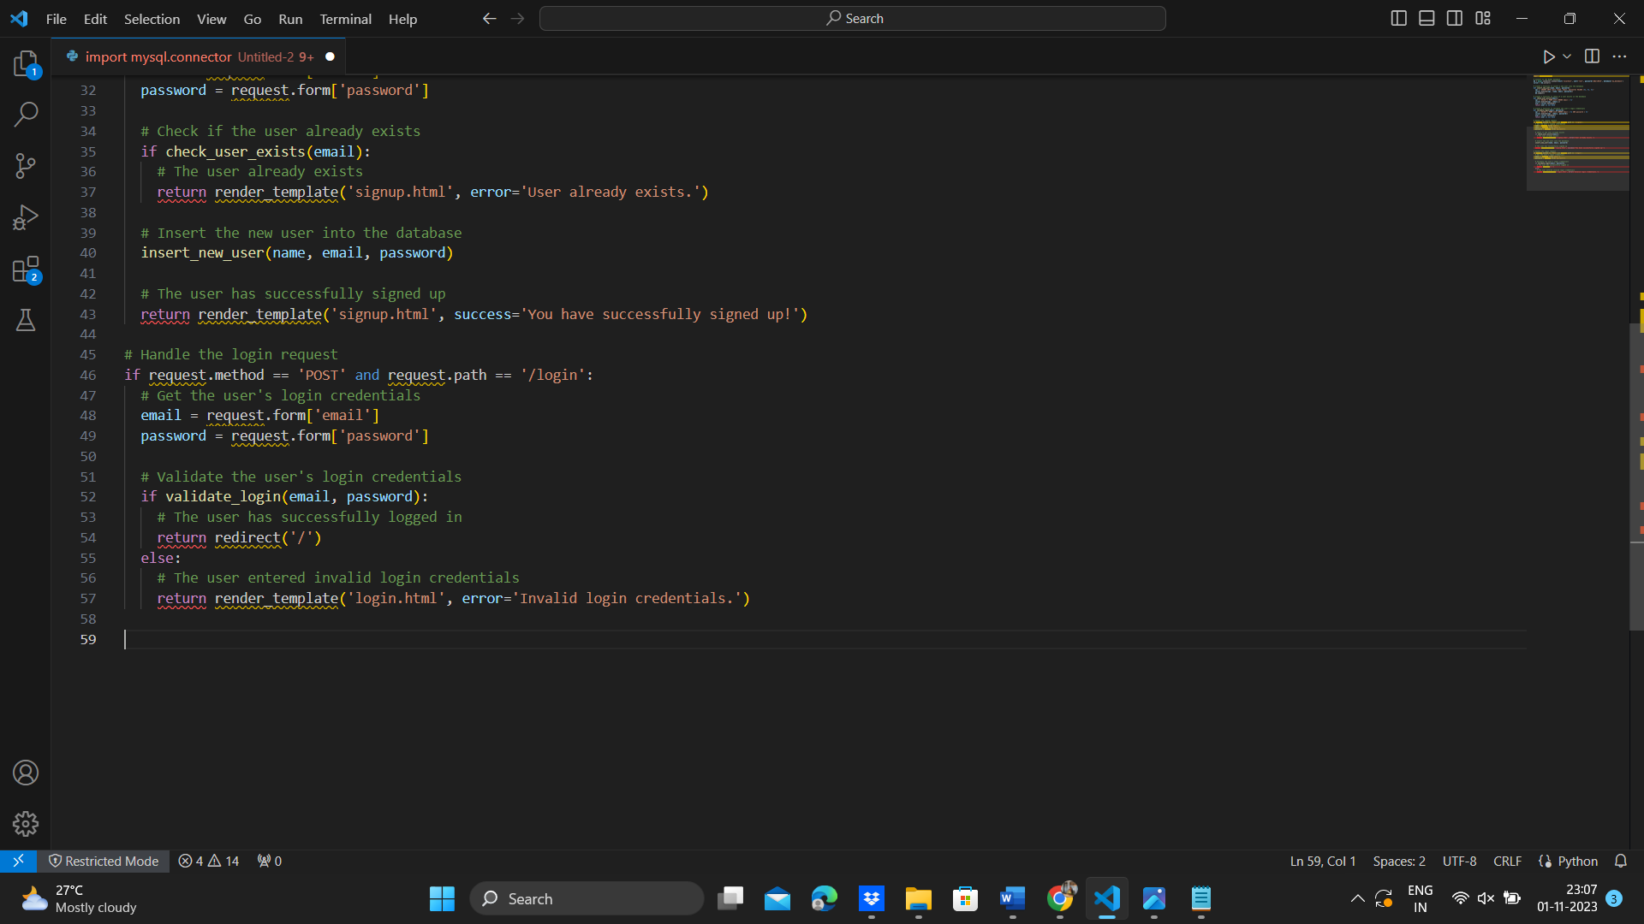

**9) STEPS TO USE CHATBOT:**

1. To use the chatbot, first chrome the website.
2. First page will display with a label and text field – Login/Signup.
3. If the user has an account, then login field has to be filled and jump into the chatbot.
4. If the user does not have an account, then the user has to create an account and login to use the chatbot.
5. In chatbot, the user can ask his/her queries as an input and get an approximate/desired output.

**10) FUTURE SCOPE:**

**1)Enhanced Natural Language Understanding (NLU):** The future will see chatbots with even more sophisticated NLU capabilities, enabling them to understand context, nuances, and multi-language interactions better. Python's extensive NLP libraries will continue to play a crucial role in these advancements.

**2)Multimodal Chatbots:** Chatbots that can understand and generate text, voice, and visual content will become more prevalent. Python's compatibility with voice and image processing libraries will be pivotal for creating multimodal chatbots.

**3)Personalization and Contextual Intelligence:** Chatbots will increasingly focus on personalization, leveraging user data to provide tailored responses and recommendations. Machine learning algorithms in Python will be essential for implementing context-aware chatbots.

**4)Industry-Specific Solutions:** The future holds significant potential for industry-specific chatbots in healthcare, finance, education, and beyond. Python's adaptability allows for the creation of specialized chatbots with domain-specific knowledge.

**5)Conversational AI in IoT:** Python's integration with IoT devices and platforms will enable chatbots to interact with and control smart devices, expanding the role of chatbots in home automation, healthcare, and more.

**6)Ethical and Bias Mitigation:** As ethical concerns and bias in AI become more prominent, Python developers will focus on creating chatbots that are ethical, unbiased, and compliant with data protection regulations.

**7)Hybrid Human-Chatbot Interactions:** Chatbots will increasingly work in conjunction with humans to provide 8)enhanced customer support and experiences. Python's adaptability for integration with human agents will facilitate this trend.

**9)Advanced User Interfaces:** Chatbots will employ more advanced user interfaces, including virtual reality (VR), augmented reality (AR), and 3D environments, to create immersive experiences.

**10)Blockchain Integration:** As data security and transparency gain importance, chatbots may integrate with blockchain technology for secure data storage and transaction processing.

**11)Quantum Computing Integration:** With the advent of quantum computing, chatbots may leverage quantum algorithms for faster processing and advanced data analysis.

**12)Augmented Intelligence:** Chatbots will serve as tools that augment human capabilities, especially in complex decision-making processes and data analysis.

**13)Voice Biometrics and Multimodal Authentication:** Improved voice recognition and facial recognition technologies will enhance chatbot security, allowing for secure voice and face-based authentication.

**14)Collaboration with Ecosystems:** Chatbots will play a central role in ecosystem collaborations, such as helping users manage various accounts and services from a single interface.

**15)Global Accessibility:** Chatbots will break language barriers and cater to a global audience with advanced multilingual support.

Increased Integration with Social Media and E-commerce: Chatbots will become integral to social media platforms, enabling businesses to engage with customers and providing personalized e-commerce experiences.

The future of chatbot development with Python is marked by innovation, advanced AI capabilities, and a deeper integration into various aspects of daily life and business operations. Python's adaptability, robust libraries, and active developer community position it as a key player in shaping the future of chatbot technology.

**11) ADVANTAGE’s:**

**1)Vast Ecosystem of Libraries:** Python boasts a rich ecosystem of libraries and frameworks for natural language processing (NLP) and machine learning, making it easier to implement advanced chatbot capabilities, such as text analysis, sentiment analysis, and machine learning-based chatbot behavior.

**2)Ease of Learning and Use:** Python is known for its simple and readable syntax, making it accessible for both beginners and experienced developers. This ease of learning and use accelerates the chatbot development process.

**3)Community Support:** Python has a large and active community of developers. This support network provides access to open-source tools, resources, and solutions that can facilitate chatbot development.

**4)Cross-Platform Compatibility:** Python is cross-platform, meaning chatbots developed with Python can be deployed on various operating systems and integrated with different platforms, including web applications, mobile apps, and IoT devices.

**5)Scalability:** Python-based chatbots can scale effectively, accommodating an increasing number of users and expanding functionalities as needed. Python offers versatile options for scaling web applications and services.

**12) DISADVANTAGE’s:**

**1)Performance Limitations:** Python is an interpreted language, which can result in slower performance compared to compiled languages like C++ or Java. This can be a concern for high-throughput or real-time applications.

**2)Resource Intensive:** Python can be memory-intensive, which may limit the scalability of chatbots and make them less efficient in resource-constrained environments.

**3)GIL (Global Interpreter Lock):** Python's GIL can hinder multi-threaded performance, which might impact the ability to handle multiple user interactions simultaneously.

**4)Lack of Multithreading Support:** Python's standard library does not provide full multithreading support due to the GIL. This can be a limitation when creating highly concurrent chatbots.

**5)Scalability Challenges:** Although Python can be used for scalable applications, it may not be as inherently scalable as some other languages. This means that chatbots that need to handle a massive number of concurrent users could face scalability challenges.

**13) RESULT:**

The creation of a chatbot using Python for the AI project has yielded a versatile and intelligent conversational agent capable of understanding and responding to user queries. The chatbot's robust NLP capabilities, driven by Python libraries, enable it to interpret user intent and context effectively. User feedback mechanisms have been integrated, facilitating continuous learning and improvement over time. Python's scalability ensures the chatbot's performance, even in high-traffic scenarios. The project sets the stage for a promising future, with opportunities for personalization, domain-specific applications, and multimodal interactions.

**14) CONCLUSION:**

The creation of a chatbot using Python for the AI project has yielded a versatile and intelligent conversational agent capable of understanding and responding to user queries. The chatbot's robust NLP capabilities, driven by Python libraries, enable it to interpret user intent and context effectively. User feedback mechanisms have been integrated, facilitating continuous learning and improvement over time. Python's scalability ensures the chatbot's performance, even in high-traffic scenarios. The project sets the stage for a promising future, with opportunities for personalization, domain-specific applications, and multimodal interactions. Therefore, the entire project has been completed successfully.