Documentation for two docker files communications

1. Create a Dockerfile with required data added for running a small python script
2. Create a python file to get connection to mysql container and printing host,user,pass details
3. Pull a mysql latest image and run the container with password associated to it
4. Log in to the container

Docker exec –it mysqname /bin/bash

Mysql –u root –p Vamsi

Show databases;

Create database and add tabes and row data and exit from the container

This is just to cross check

1. Docker inspect mysqlcontname – to check newtowrk ip bridge and env varibles
2. Add the network ip of mysql , user and pas details as env varibles in docker file
3. Build the docker images
4. Run the python container
5. Linking is required if both are going to build in different network bridges
6. By default all the containers are built in default network bridge so every container is able to communicate with each other
7. docker run -d -P –e BAC=Vamsi --name web --link db:db training/webapp python app.py

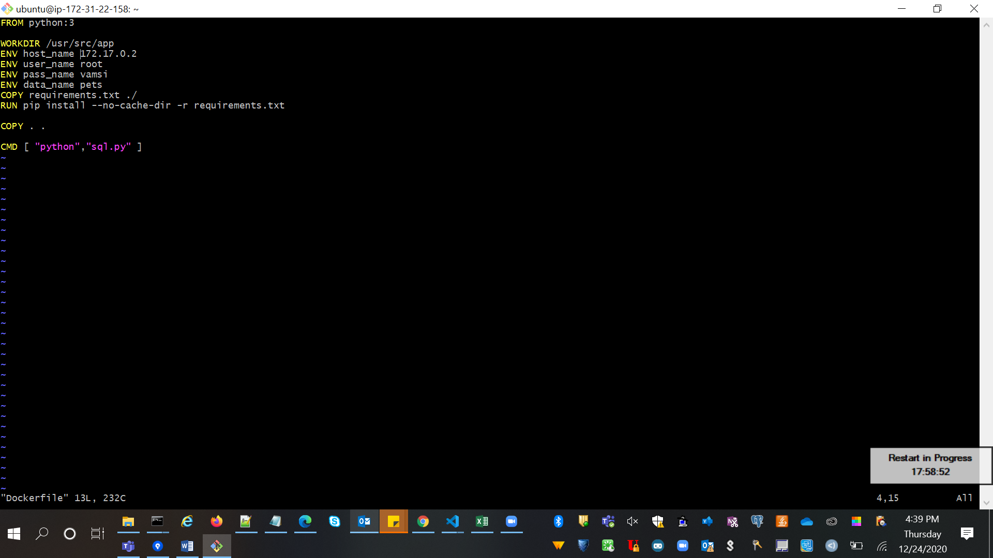

1. Now If we want to connect it to the aws rds db mysql instance
2. Create a mysql rds db instance and note doen the endpoints, user and pswd
3. Make sure to select the public access if we want access from anywhere in the world and you can see attribute as public connectivity as yes
4. If we don’t want it to access publicly then enable the ip address of specific in security group and create proper rds instances

