**1.Register Page**: To be authenticated first have to be registered.

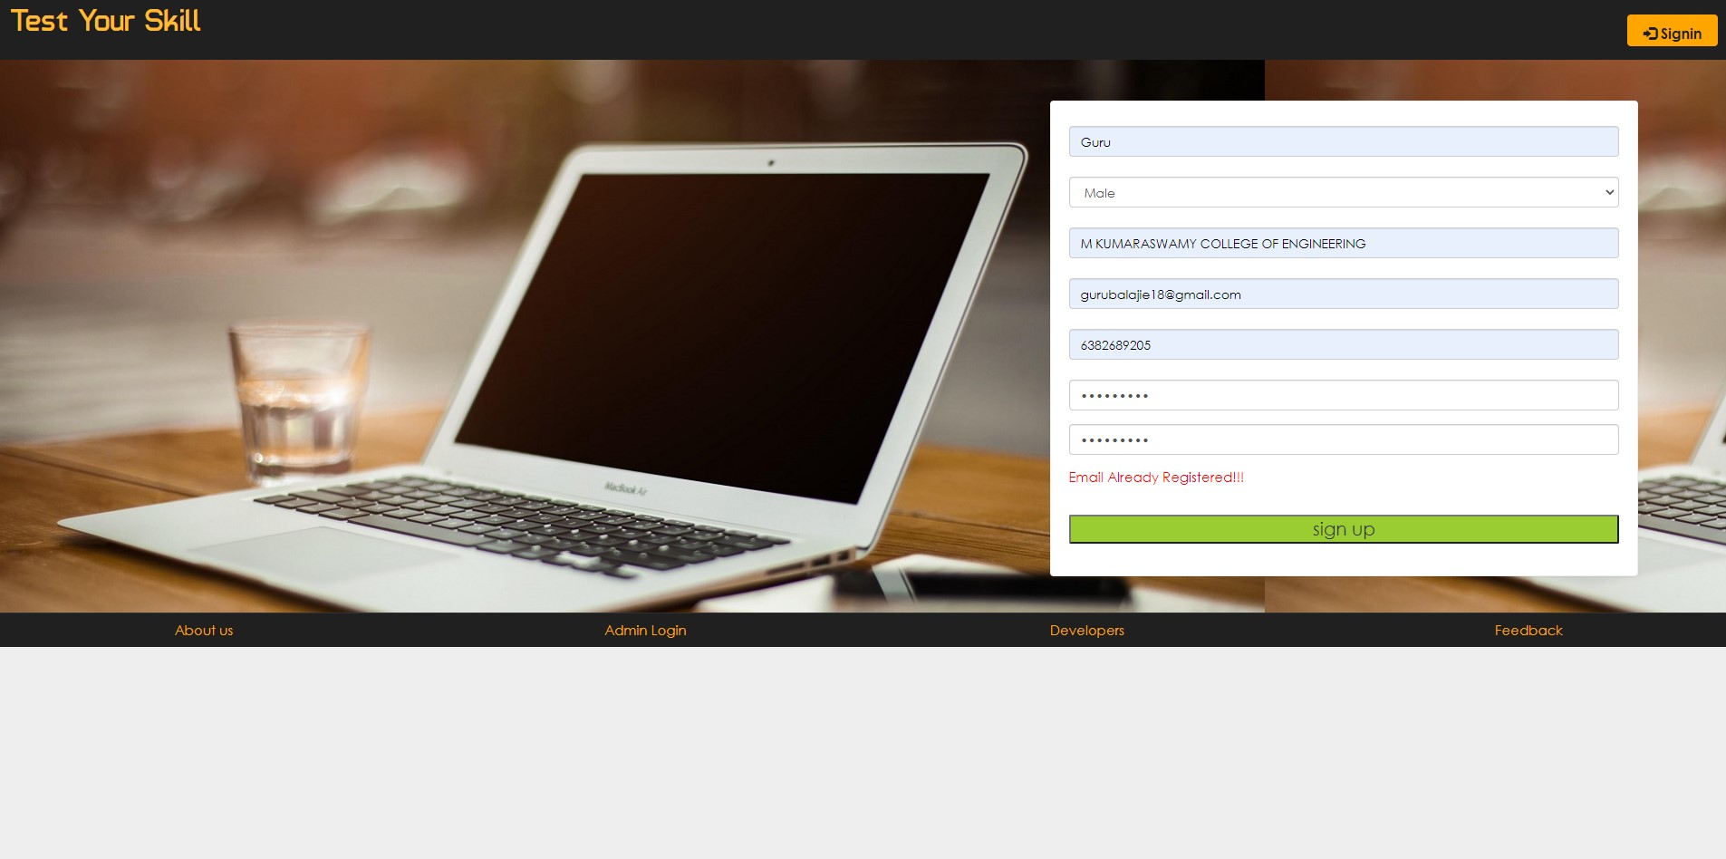

**2. Login:** The Registered User Can be Allowed to view inner details for which he Permitted.

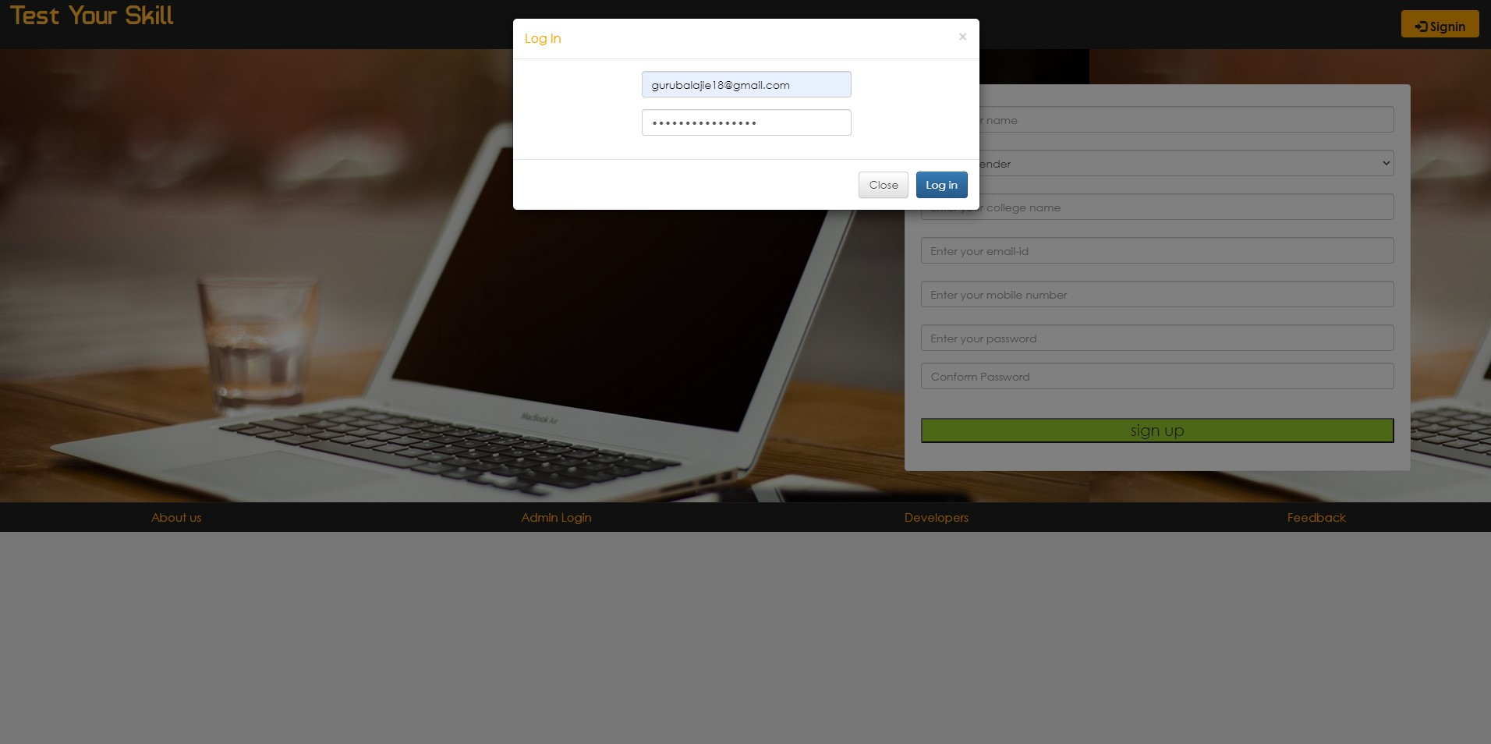

**3.Change Passwords and Forget Passwords:** User has rights to modify his login details& also be informed through mails if he is unable to login.

**4.Student Modifying Details:** User can be modified to change status of

each User.

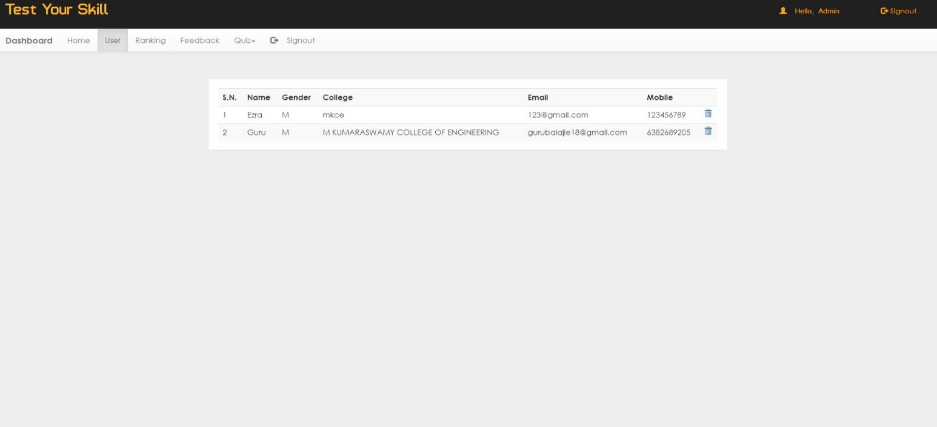

**5.Departments-Entering/Modifying Details**: New departments adding and old department deletions are spent by this user.

20

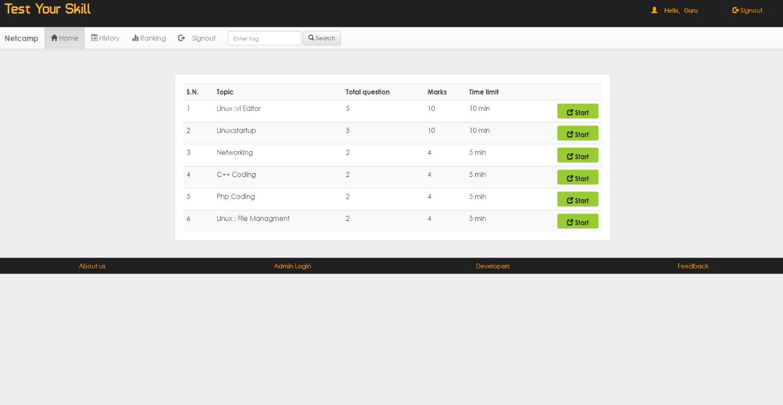

**6.Instructor Details-Modifying Details:** According to staff he can add or delete Instructors for specific platforms.

