Simple Linear Regression
It’s related to the Co2 emission of different cars. It includes Engine size, Cylinders, Fuel Consumption and Co2 emissions for various car models.
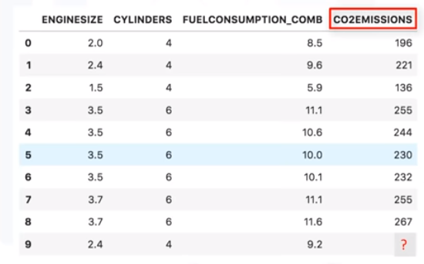
The question is: Given this dataset, can we predict the Co2 emission of a car, using another field, such as Engine size?

Linear regression is the approximation of a linear model used to describe the relationship between two or more variables.

In simple linear regression, there are two variables:
a dependent variable and
an independent variable.
(The key point in the linear regression is that our dependent value should be continuous and cannot be a discreet value. However, the independent variable(s) can be measured on either a categorical or continuous measurement scale.)

There are two types of linear regression models.
They are: simple regression and multiple regression.
Simple linear regression is when one independent variable is used to estimate a dependent variable. For example, predicting Co2 emission using the EngineSize variable.
When more than one independent variable is present, the process is called multiple linear regression. For example, predicting Co2 emission using EngineSize and Cylinders of cars.

Simple linear regression
1. Plotting data using scatter plot
x= EngineSize
y = Co2 emission
( A scatterplot clearly shows the relation between variables where changes in one variable "explain" or possibly "cause" changes in the other variable. Also, it indicates that these variables are linearly related. With linear regression you can fit a line through the data. For instance, as the EngineSize increases, so do the emissions.)
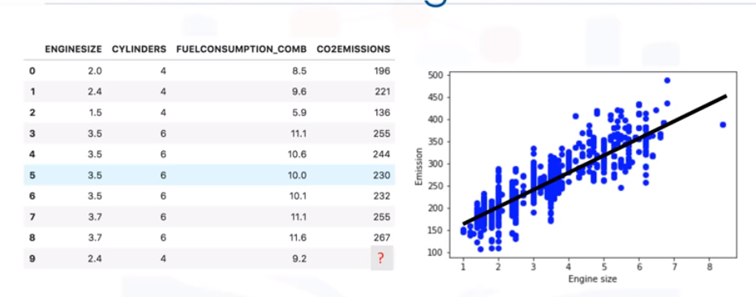
2. How do we use this line for prediction now?
Let us assume, for a moment, that the line is a good fit of data. We can use it to predict the emission of an unknown car. For example, for a sample car, with enginesize 2.4, you can find the emission is 214.
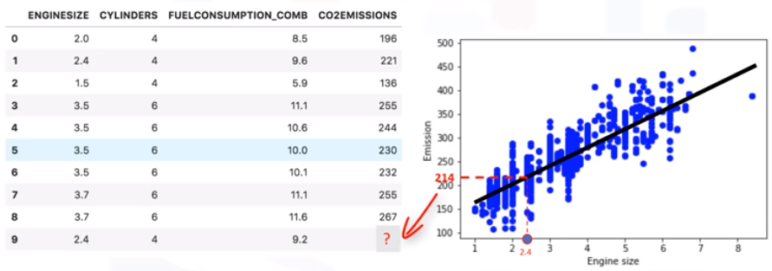

3. What this fitting line actually is ?
We’re going to predict the target value, y. In our case, using the independent variable, "Engine Size," represented by x1. The fit line is shown traditionally as a polynomial.
In a simple regression problem (a single x), the form of the model would be :
y ̂ = θ0 + θ1 . x1
In this equation,
y ̂ is the dependent variable or the predicted value, and
x1 is the independent variable;
θ0 and θ1 are the parameters of the line that we must adjust.
θ1 is known as the "slope" or "gradient" of the fitting line and
θ0 is known as the "intercept."

θ0 and θ1 are also called the coefficients of the linear equation.
You can interpret this equation as y ̂ being a function of x1, or y ̂ being dependent of x1.
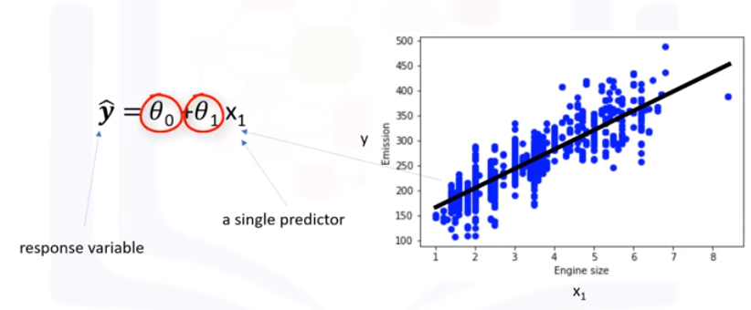

4. "How would you draw a line through the points?" And, "How do you determine which line ‘fits best’?"
Linear regression estimates the coefficients of the line.
This means we must calculate θ0 and θ1 to find the best line to ‘fit’ the data.
This line would best estimate the emission of the unknown data points.
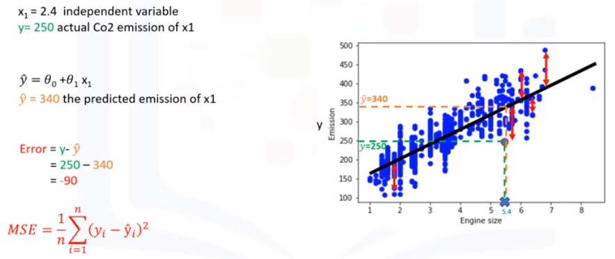
Let’s see how we can find this line, or to be more precise, how we can adjust the parameters to make the line the best fit for the data.

- For a moment, let’s assume we’ve already found the best fit line for our data. Now, let’s go through all the points and check how well they align with this line.
- Best fit, here, means that if we have, for instance, a car with engine size x1=5.4, and
actual Co2=250, its Co2 should be predicted very close to the actual value, which is y=250,
based on historical data.
- But, if we use the fit line, or better to say, using our polynomial with known parameters to predict the Co2 emission, it will return y ̂ =340.
- Now, if you compare the actual value of the emission of the car with what we predicted using our model, you will find out that we have a 90-unit error. This means our prediction line is not accurate. This error is also called the residual error.

RSS - Residual sum of squares - The residual values squared and summed together.
TSS - Total sum of squares - Difference between the mean value and the actual values, squared then summed.
R² -
- coefficient of determination
- A measure of how close the data are to the fitted regression linear
- computed by 1- (RSS/TSS)
- Ratio of variation explained bhy the model verses the actual variation in the sample data
- Always between 0 and 1
- 0 means the model explains none of the variation of the data from its mean
- 1 means the model explains all the variation
- Higher the R² better the model fits the data

- So, we can say the error is the distance from the data point to the fitted regression line. The mean of all residual errors(MSE) shows how poorly the line fits with the whole dataset.

“The objective of linear regression is to minimize this MSE equation, and to minimize it, we should find the best parameters, θ0 and θ1.”

5. Now, the question is, how to find θ0 and θ1 in such a way that it minimizes this error? How can we find such a perfect line? Or, said another way, how should we find the best parameters for our line?
Option 1 - We can use a mathematical approach. Or,
Option 2 - We can use an optimization approach.
Option 1
Let’s see how we can easily use a mathematical formula to find the θ0 and θ1. As mentioned before, θ0 and θ1, in the simple linear regression, are the coefficients of the fit line. We can use a simple equation to estimate these coefficients. That is, given that it’s a simple linear regression, with only 2 parameters, and knowing that θ0 and θ1 are the intercept and slope of the line, we can estimate them directly from our data.
1. It requires that we calculate the mean of the independent and dependent or target columns,
from the dataset. Notice that all of the data must be available to traverse and calculate the parameters.
2. It can be shown that the intercept(θ0) and slope(θ1) can be calculated using these equations.
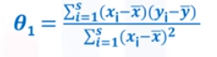

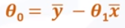

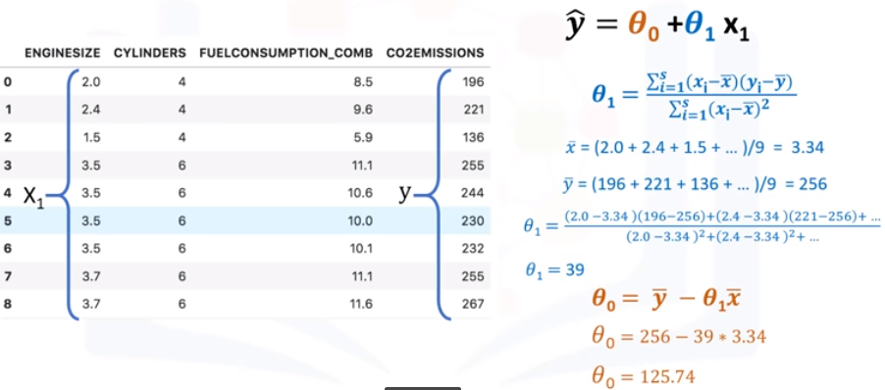

So, these are the two parameters for the line, where
θ0 is also called the bias coefficient and
θ1 is the coefficient for the Co2 Emission column.
Now, we can write down the polynomial of the line.
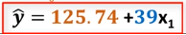
Best fit for our data, and its equation->

6. "How can we use it to predict the emission of a new car based on its engine size?"
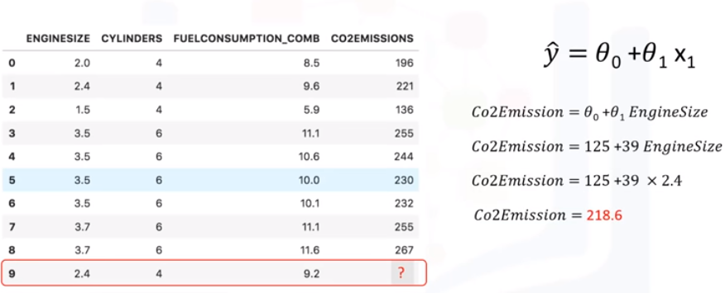

ADVANTAGES OF LINEAR REGRESSION
1. Quite simply, it is the most basic regression to use and understand.
2. In fact, one reason why Linear Regression is so useful is that it’s fast!
3. It also doesn’t require tuning of parameters. So, something like tuning the K parameter in K-Nearest Neighbors or the learning rate in Neural Networks isn’t something to worry about.
4. Linear Regression is also easy to understand
5. Highly interpretable.

