Prospective business opportunities in Mumbai
A Capstone project

Introduction/Business Problem
Mumbai is the city of opportunities for any kind of business, small or big as well as for job opportunities and also being one of the largest populated cities around the globe. Considering the same, it is always an exciting task to work on the amount of data produced which can be directed through various analysis and in-sights to develop new business opportunity that isn’t quite an easy task without the bird eye view considering the high competition in almost all venue categories.
In this project, we’ll explore venues in Mumbai, based on their average rating, likes and tips. Whenever people visit a new city in India or else where, the question of which places near by are good to visit based on their current location is vital as well as quite scattered on the internet. Similarly a business opportunity always exists when one becomes aware of the various in-demand and/or lack of some elsewhere-in-demand venue.
Through this project I’ve made an attempt to find out such prospective opportunities that can help start a new business or can help boom current businesses by making one realize about a missing category of venue in a particular area. Irrespective of the business opportunity a normal visitor can always have a upper-hand in deciding on visiting nearby trending venues. Specifically will find the possibility of having a Chinese restaurant in various section of Mumbai, since it is one of the top 5 visited venue categories but still not very much available in all places and thus resulting into a possible business idea.

Data gathering
Any city/town information can be used to get started with such a problem statement, I have chosen my current resident city, Mumbai. The data for various neighborhoods in Mumbai is collected from the Wikipedia and was cleaned and pre-processed according to the analysis requirement. This includes Town, Station, Neighborhood. Mumbai is divided into various geographical sections which includes the Western Suburbs, Eastern suburbs, Harbour Suburbs, South Mumbai and others. I have decided to work on Western Suburbs and South Mumbai data.
Data source : https://en.wikipedia.org/wiki/List_of_neighbourhoods_in_Mumbai
Description : This data set includes various neighborhoods in different sections of Mumbai city.

Using geopy library of python, we obtain the location(latitudes and longitudes) of each station data collected.

Collect Chinese restaurants in each neighborhood of Western Suburbs and South Mumbai.
Data source : Foursquare API
Description : By using this api we will get all the venues in each neighborhood. We can filter these venues to get only Chinese restaurants.

Methodology and Analysis
Explore Venue Categories
- After collecting the location data of each neighbourhoods, we now collect the nearby venues categories which is further used to find the top ten nearby among a particular station. This is done with the help of Foursquare API.
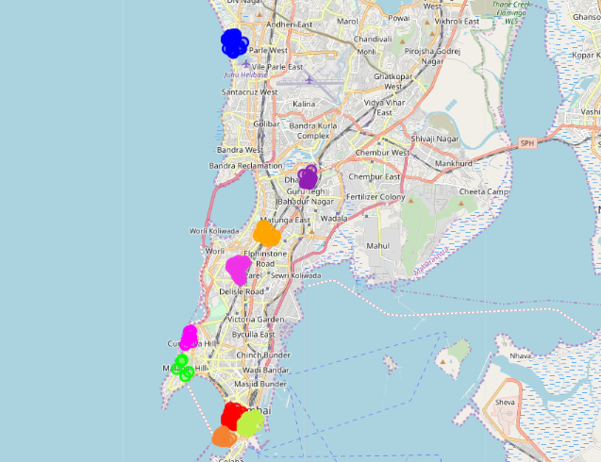

- Plot the 10 Most Frequently existing Venue Categories
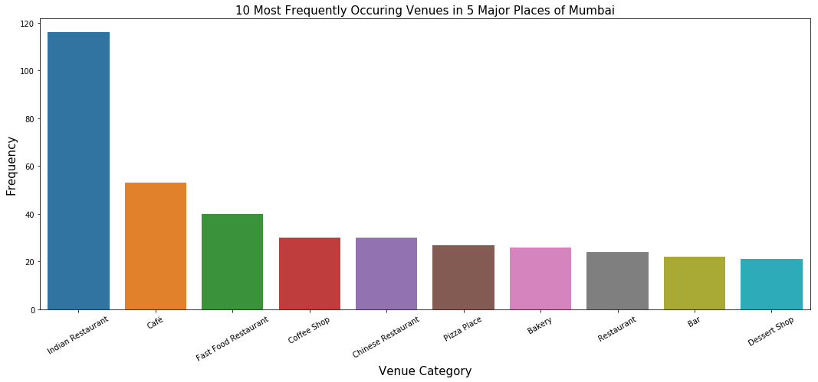
- Analyze Each Neighborhood to find 10 most common Venue in each of them, Plot the same

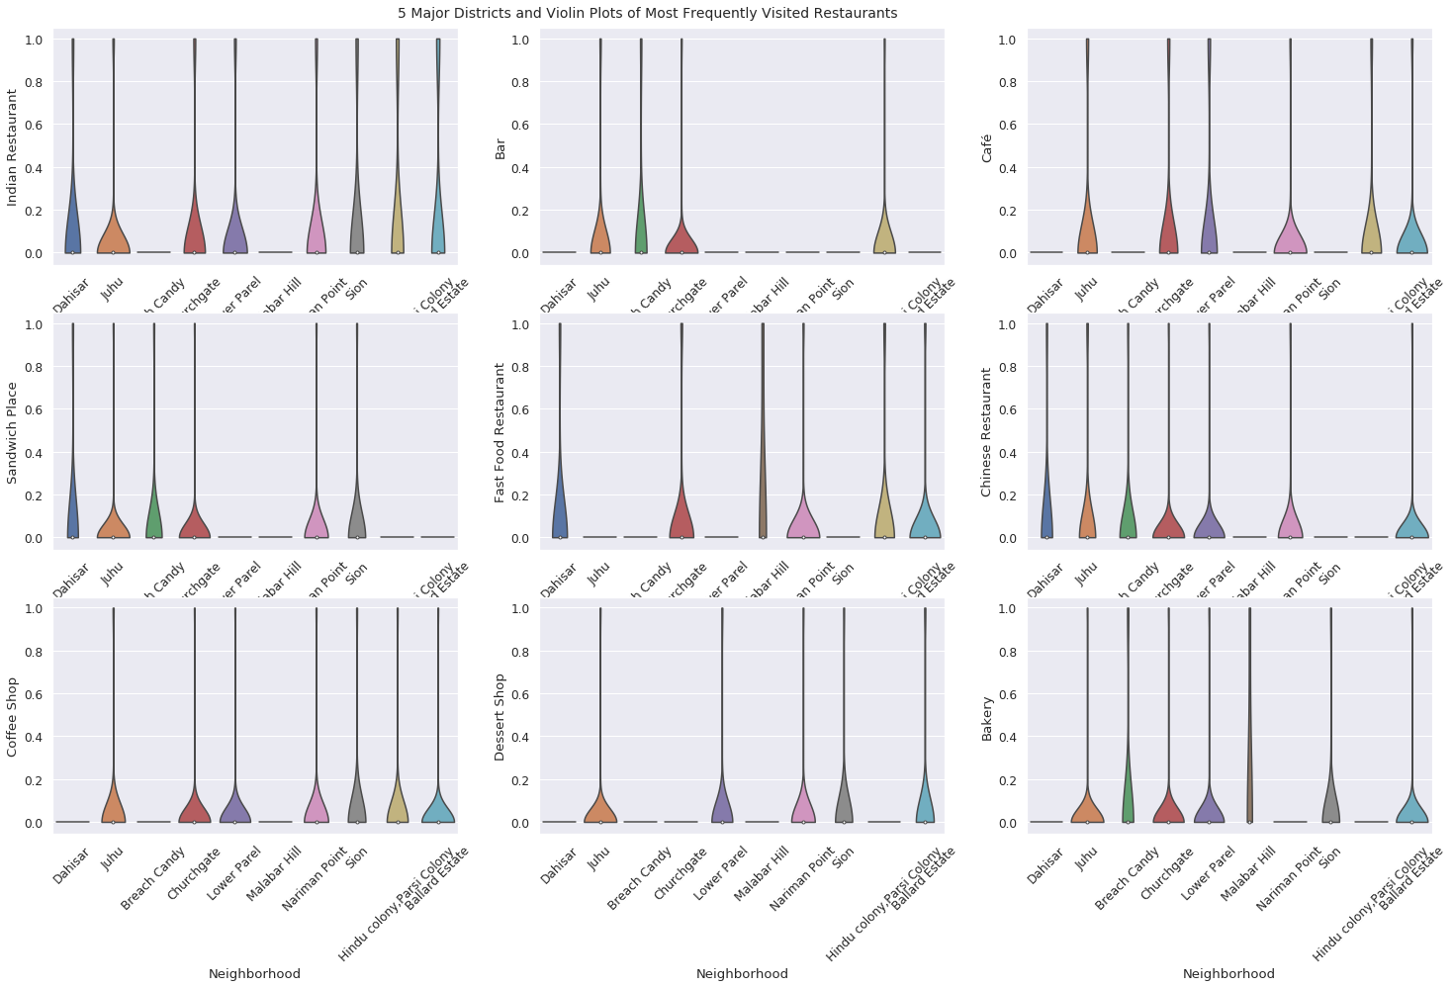

- Cluster Neighborhood using K means clustering to identify which neighborhoods are similar or dissimilar
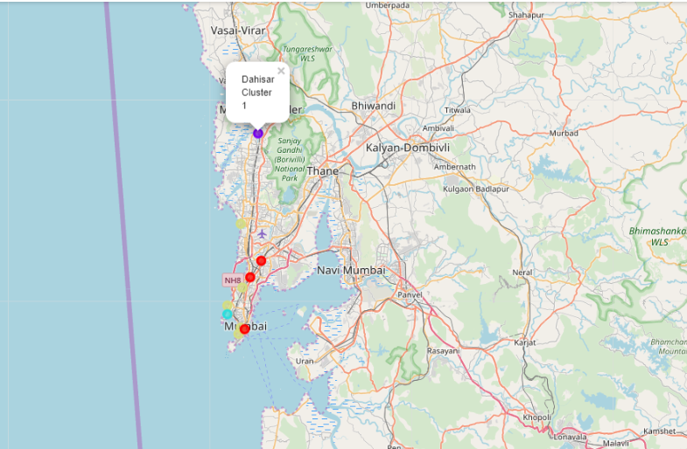

Based on the number of Venues in each neighborhood to visualize the same on the map to visually find the in-demand market.

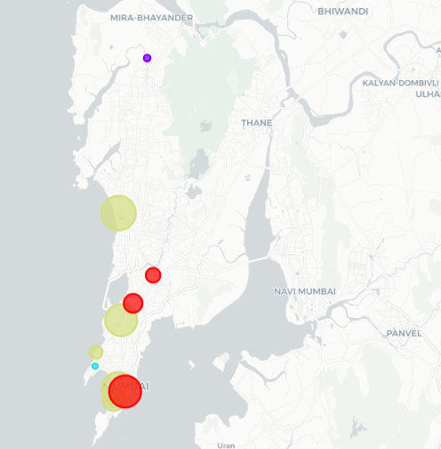

- Filter out all venues that are Chinese Restaurants.

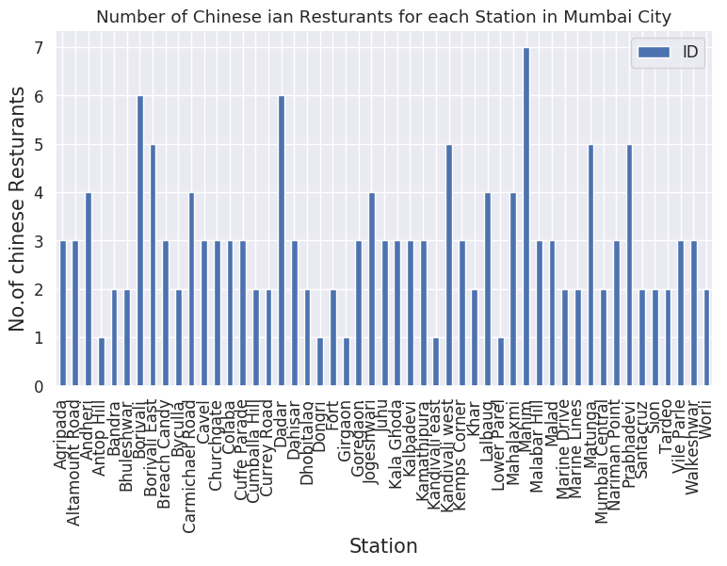

- Find rating , tips and like count for each Chinese Restaurants using FourSquare API.

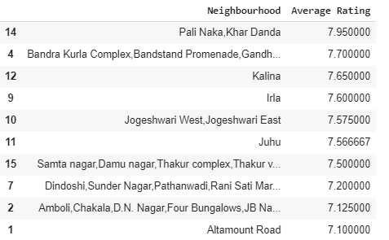

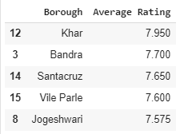

- Visualize the Ranking of neighborhoods using folium library(python)

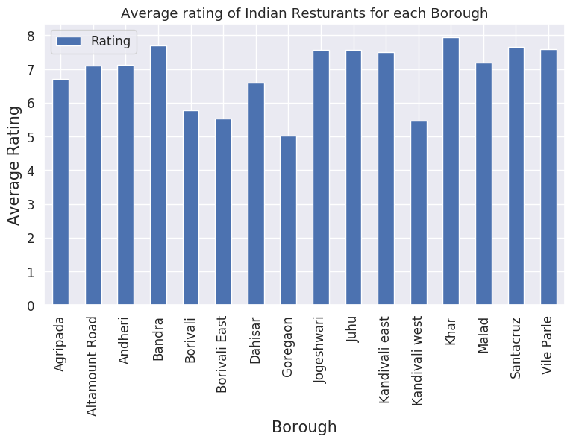

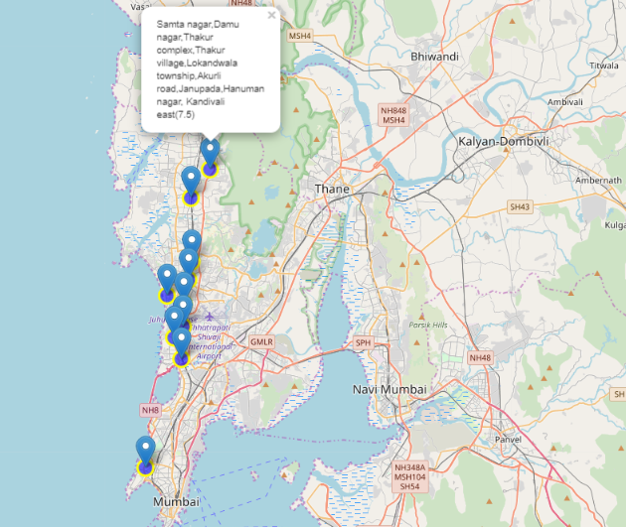

Discussion and Results
As observed in the above analysis and map plots, the top 5 venue categories in Mumbai are
1. Indian Restaurants
2. Cafe
3. Fast Food
4. Coffee shop
5. Chinese Restaurants

- On analyzing the top 10 most common place in a neighbourhood, it is observed that even being one of the top venue categories, Chinese Restaurants are still not in the list for many popular places like Malabar Hill, Sion and Hindu/Parsi Colony, thus making it highly effective opportunity for business.

- On collecting Chinese Restaurants info for each Neighborhood for prospective business Locations, we observed that there are 55 Chinese Restaurants about the neighbourhood searched. Out of these 55, Mahim has the highest number of Chinese restaurants

- On ranking these restaurants, we found that the following :
a. 5 Spice, in Goregaon, has the highest number of Likes i.e 73
b. Wok Express in Bandra, has the highest rating of 8.3
c. 5 Spice, in Goregaon, has the highest number of Tips i.e 42
d. Khar and Bandra are among the Highest average rating Chinese Restaurants of 7.95 and 7.7 respectively.

Therefore, Khar, Andheri and Bandra are some of the best neighborhoods for Chinese cuisine. Also Malabar Hill and Sion have potential Chinese Restaurant business opportunities

Conclusion
The purpose of this project was to explore the places that a person visiting Mumbai should experience as well as a business hunter can have an insight based on the areas to consider for business opportunities for Chinese restaurants. The venues have been identified using Foursquare API and have been plotted on the map using the Folium library of python. The map reveals that there are three major areas a person can visit: Khar, Andheri, Bandra. Based on the visitor’s venue rating and price preferences, he/she can choose among-st the three places. There are a lot of other insights that can be attained by increasing the distance of a nieghbourhood venues, using Foursquare API premium search and explore functionalities one can obtaining further exciting insights about the venues near by.

