XGBoost

XGBoost (eXtreme Gradient Boosting)
- [Optional] A Gentle Introduction to the Gradient Boosting Algorithm for Machine Learning
- Introducing the Gradient Boosting and extensive references to understand XGBoost. (If you already understand Gradient Boosting, you may skip it.)
- A Gentle Introduction to XGBoost for Applied Machine Learning
- Jason Brownlee, the same author, kindly introduces concept descriptions and additional learning materials for those who first learn XGBoost.
- 7 Step Mini-Course to Get Started with XGBoost in Python
- It is a 7 step summary with a simple Python code, and I think it will be helpful to clean up the concept.

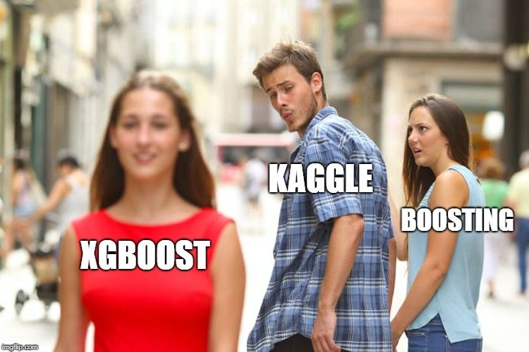

Kaggle
“Using XGBoost without parameter tuning is like driving a car without changing its gears; you can never up your speed”
- What I’ve learned from competing in machine learning contests on Kaggle
- In fact, this is about Kaggle, but good for people who want to participate in the Kaggle with XGBoost as a starter kit.
- [Optional] An MVP Aproach
- This is a tutorial detailed to solve the Kaggle problem with XGBoost with code. (from A to Z with XGBoost Tutorial)

[Optional] Further Reading
- CatBoost vs. Light GBM vs. XGBoost
- It introduces and compares three popular gradient boosting methods.
- Complete Guide to Parameter Tuning in XGBoost (with codes in Python)
- An comprehensive document to tune the hyperparameters of XGBoost.
- Accelerated Gradient Boosting(AGB)
- An interesting gradient boosting research paper, it improves performance by calculating Hessian in addition to the Gradient.

