A Crash-Course Introduction to Convolutional Neural Networks
Introduction

Last week, we introduced the concept of a feed forward neural network. Today we will look at a variation called a convolutional neural network.
A convolutional neural network (CNN) is an architecture specialized for computer vision tasks. The main innovation of these networks is using what’s called a convolutional layer, which preserves the spatial relationships between pixels. In particular the tasks of image classification, object detection, and image segmentation benefit from this approach. There has also been some success in applying CNNs to natural language processing in recent years.

Neocognitron (1980)
The principles underlying the CNN were first formalized in 1980 with Kunihiko Fukushima’s neocognitron. This introduced convolutional layers, inspired by prior work identifying regions in a cat’s brain which would light up when presented with visual stimulus. This work also introduced the pooling layer.
Neocognitron Paper

Convolutional Layer
The fundamental innovation at the heart of CNNs is the convolutional layer. These work by passing a sliding window over the input layer which acts as a feature detector, emphasizing certain visual information. The window that passes over the input is called the ‘receptive field’ and the collective weights of the receptive field are called the ‘convolution kernel’. The output is produced by multiplying the weight of the kernel element-wise by those units which fall in the receptive field and taking the sum.
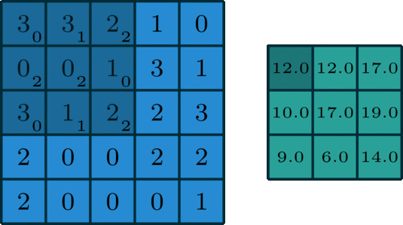from Intuitively Understanding Convolutions for Deep Learning
Padding
In order to touch every position equally with our receptive field, a common trick is to use what’s called ‘zero-padding’. This simply means adding a boundary of zeros around the input.
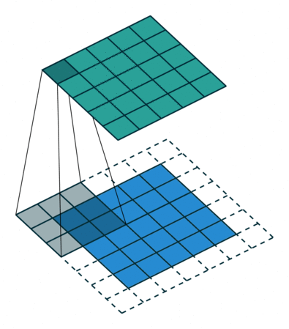
Pooling Layer, Max Pooling
In between each convolutional layer, it is common practice to add a pooling layer (also called downsampling or subsampling layer). These are similar to convolution layers, except that they have no weights associated. They help to reduce the overall number of parameters in the network as well as reduce dimensionality as we progress toward the output layer. Max-pooling is a common method, where (as the name suggests) we take the maximum value in our receptive field.

LeNet – 5 (1998)
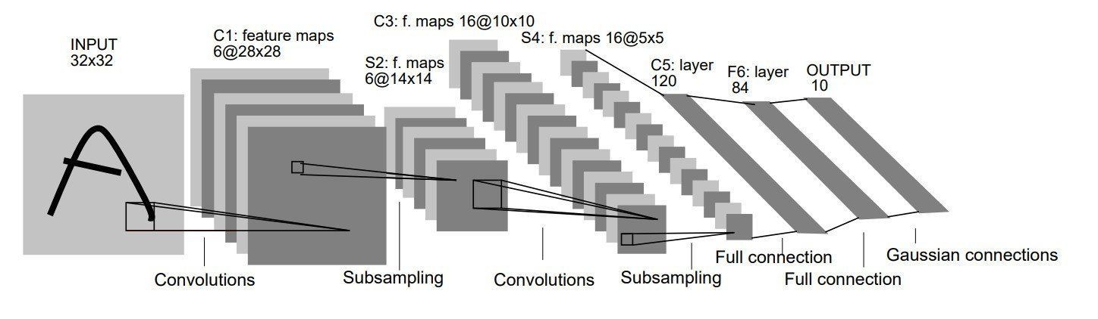from Gradient-Based Learning Applied to Document Recognition
In 1998, a team of researchers including Yann LeCun and Yoshua Bengio produced some of the first tangible results in a model called LeNet – 5 by training it to recognize numbers written on checks. The problem of identifying written digits was eventually standardized into a dataset called MNIST which is still used today as a baseline. It should be noted that classification of digits from MNIST is considered too simple a task to be a useful measure of success, as one can easily achieve an accuracy over 99%. Check out this link to see an interactive visualization of an MNIST classifier.
LeNet – 5 Paper

AlexNet

In 2012, another major milestone was achieved. Alex Krizhevsky, Geoffrey Hinton, and Ilya Sutskever released a model called AlexNet as part of the ImageNet Large-Scale Visual Recognition Challenge (ILSVRC), blowing competition out of the water and sparking the fire of interest in deep learning seen today. This also established the usage of GPUs as a standard way to speed up training.
AlexNet Paper

GoogleNet AKA InceptionV1 (2014)

Named after the 2010 blockbuster, Inception was the winner of the ILSVRC14 challenge. This model architecture introduced a structure called ‘inception modules’ which helped to decrease the number of trained parameters in the network, greatly accelerating training. Check out this articlefor more information on inception modules.
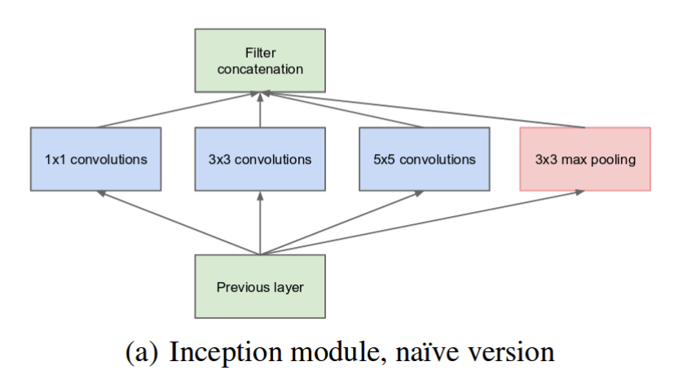from Going deeper with convolutions
GoogleNet / Inception Paper

ResNet

The winner of ILSVRC in 2015 was ResNet. The researchers introduced ‘skip-connections’, which helped to protect against the vanishing gradient problem far more effectively than prior techniques such as auxiliary classifiers. This architecture enjoys great popularity in the community today. It should be noted that a synthesis was achieved between ResNet and Inception in 2017.
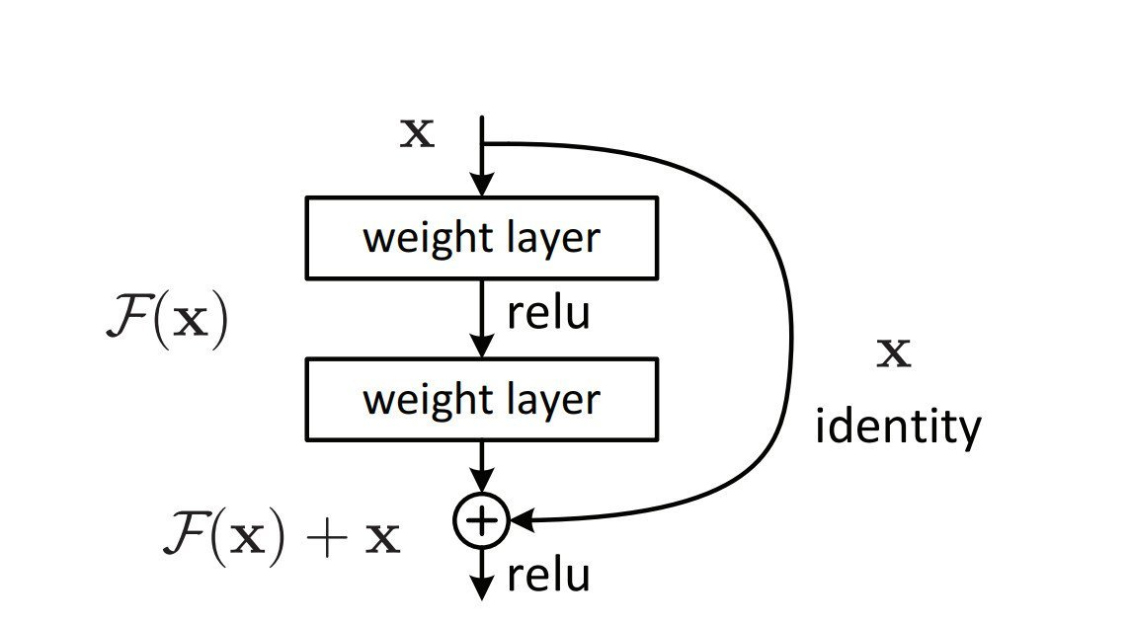From Deep Residual Learning for Image Recognition
ResNet Paper

SeNet
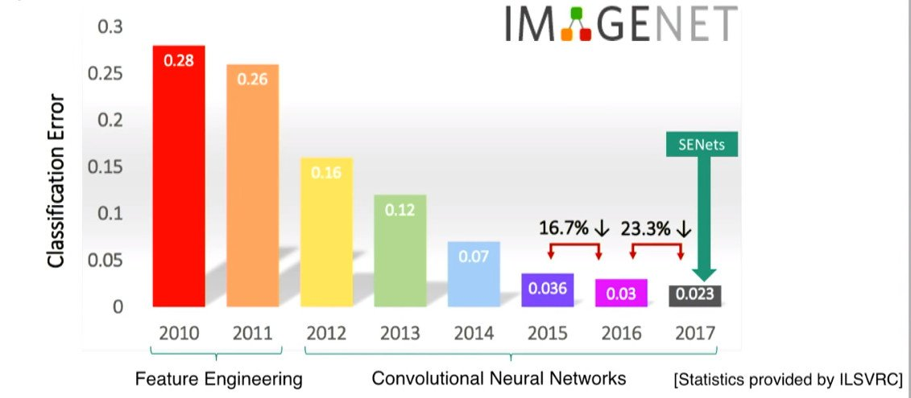from CVPR18: Session 3-1A: Object Recognition & Scene Understanding IV
In 2017 the last ILSVRC was held. The winning architecture was titled a ‘squeeze and excitation network’. This work was motivated by the question, “can the representational power of a network be enhanced by channel relationships?” The new squeeze-and-excite block selectively emphasises features based on global information. As the author describes in a recent talk, this allows the network to associate distant spatial information, such as the head and tail of a dog. SeNets can also be combined with Inception and ResNet architectures.
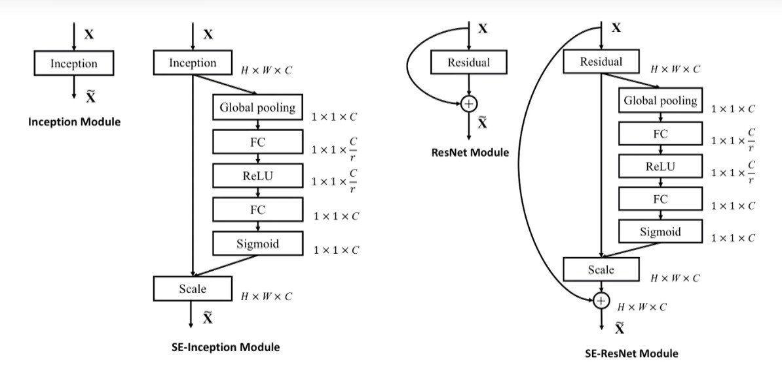From Squeeze-and-Excitation Networks
SeNet Paper

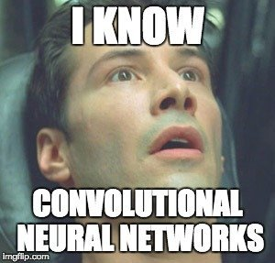
Further Resources
Introduction to Deep Learning: What Are Convolutional Neural Networks?
[Video content from MATLAB team]
ML Practicum: Image Classification
[Mini-course from Google team]

