Regression
In regression we try to determine the relationship between one or more independent and dependent variables.

Simple Linear Regression
Simple linear regression is a tool used to estimate a line of best fit to a set of data points. This line represents an estimated relationship between ‘x’ (the independent variable) and ‘y’ (the dependent variable).
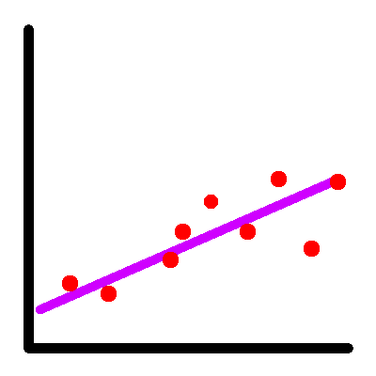
A linear regression model is only useful under a series of assumptions:
- We don’t have outliers
- Observations (samples) are independent
- We have a normally distributed error term with a mean of zero
- There’s no heteroscedasticity
- There is no multicollinearity
- There is no autocorrelation
- Perhaps most importantly, there’s a linear relationship between our independent and dependent variables.
Heteroscedasticity
Heteroscedasticity is a term used to describe data that increases or decreases in variation in relation to the increase of a certain variable. This is one of the potential hangups for applying a linear regression model. If you plot the data on a two dimensional graph, it can be identified as a triangle shape in the data points.
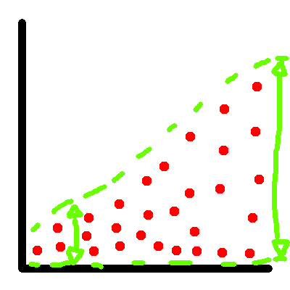
Multicollinearity
Multicollinearity means that our independent variables happen to be correlated (one variable can be used to predict the value of the other). Whenever we are dealing with multiple regression, it’s important to be careful of multicollinearity interfering with our results.
Autocorrelation
Autocorrelation describes the situation when we have a high degree of correlation between a time series and a lagged version of itself.
Multiple Regression
Multiple regression refers to a linear regression scenario where we have more than one independent variable.
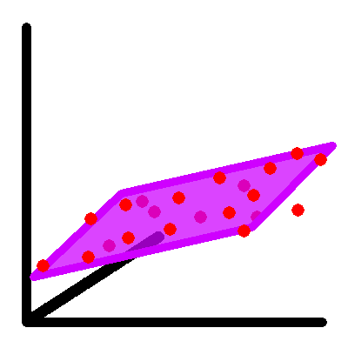
When we are dealing with 2 independent variables, we use a plane instead of a line to represent our model.

Logistic Regression
Whenever we want to predict a binary outcome (true or false), logistic regression is the tool of choice. The graph of this type of model is shaped like an snake, where the head and tail represent the domains of x for which we expect to see 1 and 0 outcomes respectively.
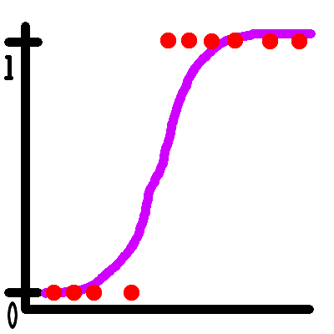

Multivariate Regression
Multivariate regression is a form of linear regression used when we have more than one dependent variable. A multivariate regression can also have more than one independent variable, similar to multiple regression.

Ridge Regression
One way to handle a multicollinearity is to use a technique like ridge regression. It’s able to decrease the weight of some of the variables on the result by penalizing the square of the coefficients (as part of the iterative process). This penalty is called the L2 norm.

Lasso Regression
Lasso regression, similar to ridge regression, helps to handle multicollinearity. Unlike ridge regression, it uses an L1 norm. That means rather than squaring the coefficients, it returns the absolute value and penalizes that. This can reduce less important features to zero, acting as a form of feature selection.

Polynomial Regression
Polynomial regression uses a more complex function to estimate a line of best fit. If you’ve taken high school level algebra, the concept of a polynomial should be at least somewhat familiar. For instance, negative x squared looks like an upside down ‘U’ when you graph it.
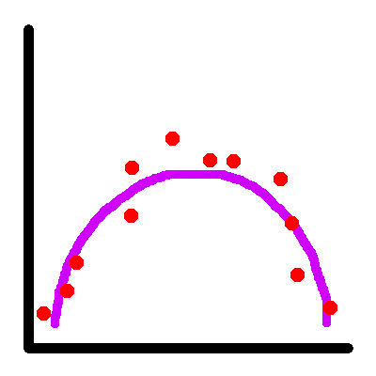
One challenge involved in this kind model is finding a balance between fittedness and simplicity. A model that is too complex will tend to overfit, resulting in a line that touches every point but fails to generalize to unseen data.
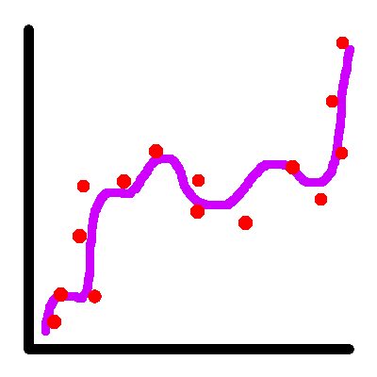
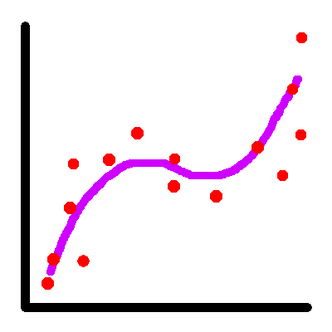
Polynomial regression is able to capture more complex relationships between our variables than simple linear regression. However, there are tools that allow even more robust forms of regression, such as support vector machines and artificial neural networks, which are able to capture non-linear relationships. We’ll start looking at these next week.
Until then, keep the data lit.

