Types of Regression
Y
X
Y=a+b∗X+e
a
b
e
a
b
Y
Y
X′B
e
Y
Y
X
X
Y=a+b∗X+e
e

1. Linear Regression
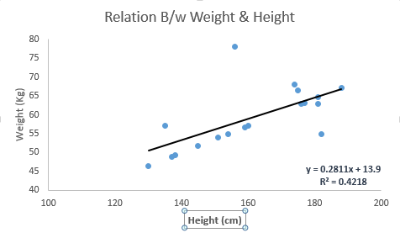
- It is the simplest form of regression and always introduced at the first order.
- The nature of regression line is linear, therefore the dependent variable(Y) is always continuous while independent variables(X) can be continuous or discrete.
- It establishes a relationship between dependent variable Y and one or more independent variables X using a best fit straight line (also known as regression line).
- In case of more than one predictors present, it is called multiple linear regression.
Y=a+b∗X+e
- a= slope of the line
- b= y-intercept
- e= error term

How to obtain best fit line (Value of a and b)?
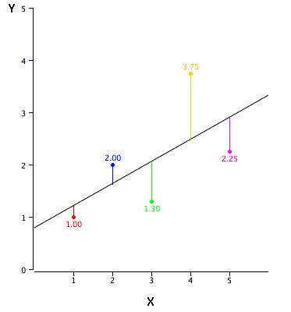
- Least Square Method is used for fitting a regression line.
- “Least squares” means that the overall solution minimizes the sum of the squares of the residuals made in the results of every single equation. (https://en.wikipedia.org/wiki/Least_squares)
- It calculates the best-fit line by minimizing the sum of the squares of the vertical deviations.
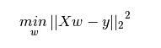

Important Points
- There must be linear relationship between independent and dependent variables.
- It is very sensitive to outliers. It can affect the regression line and eventually the prediction.
- Multiple regression suffers from multicollinearity.
- Multicollinearity can increase the variance of the coefficient estimates and make the estimates very sensitive to minor changes. The result may be unstable.
- In case of multiple independent variables, try to use forward selection, backward elimination and step wise approach to select most significant independent variables .

http://www.stat.yale.edu/Courses/1997-98/101/linreg.htm

2. Logistic Regression
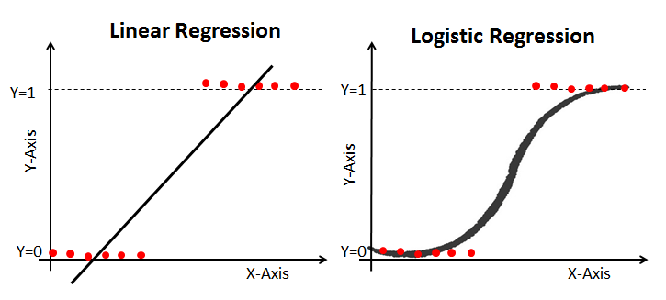This image is from https://www.imagenesmy.com/imagenes/logistic-regressopm-27.html
- It describes the relationship between a set of independent variables and a categorical dependent variable.
* A categorical variable is one that has two or more categories.
- It is used to find the probability of event=Success and event=Failure when the dependent variable is binary (0/ 1, True/ False, Yes/ No) in nature.
- The value of Y ranges from 0 to 1 and it can represented by following equation.
odds= p/ (1-p) = probability of event occurrence / probability of not event occurrence
ln(odds) = ln(p/(1-p))
logit(p) = ln(p/(1-p)) = b0+b1X1+b2X2+b3X3....+bkXk

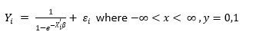Using logistic regression
- In linear regression, range of Y is real line but here it can take only 2 values. So Y is either 0 or 1
- But X′B is continuous thus we can’t use usual linear regression in such a situation.
- Secondly, the error terms e are not normally distributed.
- Y follows binomial distribution and hence is not normal.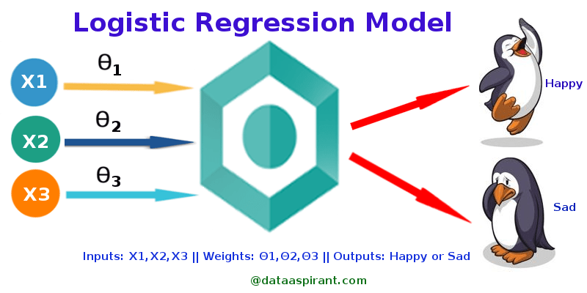

Important Points
- It is widely used for classification problems.
- It doesn’t require linear relationship between dependent and independent variables.
- It applies a non-linear log transformation to the predicted odds ratio thus it can handle various types of relationships.
- To avoid over fitting and under fitting, you should include all significant variables.
- It requires large sample sizes because maximum likelihood estimates are less powerful at low sample sizes than ordinary least square
- The independent variables should not be correlated with each other i.e. no multicollinearity.
- If the values of dependent variable is ordinal, then it is called as Ordinal logistic regression
- If dependent variable is multi class then it is known as Multinomial Logistic regression.

3. Ridge Regression (Shrinkage Regression)
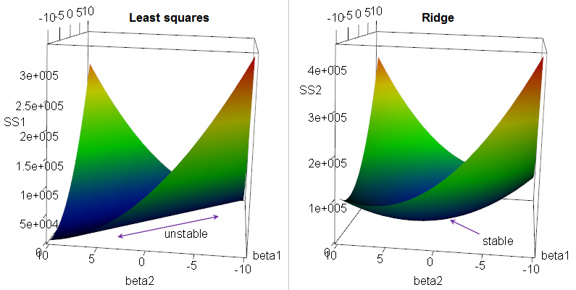This image is from Robert R.F. DeFilippi’s blog
- A standard linear or polynomial regression will fail in the case where there is high collinearity among the feature variables. ( independent variables are highly correlated).
- By adding a degree of bias, ridge regression reduces the standard errors.
- A regression coefficient is not significant even though, theoretically, that variable should be highly correlated with Y.
- When you add or delete an X feature variable, the regression coefficients change dramatically.
- Your X feature variables have high pairwise correlations (check the correlation matrix).

Let’s review linear regression
- Y=a+b∗X+e
- Prediction errors can be decomposed into two sub components, the biased and the variance.
error term e is the value needed to correct for a prediction error between the observed and predicted value
y = a+ b*x+ e
= a+ y
= a+ b1x1+ b2x2+...+ e, for multiple independent variables.

How to solve the multicollinearity problem?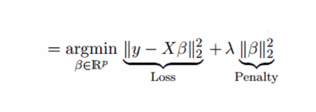
- It uses shrinkage parameter λ (lambda).
- In the equation, there are two components.
  - First one is least square term.
  - Other one is lambda of the summation of β2 (beta- square) where β is the coefficient.
This is added to least square term in order to shrink the parameter to have a very low variance.

Important Points
- The assumptions of this regression is same as least squared regression except normality is not to be assumed.
- It shrinks the value of coefficients but doesn’t reach to zero, which suggests no feature selection feature.
- This is a regularization method and uses l2 regularization.

Other types of regression
- Polynomial Regression
- Quantile Regression
- Lasso Regression
- ElasticNet Regression
- Principal Component Regression
- Partial Least Square Regression
- Support Vector Regression
- Ordinal Regression
- Poisson Regression
- Negative Binomial Regression
- Quasi-Poisson Regression
- Cox Regression
Check this article for more details.

Conclusion
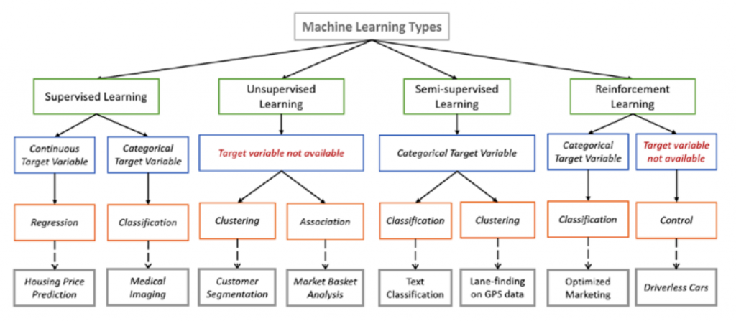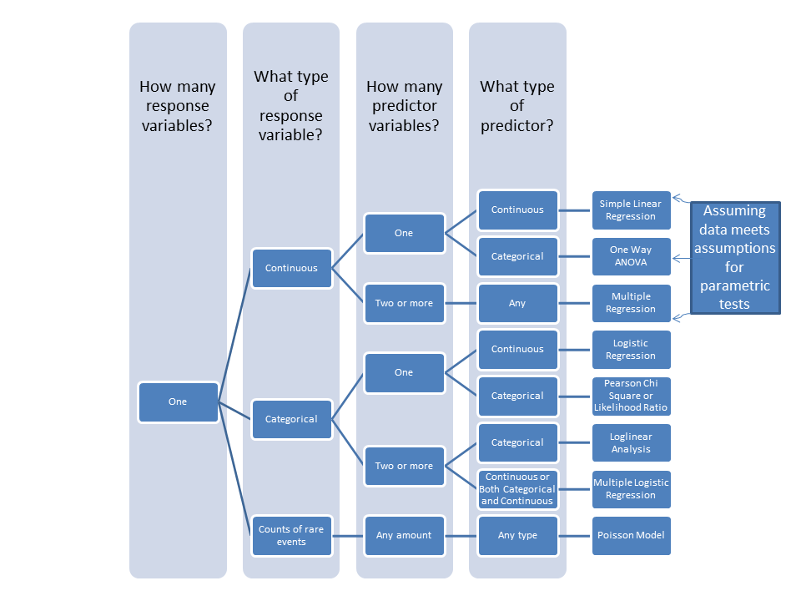
This image is from Mahrita Harahap’s blog
- If dependent variable is continuous and model is suffering from collinearity or there are a lot of independent variables,
  - Try PCR, PLS, ridge, lasso and elastic net regressions.
  - You can select the final model based on Adjusted r-square, RMSE, AIC and BIC.
- If you are working on count data,
  - Try poisson, quasi-poisson and negative binomial regression.
- To avoid overfitting,
  - Use cross-validation method to evaluate models used for prediction.
  - Also try ridge, lasso and elastic net regressions techniques.
- When you have non-linear model
  - Try support vector regression.

