NIPS Papers
https://www.kaggle.com/gurubux/nipspapers-basictextmining

Approach 1 -
Fetch word count for each abstract
Most common and uncommon words
Text Pre-processing
Stemming normalizes text by removing suffixes.
Lemmatisation is a more advanced technique which works based on the root of the word.
Removing stopwords

Data Exploration
Text preparation
Creating a vector of word counts
n-grams
Visualize top N uni-grams, bi-grams & tri-grams

Converting to a matrix of integers
TF-IDF vectoriser
Based on the TF-IDF scores, we can extract the words with the highest scores to get the keywords for a document.

Approach 2
Processing
Initial cleaning
Tokenize
Stemming
Stop words
Final cleaning
Latent Dirichlet allocation – LDA
Ploting - TSNE

Approach 1 -
Fetch word count for each abstract
Most common and uncommon words
value_counts()
Text Pre-processing
Stemming normalizes text by removing suffixes.
Lemmatisation is a more advanced technique which works based on the root of the word.
Removing stopwords
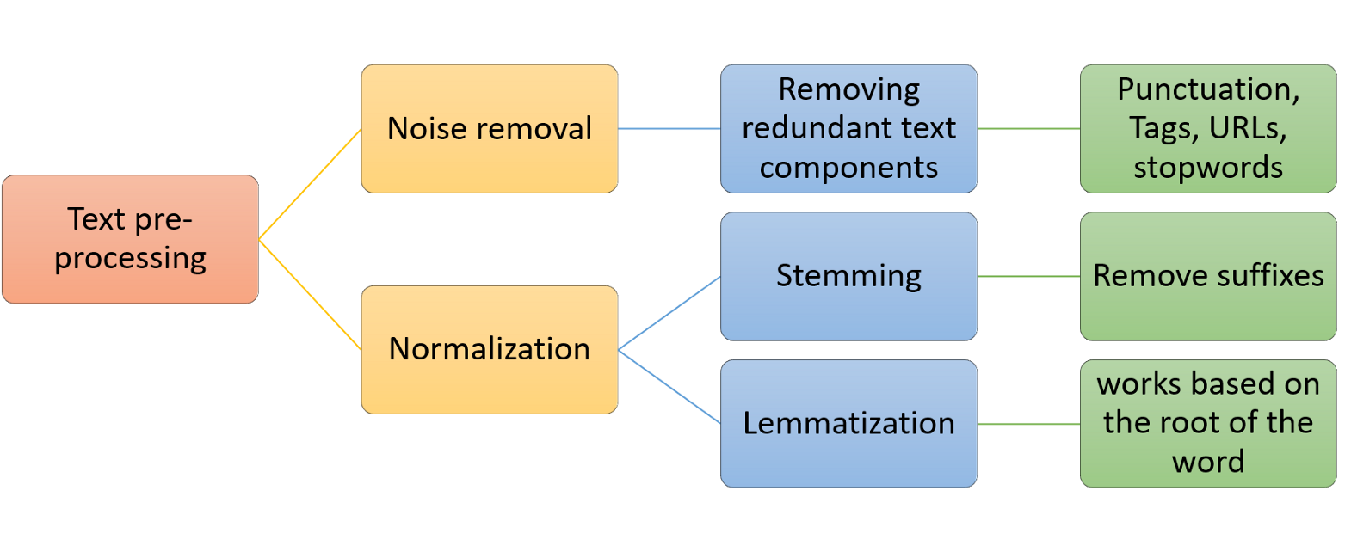
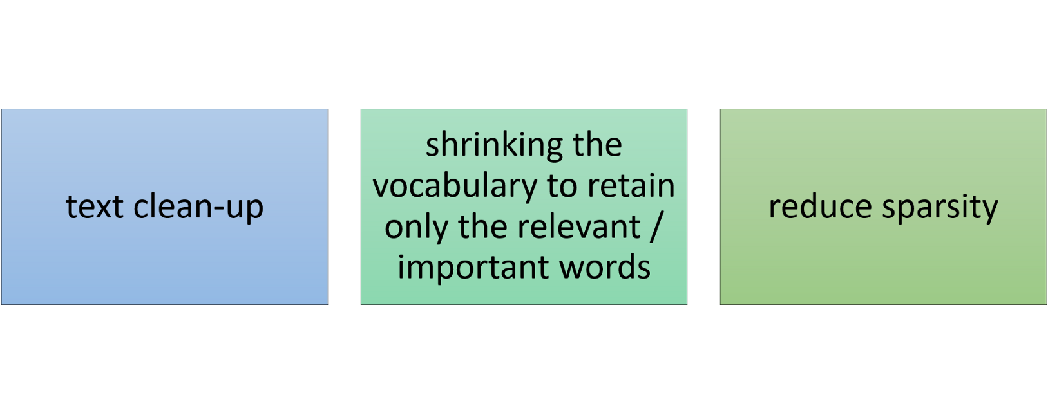

# Libraries for text preprocessing
import re
import nltk

#nltk.download('stopwords')
from nltk.corpus import stopwords

from nltk.stem.porter import PorterStemmer
from nltk.tokenize import RegexpTokenizer

#nltk.download('wordnet')
from nltk.stem.wordnet import WordNetLemmatizer

lem = WordNetLemmatizer()
stem = PorterStemmer()
word = "inversely"
print("stemming:",stem.stem(word))
print("lemmatization:", lem.lemmatize(word, "v"))
stemming: invers
lemmatization: inversely

stop_words = set(stopwords.words("english"))

#Remove punctuations
text = re.sub('[^a-zA-Z]', ' ', dataset['abstract'][i])

#Convert to lowercase
text = text.lower()

#remove tags
text=re.sub("&lt;/?.*?&gt;"," &lt;&gt; ",text)

# remove special characters and digits
text=re.sub("(\\d|\\W)+"," ",text)

#Convert to list from string
text = text.split()

##Stemming
ps=PorterStemmer()

#Lemmatisation
lem = WordNetLemmatizer()
text = [lem.lemmatize(word) for word in text if not word in stop_words]
text = " ".join(text)

Brain-computer interfaces (BCIs), as any other interaction modality based on physiological signals and body channels
TO
brain computer interface bcis interaction modality based physiological signal body channel

Data Exploration
from wordcloud import WordCloud, STOPWORDS, ImageColorGenerator
wordcloud = WordCloud(
background_color='white',
stopwords=stop_words,
max_words=100,
max_font_size=50,
random_state=42
).generate(str(corpus))
print(wordcloud)
fig = plt.figure(1)
plt.imshow(wordcloud)
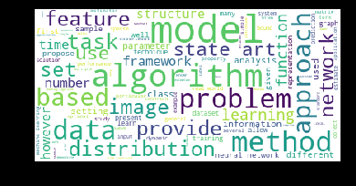

Text preparation
Tokenisation is the process of converting the continuous text into a list of words. The list of words is then converted to a matrix of integers by the process of vectorisation. Vectorisation is also called feature extraction

Creating a vector of word counts
n-grams
– Visualize top N uni-grams, bi-grams & tri-grams
from sklearn.feature_extraction.text import CountVectorizer
import re
cv=CountVectorizer(max_df=0.8,stop_words=stop_words, max_features=10000, ngram_range=(1,3))
X=cv.fit_transform(corpus)
#uni-grams
vec = CountVectorizer().fit(corpus)
bag_of_words = vec.transform(corpus)
sum_words = bag_of_words.sum(axis=0)
#bi-grams
vec1 = CountVectorizer(ngram_range=(2,2),max_features=2000).fit(corpus)
#tri-grams
vec1 = CountVectorizer(ngram_range=(3,3), max_features=2000).fit(corpus)
words_freq = [(word, sum_words[0, idx]) for word, idx in vec1.vocabulary_.items()]
words_freq = sorted(words_freq, key = lambda x: x[1], reverse=True)
return words_freq[:n]
Tri-gram | Freq
0 convolutional neural network | 100
1 deep neural network | 94
2 state art performance | 82
3 stochastic gradient descent | 80
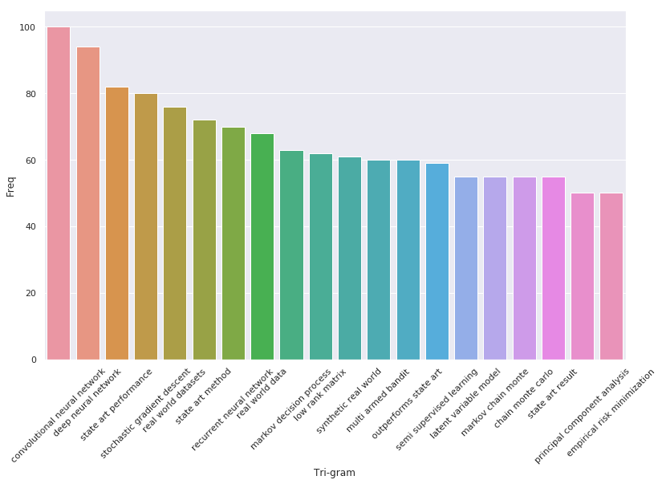

Converting to a matrix of integers
TF-IDF vectoriser
TF — term frequency
IDF — Inverse document frequency

from sklearn.feature_extraction.text import TfidfTransformer

tfidf_transformer=TfidfTransformer(smooth_idf=True,use_idf=True)
tfidf_transformer.fit(X)

# get feature names
feature_names=cv.get_feature_names()
['ability',
'able',
'able achieve',
'able capture',
'able handle',
'able learn',
'able significantly',
'absence',
'absolute',
'abstention']
# fetch document for which keywords needs to be extracted
doc=corpus[532]
'present theory compositionality stochastic optimal control showing task optimal controller constructed certain primitive primitive feedback controller pursuing agenda mixed proportion much progress making towards agenda compatible agenda present task resulting composite control law provably optimal problem belongs certain class class rather general yet number unique property bellman equation made linear even non linear discrete dynamic give rise compositionality developed special case linear dynamic gaussian noise framework yield analytical solution e non linear mixture linear quadratic regulator without requiring final cost quadratic generally natural set control primitive constructed applying svd green function bellman equation illustrate theory context human arm movement idea optimality compositionality prominent field motor control yet hard reconcile work make possible'

#generate tf-idf for the given document
tf_idf_vector=tfidf_transformer.transform(cv.transform([doc]))

tf_idf_vector.tocoo().col
(array([9990, 9988, 9955, 9945, 9935, 9927, 9562, 9348, 9241, 9108, 9025,
8793, 8625, 8624, 8535, 8394, 8300, 8014, 7956, 7900, 7560, 7461,
7364, 7284, 7280, 7261, 7249, 7078, 7021, 6955, 6861, 6410, 6394,
6387, 6206, 6105, 6091, 6072, 5914, 5812, 5800, 5794, 5793, 5506,
5500, 5078, 5073, 5068, 5041, 4849, 4824, 4813, 4606, 4027, 4002,
3968, 3829, 3682, 3678, 3644, 3612, 3592, 3584, 3503, 3459, 3300,
3289, 3282, 2955, 2952, 2879, 2648, 2479, 2348, 1918, 1828, 1822,
1790, 1775, 1610, 1607, 1566, 1397, 1324, 1323, 1277, 1272, 983,
978, 672, 560, 488], dtype=int32),

tf_idf_vector.tocoo().data,
array([0.06104522, 0.13393535, 0.11028218, 0.04225602, 0.10405079,
0.05422708, 0.08674571, 0.07548234, 0.11452222, 0.08071359,
0.09473541, 0.04926482, 0.07014114, 0.06492985, 0.05148359,
0.0662945 , 0.03937382, 0.08850402, 0.05820426, 0.08373741,
0.06544047, 0.1435521 , 0.07258087, 0.09405225, 0.04862586,
0.09620018, 0.08479773, 0.02680772, 0.29096544, 0.07693579,
0.05608737, 0.07906215, 0.10405079, 0.13327045, 0.03960406,
0.15302835, 0.08553981, 0.05678081, 0.05422708, 0.05672181,
0.0899688 , 0.11233435, 0.08897694, 0.06358424, 0.08242867,
0.06192825, 0.09405225, 0.05274867, 0.07274701, 0.11233435,
0.11233435, 0.21151015, 0.08516807, 0.06564957, 0.06414657,
0.0578834 , 0.0666274 , 0.09102911, 0.05672181, 0.07508826,
0.04621711, 0.09405225, 0.05195127, 0.03581926, 0.04234818,
0.08479773, 0.06050861, 0.07630219, 0.10847203, 0.05256786,
0.15389423, 0.11217475, 0.06554467, 0.07162002, 0.05520893,
0.1973957 , 0.25360514, 0.06043346, 0.15863236, 0.32541609,
0.09216804, 0.09473541, 0.08992368, 0.11028218, 0.1294605 ,
0.10847203, 0.04504425, 0.09869785, 0.19563882, 0.07808604,
0.07508826, 0.0899688 ]),

[feature_names[i] for i in tf_idf_vector.tocoo().col]
['yield','yet','work make','work','without requiring','without','unique','towards','theory','task','svd','stochastic','special case','special','solution','showing','set','rise','resulting','requiring','rather','quadratic','provably','proportion','property','prominent','progress','problem','primitive','present','possible','optimality','optimal control','optimal','number','non linear','non','noise','natural','much','movement','motor control','motor','mixture','mixed','making','make possible','make','made','linear quadratic','linear dynamic','linear','law','illustrate','idea','human','hard','give rise','give','generally','general','gaussian noise','gaussian','function','framework','final','field','feedback','even non','even','equation','dynamic','discrete','developed','cost','controller','control','context','constructed','compositionality','composite','compatible','class','certain class','certain','case linear','case','belongs','bellman','arm','applying','analytical'])

Based on the TF-IDF scores, we can extract the words with the highest scores to get the keywords/TAGS for a document.
#Function for sorting tf_idf in descending order
from scipy.sparse import coo_matrix
def sort_coo(coo_matrix):
tuples = zip(coo_matrix.col, coo_matrix.data)
return sorted(tuples, key=lambda x: (x[1], x[0]), reverse=True)

def extract_topn_from_vector(feature_names, sorted_items, topn=10):
"""get the feature names and tf-idf score of top n items"""

#use only topn items from vector
sorted_items = sorted_items[:topn]

score_vals = []
feature_vals = []

# word index and corresponding tf-idf score
for idx, score in sorted_items:

#keep track of feature name and its corresponding score
score_vals.append(round(score, 3))
feature_vals.append(feature_names[idx])

#create a tuples of feature,score
#results = zip(feature_vals,score_vals)
results= {}
for idx in range(len(feature_vals)):
results[feature_vals[idx]]=score_vals[idx]

return results
#sort the tf-idf vectors by descending order of scores
sorted_items=sort_coo(tf_idf_vector.tocoo())
print(sorted_items)
#extract only the top n; n here is 10
keywords=extract_topn_from_vector(feature_names,sorted_items,5)

# now print the results
print("\nAbstract:")
print(doc)
print("\nKeywords:")
for k in keywords:
print(k,keywords[k])
Keywords:
compositionality 0.325
primitive 0.291
control 0.254
linear 0.212
controller 0.197
Approach 2
Processing
Initial cleaning
Tokenize
Stemming
Stop words
Final cleaning
Latent Dirichlet allocation – LDA
Ploting – TSNE

# LDA, tSNE
from sklearn.manifold import TSNE
from gensim.models.ldamodel import LdaModel
# NLTK
from nltk.tokenize import RegexpTokenizer
from nltk.stem.snowball import SnowballStemmer
from nltk.corpus import stopwords
import re

SELF-ORGANIZATION OF ASSOCIATIVE DATABASE
AND ITS APPLICATIONS
Hisashi Suzuki and Suguru Arimoto
Osaka University, Toyonaka, Osaka 560, Japan
ABSTRACT
An efficient method of self-organizing associative databases is proposed together with
applications to robot eyesight systems. The proposed databases can associate any input
with some output. In the first half part of discussion, an algorithm of self-organization is
proposed. From an aspect of hardware, it produces a new style of neural netwo

[Processing
Initial cleaning
Tokenize
Stemming
Stop words
Final cleaning]

['self', 'organ', 'associ', 'databas', 'applic', 'hisashi', 'suzuki', 'suguru', 'arimoto', 'osaka', 'univers', 'toyonaka', 'osaka', 'japan', 'abstract', 'effici', 'method', 'self', 'organ', 'associ', 'databas', 'propos', 'togeth', 'applic', 'robot']

Latent Dirichlet allocation – LDA
from gensim import corpora, models
np.random.seed(2017)
texts = df['paper_text_tokens'].values
dictionary = corpora.Dictionary(texts)

corpus = [dictionary.doc2bow(text) for text in texts]
ldamodel = models.ldamodel.LdaModel(corpus, id2word=dictionary, num_topics=8, passes=5, minimum_probability=0)

ldamodel.print_topics()
[(0,
'0.020*"imag" + 0.014*"model" + 0.014*"learn" + 0.014*"use" + 0.012*"featur" + 0.010*"object" + 0.009*"train" + 0.007*"label" + 0.007*"data" + 0.006*"set"'),
(1,
'0.012*"network" + 0.012*"function" + 0.008*"learn" + 0.007*"system" + 0.007*"time" + 0.007*"algorithm" + 0.007*"weight" + 0.006*"comput" + 0.006*"dynam" + 0.006*"converg"'),
(2,
'0.030*"network" + 0.017*"train" + 0.013*"use" + 0.013*"neural" + 0.013*"layer" + 0.011*"learn" + 0.010*"input" + 0.008*"output" + 0.008*"model" + 0.008*"unit"'),
(3,
'0.012*"bound" + 0.010*"set" + 0.010*"estim" + 0.010*"function" + 0.010*"learn" + 0.009*"distribut" + 0.008*"algorithm" + 0.008*"sampl" + 0.007*"use" + 0.006*"data"'),
(4,
'0.014*"algorithm" + 0.009*"problem" + 0.009*"matrix" + 0.008*"method" + 0.008*"optim" + 0.008*"use" + 0.008*"set" + 0.007*"function" + 0.006*"comput" + 0.006*"data"'),
(5,
'0.027*"model" + 0.012*"use" + 0.011*"distribut" + 0.010*"data" + 0.008*"infer" + 0.008*"sampl" + 0.008*"variabl" + 0.008*"estim" + 0.007*"paramet" + 0.007*"process"'),
(6,
'0.014*"learn" + 0.013*"state" + 0.013*"algorithm" + 0.011*"polici" + 0.009*"action" + 0.009*"optim" + 0.009*"use" + 0.008*"time" + 0.008*"function" + 0.007*"reward"'),
(7,
'0.014*"model" + 0.011*"neuron" + 0.008*"time" + 0.007*"activ" + 0.007*"spike" + 0.007*"cell" + 0.006*"figur" + 0.006*"respons" + 0.006*"use" + 0.006*"neural"')]

Refactoring results of LDA into numpy matrix (number_of_papers x number_of_topics).
hm = np.array([[y for (x,y) in ldamodel[corpus[i]]] for i in range(len(corpus))])
hm
array([[1.80192605e-01, 2.01878250e-01, 1.62038088e-01, ...,
6.91922178e-05, 1.50376588e-01, 1.45826176e-01],
[9.52171613e-05, 3.03285539e-01, 2.37325616e-02, ...,
9.52374103e-05, 9.53097478e-05, 6.72505617e-01],
[7.06949650e-05, 2.24076025e-03, 7.07444269e-05, ...,
7.07069266e-05, 7.07350118e-05, 9.97334898e-01],
...,
[3.25600207e-02, 8.00145686e-01, 1.27378508e-01, ...,
1.01935315e-04, 1.01918573e-04, 3.95080894e-02],
[1.30846277e-01, 1.23392269e-02, 2.10390240e-02, ...,
7.28634404e-05, 6.82875467e-03, 8.28728139e-01],
[6.11942112e-01, 6.38993661e-05, 9.63534266e-02, ...,
6.38923593e-05, 3.16320662e-03, 2.88285702e-01]], dtype=float32)
hm.shape
(7241, 8)

tsne = TSNE(random_state=2017, perplexity=30, early_exaggeration=120)
embedding = tsne.fit_transform(hm)
embedding = pd.DataFrame(embedding, columns=['x','y'])
embedding['hue'] = hm.argmax(axis=1)
embedding

x y hue
0 3.606235 5.409382 1
1 -39.632271 26.357269 7
2 -62.570656 2.267107 7
3 8.089802 26.345882 3
… … … …
7238 -14.459015 58.812084 1

7241 rows × 3 columns

Ploting – TSNE

