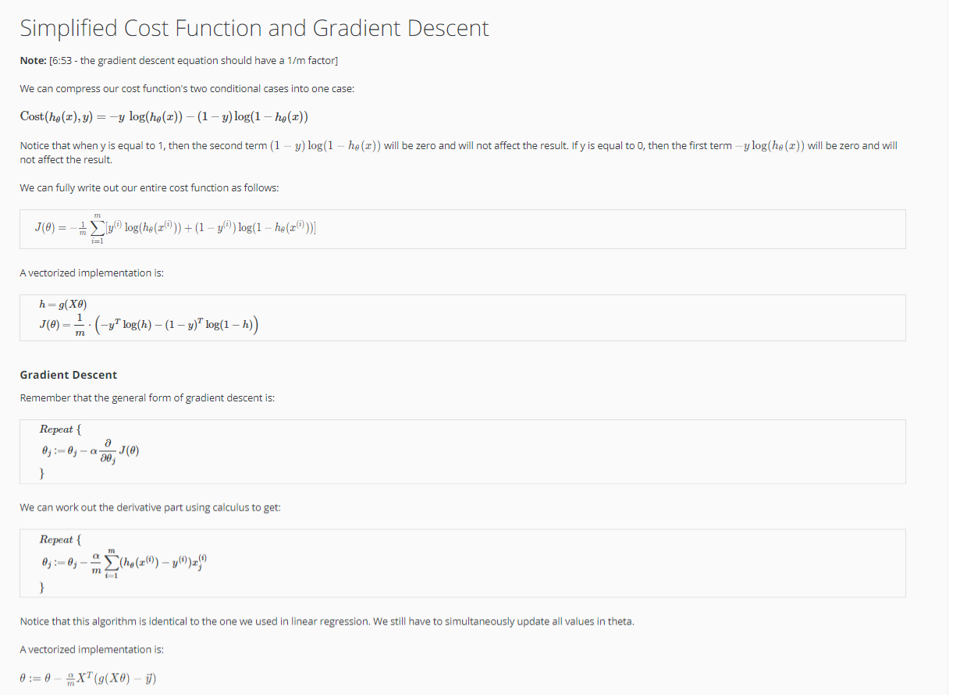
Simplified Cost Function and Gradient Descent

