Hypothesis Representation
We could approach the classification problem ignoring the fact that y is discrete-valued, and use our old linear regression algorithm to try to predict y given x. However, it is easy to construct examples where this method performs very poorly. Intuitively, it also doesn’t make sense for h_\theta (x)hθ​(x) to take values larger than 1 or smaller than 0 when we know that y ∈ {0, 1}. To fix this, let’s change the form for our hypotheses h_\theta (x)hθ​(x) to satisfy 0 \leq h_\theta (x) \leq 10≤hθ​(x)≤1. This is accomplished by plugging \theta^TxθTx into the Logistic Function.
Our new form uses the "Sigmoid Function," also called the "Logistic Function":
hθ(x)=g(θTx)z=θTxg(z)=11+e−z
The following image shows us what the sigmoid function looks like:
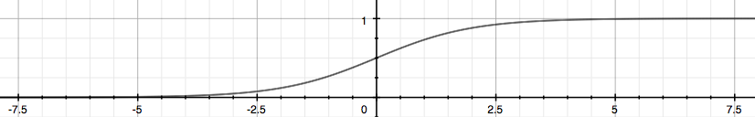
The function g(z), shown here, maps any real number to the (0, 1) interval, making it useful for transforming an arbitrary-valued function into a function better suited for classification.
h_\theta(x)hθ​(x) will give us the probability that our output is 1. For example, h_\theta(x)=0.7hθ​(x)=0.7 gives us a probability of 70% that our output is 1. Our probability that our prediction is 0 is just the complement of our probability that it is 1 (e.g. if probability that it is 1 is 70%, then the probability that it is 0 is 30%).
hθ(x)=P(y=1|x;θ)=1−P(y=0|x;θ)P(y=0|x;θ)+P(y=1|x;θ)=1

