Gradient Descent Intuition
In this video we explored the scenario where we used one parameter α and plotted its cost function to implement a gradient descent. Our formula for a single parameter was :
Repeat until convergence:
θ1:=θ1-α d/dθ1 Jθ1​ θ1​:= θ1​− α d/dθ1 ​J(θ1​)
Regardless of the slope's sign for d/dθ1 Jθ1​dθ1​d​J(θ1​), α eventually converges to its minimum value. The following graph shows that when the slope is negative, the value of α increases and when it is positive, the value of α decreases.
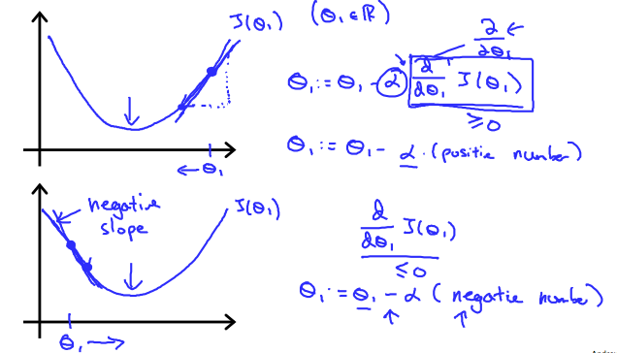
On a side note, we should adjust our parameter to ensure that the gradient descent algorithm converges in a reasonable time. Failure to converge or too much time to obtain the minimum value imply that our step size is wrong.

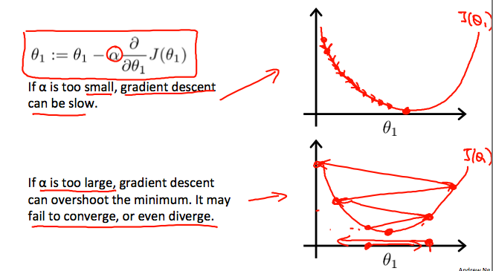

How does gradient descent converge with a fixed step size α?
The intuition behind the convergence is that dθ1​d​J(θ1​) approaches 0 as we approach the bottom of our convex function. At the minimum, the derivative will always be 0 and thus we get:
θ₁:= θ₁ − α ∗ 0
